Morse Tutor Simplified Schematic

A 'port' of the W8BH 'Blue Pill' Morse Tutor to a Mega 2560
by Ken, KM4NFQ "Not Fully Qualified" 6 August 2019
modified by GM4CID to simplify assembly 14 August 2019

Hardware

Arduino Mega 2560
2.4 inch LCD Display Shield
Switched Rotary Encoder
Piezo Sounder

18 19 20 21
A8 A9 A10 A11 A12 A13
Encoder
PIEZO
MEGA 2560
MORSE PADDLE
DIT
DAH
GND

2.4 inch LCD Display Shield mounts directly on Mega 2560

See next page for three wire adds on rear of Mega board

Mega is 5v USB powered from a mobile phone power bank

GM4CID 14 August 2019

Wire adds on rear of Mega 2560 board

50 (MISO) to 12
51 (MOSI) to 11
52 (SCK) to 13

Noter - 11, 12 and 13 are set high impedance in sketch

Wire adds are on track side of board, following
picture is of the component side.

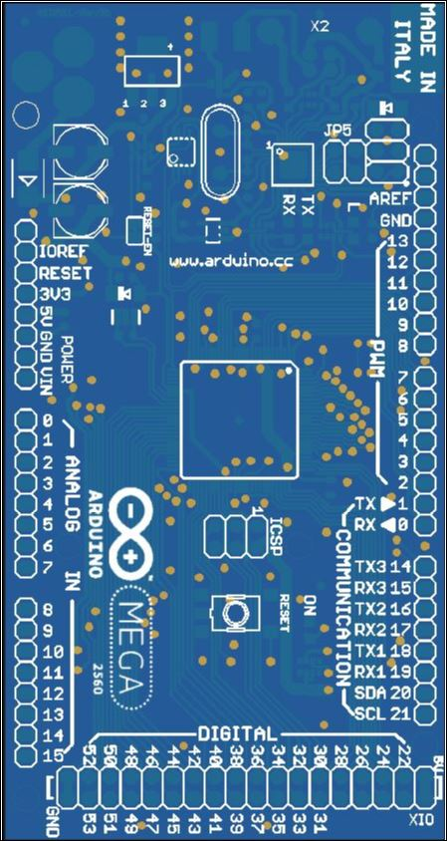

SCK
MISO to SD Reader
MOSI

GM4CID 14 August 2019

