Frame and caster dimensions:

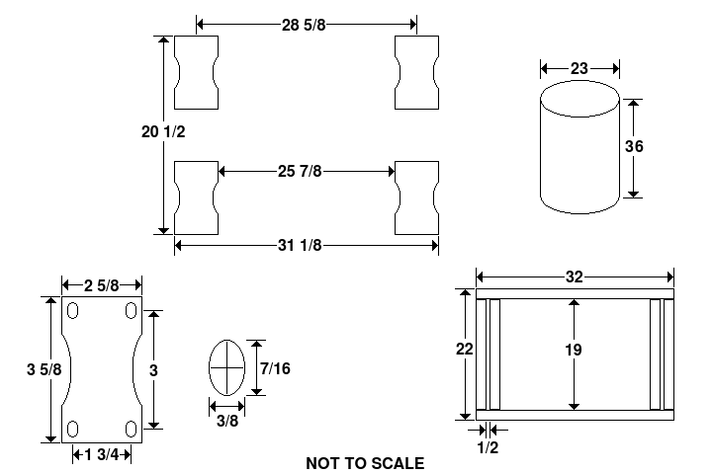
Four 5 inch diameter casters with ball bearings were purchased for each barrel. The casters rested on pieces of ¾ inch thick plywood, 3 ½ inches wide by 22 inches long. The plywood was nailed to a 2x4 frame that was 22 inches wide by 32 inches long.

