Front View of Compost Bins with Fence Posts:

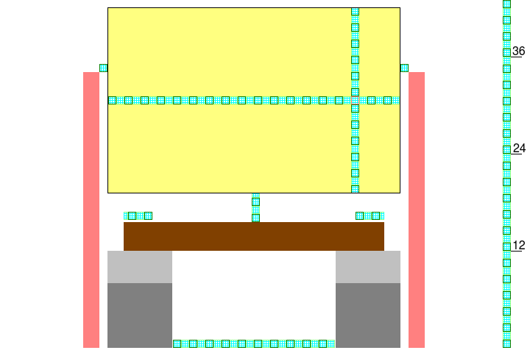
The cinder blocks are spaced far enough apart to be able to insert a masonry tray between them.

