The Plywood and Casters:

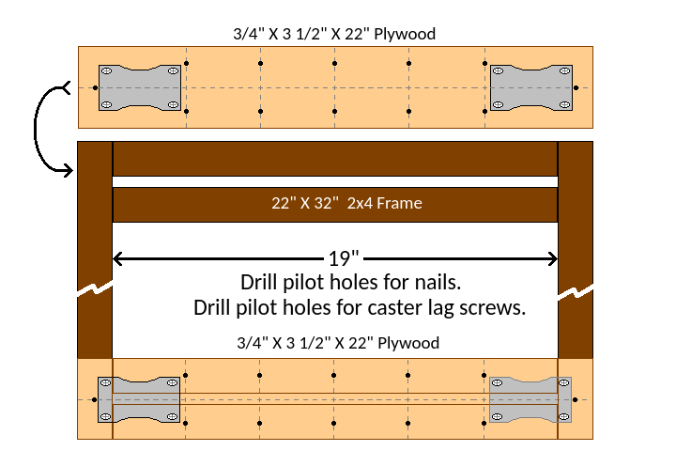
The pilot holes for the 12d nails were made with a drill bit that was slightly smaller than the diameter of the nail. The casters were centered on the plywood with one end of each caster about ¾ inch from the end of the plywood.

