Hinges and Latch:

Hot glue was used with the wood screws that came with the hinges and latch to fix them in place.

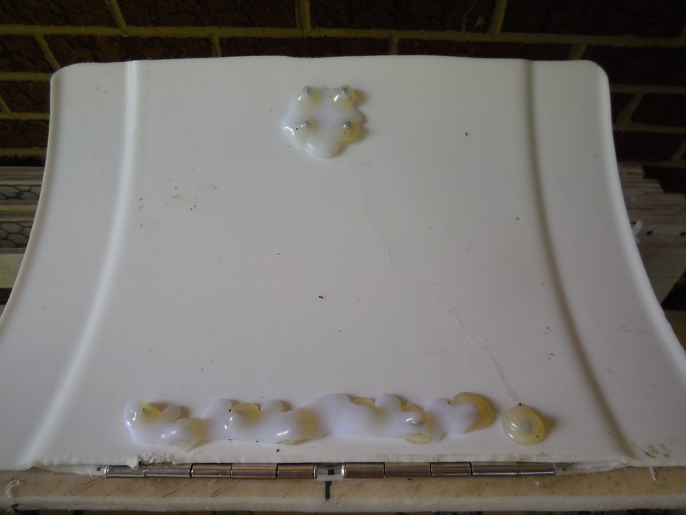
The hinges are stainless steel 3 ½ by 2 1/8. The latch is 1 ¼ by 5 inches long.

