Handles, Paddles, and Ventilation Holes:

The outside handles for turning were made from ½ inch copper pipe, 7 inches long, with the ends flattened and drilled. The inside stirring paddles were made from 1x1x12 inch aluminum tubing.

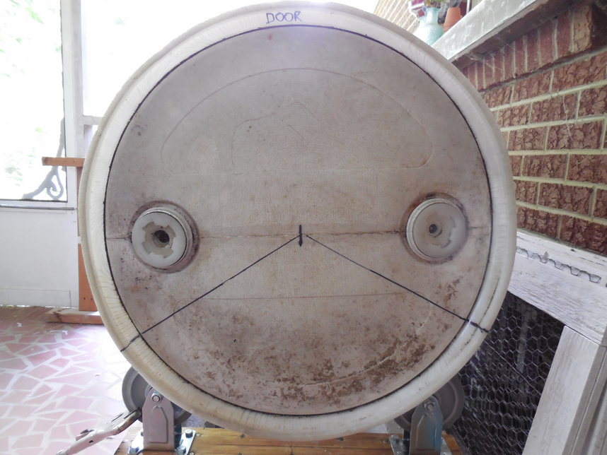
1 ½ inch long bolts with lock nuts were used to fasten the handles and paddles through the barrel walls. They were placed in an equilateral triangle.

