Cinder Block Foundation:

Six 8x8x16 inch cinder blocks were leveled at the compost bin site. Three blocks on each side. They are spaced 36 inches apart.

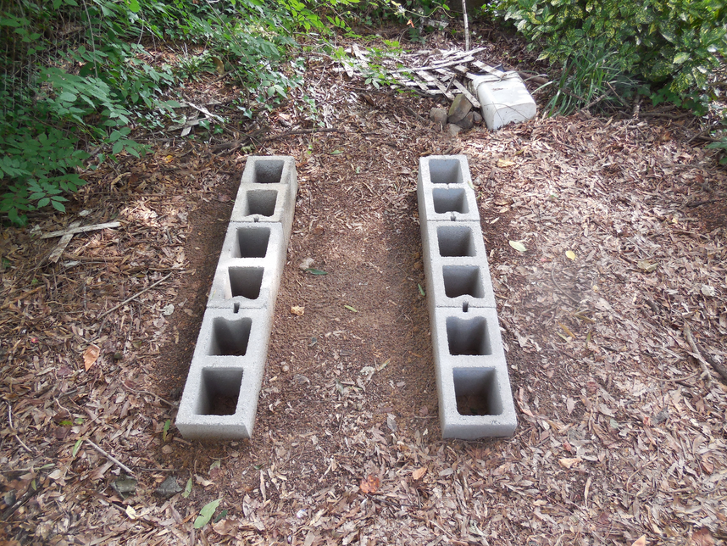
Six more were added on top of these six to make the foundation two blocks high.

