9C&A ASW Tools Guide
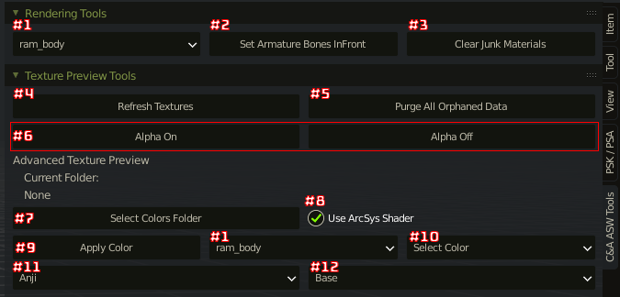
Note: This Addon was made mainly with GLTF, it may or may not work with other model file types.

#1 - Armature Dropdown
Select an armature in the scene

#2 - Set Armature Bones InFront Button
Pressing this button will set the bones of the currently selected armature to be in front and also set them to display as bounds and stick
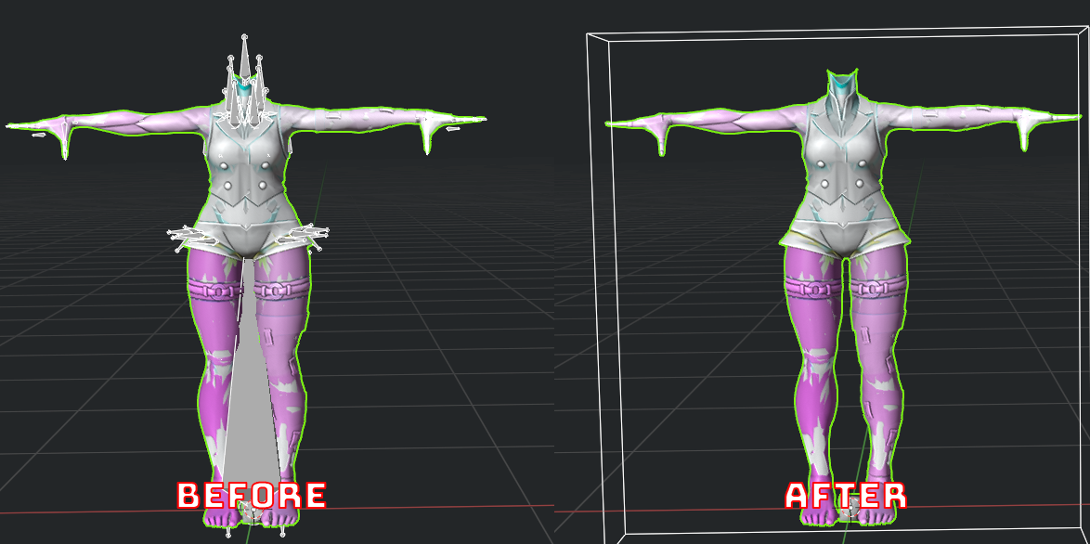

#3 - Clear Junk Materials Button
Pressing this button will clear the outline and shadow meshes from the model
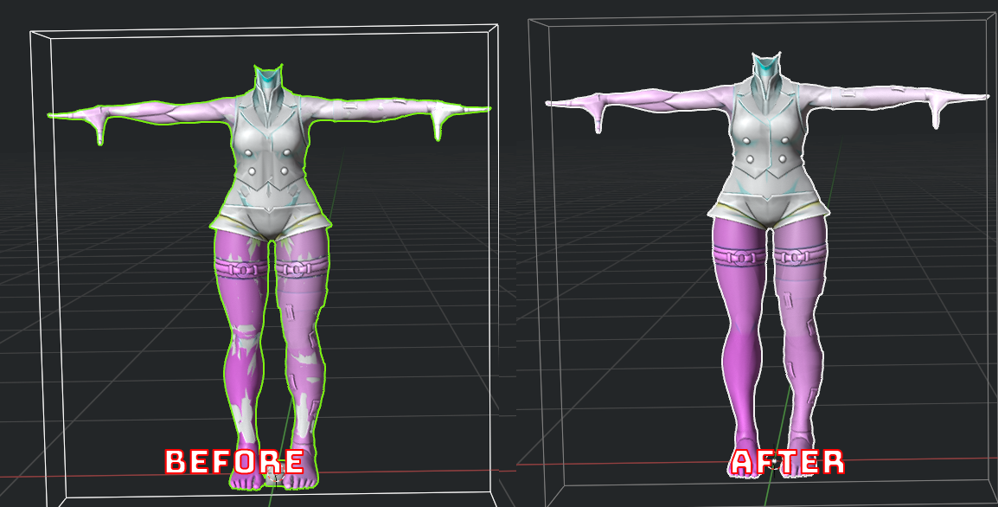

#4 - Refresh Textures Button
Pressing this button will refresh all textures so if you have edited any textures in another application, pressing this button will update them

#5 - Purge Orphaned Data Button
Pressing this button will clean/delete all unused meshes, materials & images

#6 - Alpha on/off Button
Pressing these buttons will turn the alpha on/off for all images, useful for looking at UVs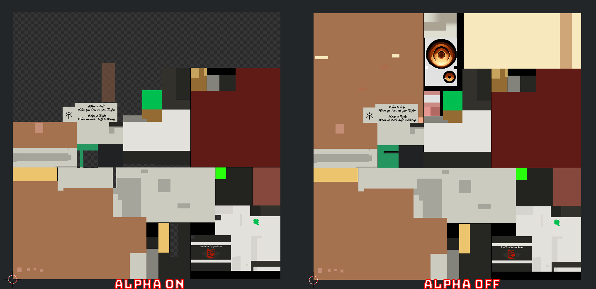

#7 - Select Colors Folder Button
Pressed this button will open up the file browser, you will want to select a folder that contains your base folder and color folders
Your base folder should contain _ilm.tga and _detail.tga, the Color folders should each contain a _Base.tga and a _Sss.tga, the same goes for extra textures likes W_Base.tga/W_Sss.tga or even character specific ones like RAMD_Base.tga/RAMD_Sss.tga for Ramlethals dog for example

Once selected #10 Color Dropdown will populate with each color in the folder.

#8 - ArcSys Shader Checkbox
Tick this checkbox if you want your textures to be previewed using the ArcSys Shader made by Aerthas Veras. (Requires you either Append the materials or set up the ArcSys Shader Application template, check the bottom of the guide on how to install the Application Template)

#9 - Apply Color Button
Pressing this button will apply the selected color in #10 Color Dropdown to each mesh in your currently selected Armature in #1 Armature Dropdown

#10 - Color Dropdown
This dropdown selects the color you with to apply with #9 Apply Color Button

#11 - Character Dropdown
Select the character whose textures you are trying to apply using this dropdown

#12 - Texture Type Dropdown
Select the texture type you are trying to apply using this dropdown (Base for Body textures Weapon for W textures ect)

How to install the ArcSys Shader Application Template
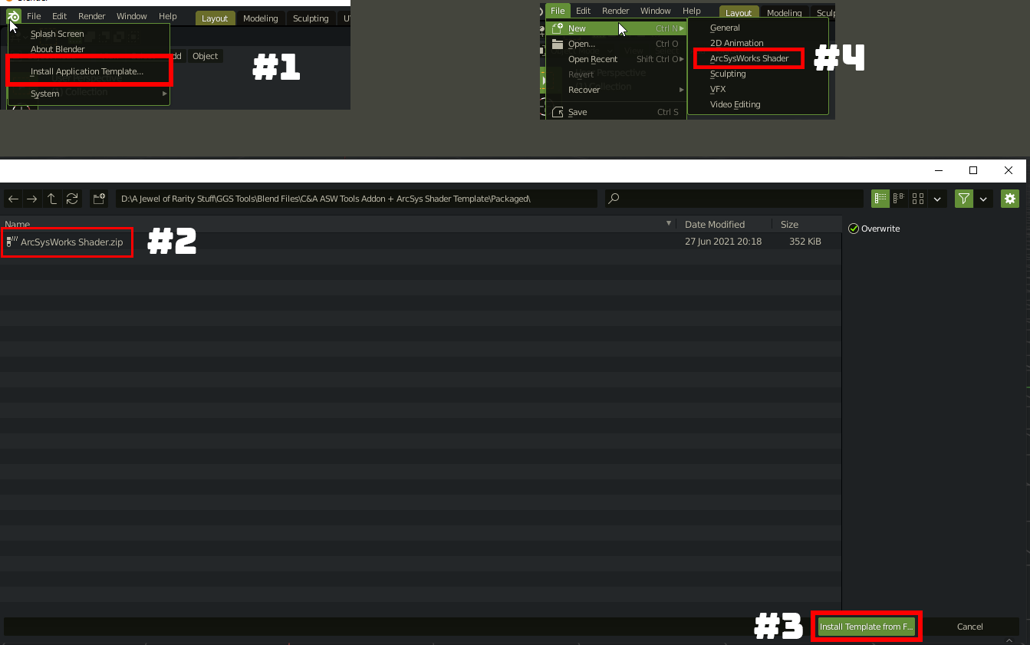

#1 - Click the blender Icon in the top left of the application
#2 - Find the ArcSysWorks Shader.zip that came with the C&A_ASW_Tools_Addon.zip and select it
#3 - Click install template from file
#4 - You should now have a new template in blender called ArcSy Shader

