1. Create a Cloning of a VM and Test it by loading the Previous Version/Cloned VM

The procedural steps are:

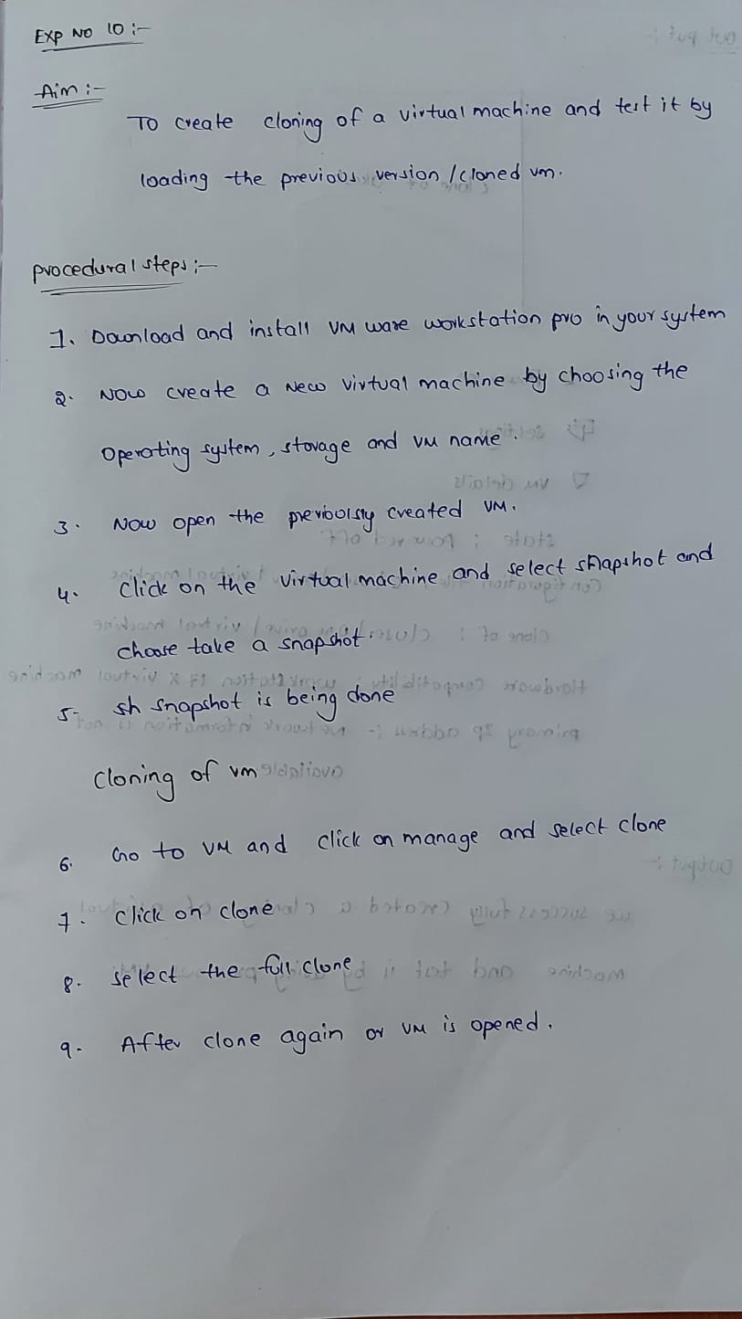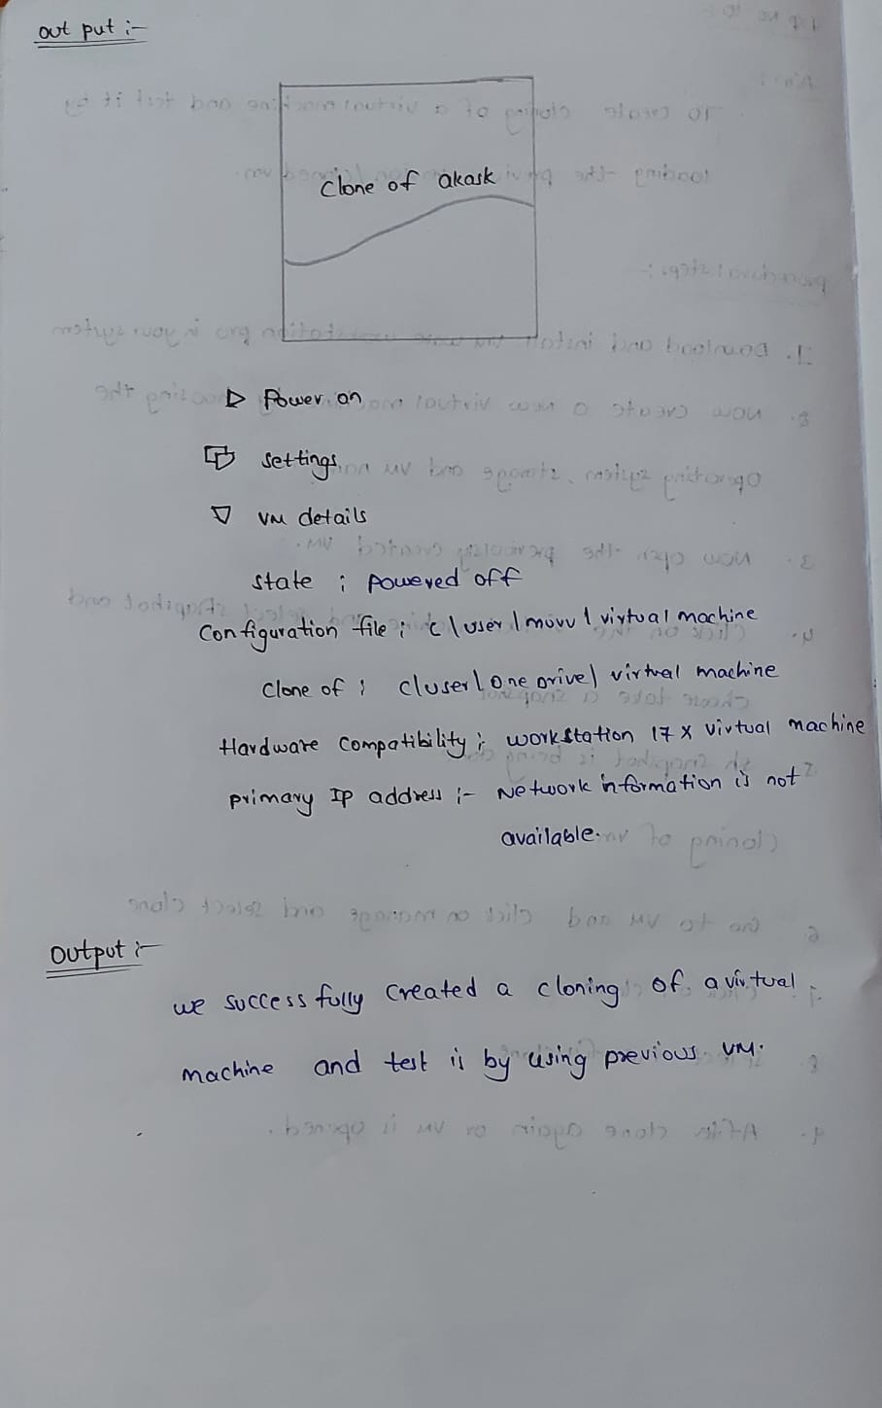

Out put

