1. Create a Snapshot of a VM and Test it by loading the Previous Version/Cloned VM

The procedural steps are:

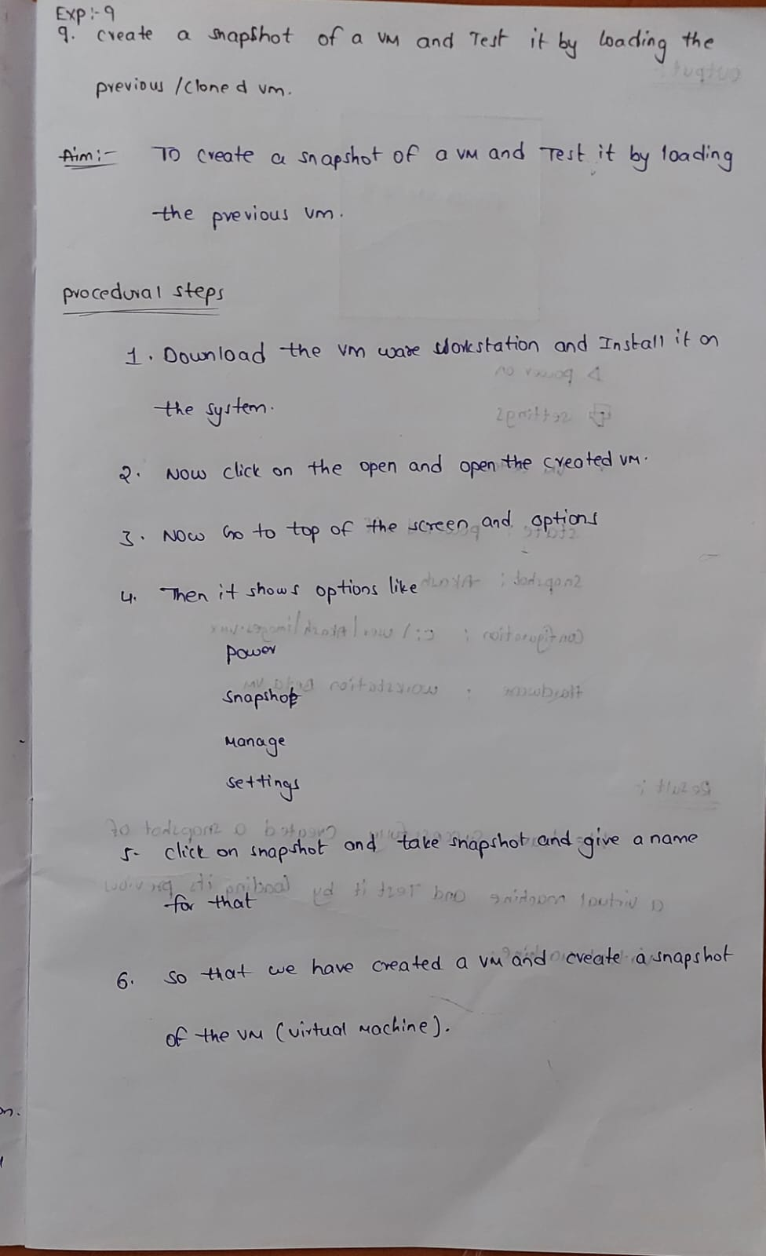

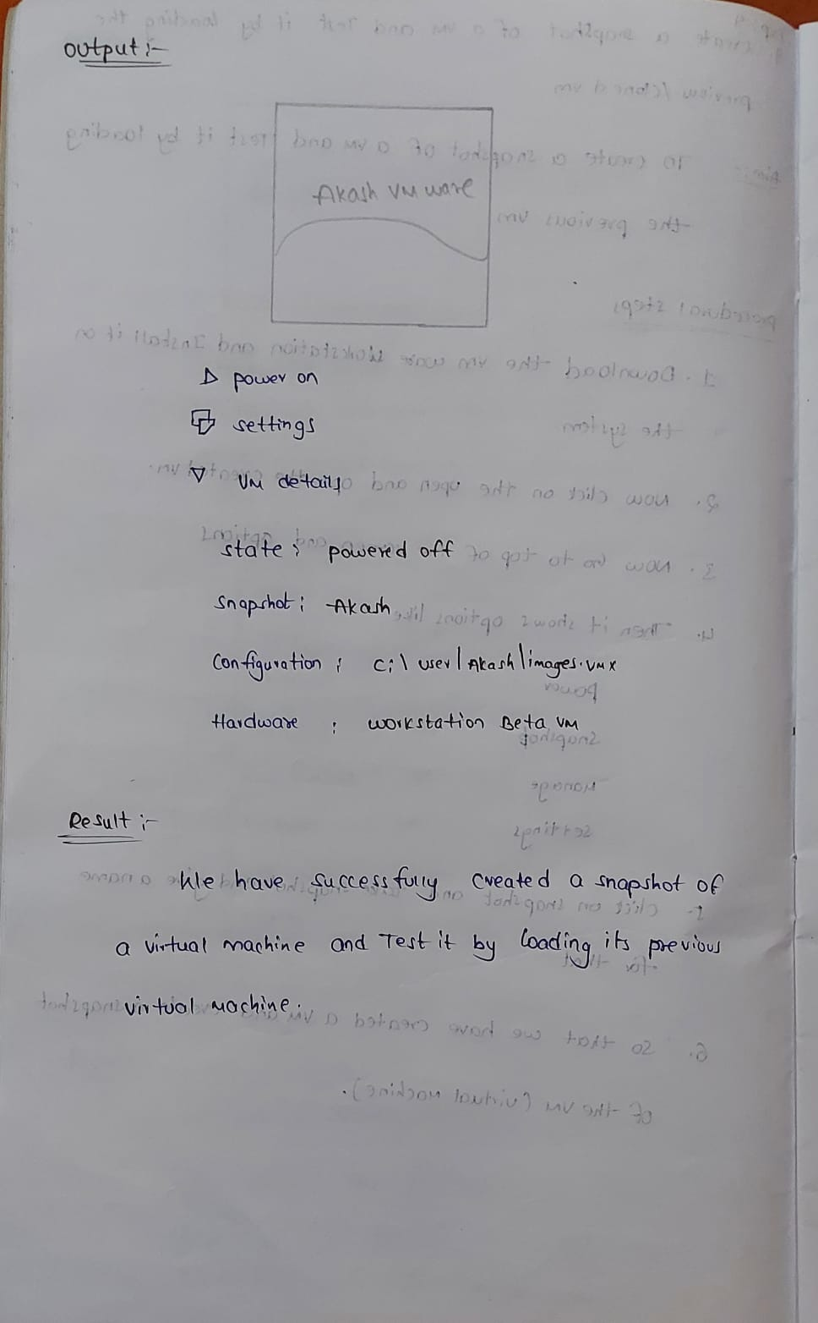

Output :

