Deployment Submission

Technologies

|  |  |  |
| --- | --- | --- |
| Technologies |  |  |
| Docker | Dockerfile |  |

Dockerfile Created to build docker Image:

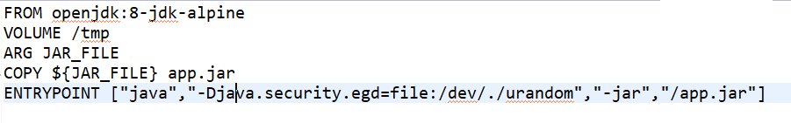

Plugin Used in Pom.xml:

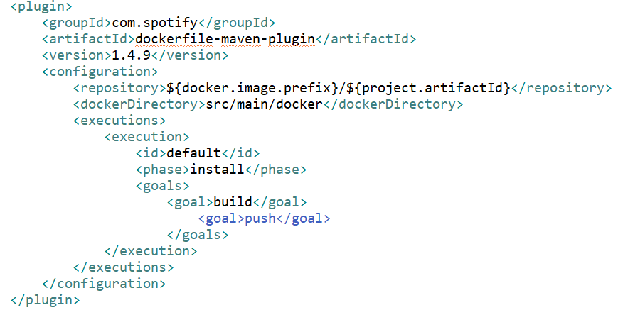

Building Image with Maven docker plugin:

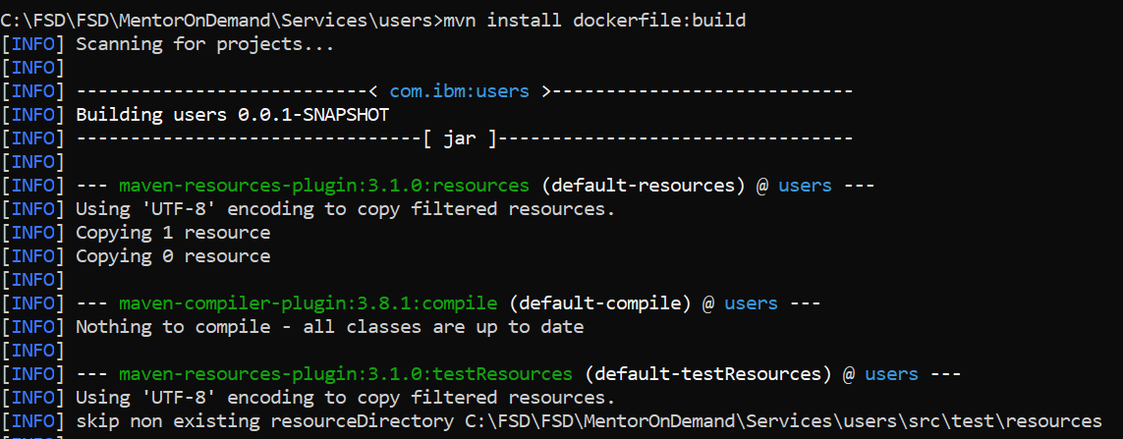

Building Image with docker console:

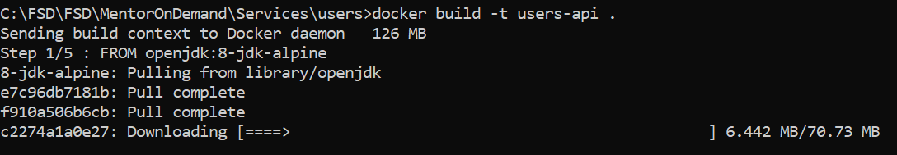

Running Image with docker console:

