OSSP SKILL
MUVVA LOHITHA(2520030378)
To Split Input into Tokens, Identify Delimiters, Handle Whitespace, Create Token Structures, Validate Token Streams, Debug Parsing Output.
To Design Parser Logic, Generate Parse Trees, Validate Syntax, Detect Errors, Handle Empty Commands, Produce Execution Structures.
(a) Code:
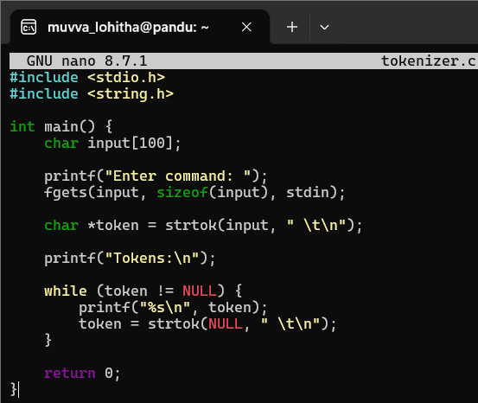
OUTPUT SCREEN SHOT:
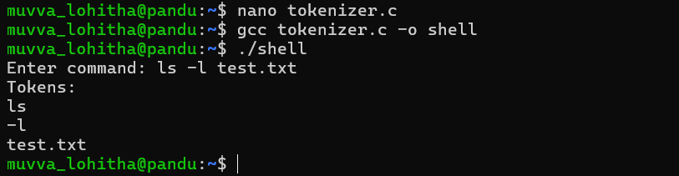
(b) Code:
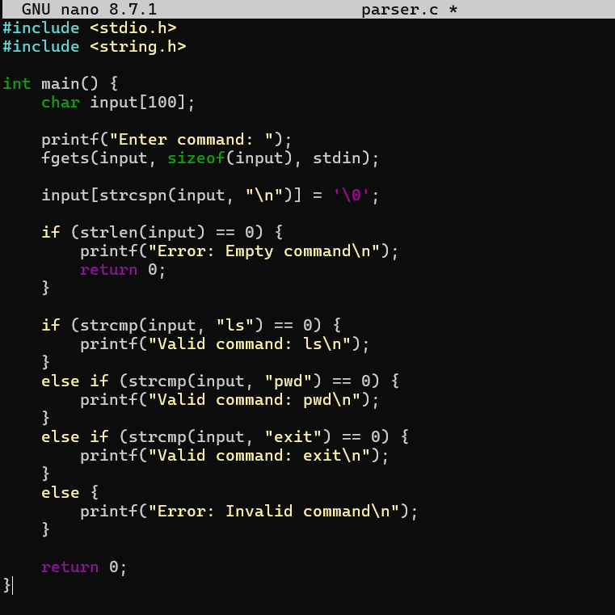
OUTPUT SCREENSHOT:
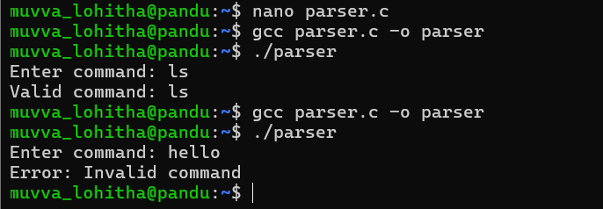
1. Process Synchronization and Child Process Monitoring Using waitpid().
To Retrieve PATH Variable, Parse Search Directories, Locate Executables, Verify Permissions, Handle Missing Commands, Test Command Resolution.
Code:
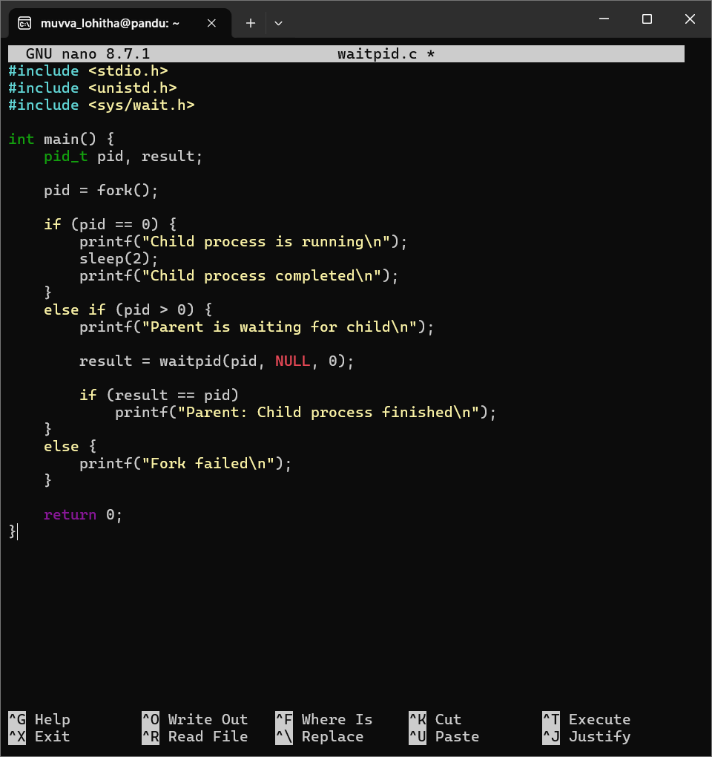
Screenshot:
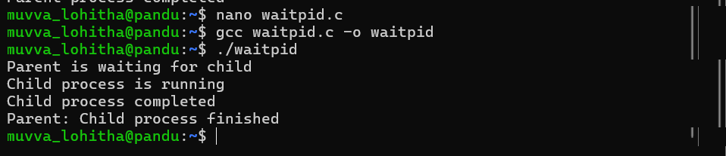
1. To Create Process Escape Sequences, Handle Escaped Spaces, Escape Special Symbols, Preserve Characters, Validate Parser Output, Test Complex Inputs.
To Create Child Processes, Execute Programs, Handle Execution Errors, Pass Arguments, Manage Parent Process, Test Command Launching
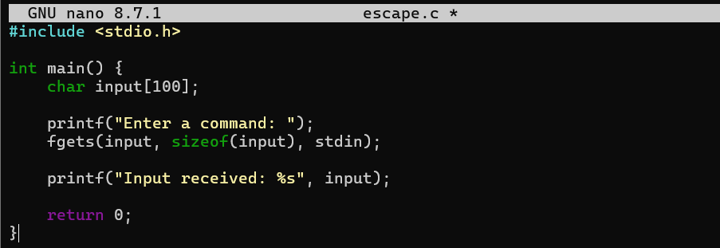
Output screen shot:
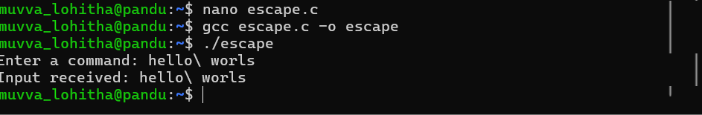
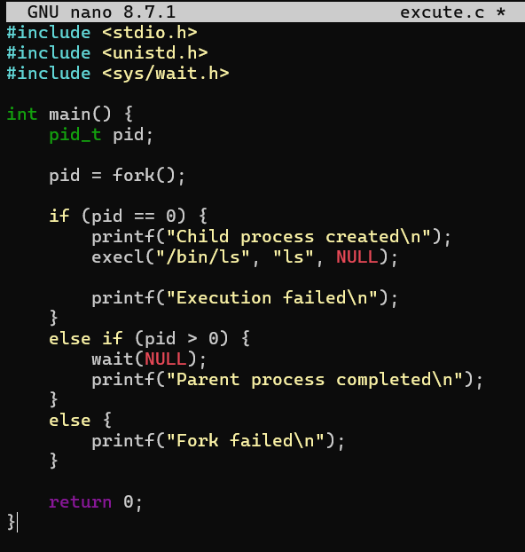
OUTPUT SCREENSHOT:
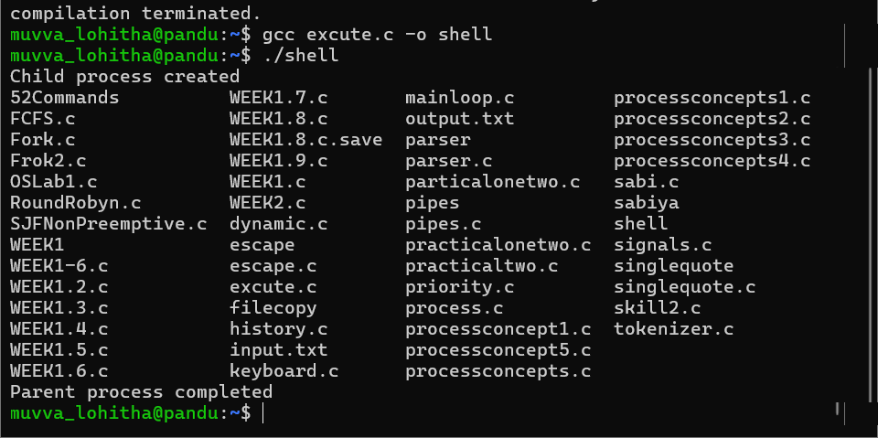
OSSP SKILL
MUVVA LOHITHA(2520030378)
To Apply Escape Sequences, Store Command History, Navigate Previous Commands, Navigate Next Commands, Update Input Buffer, Test Recall Functionality.
To Allocate Buffers Dynamically, Resize Arrays, Prevent Buffer Overflow, Manage Linked Lists, Release Memory Correctly, Verify with Valgrind
(a)Code
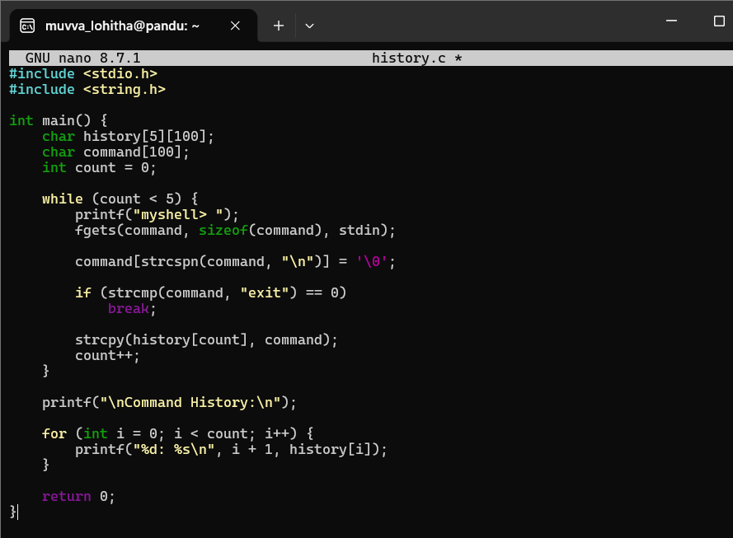
OUTPUT SCREENSHOT:
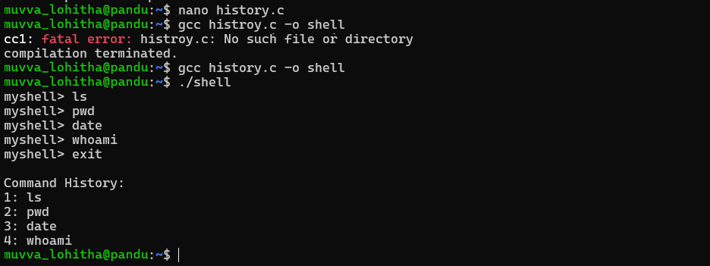
(b)Code:
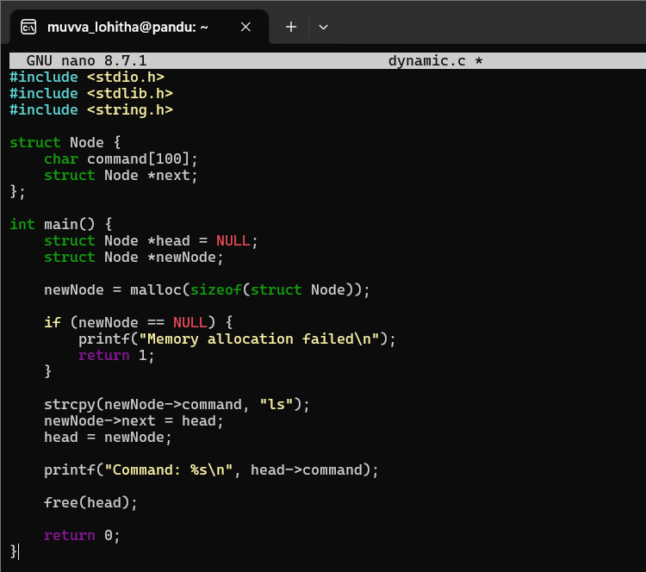
OUTPUT SCREEN SHOT:
