**MANUFAX**

Cheap Manufacturing and Automation of 3d printers Integrated with Machine Learning

M.MUWAHID ASIM - 2019352

SYED M FASIH UL HASSAN - 2019501

ADNAN TANVEER - 2019035

M.SAAIM QURESHI - 2019444

20 December 2022

**Executive Summary**

We aim to manufacture 3d printers at 50 % of the market cost. We aim to cheaply manufacture 3d printers integrated with machine learning. Most of the parts will be 3d printed which will cost much less than other materials. The 3d printer will be customizable as the Marlin open source code that will be deployed in Arduino atmega 2560 is modifiable. As we know that our business is an on-site business where we have to build a trust relationship with our client it can be done by giving values to the customers by providing them stuff at low cost & of good quality, so we will chose market penetration strategy where we use the opposite of the short-term profit strategy selling at the lowest possible price for a short-term period. This strategy, known as market penetration pricing, is often used to introduce a new product or business with an expected long-term life cycle. As we know that our business is an on-site business where we have to build a trust relationship with our client it can be done by giving values to the customers by providing them stuff at low cost & of good quality, so we will chose market penetration strategy where we use the opposite of the short-term profit strategy selling at the lowest possible price for a short-term period. This strategy, known as market penetration pricing, is often used to introduce a new product or business with an expected long-term life cycle.

Table of Contents

CONCEPT BACKGROUND AND HISTORY 4

GOALS AND OBJECTIVES 6

COMPANY AND PRODUCT MODEL 8

MARKETING STRATEGY AND PRICING PLAN 9

LEGAL REQUIREMENTS FOR STARTING A BUSINESS IN PAKISTAN 12

FORM OF OWNERSHIP 11

FINANCIAL PLAN 13

SWOT ANALYSIS 16

COMPETITIVE ANALYSIS 16

ORGANIZATION,MANAGEMENT AND STAFFING PLAN………………………...17

SPECIAL CONSIDERATIONS 19

REFERENCES 20

**CONCEPT BACKGROUND AND HISTORY**

**What is 3d printing?**

3D printing or additive manufacturing is a process of making three-dimensional solid objects from a digital file.The creation of a 3D-printed object is achieved using additive processes. In an additive process an object is created by laying down successive layers of material until the object is created. Each of these layers can be seen as a thinly sliced cross-section of the object.3D printing is the opposite of subtractive manufacturing which is cutting out / hollowing out a piece of metal or plastic with for instance a milling machine.3D printing enables you to produce complex shapes using less material than traditional manufacturing methods.

**History and Background**

The first documented iterations of 3D printing can be traced back to the early 1980s in Japan. In 1981, Hideo Kodama was trying to find a way to develop a rapid prototyping system. He came up with a layer-by-layer approach for manufacturing, using a photosensitive resin that was polymerized by UV light.

In the 90s, many companies and startups began popping up and experimenting with the different additive manufacturing technologies. In 2006, the first commercially available SLS printer was released, changing the game in terms of creating on-demand manufacturing of industrial parts.

CAD tools also became more available at this time, allowing people to develop 3D models on their computers. This is one of the most important tools in the early stages of creating a 3D print.

During this time, the machines were very different from those that we use now. They were difficult to use, expensive, and many of the final prints required a lot of post-processing. But innovations were happening every day and discoveries, methods, and practices were being refined and invented.

Then, in 2005, Open Source changed the game for 3D printing, giving people more access to this technology. Dr. Adrian Bowyer created the [RepRap Project](https://reprap.org/wiki/RepRap), which was an open-source initiative to create a 3D printer that could build another 3D printer, along with other 3D printed objects.

In 2008, the first prosthetic leg was printed, propelling 3D printing into the spotlight and introducing the term to millions across the globe.

Then, in 2009, the FDM patents filed in the 80s fell into the public domain, altering the history of 3D printing and opening the door for innovation. Because the technology was now more available to new companies and competition, the prices of 3D printers began to decrease and 3D printing became more and more accessible.

In the 2010s, the prices of 3D printers started to decline, making them available to the general public. Along with the lowering prices, the quality and ease of printing also increased.

The materials that printers use have also evolved. Now there are a variety of plastics and filaments that are widely available. Materials like Carbon Fiber and Glass Fiber can also be 3D printed. Some creatives are even experimenting with printing materials like chocolate or [pasta](https://www.saveur.com/3d-printers-pasta-barilla/)!

In 2019, the world’s largest functional [3D printed building was completed](https://www.bcn3d.com/what-can-you-make-with-a-professional-3d-printer/). 3D printing is now consistently used in developing hearing aids and other [healthcare applications](https://www.bcn3d.com/7-uses-of-3d-printing-in-the-healthcare-industry/), and many industries and sectors have adopted the technology into their everyday [workflow](https://www.bcn3d.com/full-walkthrough-3d-printing-workflow/).

**Product Description**

We aim to manufacture 3d printers at 50 % of the market cost. We aim to cheaply manufacture 3d printers integrated with machine learning. Most of the parts will be 3d printed which will cost much less than other materials. The 3d printer will be customizable as the Marlin open source code that will be deployed in Arduino atmega 2560 is modifiable.

**GOALS AND OBJECTIVES**

**A. What do I want to achieve?**

·      A company that stands on its feet and is able to generate capital for its own needs. A company that is profitable

·      A reputable company

**B. What specific results do I need to accomplish that will help me reach my goal?**

·       Cheap manufacturing of 3d printing

·       3d printers must be customizable

·       Secure an initial investment to fund our internal and external needs

·       get a good return on investment that is profitable enough so that we have our own money to invest and that we return borrowed money to do this we have to make assets that are growing in value

**C. Short-Term and Long-Term Goals**

|  |  |
| --- | --- |
| **Short term goals** | **Long Term Benefits** |
| Create a healthy respectable culture and work- space | Employees feel safe and there is a healthy work environment, so employees stay |
| Secure investors | Provides capital for expenses |
| Make good public image | Helps in getting investors |
| Hire young and growing engineers e.g fresh graduates | • Demands low salary   • Can be trained accordingly and will be loyal in the future |
| Find a low cost office (work space) e.g. rent a garage etc. | It will save capital for important needs |
| Get the products tested initially by the professionals who are friends from the same industry | This saves money in the long run to hire specialists later |
| Sign contracts with small companies to sell out sub products | This can help us generate revenue and make a good market repute |
| Hire a friend corporate lawyer | He will be less expensive and own our company AND WILL SOLVE OUR LEAGL MATTERS he will also guide us the right and wrong steps |
| Have capital for employee benefits and further investment | Cut our salaries |
| Make the company self-sufficient that is not dependent upon external capital | We will have to raise capital from the external sources initially and bear with their terms and conditions |

**COMPANY AND PRODUCT MODEL**

**Company’s Logo:**



**Model Design:**

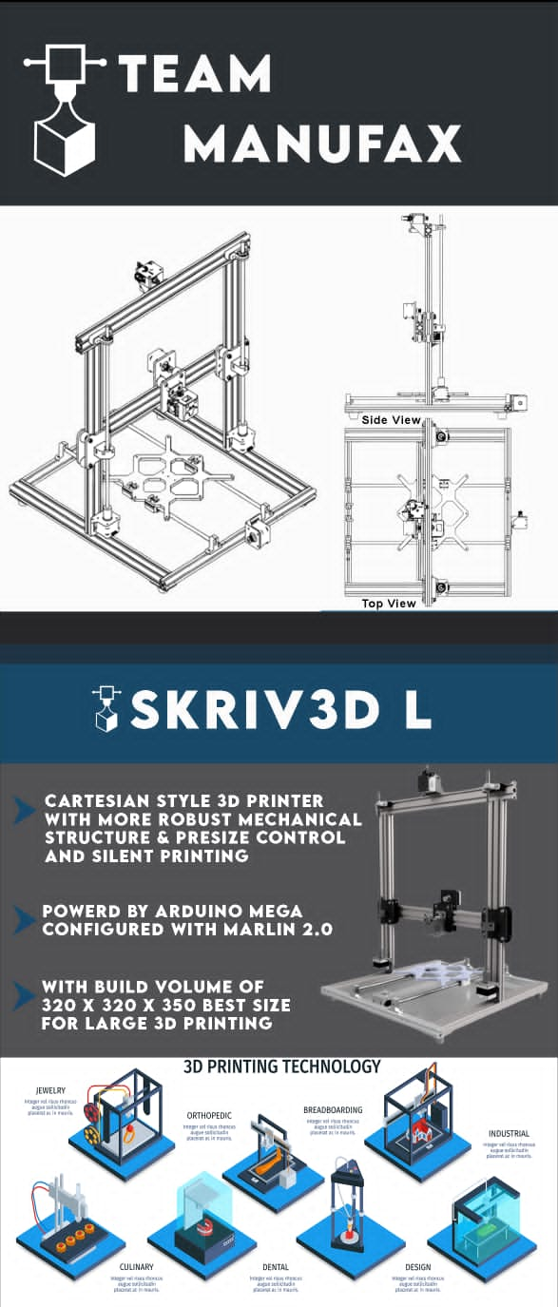

**MARKETING PLAN AND PRICING STRATEGY**

As we know that our business is an on-site business where we have to build a trust relationship with our client it can be done by giving values to the customers by providing them stuff at low cost & of good quality, so we will chose market penetration strategy where we use the opposite of the short-term profit strategy selling at the lowest possible price for a short-term period. This strategy, known as market penetration pricing, is often used to introduce a new product or business with an expected long-term life cycle. The idea is to gain market share. By setting a low price to entice people to try a new product, the business is hoping to gain customers at their competitors’ expense. Taking customers from the competition dilutes the competition’s portion of the market while increasing the market penetrator’s portion. We will also consider some factors, as well like the economic conditions of the country if the buyers of the printers decrease there could be a disaster in our business so for that we have to think about more productive we have to move somewhere where still the 3d printers are present so that our start-up does not end. All the things we are selling should be legal & at fair cost so that costumer could be satisfied, also we will be giving discounts on special days so that it attracts customers more it will increase our buyers.

**Legal requirements for starting a business in Pakistan:-**

**Create an LLC or Corporation**

The first legal requirement you’ll need to meet as a new business owner is to choose your company's business structure. We can choose between forming an LLC or a corporation. We are going for an LLC type of business structure because A LLC, or Limited Liability Company, protects you from personal liability under most circumstances. This means that if your business is sued or if it declares bankruptcy, your assets including your home and vehicle won’t be at risk. With an LLC you’ll be able to file your business income as part of your income taxes, but you will likely need to pay self-employment tax. Where a corporation, or C corp, is a company that is legally a separate entity from its owner or owners. Corporations offer the greatest level of personal protection from liability out of all business structures. However, they’re more expensive and complicated to form. Corporations file separate income taxes on their profits.

**Register Your Business Name**

Once we’ve decided on a business structure. We need to register ourselves with a business name. We aim to choose a name that reflects the technology, product and services we are going to offer and make sure it hasn’t already been claimed.

* **An entity name:** Manufax
* **A trademark:**
* **A DBA (Doing Business As):** LLC
* **A domain name:** [www.Maufax.pk](http://www.Maufax.pk)

**Apply for a Federal Tax ID Number**

We also require a federal tax identification number known as an Employer Identification Number (EIN) and it allows us to legally hire employees, pay federal taxes, apply for business licenses and open a business bank account.

**Obtain Business Permits and Licenses**

We are also required to apply for business licenses and permits at the federal and state government level, but the specific licenses you need depend on the industry you work in and your business location.

**Protect Your Business with Insurance**

Business insurance can protect you in cases where the personal liability protections offered by your specific business structure aren’t enough. Business insurance can protect not just your personal assets, but your business assets as well. Some types of insurance are required by law, such as unemployment and disability insurance. It’s also a good idea to purchase business insurance to protect your startup from other potential risks. Some common business insurance options include:

* **General liability insurance:** Protects your business from various forms of financial loss, including property damage, injury, medical issues, lawsuit settlements or judgements
* **Product liability insurance:** If your business sells products, this insurance protects you in the case that one of your products is defective and injures a customer
* **Commercial property insurance:** Protects your business from loss or damage to company property, as a result of natural disasters, accidents or vandalism

We can later do further analysis and choose which type of insurance we want to avail.

Reference: <https://www.freshbooks.com/hub/startup/starting-small-business-legal-requirements>

**Form of ownership**

We can choose between forming an LLC or a corporation. We are going for an LLC type of business structure because A LLC, or Limited Liability Company, protects you from personal liability under most circumstances. This means that if your business is sued or if it declares bankruptcy, your assets including your home and vehicle won’t be at risk. With an LLC you’ll be able to file your business income as part of your income taxes, but you will likely need to pay self-employment tax. Where a corporation, or C corp, is a company that is legally a separate entity from its owner or owners. Corporations offer the greatest level of personal protection from liability out of all business structures. However, they’re more expensive and complicated to form. We will be initially going for LLC, which is a form of corporation that is much simpler than a corporation. For a startup, we think it's better to start simpler where we have easier management and lesser complications in terms of paperwork and other legal responsibilities. Later on, once our startup is on track to success and we gain more experience then we can change our corporate status from LLC to a Corporation.

**Why this corporation is being formed:** thebasic purpose of forming this LLC is to provide benefits to potential manufacturers, hobbyists and students. we have used advanced printing automation ideas and tools to facilitate our customers in such a way that no other 3D printer Manufacturer has used this colour operation technology integrated with print quality fault detection and classification ability.

**Financial Plan**

Initial Capitalisation Plan:

| **Initial Capital sources** | **Contributed Amounts** |
| --- | --- |
| Self -Funding | Rs 1000,000 |
| GIKI Incubator | Rs 500,000 |
| Venture Capitalists | Rs 15,00000 |
| ALL3DP | Rs 200,000 |
| HBL | Rs 100,000 |

Total Initial Capital sources: Rs 2400,000

Contract with ALL3DP and HBL to market our website

* our customers will have transactions via HBL
* we will have a business account in HBL
* HBL will put our printed posters in their branches
* We will run ads of partners of HBL and HBL on our products
* ALL3DP will put our printers for sale and promotion on their website in return we will show them as our technical and marketing partner on all our products.

**Basic Fiscal Quarter financial breakdown**

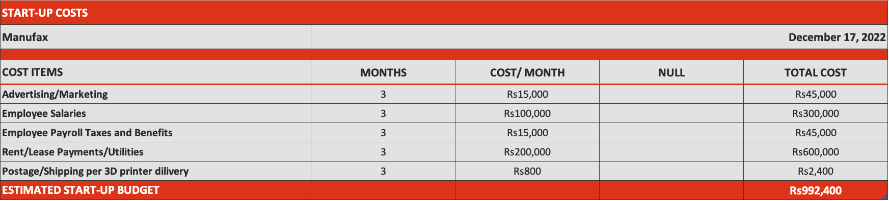

**Projected 5-Year Financial Plan for the startup Manufax:-**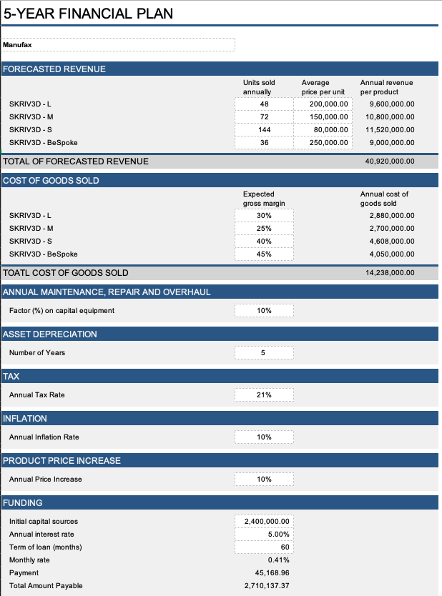

**SWOT Analysis**

**Strength**

Low operational costs

Time-saving

Rapid Prototyping

Strong and lightweight parts

**Weakness**

Takes time in printing like any other printer

Restricted Build Size

Limited Materials

**Opportunity**

Changing trend

An increasing number of users

High availability

**Threats**

Competitors increasing day by day towards 3d-printing

Copyright issues in design

**Competitive Analysis**

**Customer Needs**

We are providing a money saving 3D Printer so that customers can make 3D products at

frequently low price by the help of machine learning.

**Our Main Competitors**

da Vinci Nano 3D Printer from XYZprinting

Voxelab Aquila

The Mini Delta V2 3D Printer

**Differentiate**

We are aiming to make 3D printers for 50 percent less than the cost of market. We want to make cheap 3D printers that are integrated using machine learning. The majority of the components will be printed 3D, which will be much cheaper as other types of materials. The 3D printer is adjustable because the Marlin open-source software that will be used in Arduino atmega 2560 can be adaptable.

**Consider their Pricing Strategy**

The pricing strategy is way lower than the others because we have built a trust relationship with the customers. As we have the same output as the product which costs double than ours.

**Organization, Management and Staffing Plan**

**Organization Chart:**

In order to further simplify the organization process in the company, an organization chart

detailing the hierarchy of our company (Manufax) is drawn below:

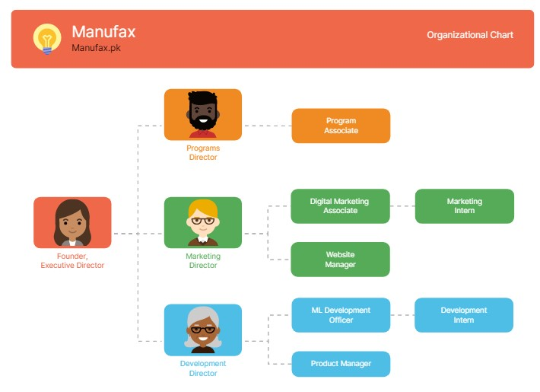

**Employee Requirements:**

In order to run the company properly and to maintain customer satisfaction the employee

requirements are:

●      2+ years of front/web development experience

●      2+ years of ML development experience

●      Educational Requirement: Bachelor’s Degree (BS)

●      Proficient in modern coding languages such as JavaScript, HTML, C++, Python

●      Must be a professional in Microsoft Office Suite

●      Should have hands-on experience in creating UX designs for app development

●      Should be comfortable working in large teams and should be good in communication

with others

**Personal Financial Statements:**

The personal financial statements of some company employees are given below:

**Employee 1**

|  |  |
| --- | --- |
| **Assets** | **Remarks** |
| **Checking Amount A** | 50,000 |
| **Savings 1** | 95,000 |
| **Checking Amount B** | 70,000 |
| **Savings 2** | 50,000 |
| **Property A** | 300,000 |
| **Property B** | 500,000 |
| **Vehicle** | 200,000 |
| **Total** | 1,265,000 |

**Employee 2**

|  |  |
| --- | --- |
| **Assets** | **Remarks** |
| **Checking Amount A** | 60,000 |
| **Savings 1** | 45,000 |
| **Checking Amount B** | 60,000 |
| **Investment** | 35,000 |
| **Property A** | 400,000 |
| **Credit Card** | 90,000 |
| **Vehicle** | 400,000 |
| **Total** | 1,090,000 |

**Company’s Expenses**

|  |  |
| --- | --- |
| **Expense Detail** | **Amount** |
| **Legal** | 25,000 |
| **Stationery** | 30,000 |
| **Electronics Equipment** | 200,000 |
| **Research and Development** | 100,000 |
| **Registration of Domain** | 30,000 |
| **Web Host License** | 20,000 |
| **App Development** | 30,000 |
| **Pamphlets and Flyers** | 75,000 |
| **Total Expenses** | 780,000 |

So, our net expenses turn out to be Rs. 780,000 which is less than our total budget of Rs. 1

million.

**Special Considerations**

**Production and Manufacturing Needs:**

As we are a manufacturing company that is using a 3D Printer to create parts for a cheap 3D Printer, we need the entire 3D printing manufacturing goods and a high-end 3D printer to print out the parts for our cheap 3D printer.

**Facility Needs:**

●      We will need personal desktop computers for our office. We can buy them in bulk by contacting PC manufacturers like Dell, HP, Lenovo etc.

●      For the database we will need a dedicated server to store information which can be bought from above-mentioned computer suppliers

●      We will need to buy an organization license for Microsoft Office and other app development software

●      PC peripherals like mice, keyboards and external hard drives will also be needed

**Education and Training Needs:**

Since we need to make 3D printers from materials created by 3D printers for cheap manufacturing, we will need to educate our software developers about the 3D printers as well. We can do this by conducting weekly seminars and workshops by IT professionals. Our customer care department and the customer helpline employees will also be trained by the HR management in order to effectively tackle customer demands and needs while satisfying the customers at the same time.

**Land and Utility Needs:**

In order to setup our office we will rent a workspace in a commercial building. The office must consist of at lest 5 to 6 rooms including the office for CEO, the customer care office, a storeroom, bathrooms, a dedicated server room etc. Renting a workspace in a building would be more feasible because in this way we would not have to worry about the electricity and gas supply as it would be the responsibility of the building owners according to the contract.

**Research and Development:**

The research and development department must concentrate on new ways to improve the

software and user experience of the mobile app and website. Since the demand and production of automobile parts and accessories is increasing day by day, so the database of the AI data must be regularly updated with the latest products so it will be easy to recognize them on the go.

**Other:**

The office furniture that suits our needs such as keyboards tables and server wall brackets etc. must be bought from a reputed office-ware supplier. The constant supply of electricity is also a must-have for a proper working environment in our office

**REFERENCES**

Since our company is a new startup hence most of the recruitment done will be external recruitment from other companies and of the fresh graduates from new companies. The candidates will be selected after they are called for interviews via newspapers, social media etc. The interview will be a proper structured interview with no biases towards any candidate. However, if the company official refers to some skilled individual then he/she will be selected after basic questioning and a skill test. The reference can be

●      From a member of our company’s top management

●      From the office of some reputed organization

For the purpose of devising this part of the report help was taken from the following sources:

[1] <https://creately.com/blog/diagrams/types-of-organizational-charts/>

[2] <https://www.wallstreetmojo.com/personal-financial-statement-template/>

[3] <https://www.vertex42.com/ExcelTemplates/personal-financial-statement.html>

[4] ·      bcn3d.com/the-history-of-3d-printing-when-was-3d-printing-invented/#:~:text=The%20first%20documented%20iterations%20of,was%20polymerized%20by%20UV%20light.

[5] ·      https://3dprinting.com/what-is-3d-printing/

[6] <https://navicoads.com/social-media-agency/>

[7] <https://taxsummaries.pwc.com/pakistan/corporate/taxes-on-corporate-income>