DOM orqali elementlarni qo‘shish va o‘zgartirish
1. Kirish
DOM (Document Object Model) – bu veb-sahifaning daraxt shaklidagi tasviri bo‘lib, JavaScript yordamida undagi har qanday elementni o‘qish, o‘zgartirish, qo‘shish yoki o‘chirish mumkin. DOM bilan ishlash veb-sahifalarni dinamik va interaktiv qilishning asosiy usullaridan biridir.
2. Asosiy DOM usullari (elementlarni qo‘shish va o‘zgartirish uchun)
Usul / Xususiyat | Maqsad | Misol
document.createElement() | Yangi element yaratish | let div = document.createElement('div')
element.textContent | Element ichiga matn qo‘yish | div.textContent = "Salom Dunyo"
element.innerHTML | Element ichiga HTML kod qo‘yish | div.innerHTML = "<strong>Bold</strong>"
parent.appendChild() | Elementni oxiriga qo‘shish | document.body.appendChild(div)
parent.append() | Bir nechta element yoki matn qo‘shish (zamonaviy usul) | parent.append(div, "Matn")
parent.prepend() | Elementni boshiga qo‘shish | parent.prepend(div)
element.before() | Element oldiga qo‘shish | existing.before(newDiv)
element.after() | Element keyiniga qo‘shish | existing.after(newDiv)
parent.insertBefore() | Muayyan joyga qo‘shish (eski usul) | parent.insertBefore(new, existing)
element.remove() | Elementni o‘chirish | div.remove()
element.classList | CSS klasslarni boshqarish | div.classList.add("active")
element.setAttribute() | Atribut qo‘shish/o‘zgartirish | div.setAttribute("id", "myDiv")
element.id, element.src | Umumiy atributlarni o‘zgartirish | img.src = "image.jpg"

3. Amaliy misollar
Misol 1: Oddiy yangi element qo‘shish
JavaScript
// Yangi <p> elementi yaratamiz
let yangiParagraph = document.createElement('p');
yangiParagraph.textContent = "Bu JavaScript orqali qo‘shilgan matn!";

// Elementga stil beramiz
yangiParagraph.style.color = "blue";
yangiParagraph.style.fontSize = "20px";

// Body ning oxiriga qo‘shamiz
document.body.appendChild(yangiParagraph);
Misol 2: Ro‘yxatga yangi element qo‘shish
JavaScript
// <ul> elementi bor deb faraz qilamiz
let ul = document.querySelector('ul');

let yangiLi = document.createElement('li');
yangiLi.textContent = "Yangi element";
ul.appendChild(yangiLi);
Misol 3: Bir nechta elementni tez qo‘shish (fragment yordamida)
JavaScript
let fragment = document.createDocumentFragment();

for (let i = 1; i <= 5; i++) {
let li = document.createElement('li');
li.textContent = `Element ${i}`;
fragment.appendChild(li);
}

document.querySelector('ul').appendChild(fragment); // faqat 1 marta DOM o‘zgartiriladi
Misol 4: Elementni o‘zgartirish
JavaScript
let element = document.querySelector('#myElement');

// Matnni o‘zgartirish
element.textContent = "Yangi matn";

// Klass qo‘shish
element.classList.add("highlight");

// Atribut o‘zgartirish
element.setAttribute("data-info", "123");
4. Eng yaxshi amaliyotlar

Har doim document.createDocumentFragment() dan foydalaning, agar ko‘p element qo‘shmoqchi bo‘lsangiz — bu ishlash tezligini 10-100 barobar oshiradi.
innerHTML o‘rniga textContent dan foydalaning, agar foydalanuvchi kiritgan matnni qo‘ymoqchi bo‘lsangiz (XSS hujumidan himoya qiladi).
querySelector va getElementById ni imkon qadar kam ishlatishga harakat qiling — o‘zgaruvchilarga saqlab oling.
Zamonaviy brauzerlarda append(), prepend(), before(), after() va remove() usullaridan foydalaning — ular qulayroq va o‘qilishi oson.

Amaliy:
<script>
/* ===================== O‘ZGARUVCHILAR ===================== */
let totalCarsCount = document.querySelectorAll(".car-card").length;

/* ===================== SAHIFA YUKLANGANDA ===================== */
window.addEventListener("load", function () {
console.log("AutoRent DOM bilan ishga tushdi");
console.log("Dastlabki avtomobillar soni:", totalCarsCount);
});

/* ===================== DOM: HEADER MATNINI O‘ZGARTIRISH ===================== */
const headerText = document.querySelector("header p");
if (headerText) {
headerText.textContent = "DOM orqali boshqariladigan avtomobil ijarasi sayti";
}

/* ===================== FUNKSIYALAR ===================== */
function rentCar(carName, price) {
alert(
"🚗 Avtomobil: " + carName +
"\n💰 Narx: " + price +
"\n\nTabriklaymiz! Ijaraga olish muvaffaqiyatli yakunlandi."
);
}

function showDetails(carName) {
alert("📄 " + carName + " haqida ma’lumot tez orada qo‘shiladi");
}

/* ===================== DOM: YANGI AVTOMOBIL QO‘SHISH ===================== */
const carsGrid = document.querySelector(".cars-grid");

if (carsGrid) {
const newCar = document.createElement("div");
newCar.classList.add("car-card");

newCar.innerHTML = `
<img src="https://encrypted-tbn0.gstatic.com/images?q=tbn:ANd9GcQ8d0yUu7pG8X8R3" class="car-image" alt="Chevrolet Onix">
<div class="car-info">
<h3 class="car-name">Chevrolet Onix</h3>
<div class="car-details">
<span class="car-detail">⚙️ Avtomat</span>
<span class="car-detail">👥 5 o‘rin</span>
<span class="car-detail">⛽ Benzin</span>
</div>
<p class="car-price">380,000 so‘m/kun</p>
<div class="car-actions">
<button class="btn btn-rent">Ijaraga olish</button>
<button class="btn btn-details">Batafsil</button>
</div>
</div>
`;

// Elementni gridga qo‘shamiz
carsGrid.appendChild(newCar);
totalCarsCount++;
}

EVENT DELEGATION (HODISALARNI BOSHQARISH)

if (carsGrid) {
carsGrid.addEventListener("click", function (event) {
const target = event.target;

// Eng yaqin .car-info va undagi ma'lumotlarni topamiz
const carInfo = target.closest(".car-info");
if (!carInfo) return; // Agar car-info topilmasa, funksiyani to'xtatamiz

const carName = carInfo.querySelector(".car-name").textContent;
const price = carInfo.querySelector(".car-price").textContent;

// "Ijaraga olish" tugmasi bosilganda
if (target.classList.contains("btn-rent")) {
rentCar(carName, price);
}

// "Batafsil" tugmasi bosilganda
if (target.classList.contains("btn-details")) {
showDetails(carName);
}
});
}

BIRINCHI KARTAGA ACTIVE CLASS QO‘SHISH
const firstCar = document.querySelector(".car-card");
if (firstCar) {
firstCar.classList.add("active");
}
</script>

Dom foydalanilmasdan oldin
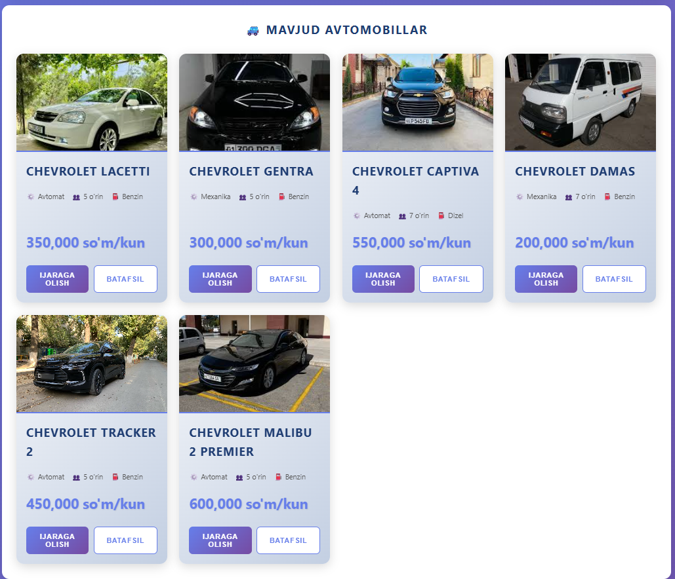
Dom foydalanganidan keyin:
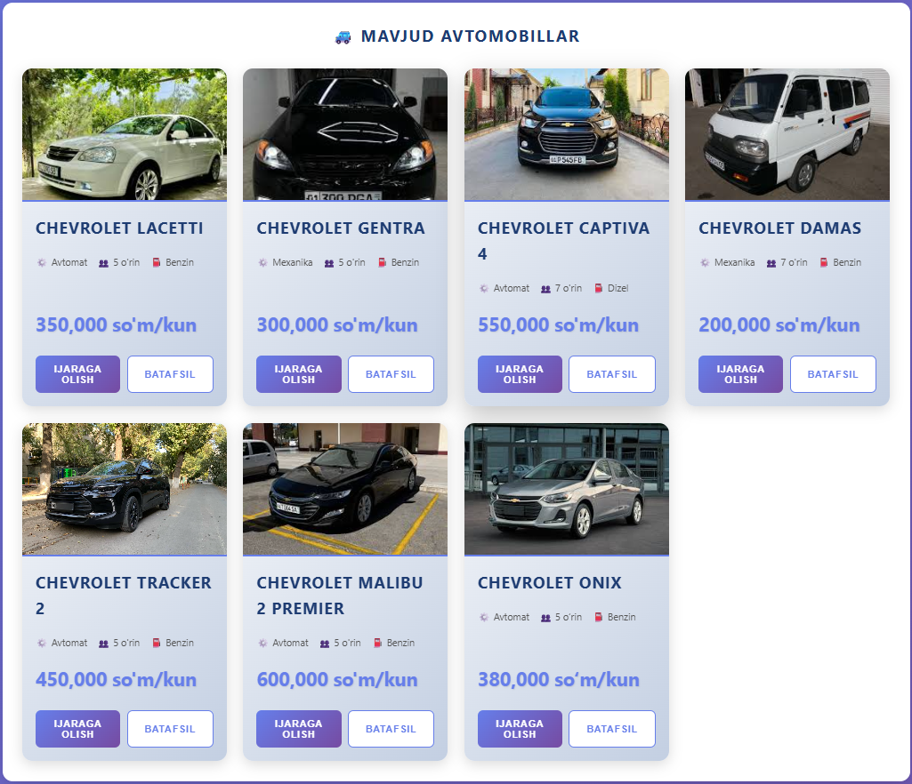

5. Xulosa
JavaScript yordamida DOM bilan ishlash veb-dasturlashning eng muhim qismlaridan biridir. Elementlarni qo‘shish, o‘chirish va o‘zgartirish orqali biz foydalanuvchi interfeysini to‘liq dinamik qila olamiz. Zamonaviy usullarni (append, prepend, classList va boshqalar) qo‘llash kodni qisqa, o‘qilishi oson va samarali qiladi.
Qo‘shimcha maslahat: Har doim console.log() yoki brauzer DevTools dan foydalanib, DOM o‘zgarishlarini real vaqtda kuzatib boring.

