Mavzu: Formani JavaScript orqali tekshirish (Validation)
1. Ishning maqsadi
Ushbu laboratoriya ishining maqsadi — Avia Kassa loyihasida foydalanuvchi tomonidan kiritilgan ma’lumotlarni JavaScript yordamida tekshirish (validation) tushunchasini amaliy tarzda o‘rganishdir.
- Formaning va validation tushunchasini anglaydi;
- Client-side tekshiruvning ahamiyatini tushunadi;
- Foydalanuvchi kiritgan ma’lumotlarni to‘g‘ri formatda olish tamoyillarini o‘zlashtiradi;
- Web-ilovalarda ma’lumot xavfsizligi va sifatini ta’minlashni bilib oladi.
2. Nazariy qism
2.1 Forma tushunchasi
Forma — foydalanuvchi bilan interaktiv aloqani ta’minlovchi web-element. Avia Kassa loyihasida forma orqali foydalanuvchi shaxsiy ma’lumotlari va tanlangan chipta ma’lumotlarini kiritadi.
2.2 Validation tushunchasi
Validation — foydalanuvchi tomonidan kiritilgan ma’lumotlarning to‘g‘riligini va belgilangan qoidalarga mosligini tekshirish jarayoni. Bu jarayon noto‘g‘ri yoki xavfli ma’lumotlarning tizimga kirib kelishini oldini oladi.
2.3 JavaScript orqali validationning zarurati
- Ma’lumotlarni real vaqt rejimida tekshirish;
- Serverga yuborilishdan oldin xatolarni aniqlash;
- Foydalanuvchi tajribasini yaxshilash;
- Serverga tushadigan ortiqcha yuklamani kamaytirish.
2.4 Tekshiriladigan holatlar
- Ism maydoni bo‘sh emasligi;
- Email va telefon raqam formati;
- Tanlangan chipta mavjudligi;
- Parol va parolni tasdiqlash maydonining mosligi (agar mavjud bo‘lsa).

4. Natija
- Foydalanuvchi Ism, Email va Manzil maydonlarini to‘g‘ri to‘ldirmasa, forma yuborilmaydi.
- Xatolar real vaqt rejimida ko‘rsatiladi (error elementi orqali).
- To‘g‘ri ma’lumot kiritilganda buyurtma tasdiqlanadi va forma tozalanadi.

<script>
// ==========================================
// ELEMENTLARNI OLISH
// ==========================================
const form = document.getElementById('bookingForm');
const modal = document.getElementById('successModal');
const modalBody = document.getElementById('modalBody');
const loader = document.getElementById('loader');
const submitBtn = document.getElementById('submitBtn');

// Form maydonlari
const fields = {
fullName: document.getElementById('fullName'),
phone: document.getElementById('phone'),
email: document.getElementById('email'),
city: document.getElementById('city'),
startDate: document.getElementById('startDate'),
endDate: document.getElementById('endDate'),
carType: document.getElementById('carType'),
license: document.getElementById('license')
};

// Statistika elementlari
const stats = {
total: document.getElementById('totalFields'),
valid: document.getElementById('validFields'),
progress: document.getElementById('progressPercent')
};

// ==========================================
// REAL-TIME VALIDATION
// ==========================================

// Ism
fields.fullName.addEventListener('input', validateFullName);
fields.fullName.addEventListener('blur', validateFullName);

// Telefon
fields.phone.addEventListener('input', function() {
formatPhone(this);
validatePhone();
});
fields.phone.addEventListener('blur', validatePhone);

// Email
fields.email.addEventListener('input', validateEmail);
fields.email.addEventListener('blur', validateEmail);

fields.city.addEventListener('change', validateCity);

// Sanalar
fields.startDate.addEventListener('change', function() {
validateStartDate();
validateEndDate();
});
fields.endDate.addEventListener('change', validateEndDate);

// Avtomobil turi
fields.carType.addEventListener('change', validateCarType);

// Guvohnoma
fields.license.addEventListener('input', function() {
formatLicense(this);
validateLicense();
});
fields.license.addEventListener('blur', validateLicense);

// ==========================================
// VALIDATION FUNCTIONS
// ==========================================

// 1. ISM TEKSHIRISH
function validateFullName() {
const value = fields.fullName.value.trim();
const error = document.getElementById('fullNameError');
const success = document.getElementById('fullNameSuccess');

if (value === '') {
showError(fields.fullName, error, '❌ Ism kiritilishi shart!');
hideSuccess(success);
return false;
}

if (value.length < 5) {
showError(fields.fullName, error, '❌ Kamida 5 ta belgi kiriting!');
hideSuccess(success);
return false;
}

if (!/^[a-zA-Zа-яА-ЯўЎқҚғҒҳҲ\s]+$/.test(value)) {
showError(fields.fullName, error, '❌ Faqat harflar kiritilishi mumkin!');
hideSuccess(success);
return false;
}

const words = value.split(' ').filter(word => word.length > 0);
if (words.length < 2) {
showError(fields.fullName, error, '❌ Ism va familiyani kiriting!');
hideSuccess(success);
return false;
}

showSuccess(fields.fullName, error, success);
return true;
}

// 2. TELEFON FORMATLASH
function formatPhone(input) {
let value = input.value.replace(/\D/g, '');

if (!value.startsWith('998')) {
value = '998' + value;
}

value = value.substring(0, 12);

let formatted = '+998';
if (value.length > 3) formatted += ' ' + value.substring(3, 5);
if (value.length > 5) formatted += ' ' + value.substring(5, 8);
if (value.length > 8) formatted += ' ' + value.substring(8, 10);
if (value.length > 10) formatted += ' ' + value.substring(10, 12);

input.value = formatted;
}

// 3. TELEFON TEKSHIRISH
function validatePhone() {
const value = fields.phone.value.replace(/\D/g, '');
const error = document.getElementById('phoneError');
const success = document.getElementById('phoneSuccess');

if (value === '' || value === '998') {
showError(fields.phone, error, '❌ Telefon raqam kiritilishi shart!');
hideSuccess(success);
return false;
}

if (value.length !== 12) {
showError(fields.phone, error, '❌ Telefon raqam to\'liq emas!');
hideSuccess(success);
return false;
}

if (!value.startsWith('998')) {
showError(fields.phone, error, '❌ +998 bilan boshlanishi kerak!');
hideSuccess(success);
return false;
}

const operators = ['90', '91', '93', '94', '95', '97', '98', '99', '33', '88'];
const operator = value.substring(3, 5);

if (!operators.includes(operator)) {
showError(fields.phone, error, '❌ Noto\'g\'ri operator kodi!');
hideSuccess(success);
return false;
}

showSuccess(fields.phone, error, success);
return true;
}

// 4. EMAIL TEKSHIRISH
function validateEmail() {
const value = fields.email.value.trim();
const error = document.getElementById('emailError');
const success = document.getElementById('emailSuccess');

if (value === '') {
showError(fields.email, error, '❌ Email kiritilishi shart!');
hideSuccess(success);
return false;
}

const emailRegex = /^[^\s@]+@[^\s@]+\.[^\s@]+$/;
if (!emailRegex.test(value)) {
showError(fields.email, error, '❌ Email formati noto\'g\'ri!');
hideSuccess(success);
return false;
}

const domain = value.split('@')[1];
const validDomains = ['gmail.com', 'mail.ru', 'yahoo.com', 'outlook.com', 'yandex.ru'];

if (!validDomains.includes(domain)) {
showError(fields.email, error, '⚠️ ${domain} - noodatiy domen');
showSuccess(fields.email, error, success);
return true;
}

showSuccess(fields.email, error, success);
return true;
}

// 5. SHAHAR TEKSHIRISH
function validateCity() {
const value = fields.city.value;
const error = document.getElementById('cityError');
const success = document.getElementById('citySuccess');

if (value === '') {
showError(fields.city, error, '❌ Shaharni tanlang!');
hideSuccess(success);
return false;
}

showSuccess(fields.city, error, success);
return true;
}

// 6. BOSHLANISH SANASI
function validateStartDate() {
const value = fields.startDate.value;
const error = document.getElementById('startDateError');
const success = document.getElementById('startDateSuccess');

if (value === '') {
showError(fields.startDate, error, '❌ Boshlanish sanasini tanlang!');
hideSuccess(success);
return false;
}

const today = new Date();
today.setHours(0, 0, 0, 0);
const selected = new Date(value);

if (selected < today) {
showError(fields.startDate, error, '❌ O\'tmishdagi sana tanlash mumkin emas!');
hideSuccess(success);
return false;
}

const maxDate = new Date();
maxDate.setDate(maxDate.getDate() + 90);

if (selected > maxDate) {
showError(fields.startDate, error, '❌ 90 kundan keyin sana tanlash mumkin emas!');
hideSuccess(success);
return false;
}

showSuccess(fields.startDate, error, success);
return true;
}

// 7. TUGASH SANASI
function validateEndDate() {
const startValue = fields.startDate.value;
const endValue = fields.endDate.value;
const error = document.getElementById('endDateError');
const success = document.getElementById('endDateSuccess');

if (endValue === '') {
showError(fields.endDate, error, '❌ Tugash sanasini tanlang!');
hideSuccess(success);
return false;
}

if (startValue === '') {
showError(fields.endDate, error, '❌ Avval boshlanish sanasini tanlang!');
hideSuccess(success);
return false;
}

const startDate = new Date(startValue);
const endDate = new Date(endValue);

if (endDate <= startDate) {
showError(fields.endDate, error, '❌ Tugash sanasi boshlanish sanasidan keyin bo\'lishi kerak!');
hideSuccess(success);
return false;
}

const daysDiff = (endDate - startDate) / (1000 * 60 * 60 * 24);

if (daysDiff > 30) {
showError(fields.endDate, error, '❌ Maksimal ijara muddati 30 kun!');
hideSuccess(success);
return false;
}

if (daysDiff < 1) {
showError(fields.endDate, error, '❌ Minimal ijara muddati 1 kun!');
hideSuccess(success);
return false;
}

showSuccess(fields.endDate, error, success);
return true;
}

// 8. AVTOMOBIL TURI
function validateCarType() {
const value = fields.carType.value;
const error = document.getElementById('carTypeError');
const success = document.getElementById('carTypeSuccess');

if (value === '') {
showError(fields.carType, error, '❌ Avtomobil turini tanlang!');
hideSuccess(success);
return false;
}

showSuccess(fields.carType, error, success);
return true;
}

// 9. GUVOHNOMA FORMATLASH
function formatLicense(input) {
let value = input.value.toUpperCase().replace(/[^A-Z0-9]/g, '');

if (value.length > 2) {
value = value.substring(0, 2) + ' ' + value.substring(2);
}

value = value.substring(0, 10);
input.value = value;
}

// 10. GUVOHNOMA TEKSHIRISH
function validateLicense() {
const value = fields.license.value.replace(/\s/g, '');
const error = document.getElementById('licenseError');
const success = document.getElementById('licenseSuccess');

if (value === '') {
showError(fields.license, error, '❌ Guvohnoma raqamini kiriting!');
hideSuccess(success);
return false;
}

if (value.length < 9) {
showError(fields.license, error, '❌ Guvohnoma to\'liq emas! (AA 1234567)');
hideSuccess(success);
return false;
}

const pattern = /^[A-Z]{2}[0-9]{7}$/;
if (!pattern.test(value)) {
showError(fields.license, error, '❌ Format: AA 1234567');
hideSuccess(success);
return false;
}

showSuccess(fields.license, error, success);
return true;
}

// ==========================================
// YORDAMCHI FUNKSIYALAR
// ==========================================

function showError(input, errorMsg, message) {
input.classList.add('error');
input.classList.remove('success');
errorMsg.textContent = message;
errorMsg.classList.add('show');
updateStats();
}

function showSuccess(input, errorMsg, successMsg) {
input.classList.remove('error');
input.classList.add('success');
errorMsg.classList.remove('show');
successMsg.classList.add('show');
updateStats();
}

function hideSuccess(successMsg) {
successMsg.classList.remove('show');
}

// ==========================================
// STATISTIKA YANGILASH
// ==========================================
function updateStats() {
const totalFields = Object.keys(fields).length;
const validFields = document.querySelectorAll('.success').length;
const progress = Math.round((validFields / totalFields) * 100);

stats.total.textContent = totalFields;
stats.valid.textContent = validFields;
stats.progress.textContent = progress + '%';

// Rang o'zgartirish
if (progress < 50) {
stats.progress.style.color = '#e74c3c';
} else if (progress < 100) {
stats.progress.style.color = '#f39c12';
} else {
stats.progress.style.color = '#27ae60';
}
}

// ==========================================
// FORM SUBMIT
// ==========================================
form.addEventListener('submit', function(e) {
e.preventDefault();

// Barcha validatsiyalarni tekshirish
const validations = [
validateFullName(),
validatePhone(),
validateEmail(),
validateCity(),
validateStartDate(),
validateEndDate(),
validateCarType(),
validateLicense()
];

const allValid = validations.every(v => v === true);

if (allValid) {
// Loader ko'rsatish
loader.classList.add('show');
submitBtn.disabled = true;
form.style.opacity = '0.5';

// 2 soniya kutish (server so'rovi simulatsiyasi)
setTimeout(() => {
loader.classList.remove('show');
submitBtn.disabled = false;
form.style.opacity = '1';
showSuccessModal();
}, 2000);
} else {
// Birinchi xatoga scroll
const firstError = document.querySelector('.error');
if (firstError) {
firstError.focus();
firstError.scrollIntoView({
behavior: 'smooth',
block: 'center'
});
}
}
});

// ==========================================
// MODAL FUNKSIYALARI
function showSuccessModal() {
const fullName = fields.fullName.value;
const phone = fields.phone.value;
const email = fields.email.value;
const city = fields.city.options[fields.city.selectedIndex].text;
const startDate = new Date(fields.startDate.value).toLocaleDateString('uz-UZ');
const endDate = new Date(fields.endDate.value).toLocaleDateString('uz-UZ');
const carType = fields.carType.options[fields.carType.selectedIndex].text;
const license = fields.license.value;

const start = new Date(fields.startDate.value);
const end = new Date(fields.endDate.value);
const days = Math.ceil((end - start) / (1000 * 60 * 60 * 24));
const estimatedPrice = days * 400000;

modalBody.innerHTML = `
<div class="info-row">
<span class="info-label">👤 To'liq Ism:</span>
<span class="info-value">${fullName}</span>
</div>
<div class="info-row">
<span class="info-label">📞 Telefon:</span>
<span class="info-value">${phone}</span>
</div>
<div class="info-row">
<span class="info-label">📧 Email:</span>
<span class="info-value">${email}</span>
</div>
<div class="info-row">
<span class="info-label">📍 Shahar:</span>
<span class="info-value">${city}</span>
</div>
<div class="info-row">
<span class="info-label">📅 Boshlanish:</span>
<span class="info-value">${startDate}</span>
</div>
<div class="info-row">
<span class="info-label">📅 Tugash:</span>
<span class="info-value">${endDate}</span>
</div>
<div class="info-row">
<span class="info-label">🚗 Avtomobil:</span>
<span class="info-value">${carType}</span>
</div>
<div class="info-row">
<span class="info-label">🪪 Guvohnoma:</span>
<span class="info-value">${license}</span>
</div>
<div class="info-row">
<span class="info-label">⏱️ Muddat:</span>
<span class="info-value">${days} kun</span>
</div>
<div class="info-row" style="background:#fff3cd;padding:15px;border-radius:10px;">
<span class="info-label" style="color:#856404;">💰 Taxminiy Narx:</span>
<span class="info-value" style="color:#856404;font-size:1.3rem;">
${estimatedPrice.toLocaleString()} so'm
</span>
</div>
`;

modal.classList.add('show');
}

function closeModal() {
modal.classList.remove('show');

// Formani tozalash
form.reset();
document.querySelectorAll('.success, .error').forEach(el => {
el.classList.remove('success', 'error');
});
document.querySelectorAll('.message.show').forEach(el => {
el.classList.remove('show');
});

updateStats();
}

function confirmBooking() {
alert('✅ Buyurtma tasdiqlandi! Tez orada operatorlarimiz siz bilan bog\'lanadi.');
closeModal();
}

// Modal tashqarisiga bosilganda
modal.addEventListener('click', function(e) {
if (e.target === modal) {
closeModal();
}
});

// ESC tugmasi
document.addEventListener('keydown', function(e) {
if (e.key === 'Escape' && modal.classList.contains('show')) {
closeModal();
}
});

// ==========================================
// SAHIFA YUKLANGANDA
// ==========================================
window.addEventListener('load', function() {
updateStats();

// Bugungi sanani minimal qiymat qilib o'rnatish
const today = new Date().toISOString().split('T')[0];
fields.startDate.setAttribute('min', today);
fields.endDate.setAttribute('min', today);
});
</script>
Natija:
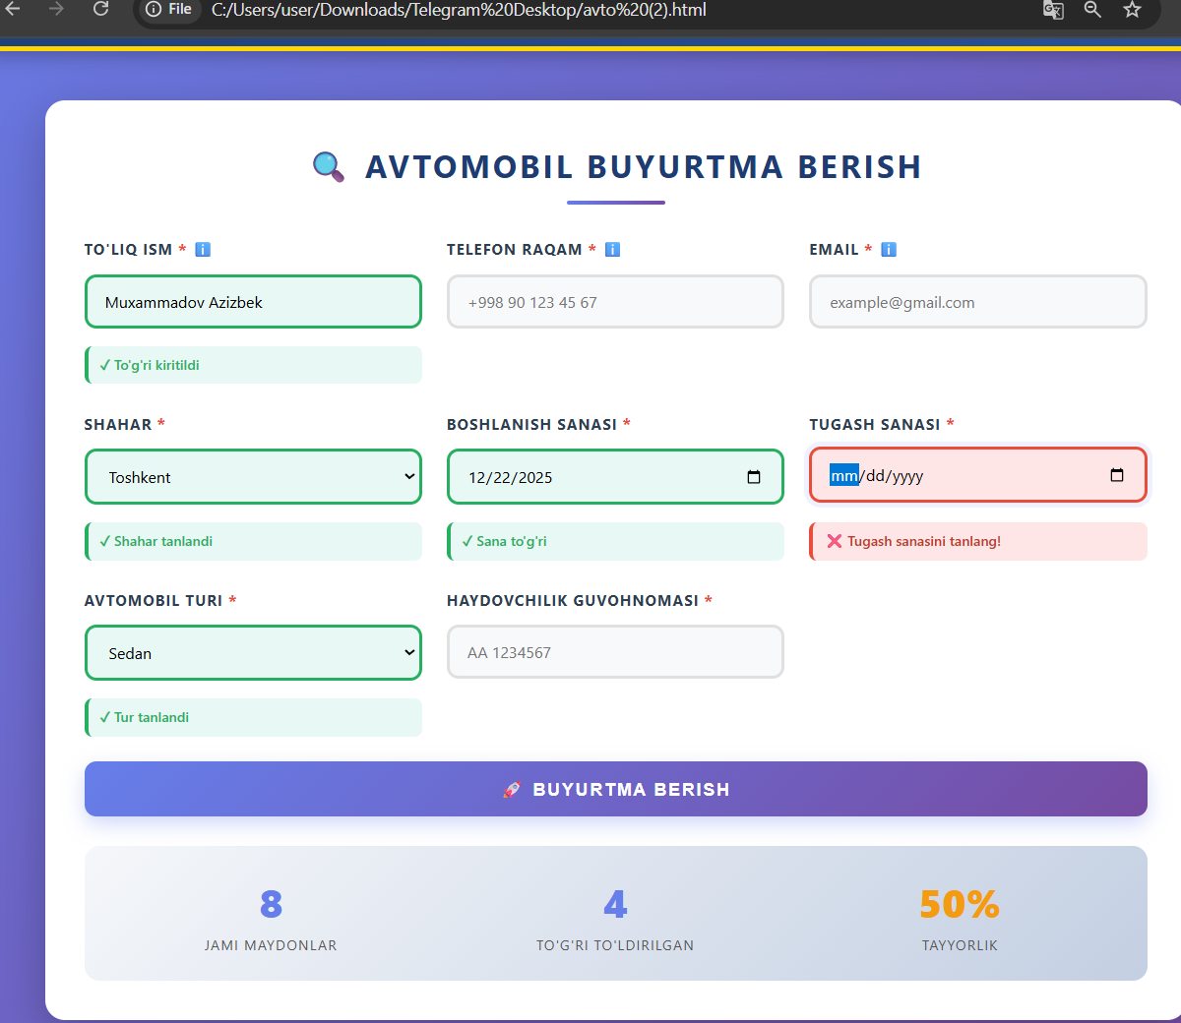
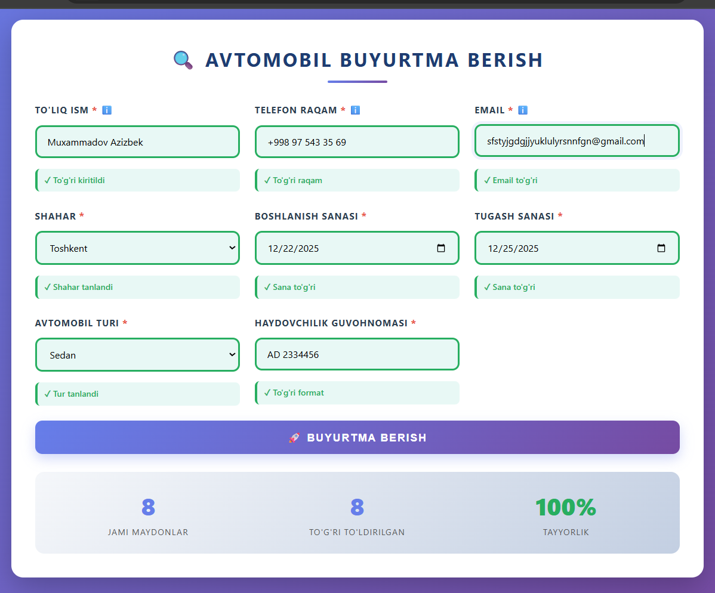
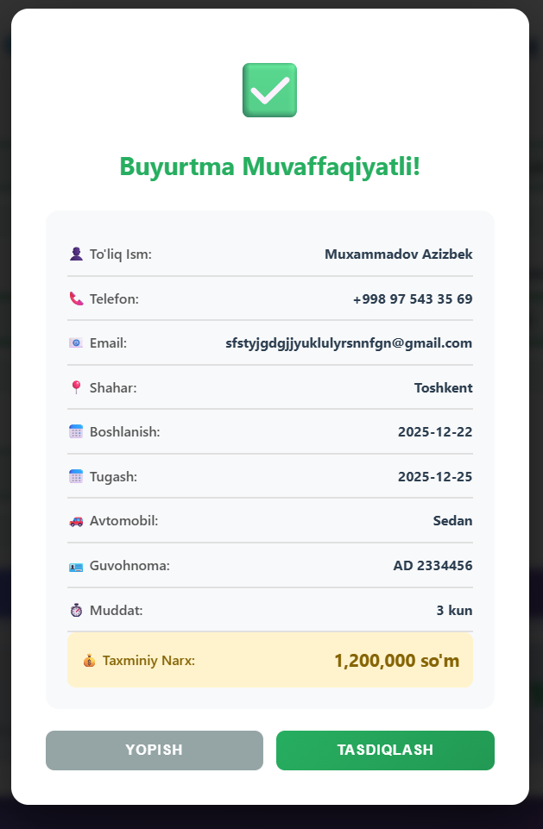

5. Xulosa
Ushbu laboratoriya ishida JavaScript orqali forma validation mavzusi Avia Kassa loyihasi misolida amaliy tarzda o‘rganildi. Forma validation foydalanuvchi kiritgan ma’lumotlarning to‘g‘riligini ta’minlash, tizim ishonchliligini oshirish va foydalanuvchi tajribasini yaxshilashda muhim ahamiyatga ega ekanligi aniqlandi.

Client-side validation foydalanuvchiga qulaylik yaratadi, tizim ish faoliyatini optimallashtiradi va zamonaviy web-dasturlashning ajralmas qismi hisoblanadi. Shu bilan birga, xavfsizlik nuqtai nazaridan server-side tekshiruv bilan birgalikda ishlashi lozim.

