CSS Flexbox va Grid bilan sahifa tartibini yaratish
1. CSS Flexbox: Bir o‘lchamli moslanuvchan tartib
Flexbox — bu elementlarni o‘z konteyneri ichida bo‘sh joyni qanday taqsimlashini boshqaradigan model. U asosan kontentning o'lchamiga qarab yo'nalishni moslashtiradi.
Flexbox’ning asosiy o‘qlari:
Flexbox bilan ishlashda ikkita o‘qni tushunish juda muhim:
- Main Axis (Asosiy o‘q): Elementlar tiziladigan asosiy yo‘nalish (standart holatda chapdan o‘ngga).
- Cross Axis (Ko‘ndalang o‘q): Asosiy o‘qqa perpendikulyar yo‘nalish (yuqoridan pastga).
Muhim xususiyatlari (Properties):
- justify-content: Elementlarni asosiy o‘q bo‘ylab tekislaydi (masalan: center, space-between).
- align-items: Elementlarni ko‘ndalang o‘q bo‘ylab (vertikal) tekislaydi.
- flex-wrap: Agar elementlar sig‘masa, ularni keyingi qatorga ko‘chiradi.
2. CSS Grid: Ikki o‘lchamli to‘r tizimi
Grid — bu CSS’dagi eng kuchli tartiblash tizimi bo‘lib, u sahifani qatorlar va ustunlardan iborat jadval ko‘rinishida boshqarishga imkon beradi.
Grid tizimining tarkibiy qismlari:
- Grid Container: To‘r e’lon qilingan ota-ona elementi.
- Grid Line: Ustun va qatorlarni ajratib turuvchi chiziqlar.
- Grid Cell: To‘rning eng kichik birligi (bir katak).
- Grid Area: Bir nechta kataklarni birlashtirgan maydon.
Muhim xususiyatlari:
- grid-template-columns: Ustunlar soni va kengligini belgilaydi (masalan: 1fr 1fr 1fr).
- grid-template-areas: Sahifa qismlariga nom berib, ularni vizual xarita kabi joylashtiradi.
- gap: Kataklar orasidagi masofani (otstup) oson belgilaydi.
3. Flexbox va Grid: Qiyosiy tahlil
Xususiyat | Flexbox | CSS Grid
O‘lcham | 1D (Faqat yo‘nalish bo‘yicha) | 2D (Qator va Ustun bir vaqtda)
Yondashuv | Kontentga asoslangan (Content-first) | Strukturaga asoslangan (Layout-first)
Elementlarni joylashtirish | Elementlar ketma-ket oqim bo‘yicha keladi | Elementlar oldindan belgilangan katakka qo‘yiladi
Elementlarning bir-biriga bog'liqligi | Har bir qator o'zidan mustaqil | Hamma elementlar umumiy setkaga bo'ysunadi
[Image comparing 1D Flexbox vs 2D CSS Grid layouts]
4. Qachon va qayerda ishlatish kerak?
Flexbox ishlatiladi:
- Elementlarni bir qatorga tekis tizish kerak bo‘lganda.
- Kichik komponentlar (tugmalar, ikonka va matnni bir chiziqqa keltirish) uchun.
- Elementlar o‘lchami turlicha bo‘lib, ularni avtomatik joylashini xohlaganda.
Grid ishlatiladi:
- Butun saytning maketini (Header, Sidebar, Content, Footer) chizishda.
- Elementlar bir vaqtda ham vertikal, ham gorizontal tekislanishi shart bo‘lganda.
- Murakkab, bir-birini kesib o‘tuvchi dizaynlarni yaratishda.
Amaliy:
HTML:
<!-- CARS SECTION -->
<section class="cars-section" id="cars">
<h2>🚙 Mavjud avtomobillar</h2>
<div class="cars-grid">
<div class="car-card">
<img src="https://encrypted-tbn0.gstatic.com/images?q=tbn:ANd9GcS8RUMuYbdSHfvn-24veenMwnyO-lmA_Gb2Zg&s" alt="Chevrolet Lacetti" class="car-image">
<div class="car-info">
<h3 class="car-name">Chevrolet Lacetti</h3>
<div class="car-details">
<span class="car-detail">⚙️ Avtomat</span>
<span class="car-detail">👥 5 o'rin</span>
<span class="car-detail">⛽ Benzin</span>
</div>
<p class="car-price">350,000 so'm/kun</p>
<div class="car-actions">
<button class="btn btn-rent">Ijaraga olish</button>
<button class="btn btn-details">Batafsil</button>
</div>
</div>
</div>

<div class="car-card">
<img src="https://encrypted-tbn0.gstatic.com/images?q=tbn:ANd9GcTM-fMlkdLyFTWdkQ8-Yj4Rfbxy01-Im0kQkA&s" alt="Chevrolet Gentra" class="car-image">
<div class="car-info">
<h3 class="car-name">Chevrolet Gentra</h3>
<div class="car-details">
<span class="car-detail">⚙️ Mexanika</span>
<span class="car-detail">👥 5 o'rin</span>
<span class="car-detail">⛽ Benzin</span>
</div>
<p class="car-price">300,000 so'm/kun</p>
<div class="car-actions">
<button class="btn btn-rent">Ijaraga olish</button>
<button class="btn btn-details">Batafsil</button>
</div>
</div>
</div>

<div class="car-card">
<img src="https://encrypted-tbn0.gstatic.com/images?q=tbn:ANd9GcQC8H5CUWhDXICKHvKrJeg6Tm12XzBQsjZ7Gg&s" alt="Chevrolet Captiva" class="car-image">
<div class="car-info">
<h3 class="car-name">Chevrolet Captiva 4</h3>
<div class="car-details">
<span class="car-detail">⚙️ Avtomat</span>
<span class="car-detail">👥 7 o'rin</span>
<span class="car-detail">⛽ Dizel</span>
</div>
<p class="car-price">550,000 so'm/kun</p>
<div class="car-actions">
<button class="btn btn-rent">Ijaraga olish</button>
<button class="btn btn-details">Batafsil</button>
</div>
</div>
</div>

<div class="car-card">
<img src="https://encrypted-tbn0.gstatic.com/images?q=tbn:ANd9GcQAGkceSovE1p49HJbYyUn22sSGDlTtsw2JQw&s" alt="Chevrolet Damas" class="car-image">
<div class="car-info">
<h3 class="car-name">Chevrolet Damas</h3>
<div class="car-details">
<span class="car-detail">⚙️ Mexanika</span>
<span class="car-detail">👥 7 o'rin</span>
<span class="car-detail">⛽ Benzin</span>
</div>
<p class="car-price">200,000 so'm/kun</p>
<div class="car-actions">
<button class="btn btn-rent">Ijaraga olish</button>
<button class="btn btn-details">Batafsil</button>
</div>
</div>
</div>

<div class="car-card">
<img src="https://repost.uz/storage/uploads/0-1663507995-avto11-post-material.jpeg" alt="Chevrolet Tracker" class="car-image">
<div class="car-info">
<h3 class="car-name">Chevrolet Tracker 2</h3>
<div class="car-details">
<span class="car-detail">⚙️ Avtomat</span>
<span class="car-detail">👥 5 o'rin</span>
<span class="car-detail">⛽ Benzin</span>
</div>
<p class="car-price">450,000 so'm/kun</p>
<div class="car-actions">
<button class="btn btn-rent">Ijaraga olish</button>
<button class="btn btn-details">Batafsil</button>
</div>
</div>
</div>

<div class="car-card">
<img src="https://encrypted-tbn0.gstatic.com/images?q=tbn:ANd9GcSmaM-idjlkorb11mxMREklDGklmGBLFe2c-w&s" alt="Chevrolet Malibu" class="car-image">
<div class="car-info">
<h3 class="car-name">Chevrolet Malibu 2 premier</h3>
<div class="car-details">
<span class="car-detail">⚙️ Avtomat</span>
<span class="car-detail">👥 5 o'rin</span>
<span class="car-detail">⛽ Benzin</span>
</div>
<p class="car-price">600,000 so'm/kun</p>
<div class="car-actions">
<button class="btn btn-rent">Ijaraga olish</button>
<button class="btn btn-details">Batafsil</button>
</div>
</div>
</div>
</div>
</section>

CSS:
/* ============= CARS GRID (Grid) ============= */
.cars-section {
background: white;
padding: 30px;
border-radius: 15px;
box-shadow: 0 10px 30px rgba(0, 0, 0, 0.2);
}

.cars-section h2 {
color: #1e3c72;
margin-bottom: 30px;
text-align: center;
text-transform: uppercase;
letter-spacing: 2px;
}

.cars-grid {
/* CSS Grid */
display: grid;
grid-template-columns: repeat(auto-fit, minmax(300px, 1fr));
gap: 25px;
}

.car-card {
background: linear-gradient(135deg, #f5f7fa 0%, #c3cfe2 100%);
border-radius: 15px;
overflow: hidden;
box-shadow: 0 5px 20px rgba(0, 0, 0, 0.15);
transition: all 0.3s ease;

/* Flexbox ichida */
display: flex;
flex-direction: column;
}

.car-card:hover {
transform: translateY(-10px);
box-shadow: 0 15px 40px rgba(0, 0, 0, 0.25);
}

.car-image {
width: 100%;
height: 200px;
object-fit: cover;
border-bottom: 3px solid #667eea;
}

.car-info {
padding: 20px;

/* Flexbox */
display: flex;
flex-direction: column;
gap: 10px;
flex-grow: 1;
}

.car-name {
font-size: 1.5rem;
font-weight: 700;
color: #1e3c72;
text-transform: uppercase;
letter-spacing: 1px;
}

.car-details {
/* Flexbox */
display: flex;
flex-wrap: wrap;
gap: 15px;
margin: 10px 0;
}

.car-detail {
/* Flexbox */
display: flex;
align-items: center;
gap: 5px;
font-size: 0.9rem;
color: #555;
}

.car-price {
font-size: 1.8rem;
font-weight: 700;
color: #667eea;
margin-top: auto;
text-shadow: 1px 1px 2px rgba(0, 0, 0, 0.1);
}

.car-actions {
/* Flexbox */
display: flex;
gap: 10px;
margin-top: 15px;
}

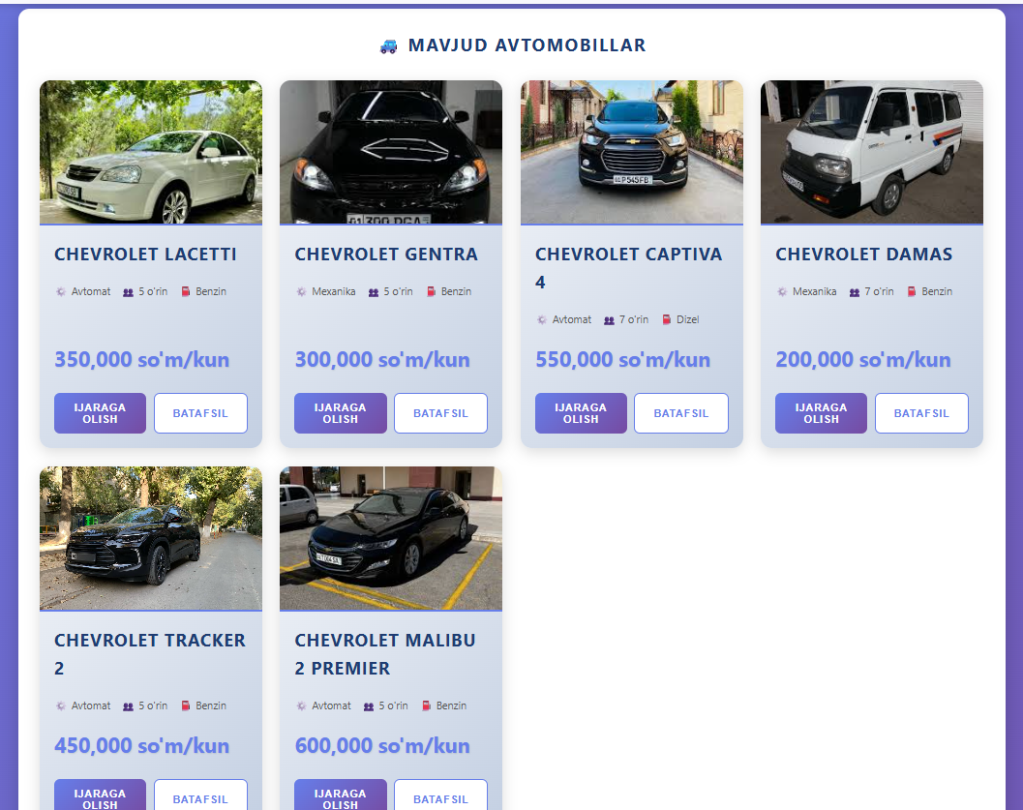
HTML:
<!-- FEATURES SECTION -->
<section class="features-section" id="features">
<h2>⭐ Bizning afzalliklarimiz</h2>
<div class="features-grid">
<div class="feature-card">
<div class="feature-icon">💰</div>
<h3 class="feature-title">Arzon narxlar</h3>
<p class="feature-text">Bozordagi eng qulay narxlarda avtomobillar ijarasi</p>
</div>

<div class="feature-card">
<div class="feature-icon">🔒</div>
<h3 class="feature-title">Xavfsizlik</h3>
<p class="feature-text">Barcha avtomobillar sug'urtalangan va texnik jihatdan sozlangan</p>
</div>

<div class="feature-card">
<div class="feature-icon">⏰</div>
<h3 class="feature-title">24/7 Xizmat</h3>
<p class="feature-text">Kunning istalgan vaqtida bizning xizmatimizdan foydalaning</p>
</div>

<div class="feature-card">
<div class="feature-icon">🚗</div>
<h3 class="feature-title">Keng tanlov</h3>
<p class="feature-text">Turli xil avtomobil modellari va toifalari</p>
</div>

<div class="feature-card">
<div class="feature-icon">📱</div>
<h3 class="feature-title">Oson buyurtma</h3>
<p class="feature-text">Mobil ilova orqali tez va oson buyurtma qilish</p>
</div>

<div class="feature-card">
<div class="feature-icon">🎯</div>
<h3 class="feature-title">Sifatli xizmat</h3>
<p class="feature-text">Professional jamoa va ajoyib mijozlar xizmati</p>
</div>
</div>
</section>
</div>

CSS:
/* ============= FEATURES SECTION (Grid) ============= */
.features-section {
background: white;
padding: 30px;
border-radius: 15px;
box-shadow: 0 10px 30px rgba(0, 0, 0, 0.2);
}

.features-section h2 {
color: #1e3c72;
margin-bottom: 30px;
text-align: center;
text-transform: uppercase;
letter-spacing: 2px;
}

.features-grid {
/* CSS Grid */
display: grid;
grid-template-columns: repeat(auto-fit, minmax(250px, 1fr));
gap: 25px;
}
.feature-card {
/* Flexbox */
display: flex;
flex-direction: column;
align-items: center;
text-align: center;
gap: 15px;
padding: 25px;
background: linear-gradient(135deg, #f5f7fa 0%, #c3cfe2 100%);
border-radius: 15px;
transition: all 0.3s ease;
}

.feature-card:hover {
transform: translateY(-5px);
box-shadow: 0 10px 25px rgba(0, 0, 0, 0.15);
}

.feature-icon {
width: 60px;
height: 60px;
background: linear-gradient(135deg, #667eea 0%, #764ba2 100%);
border-radius: 50%;

/* Flexbox */
display: flex;
align-items: center;
justify-content: center;
color: white;
font-size: 1.8rem;
}

.feature-title {
font-size: 1.2rem;
font-weight: 700;
color: #1e3c72;
text-transform: uppercase;
letter-spacing: 1px;
}

.feature-text {
color: #555;
line-height: 1.6;
}

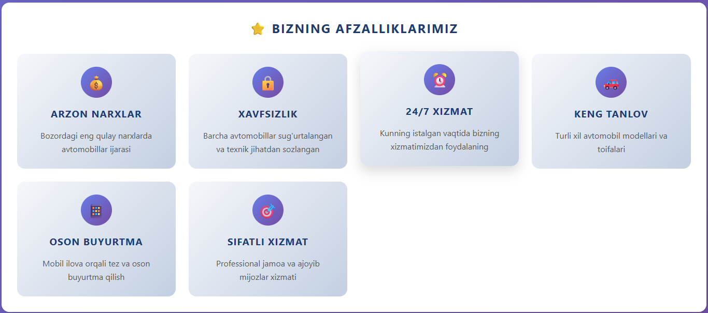

Xulosa: Zamonaviy dasturchi butun sayt strukturasini Grid bilan quradi, uning ichidagi mayda elementlarni (masalan, menyu ichidagi tugmalarni) Flexbox bilan boshqaradi.

