Assignment 5 Strategy Pattern Report
Student: Zhuman Mukhammed
Group: SE-2522
Course: Software Design Patterns 2026-2027
Topic: Option B Calculator
Prepared: 23 October 2026

1 Introduction
This project implements the Strategy behavioral design pattern in a Java 17 console calculator. Addition, subtraction, and multiplication form a family of interchangeable algorithms. Each accepts two BigDecimal operands and returns a BigDecimal result. One Calculator object can change its algorithm at runtime without changing its class.
The client chooses an operation and supplies its strategy to the context. Calculator delegates execution through OperationStrategy. Arithmetic logic stays inside the concrete strategies, so the context does not branch on operation names or strategy types.
BigDecimal values are constructed from input strings. The three core operations use exact decimal arithmetic. The separate division extension uses MathContext.DECIMAL64: 16 significant digits with HALF_EVEN rounding. Division by zero raises ArithmeticException. [1]

Implementation roles
Strategy interface: OperationStrategy declares execute(left, right).
Context: Calculator stores the current strategy and exposes setStrategy and calculate.
Concrete strategies: AddStrategy, SubtractStrategy, and MultiplyStrategy implement the arithmetic.
Client: Main creates strategies, reads input, and reuses one Calculator.

Runtime demonstration
add(12, 4) = 16
subtract(12, 4) = 8
multiply(12, 4) = 48
The extension client DivisionDemo switches the same context from addition to division and changes the result from 16 to 3. No original file under src/ was modified for that extension.
Verification passed 23 Java checks and 14 command-line checks. These cover arithmetic, switching, delegation, null rejection, invalid-input recovery, and end-of-input handling. Actual results are saved in VERIFICATION.txt.

2 UML class diagram
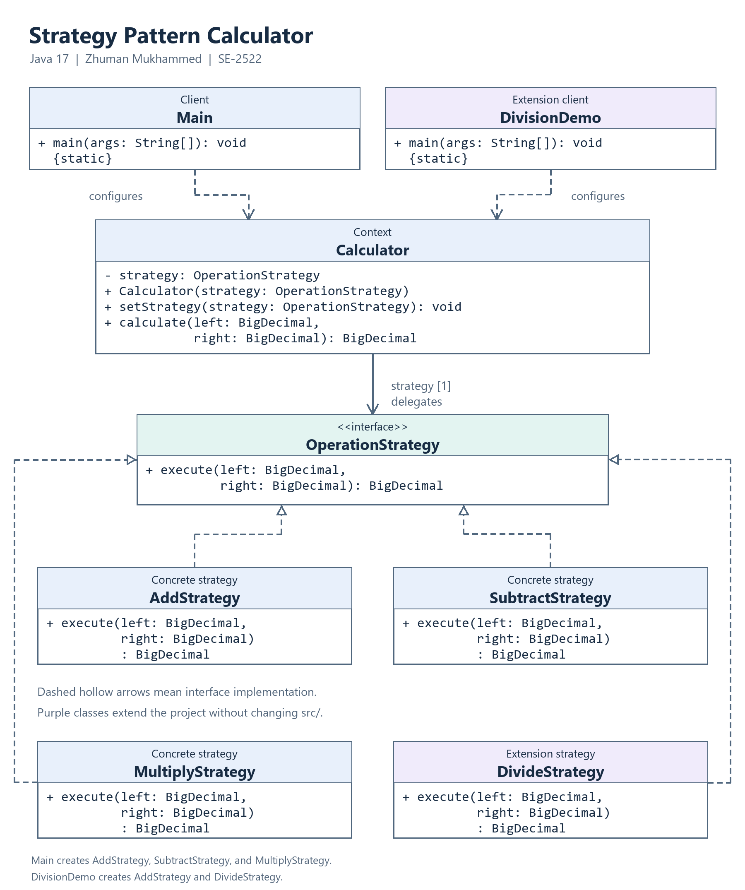

3 Clean Code

Polymorphism replaces algorithm branches
Calculator.calculate delegates through the interface. Dynamic dispatch selects the implementation, so the context does not need an if or switch for every algorithm. The client map resolves commands; validation branches do not perform arithmetic.
return strategy.execute(left, right);

Names reveal intent
The command and class name identify the operation. The operand names left and right preserve order, which matters for subtraction and division.
strategies.put("subtract", new SubtractStrategy());

Each class has one responsibility
MultiplyStrategy performs multiplication only. Main handles console input and formatting, while Calculator stores and replaces the selected strategy. These concerns can change independently.
public BigDecimal execute(BigDecimal left, BigDecimal right) {
return left.multiply(right);
}

The context depends on an abstraction
The context stores OperationStrategy and imports no concrete implementation. A new implementation can be injected later. The null check rejects an invalid replacement before changing the field, preserving the previous strategy.
private OperationStrategy strategy;
public void setStrategy(OperationStrategy strategy) {
this.strategy = Objects.requireNonNull(strategy,
"Strategy must not be null.");
}

Extension preserves existing calculation classes
DivideStrategy implements the same interface, and a new client supplies it to Calculator. The extension adds classes without editing src/. Adding division to the original menu would require one client registration entry, while the context and existing algorithms remain unchanged.
calculator.setStrategy(new DivideStrategy());
calculator.calculate(left, right);

4 Strategy versus State
This calculator needs Strategy because the user explicitly selects a calculation algorithm. Selecting multiplication is not a transition in the object's lifecycle. The strategies do not know one another, enforce transitions, or replace themselves.
State instead models behavior associated with lifecycle conditions, such as a document moving from draft to review to publication. Both patterns can use composition and delegation, but their purpose and the meaning of replacing the delegated object differ. [2][3]

5 Conclusion
The design separates arithmetic variation from the context and supports runtime replacement through one interface. The division example demonstrates this flexibility without changing original source files. The cost is more small classes and client configuration. For only three expressions, a simple function would be shorter; the class-based design makes the pattern and extension boundary explicit.
The Java tests verify exact decimals, negative numbers, operand order, same-context switching, null rejection, custom delegation, and division behavior. The CLI checks verify menu interaction, recovery from invalid values, help and invalid arguments, and clean end-of-input handling. All 37 checks passed on JDK 17.

6 GitHub repository
Pending publication. The project folder contains a local Git repository with incremental implementation, extension, and documentation commits. Add the verified GitHub repository URL after publication; the local folder does not replace the required repository link.

References
[1] Oracle. Java SE 17 API. BigDecimal and linked MathContext documentation.
[2] Refactoring.Guru. Strategy pattern roles and intent.
[3] Refactoring.Guru. State pattern and comparison with Strategy.
[4] AITU. Assignment 5 Strategy Pattern, academic year 2026-2027. Supplied assignment PDF. Online references consulted on 23 October 2026.

Preparation disclosure
OpenAI Codex assisted with implementation, report drafting, and verification on 23 October 2026. This report does not claim unaided authorship. Student review and the personal defense remain to be completed.

