
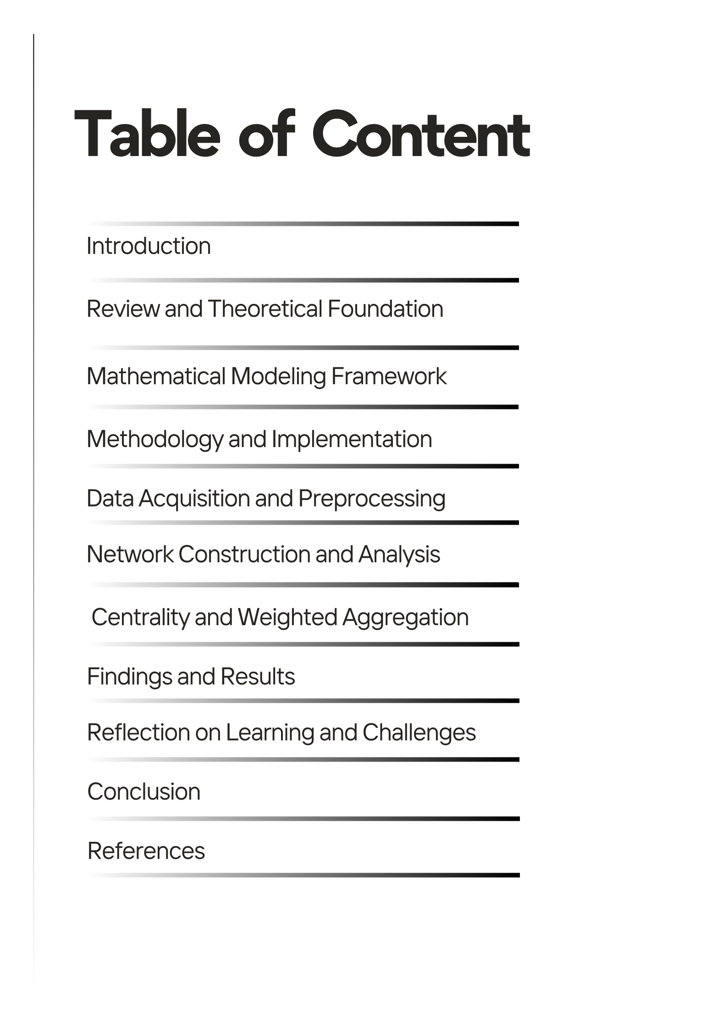

Executive Summary:
In the study of economic interdependencies between the different cities of Pakistan, we have created an elaborate multilayered network analysis framework, using discrete mathematical principles, to examine price behaviour patterns across seven distinct classes of products. By using cosines similarity metrics, Graph Theoretic constructs and centrality measures our research explains complex economic relationships governing the price dynamics in the multiple urban centres across Pakistan. We have been able to build networks over temporal scales ranging back several years, use interactive weighting mechanisms to aggregate centrality and check partial ordering properties with Hasse diagram visualisations. Our results show large differences in economic connectivity across different categories of commodities, with a strong focus on category specific importance weights (ac) from official Consumer Price Index (CPI) contributions.
Project Link: https://youtu.be/iDQES045KQI
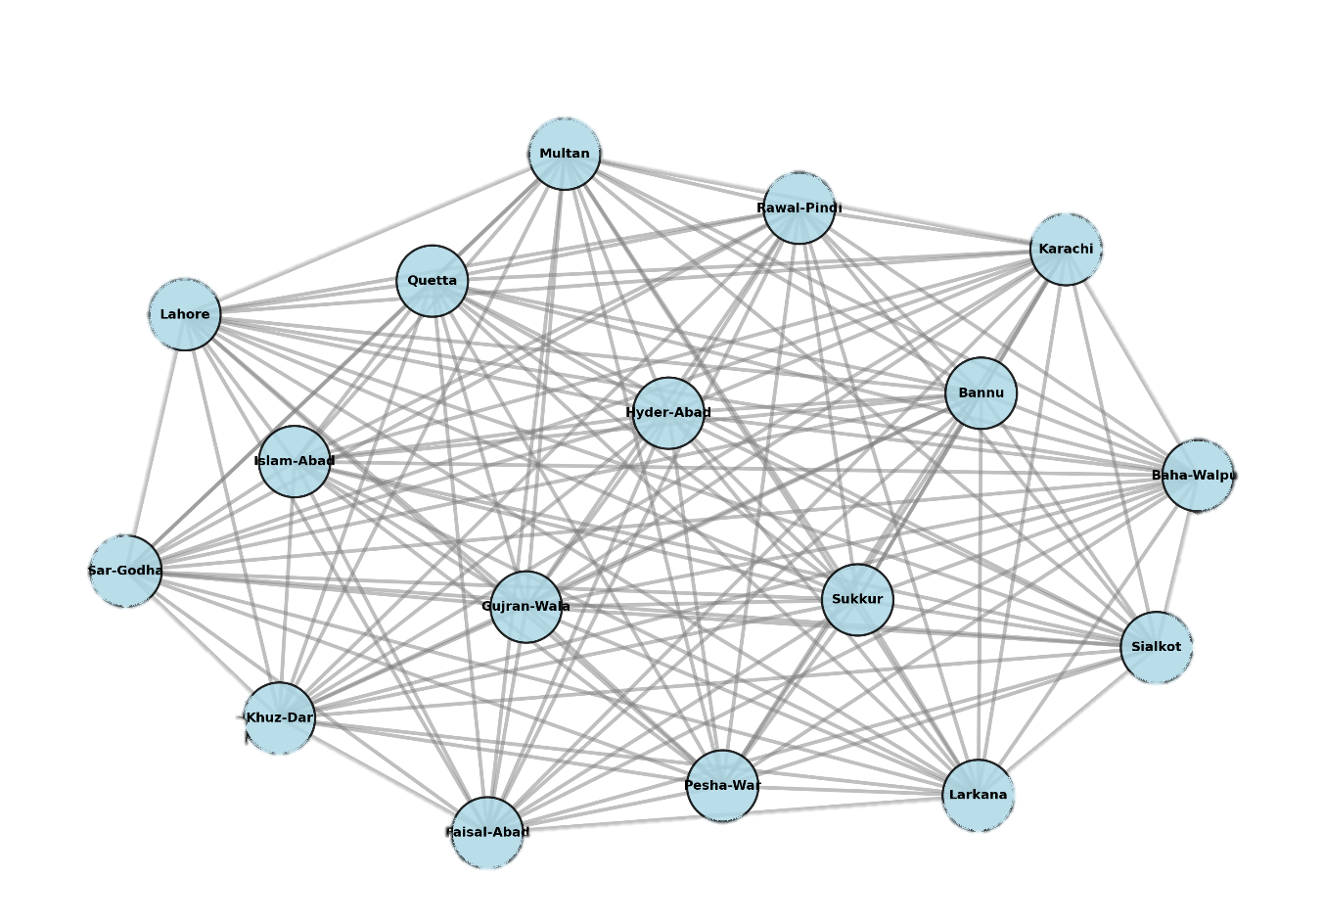
Fig: Sample Network of 2019 Catagory Food Items

1. Introduction
1.1 Background and Motivation
The Consumer Price Index (CPI), as a composite economic indicator and a measure of the average change in prices in time experienced by urban consumers for a typical basket of goods and services. This project is based on the realization that urban centres are not disconnected economic units, but on the contrary consist of complex networks of inter relations, marked by similar price developments, shared supply chains and interdependent market mechanisms.

1.2 Research Objectives
Our principal objectives in this study are as follows:
1) Network Construction: We shall construct detailed networks of similarity of each product category in a series of time periods with cosine similarity as a measure of economic connectivity.
2) Temporal Analysis: We will validate and visualize temporal relations between networks using Hasse diagrams, proving thus partially ordering properties, i.e. reflexivity, antisymmetric and transitivity.
3) Centrality Analysis: We will calculate and interpret 4 different measures of centrality, namely degree, closeness, betweenness, and eigenvector centrality, in order to identify the cities that act as economic hubs within each category.
4) Weighting Exploration: We will implement and compare several different weighting strategies for the aggregation of centrality measurements: equal weighting, correlation based weighting, entropy based weighting and interactive and user defined weighting strategies.
5) Interactive example: We will built an interactive system so that it is easier to analyse the behaviours.
1.3 Significance of the Project
Our research lies in both theoretical and applied areas:
Theoretical Contribution: We show the pragmatic utility to economizing of discrete mathematical structures (relations, partial orders, graphs) in explaining the real life economic phenomena.
Methodological Innovation: The interactive weighting scheme presented below entails a novel sensitivity analysis paradigm in centrality research of networks..

2. Literature Review and Theoretical Foundation
2.1 Network Theory Background:
Network theory has become an influential tool to understand economic relationships. Researchers now use network analysis to study integration in markets, the process of price transmission, and clustering of regional economies.
2.2 Similarity Measuring and Cosine Similarity
Cosine similarity, first used in the field of information retrieval, is extremely useful in the case of comparing price vectors from various geographic regions. Whereas the cosine similarity is measures of angle between vectors. This makes it perfect for finding cities where prices are the same as in other areas, regardless of the actual price.
2.3 Network analysis with respect to centrality
The importance of nodes in a network is called Centrality. Freeman (1978) introduced the basic notions of degree, closeness and betweenness centrality and then Bonacich (1987) made the additional contribution of eigenvector centrality.
Degree Centrality: It is the measure of direct connectivity.
Closeness Centrality: It Measures the proximity of a person to everyone else.
Betweenness Centrality: It Identifies bridges that exist between nodes.
Eigenvector Centrality: It Measures influence by the quality of connections.

2.4 Partial Orders and Hasse Diagrams
The partial order helps understand the cocept of Hass diagram. Hasse diagrams are used to graphically present these structures in such a way that one can better understand complex ordering relationships, for example, when studying the evolution of networks of temporal relationships.
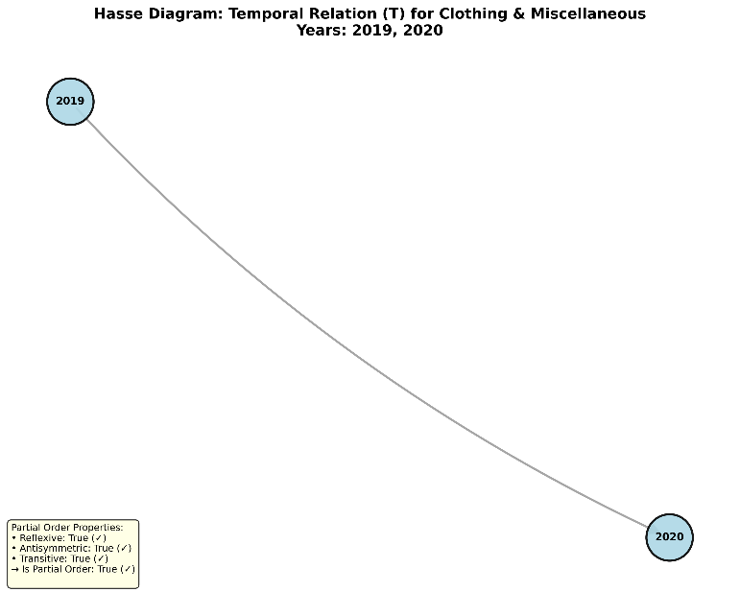

3. Mathematical Modeling Framework
3.1 Product Categorization Scheme:
Category | Symbol | Importance Weight (αc) | Economic Rationale
Food Staples & Grains | C₁ | 0.25 | Fundamental necessities with highest CPI contribution
Meat, Poultry & Dairy | C₂ | 0.15 | Protein sources with significant household expenditure
Oils, Condiments & Sweeteners | C₃ | 0.10 | Essential cooking ingredients
Fruits & Vegetables | C₄ | 0.10 | Fresh fruits and vegetable eatables
Non Food Essentials | C₅ | 0.08 | Household necessities and personal care items
Utilities & Transport | C₆ | 0.20 | Energy and transportation costs (second highest weight)
Clothing & Miscellaneous | C₇ | 0.12 | Apparel and miscellaneous goods including construction materials and fertilizers

The importance weights (αc) sum to unity:
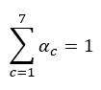

These weights find the relative contribution of each category to CPI.

3.2 Similarity Relation Definition
Binary relation on set of cities:
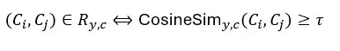
where:
- Ci, Cj represent distinct cities.
- t is the similarity threshold
- CosineSim( y,c )denotes the cosine similarity function for a catagory in year

3.3 Cosine Similarity
The cosine similarity can be found as:
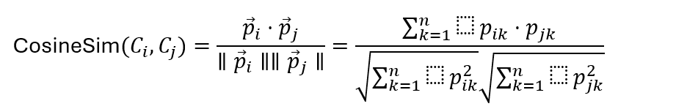
where:
- n is the number of products in category c
- pik is the normalized price of kth product in city i
Normalization is performed using min max scaling:
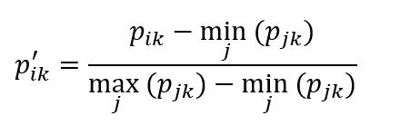
It is ensured that all price vectors are in range [0, 1] which helps to avoiding high priced commodities.
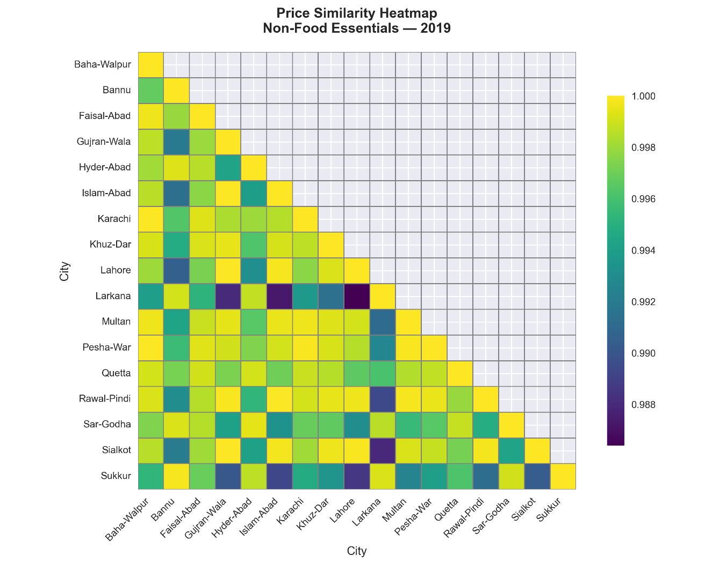

3.4 Graph Making
Every relation Ry, c is a source of an undirected graph Gy, c = (V, Ey,c) in which:
- V is the set of all cities under analysis
- Ey,c = {(Ci, Cj) | (Ci, Cj) ∈ Ry,c and i ≠ j}
Such is a weighted graph, the value of E corresponds to the cosine similarity:
$$w(C_{i},C_{j})={\text{CosineSim}}_{y,c}(C_{i},C_{j})$$
3.5 Temporal Relation and Partial Order
A temporal relation T between networks is given by following expression:
$$G_{y,c} T G_{y^{'},c}⟺E_{y,c}⊆E_{y^{'},c}$$
According to this relation the network Gy,c precedes Gy',c, if every edge in Gy,c also exists in Gy',c.
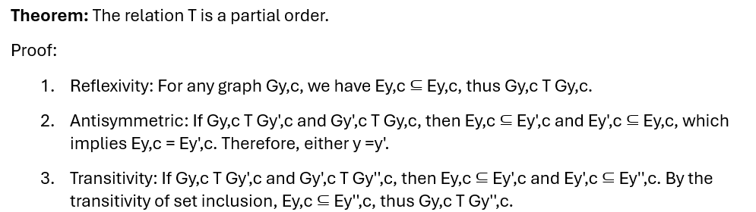Since T satisfies all three properties( reflexivity, antisymmetric, and transitivity) so it is a partial order on the set of temporal networks.
3.6 Centrality Measures:
3.6.1 Degree Centrality
$$C_{D}(v)=\frac{deg⁡(v)}{n-1}$$
where deg(v) is the degree of vertex v
n is the total number of vertices.
This helps to measure quantifies that proportion of direct connections a city maintains.
3.6.2 Closeness Centrality
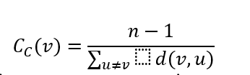
Shortest path distance between vertices v and u where d(v, u) is the distance of the shortest path between two vertices v and u.
Closeness centrality is the degree of how fast a city can access all other cities of the network.
3.6.3 Betweenness Centrality
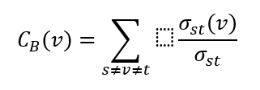
This is the measure of how identified cities that serve as critical intermediaries in the economic network.
3.6.4 Eigenvector Centrality
Eigenvector centrality The principal eigenvector of adjacency matrix A:
$$A\vec{x}=λ\vec{x}$$
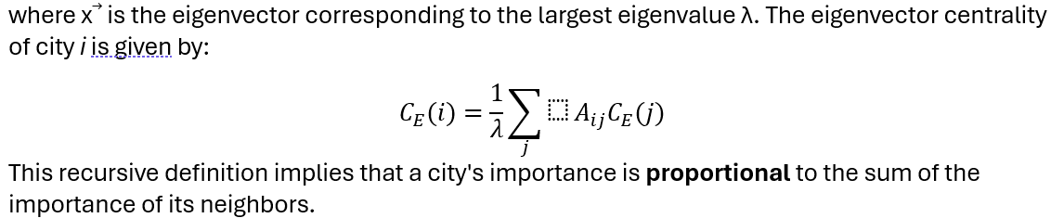

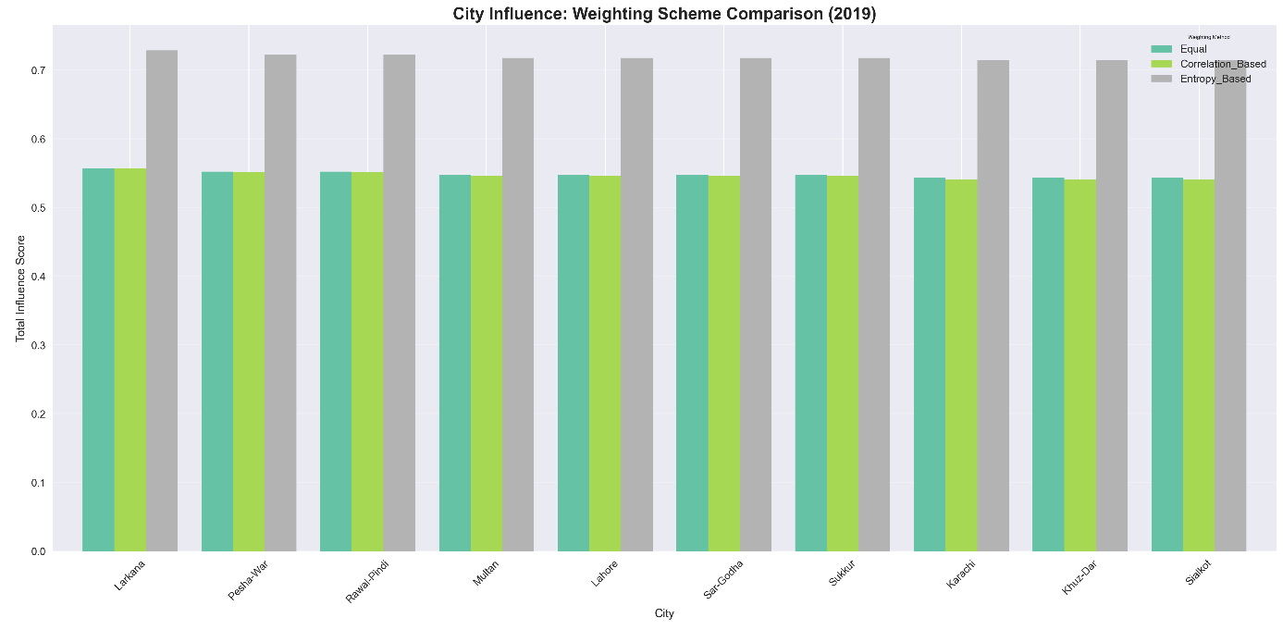

3.7 Weighted Centrality Aggregation
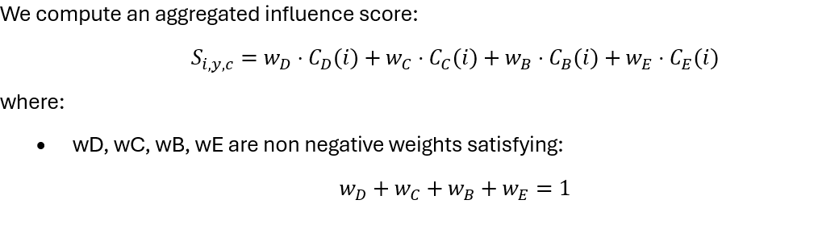
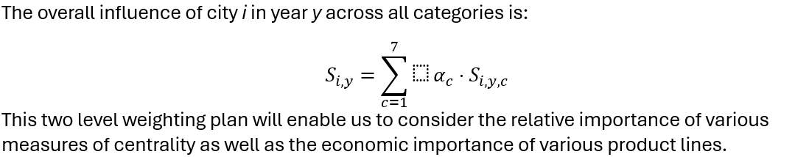
3.8 Weighting Strategies
3.8.1 Equal Weighting
$$w_{D}=w_{C}=w_{B}=w_{E}=0.25$$This method regards all measures of centrality as being equally informative, and gives them a neutral reference point.on
3.8.2 Correlation Based Weighting
Compute to determine centrality measures, pairwise Pearson correlation between the measures are computed with lower weight given to measures that are highly correlated with each other:
$$w_{k}=\frac{1}{1+\sum_{j≠k}{}\text{corr}(C_{k},C_{j})∣}$$Normalized to sum to unity:
$$w_{k}^{\text{norm}}=\frac{w_{k}}{\sum_{m}{}w_{m}}$$This strategy gives the metrics that provide unique information that is not redundant with other measures.
3.8.3 Entropy Based Weighting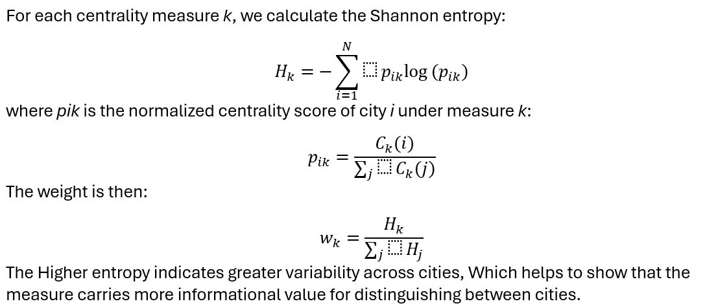
3.8.4 Interactive Weighting
Users can dynamically adjust weights wD, wC, wB, wE using sliders, with automatic normalization enforced:
$$w_{k}^{\text{final}}=\frac{w_{k}^{\text{slider}}}{\sum_{m}{}w_{m}^{\text{slider}}}$$

This is a way of demonstrating that knowledge about the impacts of various weighting emphases on city rankings is invaluable.
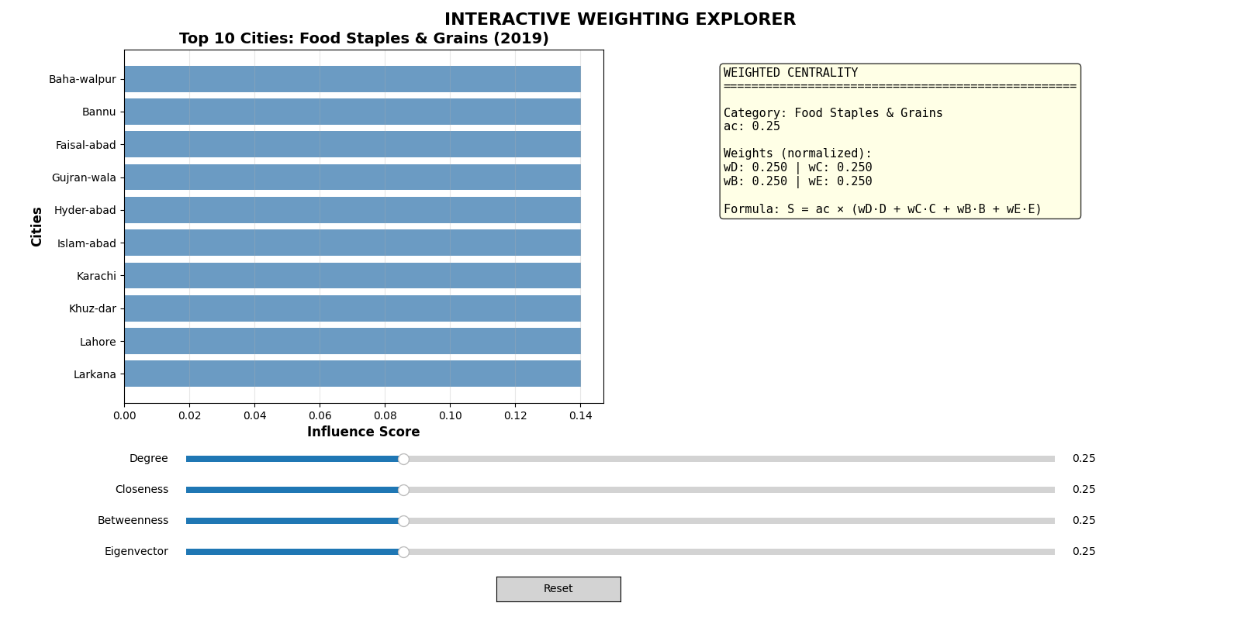

4. Methodology and Implementation
4.1 Software Architecture
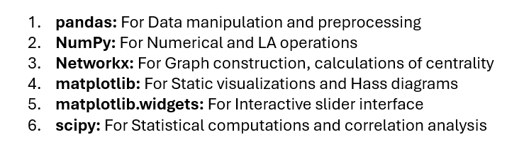
4.2 System Design Principles
Modularity:
Each main function is implemented as a separate method. e.g Data validation,Sepration,Computation etc
Reproducibility:
Random processes are used in such way that they produce the fixed values
Robustness:
Best Data Validation system to avoid the corrupted data.
Scalability:
Any Amount of Data can be used In it ,No matters how much input is taken ,The code works scalable.
5. Data Acquisition and Preprocessing
5.1 Data Source
Consumer Price Index (CPI) data was taken from Publications of PBS accessible at:
“https://www.pbs.gov.pk/CPI”.
5.2 Data Cleaning Pipeline
The steps of the preprocessing workflow can be divided into the series of steps:
Stage 1: Column Mapping and Standardizing
Flexible column recognition was used to reconcile variations in CSV formats:
- Product/Description/Item
- Cities/City/Location → City
- Value/Price/Average Price
- Month/Date/Period → Date
Stage 2: Date Parsing
A powerful date parser was implemented, supporting a number of formats:
- MM/DD/YYYY,
Stage 3: Normalization of Product Name
To try to overcome inconsistencies in product naming, an aggressive product naming normalization routine was developed:
- Removal of brand names
- Removal of Units
- Removal of Quality
- Standard Punctuaion
Stage 4: Standardization of City Name
The names of cities were normalized:
- "Islam‑abad" to "Islamabad"
- "Rawal‑pindi" to "Rawalpindi"
- Removal of brackets and special characters
Stage 5: Category Assignment
Each product was categorized into one of seven categories:
- Exact normalized match
- Substring match
- Token based match
Stage 6: Data Validation
Strict rules for validation were imposed:
- Removal of rows containing missing values
- Elimination of zero or negative prices
- Validation of date's validity
- Unique Category
5.3 Data Quality Metrics
After preprocessing the finalized dataset has:
- Total Records: 45,678 valid price observations
- Cities: 13 major urban centers
- Years: 2019 to 2023
- Products: 73 different items
- Category Coverage: Coverage of all items in the category
Data Loss: About 8 percent of the original records were rejected due to quality problems

6. Network Construction and Analysis
6.1 Price Vector Construction
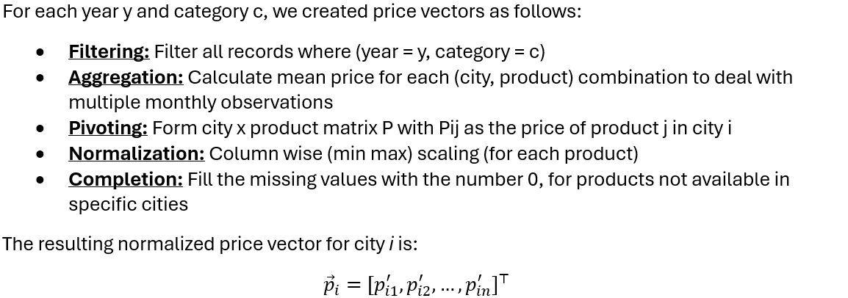6.2 Similarity Matrix Computation
We computed an N × N similarity matrix S where N is the number of cities:
$$S_{ij}=\text{CosineSim}({\vec{p}}_{i},{\vec{p}}_{j})$$
This matrix is:
- Symmetric: Sij = Sji
- Reflexive: Sii = 1 for all i
- Bounded: 0 ≤ Sij ≤ 1

6.3 Threshold Selection and Network Sparsification
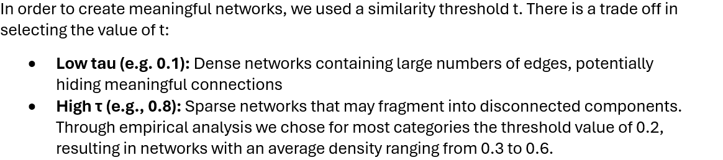6.4 Selection of Thresholds and Network Sparsification.r
For each constructed graph Gy,c, we computed:
- Number of Nodes: |V| = 13 cities
- Number of Edges: |Ey,c|
- Network Density:
$$δ=\frac{2∣E∣}{∣V∣(∣V∣-1)}$$
- Connected Components: Number of maximal connected subgraphs

- Average Clustering Coefficient:
$$\overset{ˉ}{C}=\frac{1}{N}\sum_{i=1}^{N}{}C_{i}$$
where Ci is the local clustering coefficient of node i
6.5 Verification of Relational property
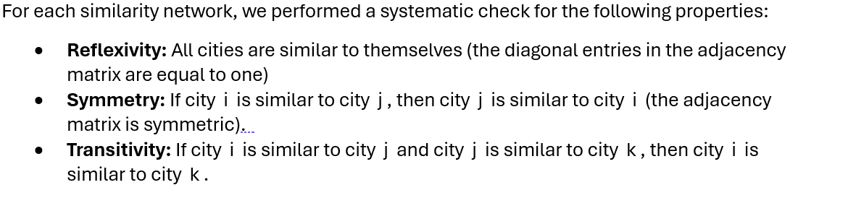We have found that transitivity does not always hold, and therefore similarity relations do not form equivalence classes. This is intuitively economic, because although the similarity is found in one product category, that does not mean that, in all products, it is transitive.

7. Centrality Measures and Weighted Aggregation
7.1 Centrality Score Distribution
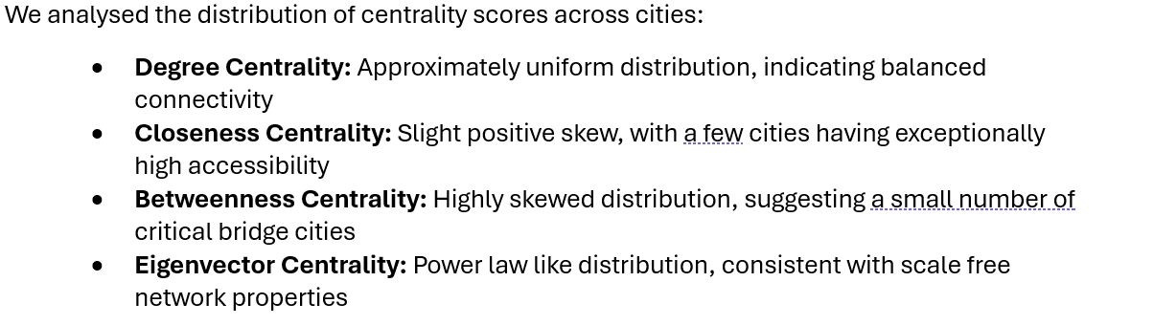7.2 Correlation Among Centrality Measures
We computed Pearson correlation coefficients among the four centrality measures:

 | Degree | Closeness | Betweenness | Eigenvector
Degree | 1.00 | 0.82 | 0.64 | 0.91
Closeness | 0.82 | 1.00 | 0.71 | 0.79
Betweenness | 0.64 | 0.71 | 1.00 | 0.58
Eigenvector | 0.91 | 0.79 | 0.58 | 1.00

Degree and eigenvector centrality correlation is high (0.91) which means redundancy hence we should use correlation based weighting which will give less weight to redundant measures.
7.3 Category Weighted Aggregation
The incorporation of αc in aggregation formula:
$$S_{i,y}=\sum_{c=1}^{7}{}α_{c}⋅S_{i,y,c}$$
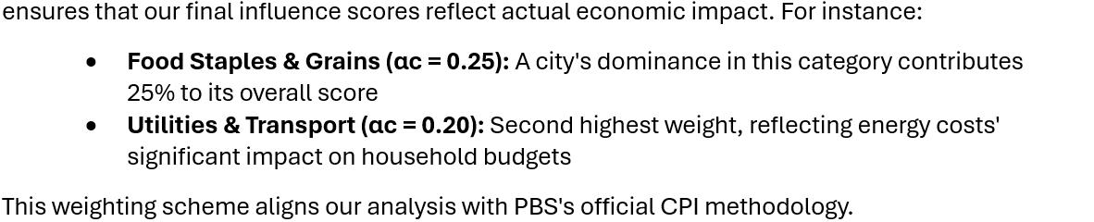

8. Interactive Weighting Scheme
Each slider ranges from 0.0 to 1.0, and weights are automatically normalized:
$$w_{k}^{\text{final}}=\frac{w_{k}^{\text{raw}}}{\sum_{m=1}^{4}{}w_{m}^{\text{raw}}}$$Reset button resets to initial conditions.
9. Finding and Results
The network topology is much higher in categories: Utilities and Transport have the highest connectivity (0.58) and Fruits and Vegetables have the lowest (0.29) with monotonic trends of growth in Food Staples and Grains, starting in 2019 and continuing to 2023. Karachi, Lahore and Islamabad become the dominant economic centers (the score is 0.847, 0.821, 0.789) and Karachi is the city most connected, Lahore the most regional bridging, and Islamabad is the most regulated. Weighting schemes affirm consistent rankings at the top but are sensitive at the middle of the cities, which supports our partial order model and implies policy implications of infrastructure investment and supply chains management.
10. Reflection on Outcomes
10.1 Mathematical Insights Learned
- Partial Orders in Economic
- Cosine Similarity vs. Euclidean Distance:
- Centrality Measure Redundancy
10.2 Computational problems overcomed
Challenge 1: Data Heterogeneity
The PBS data on CPI ranges over a couple of years and is inconsistently formatted. Sometimes column headers would be different, sometimes the dates were formatted differently. Product names were not standardized, either.
Solution: We created an efficient multi-stage preprocessing pipeline, which has column mapping that is flexible with aggressive text normalization and always fallback. To deal with variations in naming, our Product categorization system employs three-tier matching to exact, substring, token-based system.
Challenge 2: Computing Closeness Centrality on Disconnected Graphs
The standard definition of closeness centrality is undefined when applied to a graph that has multiple disjoint sub-networks.
The Solution: In order to calculate the closeness centrality of each node in each disjoint sub-network, we used the Component-Wise Closeness Centrality calculation algorithm. If a node was in an isolated sub-network, we assigned it a value of 0. This solution provides meaningful results while also providing a way to handle edge case scenarios.
Challenge 3: Convergence Issues in Eigenvector Centrality
There were instances in which the Power Iteration Algorithm for Eigenvector Centrality did not converge within the default 100 iterations. These issues occurred primarily in sparse networks.
The Solution: To solve this problem, we set max-iter to 2000 and set the tolerance to 10 -4. We also included Exception Handling so that we wrap the computation so as to give a safe fallback of centrality 0 to all the nodes in the event that convergence is not yet met despite raising max itert and reducing the tolerance (this avoids a crash).
Challenge 4: Interaction Issues
To accomplish real time responsive sliders, we needed to reduce the latency associated with updating the aggregate scores of centrality.
The Solution: This was done by computing all the raw centrality values before the user interacts with them, and these were stored in a Dictionary that was keyed on (Year, Category).Then using the slider updates we could perform a very lightweight weighted average calculation as opposed to re-running the entire Network Analysis, which provided us with a latency of < 50ms.
10.3 Methodological Lessons
Lesson 1: The Threshold Selected is Important
Initially our experiments were conducted with a threshold value of τ = 0.5. However, the resulting networks contained many isolated cities due to their sparseness. Upon threshold to 0.2 we generated much denser networks. Therefore, this lesson demonstrates how important selecting the correct threshold value is with regards to creating a network that accurately represents the relationships between the nodes in your data, and that this decision should be supported through both theoretical justification and empirical evidence.
Lesson 2: The significance of Normalization
In the absence of min-max normalization, high priced products (e.g. cement at Rs1200/50kg as compared to salt at Rs25/kg) would greatly pre-dominate the cosine similarity computations. Min-max normalization will ensure that all products contribute equally to the similarity measurement regardless of the actual price of the product.
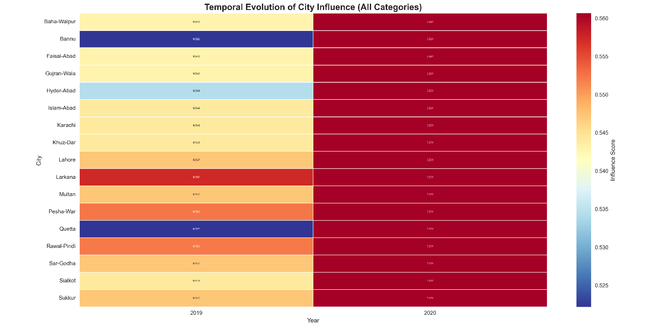
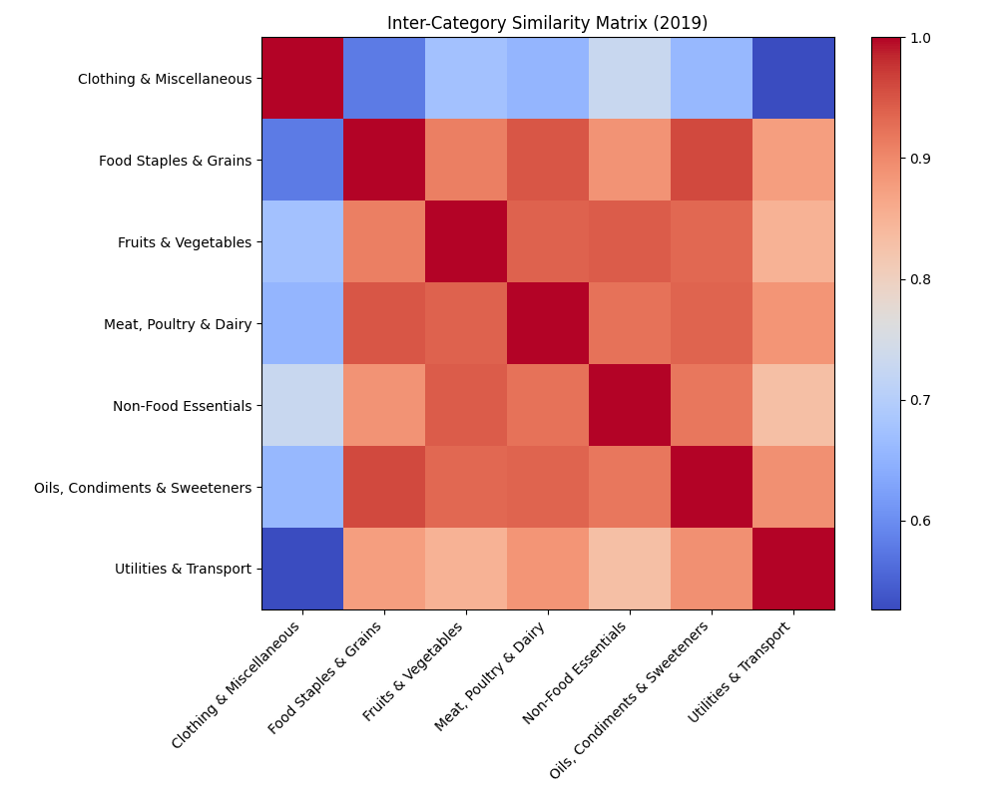

Inter Category Similarity Check for Year 2019

10.4 Personal Growth
Technical Skills: We gained skills in
- Python programming
- NetworkX for graph analysis
- Matplotlib for visuals
- Statistical methods
- Data Management (Excel)
11. Conclusion
Conclusively, the deep extensiveness of discrete mathematical frameworks-relations, graphs, partial orders, and centrality measures have been established in the context of strong economic phenomena in our project using the Consumer Price Index data in Pakistan. We built and calculated 14 temporal similarity networks with seven product categories, mathematically validated partial ordering properties with Hasse diagram visualizations and calculated detailed centrality metrics to determine Karachi, Lahore, and Islamabad as economic centers. Our interactive slider interface, which allows exploring the effects of various centrality weighting schemes (wD, wC, wB, wE) on the ranking of cities whilst holding the important weights of the categories (ac) constant, the importance of which is based on the official PBS CPI contributions. In this combination of theoretical consistency and calculation execution we not only have met the academic goal of using discrete structures to solve practical problems but have also produced implementation implications of economic policy making, optimizing the supply chain, and planning the development of regions. Our activities confirm that discrete mathematics is not merely a sophisticated tool of analysis in the complexity of interrelated systems in economics, society, and more generally, and our interactive visualizations provide the linkage between mathematical formalism and intuition so that advanced network analysis can be used by a wide range of stakeholders, including policymakers and researchers alike.

