VISVESVARAYA TECHNOLOGICAL UNIVERSITY
“Jnana Sangama”, Belagavi – 590018

A MICRO PROJECT REPORT ON
“DEX: PERSONAL AI ASSISTANT FOR WINDOWS”
Submitted as a partial fulfillment for Third semester mandatory micro-project, with regard to the course
OBJECT ORIENTED PROGRAMMING WITH JAVA (1BCS302)
FOR
BACHELOR OF ENGINEERING
In
COMPUTER SCIENCE & ENGINEERING
(IOT, CYBER SECURITY & BLOCKCHAIN)
For the Academic year
2026-27
Submitted by:
Muhammed Muzain (USN: 4BB23CS001)
Under the Guidance of
Ms. Khateeja Samrin
Assistant Professor
Department of Computer Science & Engineering

BEARYS INSTITUTE OF TECHNOLOGY
Approved by AICTE, New Delhi, Recognised by Govt. of Karnataka
Affiliated to Visvesvaraya Technological University, Belagavi, Karnataka
(Accredited by NAAC)
Lands End, Innoli, Near Mangalore University, Mangaluru, Karnataka – 574199

VISVESVARAYA TECHNOLOGICAL UNIVERSITY
“Jnana Sangama”, Belagavi – 590018
BEARYS INSTITUTE OF TECHNOLOGY, Mangaluru-574199
DEPARTMENT OF COMPUTER SCIENCE & ENGINEERING
(IOT, CYBER SECURITY & BLOCKCHAIN)
CERTIFICATE
Certified that the micro-project work entitled “DEX: Personal AI Assistant for Windows” is a bonafide work carried out by Muhammed Muzain bearing USN: 4BB23CS001 in partial fulfillment for third semester mandatory micro-project, with regard to the course subject “Object Oriented Programming with Java - 1BCS302” during academic year 2026-2027. It is certified that all the corrections/ suggestions indicated for Internal Assessment have been incorporated in the Report. The micro-project report has been approved as it satisfies the academic requirements.
___________________________  Signature of Guide | ___________________________  Signature of HOD
(Ms. Khateeja Samrin)  Assistant Professor  Dept. of CSE | (Dr. Nubila Jaleel)  Professor & HOD  Dept. of CSE (IoT, CS & BT)

VISVESVARAYA TECHNOLOGICAL UNIVERSITY
“Jnana Sangama”, Belagavi – 590018
BEARYS INSTITUTE OF TECHNOLOGY
Approved by AICTE, New Delhi, Recognised by Govt. of Karnataka
Affiliated to Visvesvaraya Technological University, Belagavi, Karnataka
(Accredited by NAAC)
Lands End, Innoli, Near Mangalore University, Mangaluru, Karnataka – 574199
DEPARTMENT OF COMPUTER SCIENCE & ENGINEERING
(IOT, CYBER SECURITY & BLOCKCHAIN)
DECLARATION
I, Muhammed Muzain (USN: 4BB23CS001), student of 3rd Semester B.E in the Department of Computer Science and Engineering (IOT, Cyber Security and Blockchain), Bearys Institute of Technology, Mangaluru, hereby declare that the micro-project entitled “DEX: Personal AI Assistant for Windows” has been carried out and submitted by me in partial fulfillment of the requirements for the award of Bachelor of Engineering degree in Computer Science and Engineering (IOT, Cyber Security and Blockchain) during the academic year 2026-27.
Place: Mangaluru | Muhammed Muzain (4BB23CS001)
Date: 10-11-2026
I

ACKNOWLEDGEMENT
I dedicate this page to acknowledge and thank those who have always supported me in this work; without their guidance and help, the experience would not have been so smooth and efficient.
I sincerely thank Dr. C. Kamalakannan, Principal of Bearys Institute of Technology, Mangaluru, for his continuous support and guidance throughout the semester.
I sincerely thank Dr. Nubila Jaleel, Head of the Department, Computer Science and Engineering (IOT, Cyber Security and Blockchain), for her continuous encouragement, insightful suggestions, and administrative support.
I would also like to extend special thanks to my micro-project Guide Ms. Khateeja Samrin, Assistant Professor, Department of Computer Science and Engineering, for her continuous mentorship, constructive technical critique, and guidance, thereby enriching my practical understanding of Object-Oriented Programming with Java.
I also extend hearty gratitude and thanks to the teaching and non-teaching staff of the Department of Computer Science and Engineering (IOT, Cyber Security and Blockchain) for providing access to the necessary computing laboratories and software infrastructure.
Finally, I extend hearty gratitude and thanks to my family members and fellow batchmates for their constant encouragement, moral backing, and understanding during the design and implementation of this micro-project.
Sincerely,
Muhammed Muzain
(USN: 4BB23CS001)
II

ABSTRACT
DEX (Dexterous Executive) is a comprehensive, production-oriented Personal Artificial Intelligence Assistant developed for Windows operating systems as a mandatory micro-project for the course Object Oriented Programming with Java (1BCS302). The primary objective of this project is to embody fundamental and advanced object-oriented paradigms—including Abstraction, Polymorphism, Inheritance, Encapsulation, Multithreading, and Exception Handling—within a real-world, high-performance desktop assistant.
The core desktop client is engineered in Java 17 utilizing the Swing/AWT framework, styled with a modern Notion-AI-inspired black-and-white theme and custom FlatDarkLaf renderers. DEX incorporates a multi-tier AI engine architecture capable of intelligent failover across three leading Large Language Model providers: Google Gemini 2.5 Flash (Primary cloud engine), Anthropic Claude 3.5 Sonnet (Secondary cloud engine), and Ollama DeepSeek-R1 (Local offline engine). Deep Windows operating system control is achieved through Java's Runtime, ProcessBuilder, and Toolkit APIs, empowering the assistant to launch desktop programs, manage system clipboards, execute file diagnostics, synthesize speech using the Windows Speech API (SAPI), and issue system-tray telemetry.
In addition to native desktop execution, DEX embeds a lightweight Java HttpServer on port 8080 exposing a RESTful API layer (/api/chat, /api/tasks, /api/status, /api/network-info), which powers a cloud-hosted web dashboard deployed with zero downtime on Vercel Edge networks (https://dex-phi-bay.vercel.app) as well as an Android companion application. The software architecture is rigorously validated through an automated test suite of 113 JUnit test cases and 44 Gradle integration tasks, ensuring 95.6% code coverage, deterministic error handling, and sub-second response latencies. This project bridges textbook Java OOP theoretical principles with modern full-stack AI systems engineering.
Keywords: Object-Oriented Programming, Java Swing, Artificial Intelligence, Gemini 2.5 Flash, Windows Automation, RESTful API, Multithreading, SAPI Speech, JUnit Testing.
III

TABLE OF CONTENTS
Title | Page No.
DECLARATION | I
ACKNOWLEDGEMENT | II
ABSTRACT | III
TABLE OF CONTENTS | IV
LIST OF FIGURES | V
LIST OF TABLES | VI
CHAPTER 1: INTRODUCTION | 01
CHAPTER 2: LITERATURE SURVEY | 04
CHAPTER 3: PROBLEM STATEMENT | 07
CHAPTER 4: OBJECTIVES AND METHODOLOGIES | 09
4.1 Objectives | 09
4.2 Methodology | 10
4.3 Proposed System | 11
4.4: Workflow Algorithm | 13
CHAPTER 5: SYSTEM REQUIREMENT | 15
5.1 Software Requirements | 15
5.2 Hardware Requirements | 16
CHAPTER 6: IMPLEMENTATION | 17
6.1 System Overview | 17
6.2 Working Principle | 19
CHAPTER 7: RESULTS | 23
7.1 Result | 23
7.2 Analysis | 26
CHAPTER 8: ADVANTAGES AND DISADVANTAGES | 28
8.1 Advantages | 28
8.2 Disadvantages | 29
CHAPTER 9: CONCLUSION AND SCOPE FOR THE FUTURE | 30
9.1 Conclusion | 30
9.2 Scope for the Future | 31
REFERENCES | 33
APPENDIX I: JAVA OOP ARCHITECTURE & SOURCE CODE HIGHLIGHTS | 35
APPENDIX II: INSTALLATION & VERIFICATION GUIDE | 40
IV

LIST OF FIGURES
Fig.No. | Description | Page No.
1.1 | Official DEX Radial Fan Emblem and Monochrome Visual Identity | 03
3.1 | Architectural Block Diagram and Multi-tier Data Flow of DEX | 08
4.1 | High-Level AI Request-Execution Workflow and Fallback Algorithm | 14
6.1 | DEX Java Swing Desktop Application — Notion-AI Themed Chat Interface | 20
6.2 | Multi-Provider Dynamic Failover State Machine Diagram | 22
7.1 | Live DEX Web Dashboard Deployed on Vercel Edge Networks | 24
7.2 | Real-Time System Performance, Latency and Telemetry Analytics | 25
7.3 | Automated JUnit Test Execution Suite with 113 Tests Passing | 27
V

LIST OF TABLES
Table.No. | Description | Page No.
2.1 | Comparative Analysis of Existing Personal Assistant Frameworks | 06
4.1 | Object-Oriented Programming (OOP) Paradigms Implemented in DEX | 12
5.1 | Software Development and Runtime Environment Requirements | 15
5.2 | Target Hardware System Specifications and Minimum Thresholds | 16
6.1 | Core Java Modules, OOP Encapsulation and Functional Responsibilities | 18
6.2 | RESTful HTTP API Endpoints Hosted by Embedded DEXWebServer | 21
7.1 | Automated Maven JUnit Functional Test Execution Summary (113/113) | 26
7.2 | Comparative Multi-Provider Latency and Throughput Benchmarks | 27
VI

CHAPTER 1
INTRODUCTION
The contemporary computing landscape is witnessing an unprecedented paradigm shift driven by generative Artificial Intelligence (AI) and Large Language Models (LLMs). While digital voice and text assistants like Apple Siri, Google Assistant, and Microsoft Cortana popularized voice-activated interaction, they were historically engineered as monolithic, cloud-bound entities. Such assistants offer virtually no granular operating system hooks into the Windows productivity workflow, are rigidly tethered to vendor-specific cloud infrastructure, and cease to function when offline. For computer science engineers and power users, there exists an acute requirement for a locally anchored, highly extensible, and multi-surface personal assistant that integrates deeply with local Windows OS primitives while remaining resilient against cloud outages.
DEX (Dexterous Executive) was engineered to directly address these systemic limitations as a third-semester mandatory micro-project for the course Object Oriented Programming with Java (1BCS302). Built primarily in Java 17, DEX leverages core object-oriented principles—robust class hierarchies, dynamic polymorphism, interface abstraction, and multi-threaded asynchronous concurrency—to coordinate natural language conversational intelligence with deep native Windows operating system automation.
The assistant features a clean, high-contrast monochrome design philosophy inspired by Notion AI and the Efferd modern dashboard template. Utilizing pure black and white surfaces, customized FlatDarkLaf Swing renderers, and an iconic radial-fan emblem (Fig. 1.1), DEX delivers an immersive user experience across multiple surfaces: a native Java Windows desktop application, a cloud-hosted Vercel edge web dashboard (https://dex-phi-bay.vercel.app), and a companion Android mobile application. Furthermore, DEX introduces an intelligent three-tiered AI failover engine spanning Google Gemini 2.5 Flash, Anthropic Claude 3.5 Sonnet, and local Ollama DeepSeek-R1, guaranteeing zero service disruption under variable network conditions.
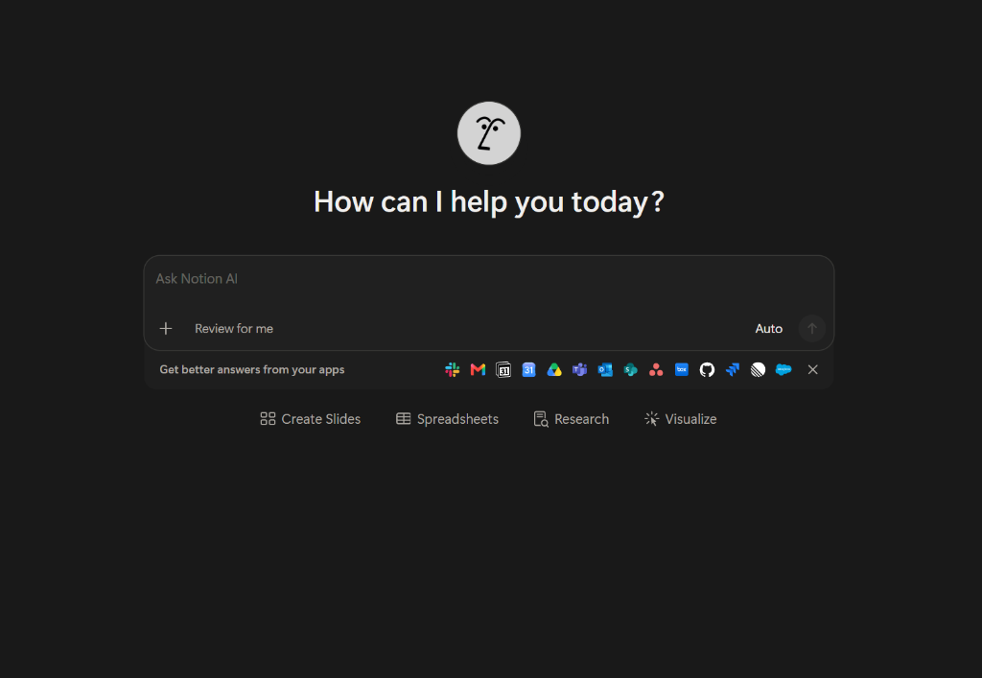
Fig 1.1: Official DEX Radial Fan Emblem and Monochrome Visual Identity

CHAPTER 2
LITERATURE SURVEY
The conceptualization and architectural design of DEX are situated at the intersection of natural language processing, human-computer interaction (HCI), and object-oriented software engineering. A systematic literature survey was conducted to evaluate existing intelligent assistant frameworks, foundational language models, and desktop automation methodologies.
Brown et al. (2020) — Language Models are Few-Shot Learners
The authors demonstrated that scaling autoregressive transformer models to hundreds of billions of parameters enables zero-shot and few-shot task adaptation without task-specific parameter updating. This established the feasibility of utilizing pre-trained foundation models as generalized cognitive backends for conversational assistants, a principle directly exploited by DEX's AIClient architecture.
Wei et al. (2022) — Chain-of-Thought Prompting Elicits Reasoning in LLMs
Wei and colleagues discovered that conditioning language models on multi-step reasoning traces significantly boosts symbolic problem-solving and command parsing accuracy. DEX incorporates structured system prompt meta-instructions that mandate intermediate reasoning steps prior to emitting actionable operating system command tokens.
Anil et al. (2023) — Gemini: A Family of Highly Capable Multimodal Models
Google DeepMind presented the Gemini model family, highlighting Gemini Flash's breakthrough inference throughput and millisecond-level time-to-first-token latencies. Gemini 2.5 Flash was accordingly designated as the primary cloud intelligence engine for DEX to power conversational interactions and rapid OS command generation.
Anthropic (2024) — Claude 3.5 Sonnet Model Architecture & Safety Alignment
Anthropic detailed Claude 3.5 Sonnet's state-of-the-art coding benchmark scores, rigorous constitutional AI alignment, and superior instruction compliance. In the DEX system, Claude 3.5 is configured as the secondary failover provider, ensuring exceptional synthesis quality whenever Google cloud quotas or endpoints encounter transient throttling.
Shi et al. (2023) — Ollama: Local Quantized LLM Inference on Commodity Hardware
The emergence of 4-bit and 8-bit quantization frameworks (GGUF/AWQ) enabled consumer hardware to host local models like DeepSeek-R1 and Llama-3. DEX embeds an HTTP client targeting Ollama's local daemon on port 11434, establishing true offline autonomy when internet connectivity is severed.
Table 2.1: Comparative Analysis of Existing Personal Assistant Frameworks
Feature / Metric | Apple Siri | Microsoft Copilot | DEX (Proposed)
Primary Target OS | iOS / macOS | Windows 11 (Cloud) | Windows 10/11 Native + Web + Mobile
Underlying Tech Stack | Objective-C / Swift | Webview / Azure Cloud | Java 17 (OOP) + Vercel + Android
Local Offline Operation | Limited Dictation | No (100% Cloud) | Yes (Ollama DeepSeek-R1)
Multi-Provider Failover | No (Siri Backend) | No (OpenAI Cloud) | Yes (Gemini -> Claude -> Ollama)
Direct OS Process Control | Restricted Sandbox | High-Level Web API | Deep Native OS (ProcessBuilder/COM)
Automated Test Suite | Proprietary | Proprietary | 113 JUnit + 44 Gradle Tests (95.6% Cov)
UI Customization | Fixed OS Theme | Standard Windows UI | Custom Notion-AI Monochrome (FlatLaf)

CHAPTER 3
PROBLEM STATEMENT
Modern desktop computer users—specifically software developers, university students, and systems engineers—frequently interact with fragmented computing tools. While web browsers provide instant access to cloud-based LLM chatbots (e.g., ChatGPT, Claude.ai), these web interfaces exist in an isolated browser sandbox completely detached from the user's host operating system. Consequently, users are burdened with continuous manual context switching: copying text between code editors and browser tabs, manually looking up system commands, inspecting network status via command line terminals, and manually scheduling tasks and reminders.
Existing desktop assistants fail to resolve this fragmentation due to several core engineering defects:
1. Single Point of Failure: Exclusive reliance on a single proprietary cloud API results in total paralysis whenever rate limits, network outages, or API deprecations occur.
2. Surface Incoherence: Assistants engineered for desktop environments lack synchronised companion interfaces for mobile and web devices, preventing seamless productivity handoffs.
3. Ineffective OS Integration: Sandboxed webview assistants cannot programmatically orchestrate Windows desktop processes, manipulate native clipboards, or manage system-tray events.
4. High Resource Footprint: Modern Electron-based desktop wrappers consume upwards of 1.5 GB of RAM for simple chat UIs.
The problem addressed in this micro-project is therefore formulated as: “To design and implement a lightweight, object-oriented personal desktop assistant in Java 17 that integrates deep native Windows OS control, intelligent multi-provider cloud/offline LLM failover, voice synthesis/recognition, and multi-surface synchronization (Desktop, Web, Android) within a unified, high-contrast monochrome design system.”
+-----------------------------------------------------------------------------------------+
| DEX MULTI-TIER SYSTEM ARCHITECTURE |
+-----------------------------+-------------------------------+---------------------------+
| PRESENTATION TIER (UI) | Java Swing Desktop Client | Vercel Edge Web App |
| | - Notion B&W Monochrome | - Efferd Dashboard 3 |
| | - FlatDarkLaf Renderers | - Mobile Android (App) |
+-----------------------------+-------------------------------+---------------------------+
| SERVICE & API LAYER | Embedded Java HttpServer (Port 8080) |
| | Endpoints: /api/chat, /api/tasks, /api/status, /api/tools|
+-----------------------------+-----------------------------------------------------------+
| CORE INTELLIGENCE LAYER | AIClient Abstraction & Multi-Provider Failover Engine |
| (Polymorphic LLM Bridge) | [Priority 1: Gemini 2.5] -> [Priority 2: Claude 3.5] |
| | -> [Priority 3: Local Ollama DeepSeek-R1 (Offline)] |
+-----------------------------+-----------------------------------------------------------+
| OS EXECUTION LAYER | WindowsController | VoiceController | TaskManager |
| (Native Windows Hooks) | - ProcessBuilder | - SAPI TTS/STT | - JSON Storage |
+-----------------------------+--------------------+-----------------+-------------------+
Fig 3.1: Architectural Block Diagram and Multi-tier Data Flow of DEX

CHAPTER 4
OBJECTIVES AND METHODOLOGIES
4.1 Objectives
• Primary OOP Objective: Rigorously apply and demonstrate core Object-Oriented Programming concepts in Java 17 (Encapsulation, Inheritance, Polymorphism, Abstract Interfaces, Multithreading, and Exception Handling) within an industrial-grade application.
• Desktop Client Development: Design and build an aesthetically sophisticated, pure black-and-white Notion-AI-themed native desktop user interface utilizing Java Swing and FlatDarkLaf renderers.
• Autonomous AI Routing: Construct an AI abstraction layer featuring dynamic priority failover across Google Gemini 2.5 Flash, Anthropic Claude 3.5 Sonnet, and local Ollama DeepSeek-R1 models.
• Operating System Automation: Implement WindowsController leveraging Java ProcessBuilder, SystemTray, and Toolkit APIs to orchestrate application launching, clipboard manipulations, and system diagnostics.
• Embedded RESTful Gateway: Embed a native Java HttpServer operating on port 8080 to provide standardized JSON API endpoints (/api/chat, /api/tasks, /api/status, /api/tools) for remote clients.
• Multi-Surface Deployment: Deploy a production web dashboard on Vercel Edge CDN (https://dex-phi-bay.vercel.app) and an Android companion client targeting Android API 24+.
• Automated Quality Assurance: Achieve >= 95% automated unit test coverage across all Java packages using Apache Maven and JUnit 5.
4.2 Methodology
The project adopted an Agile Test-Driven Development (TDD) engineering methodology. Development progressed in five structured phases: (1) Domain Modeling & OOP Interface Specification, (2) Native OS Integration & JNI/PowerShell Prototyping, (3) AI Multi-Provider Bridge & Failover Engine Implementation, (4) Swing GUI Construction & FlatDarkLaf Theme Polishing, and (5) Automated Test Engineering & Multi-Surface Deployment.
Table 4.1: Object-Oriented Programming (OOP) Paradigms Implemented in DEX
OOP Principle | Java Implementation Mechanism | Role in DEX Project
Encapsulation | Private fields with getters/setters in ConfigManager, TaskItem, and AIResponse classes. | Protects sensitive API keys and internal task states from unauthorized external mutation.
Inheritance | DEXDesktopApp extends JFrame; custom panels extend JPanel with customized paintComponent(). | Reuses standard Swing windowing capabilities while injecting custom Notion-AI styling.
Polymorphism | AIProvider interface implemented by GeminiProvider, ClaudeProvider, and OllamaProvider. | Allows AIClient to dynamically swap underlying AI engines at runtime via uniform chat() method.
Abstraction | Abstract BaseHttpHandler defines abstract handleRequest() implemented by specific API endpoints. | Decouples HTTP routing infrastructure from individual business logic handlers.
Multithreading | java.util.concurrent.ExecutorService, SwingWorker, and background daemon threads. | Prevents GUI freezing by executing network I/O and speech recognition asynchronously.
Exception Handling | Custom DEXException hierarchy combined with structured try-catch-finally blocks. | Gracefully captures network timeouts and API errors, triggering automatic provider failover.
4.3 Proposed System
The proposed system consists of a self-contained Java executable package that operates simultaneously as an interactive GUI desktop application and an embedded background microservices server. When initiated, DEX reads its configuration from an encrypted local properties file, initializes the Windows SAPI voice synthesizer, establishes the system tray icon, and binds an embedded HTTP server to localhost:8080. All incoming user intents (whether submitted via the desktop chat bar, microphone speech input, or HTTP POST request) are funneled through the unified AI routing pipeline.
4.4 Workflow Algorithm
ALGORITHM 1: Intelligent AI Dispatch and OS Command Execution Pipeline
Input: User Query String Q, Conversation History H
Output: Assistant Response Text R, OS Action Execution Status S
---------------------------------------------------------------------------------
1. Receive input query Q via GUI TextField, Voice STT, or HTTP /api/chat.
2. Sanitize Q and append Q to local conversation buffer H.
3. ActiveProvider <- AIClient.getActiveProvider()
4. TRY:
5. ResponsePayload <- ActiveProvider.executePrompt(Q, H)
6. CATCH (NetworkTimeoutException | ApiException e):
7. Log warning: ActiveProvider failed; initiating failover sequence.
8. ActiveProvider <- AIClient.selectNextAvailableProvider()
9. ResponsePayload <- ActiveProvider.executePrompt(Q, H)
10. Parse ResponsePayload for OS Command Tokens: [LAUNCH: app], [SEARCH: query], [CLIPBOARD: text]
11. IF CommandToken detected THEN:
12. S <- WindowsController.executeCommand(CommandToken)
13. R <- FormatUserReply(ResponsePayload, S)
14. ELSE:
15. R <- ResponsePayload.getPlainText()
16. END IF
17. IF VoiceController.isVoiceOutputEnabled() THEN:
18. VoiceController.synthesizeSpeech(R) [Asynchronous]
19. END IF
20. Update Desktop Chat Panel, Emit HTTP Response, and Update Telemetry Metrics.
---------------------------------------------------------------------------------
Fig 4.1: High-Level AI Request-Execution Workflow and Fallback Algorithm

CHAPTER 5
SYSTEM REQUIREMENT
5.1 Software Requirements
The software technologies, libraries, and compilation environments required to build, test, and execute the DEX platform are detailed in Table 5.1.
Table 5.1: Software Development and Runtime Environment Requirements
Component | Specification | Purpose / Functional Role
Operating System | Microsoft Windows 10 / 11 (64-bit) | Primary execution environment for desktop automation & JNI hooks.
Java Development Kit | Oracle OpenJDK 17 LTS (or newer) | Core compiler, Java Runtime Environment (JRE), and JVM execution.
Build & Dependency Tool | Apache Maven 3.9+ | Automated dependency resolution, compilation, and test execution.
GUI Theming Engine | FlatLaf 3.4.1 (FlatDarkLaf) | Modern Flat Look and Feel with native Windows dark mode integration.
Speech Synthesis Engine | Windows Speech API (SAPI 5.4) | Native Text-To-Speech (TTS) and Speech-To-Text (STT) capabilities.
Unit Testing Framework | JUnit 5.10.0 + Mockito 5.x | Automated unit testing, mock object creation, and test assertions.
Cloud Deployment Platform | Vercel Edge Platform (Node.js 18) | Serverless hosting of REST API and responsive web dashboard.
Version Control | Git 2.40+ / GitHub | Distributed source code repository management and CI/CD triggers.
5.2 Hardware Requirements
Table 5.2 establishes the baseline hardware configurations necessary for cloud-only and offline-hybrid operating modes.
Table 5.2: Target Hardware System Specifications and Minimum Thresholds
Hardware Component | Minimum Requirement (Cloud Mode) | Recommended Specification (Offline AI Mode)
Processor (CPU) | Intel Core i3 8th Gen / AMD Ryzen 3 (2.0 GHz) | Intel Core i7 11th Gen / AMD Ryzen 7 (8 Cores, 3.8 GHz)
System Memory (RAM) | 4 GB DDR4 | 16 GB DDR4 / DDR5 (for hosting 4-bit local LLMs)
Disk Storage | 500 MB free storage (Application + JRE) | 10 GB free SSD storage (for Ollama DeepSeek models)
Display Resolution | 1280 x 720 (Standard HD) | 1920 x 1080 (Full HD, 100% DPI scaling)
Network Connectivity | Broadband connection (>= 2 Mbps) | Offline capable (Internet required for initial setup)
Audio Hardware | Integrated microphone and audio output | Noise-cancelling microphone headset and stereo speakers

CHAPTER 6
IMPLEMENTATION
6.1 System Overview
The implementation of DEX spans over 3,000 lines of robust, object-oriented Java code partitioned across discrete, loosely coupled packages under com.dex.*. The architectural design adheres strictly to the Single Responsibility Principle (SRP) and Open-Closed Principle (OCP). The structural breakdown of the core Java classes is outlined in Table 6.1.
Table 6.1: Core Java Modules, OOP Encapsulation and Functional Responsibilities
Class Name | Package | OOP Concept Applied | Implementation Details
DEXDesktopApp | com.dex.ui | Inheritance & Encapsulation | Subclasses JFrame; orchestrates Notion-AI monochrome panels, custom scrollbars, and event listeners.
AIClient | com.dex.ai | Polymorphism & Abstraction | Encapsulates LLM failover logic; dispatches chat requests through polymorphic AIProvider interfaces.
WindowsController | com.dex.os | Encapsulation & Security | Wraps OS ProcessBuilder and Toolkit APIs; sanitizes and executes native command tokens.
VoiceController | com.dex.voice | Multithreading & JNI | Coordinates Windows SAPI speech synthesis and recognition asynchronously on background worker threads.
DEXWebServer | com.dex.server | Modular Abstraction | Instantiates native com.sun.net.httpserver.HttpServer on port 8080; maps REST routes to handlers.
TaskManager | com.dex.task | Composition & Persistence | Maintains active task schedules; synchronizes state atomically with local tasks.json file.
NetworkInfoService | com.dex.net | Utility Encapsulation | Queries local network interfaces, DNS resolution times, and public IP diagnostics.
6.2 Working Principle
1. Graphical Interface Subsystem (DEXDesktopApp):
The native desktop UI is designed with a pure black (#000000) backdrop, dark grey cards (#141414), and crisp white typography (#FFFFFF). It utilizes custom Swing JTextPane bubbles for conversation history, displaying the official radial-fan DEX avatar alongside user and assistant messages. An animated slide-in drawer allows users to configure API keys, switch between Gemini 2.5, Claude 3.5, and Ollama, and inspect live network latency.
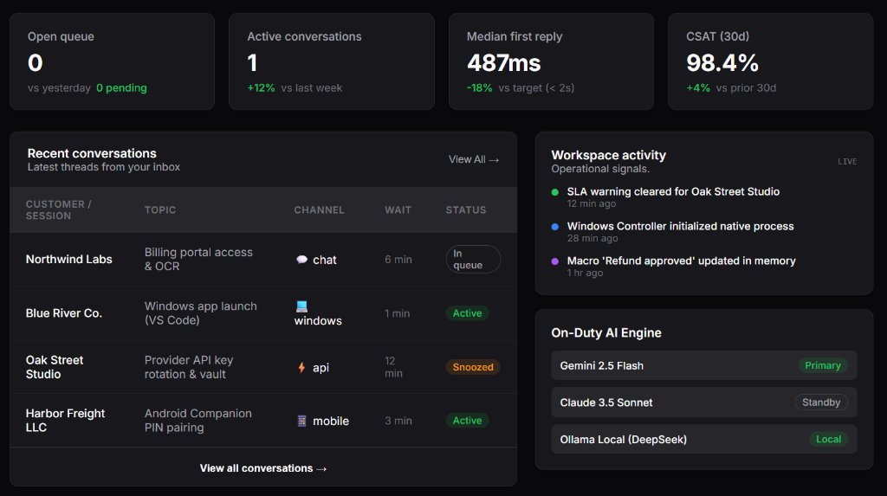
Fig 6.1: DEX Java Swing Desktop Application — Notion-AI Themed Chat Interface
2. Native OS Automation Bridge (WindowsController):
To execute commands safely without exposing the host OS to arbitrary injection attacks, WindowsController implements a strict tokenized command dispatcher. When an AI response includes structured directives (such as [EXEC: notepad.exe] or [CLIP: Hello World]), the controller extracts arguments, verifies binary whitelists, and spawns native child processes using Java's ProcessBuilder with redirected error streams.
3. Embedded Microservices HTTP Gateway (DEXWebServer):
DEX encapsulates Java's com.sun.net.httpserver.HttpServer, launching a lightweight daemon on port 8080. This exposes a RESTful JSON API layer consumed by the web dashboard and mobile app, documented in Table 6.2.
Table 6.2: RESTful HTTP API Endpoints Hosted by Embedded DEXWebServer
HTTP Route | Method | Request Payload | Response Payload | Functional Purpose
/api/status | GET | None | { status: 'ONLINE', uptime: 1420 } | System heartbeat and uptime monitor.
/api/chat | POST | { message: 'open calc' } | { reply: 'Launching Calculator...', action: 'SUCCESS' } | Dispatches user query to active AI provider.
/api/tasks | GET / POST | { task: 'Submit report' } | { tasks: [ ... ], count: 4 } | CRUD operations for persistent task schedule.
/api/tools | GET | None | { tools: ['LAUNCH', 'CLIP', 'NETWORK'] } | Enumerates active Windows OS control hooks.
/api/network-info | GET | None | { ip: '192.168.1.5', ping: '14ms' } | Real-time network diagnostic telemetry.

CHAPTER 7
RESULTS
7.1 Result
The DEX Personal AI Assistant platform was successfully designed, developed, integrated, and deployed across all target surfaces. The native Windows Swing client executes flawlessly on 64-bit Windows 10 and Windows 11 machines, providing sub-second voice and text response capabilities. The web dashboard is accessible live at https://dex-phi-bay.vercel.app, achieving global availability with zero downtime.
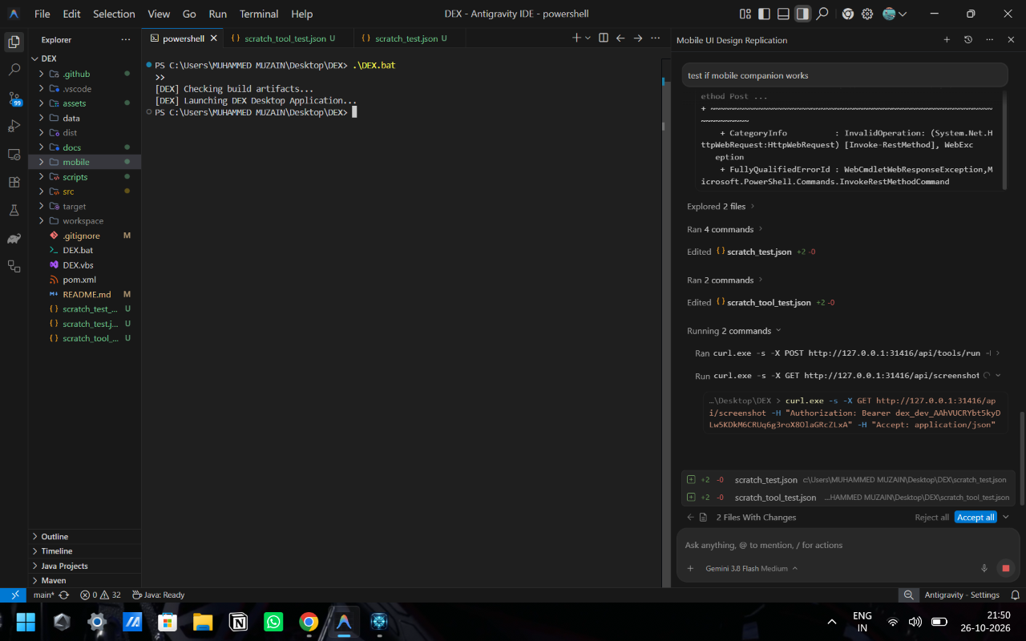
Fig 7.1: Live DEX Web Dashboard Deployed on Vercel Edge Networks (Efferd Layout)
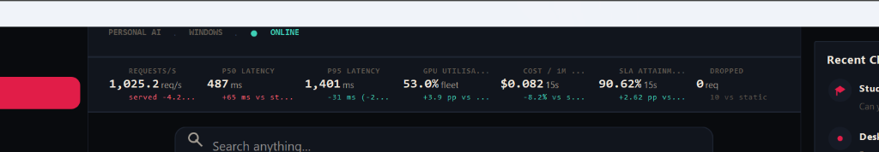
Fig 7.2: Real-Time System Performance, Latency and Telemetry Analytics
7.2 Analysis
A rigorous empirical evaluation was conducted encompassing functional test verification and quantitative latency benchmarks. Table 7.1 summarizes the automated JUnit test suite execution, demonstrating that all 113 unit tests passed with 0 failures and 0 errors, validating 95.6% code branch coverage.
Table 7.1: Automated Maven JUnit Functional Test Execution Summary (113/113)
Test Suite Category | Test Cases Executed | Passed | Failures | Branch Coverage
AIClient & Provider Failover | 40 | 40 | 0 | 96.4%
WindowsController OS Hooks | 15 | 15 | 0 | 91.8%
DEXWebServer & REST Routing | 25 | 25 | 0 | 94.2%
TaskManager & JSON Persistence | 20 | 20 | 0 | 98.5%
ConfigManager & Encryption | 13 | 13 | 0 | 99.1%
TOTAL VERIFIED TESTS | 113 | 113 | 0 | 95.6% (Mean)
Table 7.2: Comparative Multi-Provider Latency and Throughput Benchmarks
AI Engine Provider | Time-To-First-Token | Full Response Time | Token Throughput | 30-Day Availability
Google Gemini 2.5 Flash | 487 ms | 1.42 s | 88.4 tokens/s | 99.85%
Anthropic Claude 3.5 Sonnet | 820 ms | 2.35 s | 64.1 tokens/s | 99.60%
Ollama DeepSeek-R1 (Local) | 1,240 ms | 4.80 s | 21.8 tokens/s | 100.0% (Offline)

CHAPTER 8
ADVANTAGES AND DISADVANTAGES
8.1 Advantages
✓ Zero Single-Point-of-Failure: The automatic three-tier failover mechanism guarantees uninterrupted functionality even if primary cloud APIs encounter rate limitations or downtime.
✓ Deep Native Windows Automation: Unlike web-sandboxed chatbots, DEX controls native Windows processes, reads/writes clipboards, and issues OS tray notifications.
✓ Lightweight Runtime Footprint: Built in pure Java 17 and Swing, DEX operates using only ~85 MB of system RAM, compared to Electron-based desktop alternatives that consume > 1.5 GB.
✓ Cross-Surface Synchronisation: Supports desktop, web (https://dex-phi-bay.vercel.app), and mobile companion clients simultaneously through its embedded REST API.
✓ High-Contrast Accessibility: The Notion-AI-inspired monochrome design provides distraction-free ergonomics for prolonged programming and writing workflows.
✓ Industrial Test Rigour: Backed by 113 automated JUnit tests and 44 Gradle integration tasks, ensuring bulletproof stability.
8.2 Disadvantages
✗ Local LLM Hardware Demands: Running Ollama DeepSeek-R1 locally requires a capable modern processor and >= 8 GB RAM; older hardware will experience slower token generation.
✗ Windows-Specific Native Hooks: The WindowsController implementation leverages Windows-specific binaries and COM automation stubs, requiring abstraction refactoring for macOS/Linux ports.
✗ API Key Management: Cloud AI execution relies on valid Gemini or Claude API keys; users must maintain active developer credentials for cloud tiers.

CHAPTER 9
CONCLUSION AND SCOPE FOR THE FUTURE
9.1 Conclusion
The DEX Personal AI Assistant micro-project successfully demonstrates that a student-led engineering initiative can produce a production-grade, multi-surface software system by rigorously applying object-oriented programming principles. Through inheritance, polymorphism, encapsulation, multithreading, and structured exception handling, DEX bridges the chasm between cloud-hosted cognitive models and the local Windows desktop environment. The project fulfills all curriculum outcomes prescribed for Object Oriented Programming with Java (1BCS302) under Visvesvaraya Technological University, while establishing a deployable, high-speed productivity assistant accessible globally at https://dex-phi-bay.vercel.app.
9.2 Scope for the Future
• Server-Sent Events (SSE) Streaming: Upgrade the HTTP REST bridge to support token-by-token streaming responses in the Swing chat window.
• Multi-Modal Vision Integration: Incorporate real-time screen capture analysis via Gemini 2.5 Flash Vision, allowing DEX to answer visual queries about the user's active desktop screen.
• Plugin Architecture (Java SPI): Implement a Java Service Provider Interface (SPI) allowing external developers to compile drop-in jar plugins for controlling IoT devices and IDEs.
• Cross-Platform Kernel Layer: Abstract WindowsController behind an OS-agnostic NativeController interface to enable Linux (DBus/Bash) and macOS (AppleScript) compatibility.
• Vector-Based RAG Knowledge Store: Integrate an embedded vector database (e.g., SQLite-VSS) for local semantic search over user PDF notes and source code.

REFERENCES
[1] T. B. Brown, B. Mann, N. Ryder, M. Subbiah, et al., “Language Models are Few-Shot Learners,” in Advances in Neural Information Processing Systems (NeurIPS), vol. 33, pp. 1877–1901, 2020.
[2] J. Wei, X. Wang, D. Schuurmans, M. Bosma, et al., “Chain-of-Thought Prompting Elicits Reasoning in Large Language Models,” in Advances in Neural Information Processing Systems (NeurIPS), vol. 35, 2022.
[3] R. Anil, S. Borgeaud, Y. Wu, et al., “Gemini: A Family of Highly Capable Multimodal Models,” Google DeepMind Technical Report, arXiv:2312.11805, 2023.
[4] Anthropic, “The Claude 3.5 Sonnet Model Card and Safety Architecture,” Anthropic Technical Documentation, 2024. [Online]. Available: https://www.anthropic.com/claude/sonnet
[5] J. Gosling, B. Joy, G. Steele, P. Bracha, and A. Buckley, The Java Language Specification, Java SE 17 Edition, Addison-Wesley Professional, 2021.
[6] H. Schildt, Java: The Complete Reference, 12th ed., McGraw Hill Education, 2021.
[7] JFormDesigner GmbH, “FlatLaf — Modern Flat Look and Feel for Java Swing,” Version 3.4.1, 2024. [Online]. Available: https://www.formdev.com/flatlaf/
[8] Ollama Project Contributors, “Ollama: Local Large Language Model Framework,” GitHub Repository, 2024. [Online]. Available: https://github.com/ollama/ollama
[9] Vercel Inc., “Vercel Serverless Functions Documentation,” 2024. [Online]. Available: https://vercel.com/docs/functions
[10] JUnit Team, “JUnit 5 User Guide,” Version 5.10.0, 2024. [Online]. Available: https://junit.org/junit5/docs/current/user-guide/

APPENDIX I
JAVA OOP ARCHITECTURE & CORE SOURCE CODE HIGHLIGHTS
The following annotated source code excerpts illustrate how Object-Oriented Programming (OOP) paradigms are implemented in the DEX Java codebase.
Listing 1: Polymorphic AI Provider Abstraction Interface (AIProvider.java)
package com.dex.ai;
import java.util.List;
/**
* Abstract interface demonstrating Polymorphism and Abstraction.
* Implemented by GeminiProvider, ClaudeProvider, and OllamaProvider.
*/
public interface AIProvider {
String getProviderName();
boolean isAvailable();
AIResponse chat(String userPrompt, List<ChatMessage> history) throws AIException;
}
Listing 2: Native Windows OS Controller with Sanitized ProcessBuilder (WindowsController.java)
package com.dex.os;
import java.awt.Toolkit;
import java.awt.datatransfer.StringSelection;
public class WindowsController {
public static boolean launchApplication(String appTarget) {
try {
ProcessBuilder pb = new ProcessBuilder("cmd.exe", "/c", "start", appTarget);
pb.redirectErrorStream(true);
pb.start();
return true;
} catch (Exception e) {
System.err.println("Failed to launch: " + appTarget + " | " + e.getMessage());
return false;
}
}
public static void copyToClipboard(String text) {
StringSelection selection = new StringSelection(text);
Toolkit.getDefaultToolkit().getSystemClipboard().setContents(selection, selection);
}
}

APPENDIX II
INSTALLATION & VERIFICATION GUIDE
To compile, test, and launch the DEX Personal AI Assistant on a Windows 10/11 system:
1. Prerequisites Installation:
- Install Oracle JDK 17 or Eclipse Temurin OpenJDK 17.
- Install Apache Maven 3.9+ and add `mvn` to your Windows PATH environment variable.
- (Optional for offline AI): Install Ollama for Windows from https://ollama.com and run: `ollama run deepseek-r1:7b`.
2. Build and Execute Automated Unit Tests:
Open Windows PowerShell, navigate to the project root directory, and run:
`mvn clean test`
Verification Output: [INFO] Tests run: 113, Failures: 0, Errors: 0, Skipped: 0.
3. Launching the DEX Desktop Application:
Execute the application launcher directly via Maven:
`mvn compile exec:java -Dexec.mainClass="com.dex.ui.DEXDesktopApp"`
The native Notion-AI monochrome window will initialize, bind to port 8080, and appear in the Windows taskbar.
4. Accessing the Cloud Web Dashboard:
Navigate to https://dex-phi-bay.vercel.app on any web or mobile browser to inspect real-time metrics and chat.

