Name: Muzaffar Ali Reg. No:. 04072313007

SETUP :

// lab3.dart - Campus Cafe Order System
// Name: ____________________ Roll no: ____________
const String rollNo = 'YOUR-ROLL-NO-HERE'; // e.g. '2100672347'
// ===== Seeded settings (generated from YOUR roll number). Do not edit. =====
final int seed = int.parse(rollNo.substring(rollNo.length - 2));
final int t = seed ~/ 10; // tens digit
final int u = seed % 10; // units digit
const List<String> menu = [
'Chai', 'Latte', 'Mocha', 'Samosa', 'Brownie',
'Sandwich', 'Cold Coffee', 'Fries', 'Pakora', 'Zinger Wrap',
];
int priceOf(int i) => 100 + 7 * i + 3 * t; // price of menu[i], in rupees
final int priceFloor = 60 + 5 * t;
final int taxPercent = 5 + t;
final int bigOrderLimit = 450 + 20 * t;
final int balanceCap = 600 + 20 * t;
final int couponPercent = 5 + t + u;
// ===========================================================================
void main() {
print('Seed: $seed (t=$t, u=$u)');
step1();
step2();
step3();
step4();
step5();
step6();
step7();
step8();
step9();
step10();
}
void step1() { print('--- Step 1 ---'); }
void step2() { print('--- Step 2 ---'); }
void step3() { print('--- Step 3 ---'); }
void step4() { print('--- Step 4 ---'); }
void step5() { print('--- Step 5 ---'); }
void step6() { print('--- Step 6 ---'); }
void step7() { print('--- Step 7 ---'); }
void step8() { print('--- Step 8 ---'); }
void step9() { print('--- Step 9 ---'); }
void step10() { print('--- Step 10 ---'); }
STEP 1:
class Dish {
late String name;
late int price;
}

void step1() {
print('--- Step 1 ---');

final item1 = Dish()
..name = menu[u]
..price = priceOf(u);

final item2 = Dish()
..name = menu[(u + 1) % 10]
..price = priceOf((u + 1) % 10);

item2.price = item2.price - u;

print('Step 1: ${item1.name} Rs ${item1.price}');
print('Step 1: ${item2.name} Rs ${item2.price}');
}

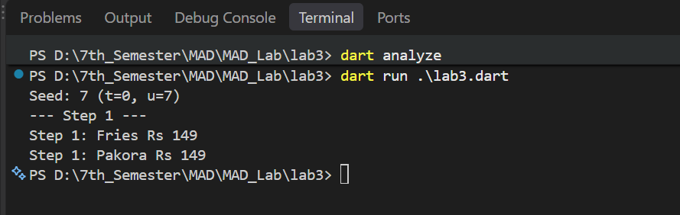
STEP 2:

class MenuItem {
String name;
int price;

MenuItem(this.name, this.price) {
if (this.price < priceFloor) {
this.price = priceFloor;
}
}
}
void step2() {
print('--- Step 2 ---');
final a = MenuItem(menu[u], priceOf(u));
final b = MenuItem('Test Special', 15 * u);

print('Step 2: ${a.name} Rs ${a.price}');
print('Step 2: Test Special Rs ${b.price}');
}

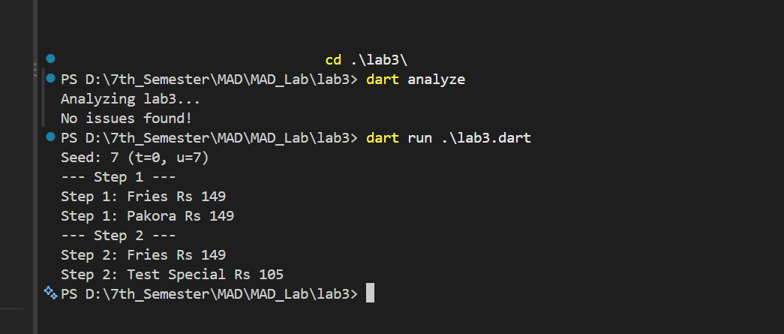

STEP 3:
class MenuItem {
String name;
int price;

MenuItem(this.name, this.price) {
if (this.price < priceFloor) {
this.price = priceFloor;
}
}

MenuItem.free(this.name) : price = 0;

MenuItem.fromString(String text)
: name = text.split(':')[0],
price = int.parse(text.split(':')[1]);

@override
String toString() => '$name (Rs $price)';
}

void step3() {
print('--- Step 3 ---');

final freebie = MenuItem.free('Water');
final i = (u + 2) % 10;
final parsed = MenuItem.fromString(
'${menu[i]}:${priceOf(i)}',
);

print('Step 3: ${freebie.name} Rs ${freebie.price}');
print('Step 3: ${parsed.name} Rs ${parsed.price}');
print('Step 3: floor=$priceFloor, free price=${freebie.price}');
}

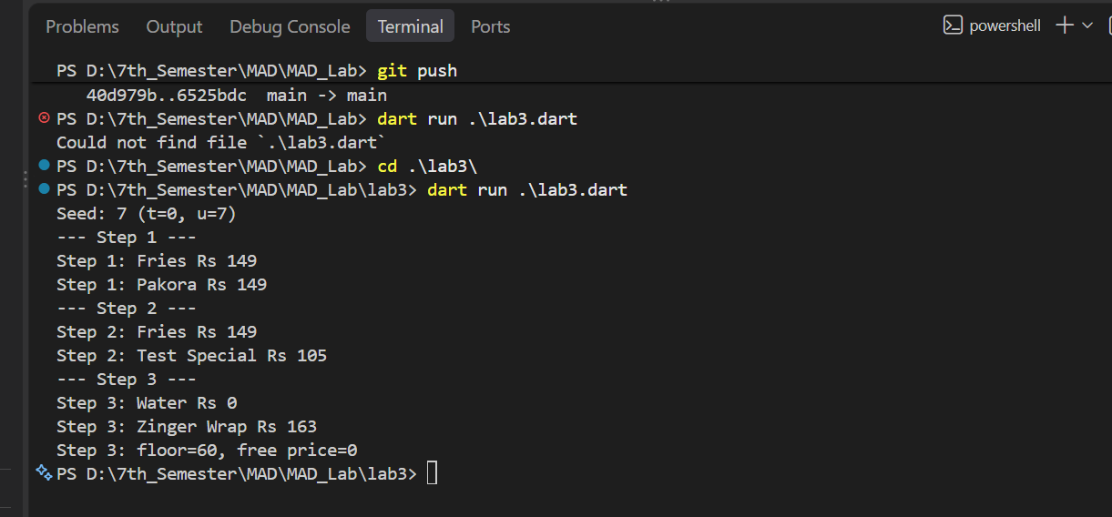

STEP 4:

class OrderLog {
static OrderLog? _instance;
final List<String> entries = [];

OrderLog._internal();

factory OrderLog() {
return _instance ??= OrderLog._internal();
}

void add(String msg) => entries.add(msg);
}

void step4() {
print('--- Step 4 ---');

final log1 = OrderLog();
final log2 = OrderLog();

for (int i = 1; i <= u + 2; i++) {
final message = 'order #${100 * t + i}';

if (i.isOdd) {
log1.add(message);
} else {
log2.add(message);
}
}
print('Step 4: same object? ${identical(log1, log2)}');
print('Step 4: entries = ${log1.entries.length}');
print('Step 4: last = ${log2.entries.last}');
}

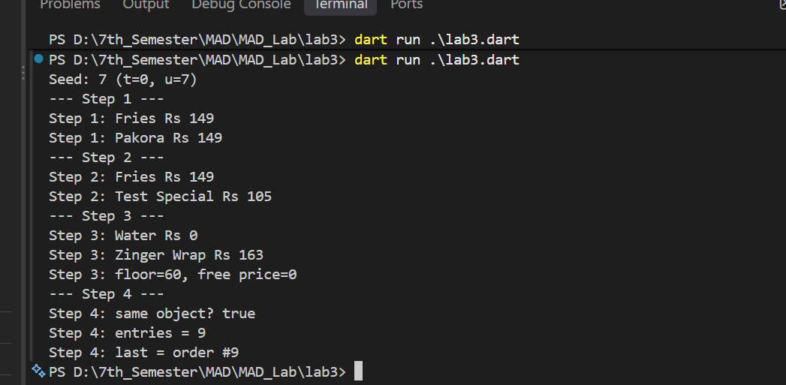

STEP 5:
class OrderLine {
final MenuItem item;
final int qty;
final int total;
final int tax;

OrderLine(this.item, this.qty)
: total = item.price * qty,
tax = item.price * qty * taxPercent ~/ 100,
assert(qty > 0, 'qty must be positive');
}

OrderLine mainOrder() {
return OrderLine(
MenuItem(menu[u], priceOf(u)),
2 + (t + u) % 5,
);
}

void step5() {
print('--- Step 5 ---');

final line = mainOrder();

print('Step 5: ${line.item.name} x${line.qty}');
print('Step 5: total=${line.total} tax=${line.tax}');

try {
OrderLine(line.item, 0);
print('Step 5: assert did NOT fire');
} on AssertionError {
print('Step 5: assert fired');
}
}

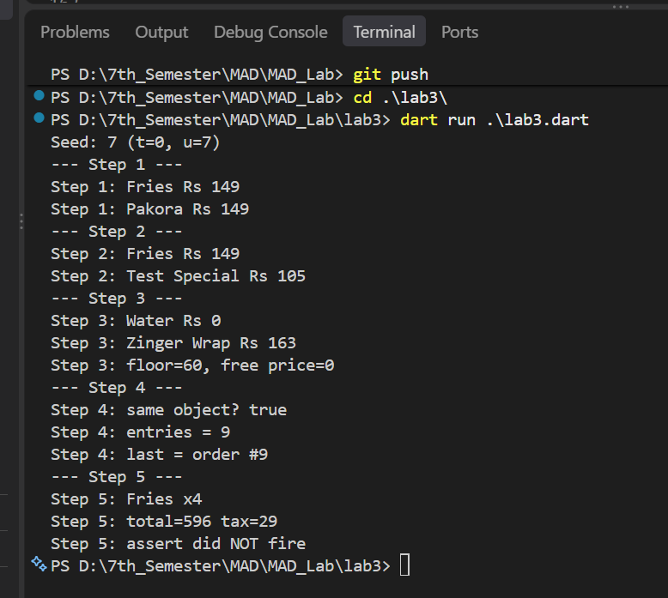

STEP 6:
extension OrderLineGetters on OrderLine {
int get grand => total + tax;

bool get isBigOrder => grand > bigOrderLimit;

String get label => '${item.name} x$qty';
}

void step6() {
print('--- Step 6 ---');

final line = mainOrder();

print('Step 6: grand=${line.grand}');
print(
'Step 6: big order? ${line.isBigOrder} (limit $bigOrderLimit)',
);
print('Step 6: label=${line.label}');
}

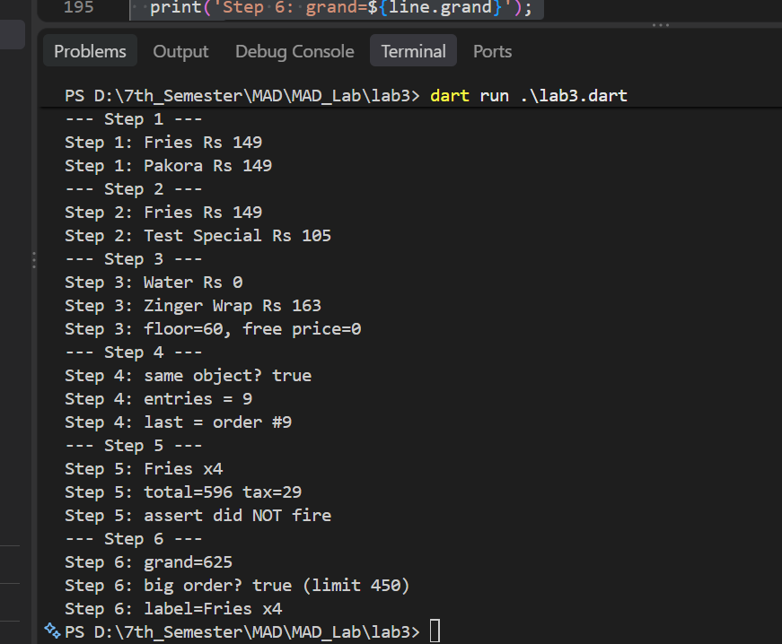

STEP 7:
class StudentCard {
final String owner;
int _balance;

StudentCard(this.owner) : _balance = 0;

int get balance => _balance;

set balance(int v) {
if (v < 0) {
_balance = 0;
} else if (v > balanceCap) {
_balance = balanceCap;
} else {
_balance = v;
}
}
}

void step7() {
print('--- Step 7 ---');

final card = StudentCard('S$seed');

card.balance = seed * 10 + 50;
print('Step 7: topped up -> ${card.balance}');

card.balance = -seed - 1;
print('Step 7: bad value -> ${card.balance}');

card.balance = balanceCap - u;
print('Step 7: reset -> ${card.balance}');

card.balance = card.balance - mainOrder().grand;
print('Step 7: paid order -> ${card.balance}');
}

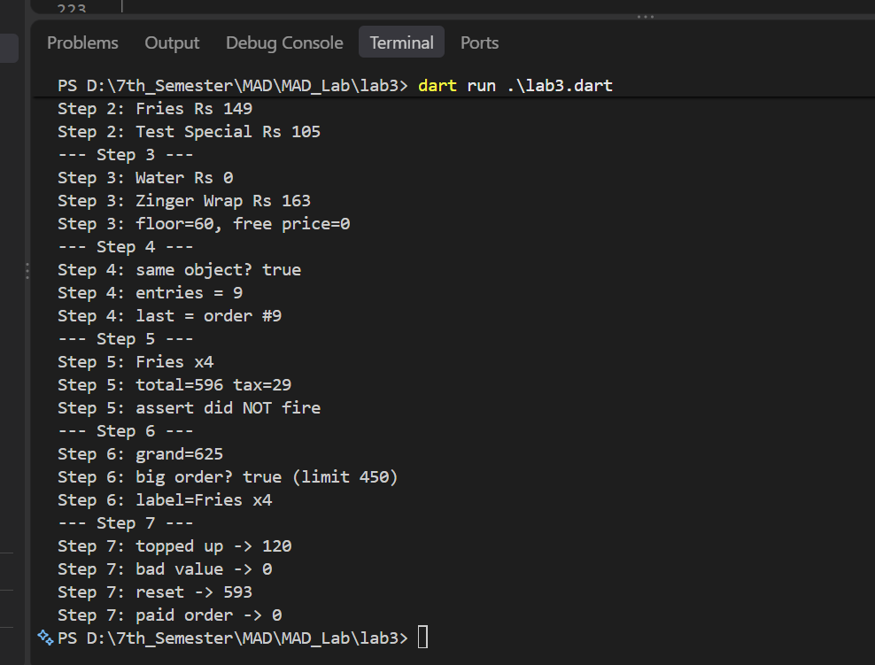

STEP 8:

