**MUZAFFER NIZAM**

Antalya, TURKEY

+90 536 222 90 10

[muzaffernizam@gmail.com](mailto:muzaffernizam@gmail.com)

**PROFILE**

Senior in Industrial Electronics, Lift Control, Robotics, Consumer Electronics, Automotive, Biomedical. An enthusiastic and ambitious engineer. Willing to work with different projects. Team worker and researcher. Experienced electronics design engineer with a demonstrated history of working in R&D Departments for more than 7 years. Skilled in Digital and Analog electronics design. Strong engineering professional with a bachelor’s degree focused in Electrical and Electronic Engineering from Akdeniz University.

**PERSONAL DETAILS**

**Eligible to work in:** Need to Visa

**Industry:** Industrial Electronics, Lift Control, Robotics, Consumer Electronics, Automotive, Biomedical, Railway.

**Total years of experience:** 7 Years 2 Months

**WORK EXPERIENCE**

1. **Electronics R&D Engineer ( 1 Years )** April 2022 - Present

**Company:** Acri Industrial LTD ŞTİ

**<https://www.acritechnology.com/>**

**Job Definition:**

**Hardware Designed below projects;**

* Lift DC Door Control Driver Board Design,
* Remote control with GSM Communication Card Design,
* Various Lift Control Boards Design,
* Elevator Main Control, Cabin Buttons Boards, Top and Bottom of Cabinet Boards, Floor Calling Boards which is communicating with CAN Bus and DC and AC signal Lines,
* Test Machine Design contains with Pogo Test Probe Tips
* Hand terminal Board design. To perform OTA update using GSM and LTE Moduls,
* In addition in relevant projects doing Hardware Designs(Schematic and PCB), Measuring, Reports and Tests,
* Designed with TM4Cxx Ti, STM32xx,Quectel MC60xx GSM module, Quectel EC200xx and Quectel EG915xx LTE module

1. **Electronics R&D Engineer ( 1 Years 1 Months 19 Days)** February 2021- April 2022

**Company:** Ake Elevator and Escalator LTD

**<https://ake.com.tr/>**

**Job Definition:**

**Hardware Designed below projects;**

* Lift DC Door Control Driver Board Design,
* Remote control with GSM Communication Card Design,
* Various Elevator Control Boards Design,
* Water Vending Control Boards Design,
* Elevator Main Control, Cabin Buttons Boards, Top and Bottom of Cabinet Boards, Floor Calling Boards which is communicating with CAN Bus and DC and AC signal Lines,
* In addition in relevant projects doing Hardware Designs(Schematic and PCB), Measuring, Reports and Tests,
* Designed with TM4Cxx Ti, MSP432xx ARM Core, MSP430xx Ti, Quectel MC60xx GSM module

1. **Electronics R&D Engineer ( 2 Years 8 Months 15 Days)** May 2018- February 2021

**Company:** Desird Tasarım Arge A.Ş. (Same Company previous one, but Commercial Title of Company changed)

**<https://desird.com/>**

**Job Definition:**

**Hardware Designed below projects;**

* Lift BLDC Door Control Driver Board Design,
* Various IOT Projects,
* Test Equipment Design contains with Pogo Test Probe Tip,
* Railway BLDC Door Control and Safety Boards which has Safety Relay and compatible relevant SIL Certificate,
* In addition in relevant projects doing Hardware Designs(Schematic and PCB), Measuring, Reports and Tests,
* Designed with STM32xx, STM8xx, NXP MCU’s, PIC16xx MCU’s

**Electronics R&D Engineer ( 2 Years 4 Months)** August 2015- October 2017

**Company:** Desird Tasarım Arge Uygulama Elekt. Des. İth. İhr. San LTD ŞTİ

**<https://desird.com/>**

**Job Deification:**

**Hardware Designed below projects;**

* Biomedical Electronic Card Design,
* Lift DC Door Control Driver Board Design,
* Various IOT Projects,
* Telemetry Card Designs with FSK communication on DC Power Line,
* Main Board Designed which is communicating with Telemetry Card,
* Test Machine Design, contains with Pogo Test Probe Tip,
* In addition in relevant projects doing Hardware Designs(Schematic and PCB), Measuring, Reports and Tests,
* Designed with STM32xx, CC13xx Ti MCU’s, PIC18xx MCU’s

1. **Electrical & Electronics Engineer Intern ( 3 Months)** June 2013- September 2013

**Company:** Turkcell Communication A.Ş.

**<https://www.turkcell.com.tr/>**

**Job Deification:**

* GSM Base Station Location Planning,
* Various Technical Calculating,
* Field operations.

**EDUCATION AND TRAINING**

**Bachelor's of Science, Electrical & Electronics Engineering Oct. 2016**

Akdeniz University

<https://www.akdeniz.edu.tr/>

**British Culture Language Schools , English Mar. 2023**

B2-Upper Intermediate

**Certificate Code:** 8882201740

<https://verifiedportfolios.com/>

**TECHNICAL PROFICIENCIES**

Digital Competence;

• Good command of Microsoft Office tools (Word, Excel, PowerPoint)

• Good command of software (Altium, Kicad, LTSpice, Matlab, Gerbv, Trello, Github, yEd, Visual Studio , Visual Studio Code, STM32CubeIDE, Code Composer Studio )

• Good command of Operating System (Windows, Linux-Ubuntu)

**INTEREST**

I am passionate about keeping abreast with recent development in the technology. My hobbies are Latin Dances (Salsa & Bachata), Theater, Chess.

**Certificate & Note of Accession**

* Safety Integrity Level for RAILWAY SYSTEM ELECTRONICS - **TUV NORD** April 2019
* Humanoid Robots Industrial Automation - **ENTEK EDUCATION TECH.** December 2012

**Hardware Competence;**

* Planning Design Block Diagram by various Programs such as yEd,
* Simulation by LTSpice and modelling by Matlab Simulink,
* Schematic and PCB design by Altium, Kicad and Eagle EDA,
* Pin assignment according to role such as various communication, input, output, PWM, Analog Inputs etc.
* Design Compliant with IPC-2221 Electrical Conductor Spacing Standards and EMC Standards,
* Design Compliant with in Environmental Temperatures and Pressure,
* Multi layer PCB Design 2,4 and more Layers by following Layer Stack Management,
* Decide PCB types according to different temperatures density PCB Materials such as FR-4 TG 130-140, TG 170 etc,
* Calculation Power Consumption by Excel,
* Creating Symbol and Footprint Library Design Compliant according to IPC standards,
* Various Design with STM32xx, CC13xx Ti, TM4Cxx Tiva Series MCU, RK3399 etc,
* Various Communication Board Design with Quectel MC60xx GSM module, Quectel EC200xx LTE module, Quectel EG915xx LTE module,
* Power Circuit Designs with Switching Regulator, Switching Controller, PMIC etc,
* DC, BLDC, PMSM, Motor Control Drivers Designs with discrete mosfets and gate drivers, IPM Modules,
* Digital Circuit Designs such as SPI, I2C, DAC, RS485, UART, Ethernet, CAN Bus,
* Wireless Communication Design such as GSM, GNSS, Bluetooth, RF Sub 1 GHz, Wifi 2.4 GHz,
* ADC, DAC, FSK Communication on Power Line, various Active and Passive Filter design,
* Creating PBA and PCB Production Files, Gerber Files, Pick and Places Files, DXF and Step files for Mechanical Design,
* Controlling PCB Production datas with GERBV (free Gerber viewer), compare stencil and panelized PCB,
* Prepare Bill of Materials List.
* Version Control with github.
* Measurement with Oscilloscope and Report,
* Environmental Test such as Temperature, Pressure, ESD Gun etc,

**Firmware Competence;**

* Generating code with STM32CubeIde and prepare low level driver library.
* Hardware Verification with Firmware .
* Firmware Testing with pooling mode, Interrupt and DMA,
  + UART/USART Communication,
  + Modbus,
  + Can Bus Communication,
  + SPI, I2C Communication,
  + ADC Input,
  + DAC Output,
  + PWM Generation,
  + General Inputs and Outputs,

**Some examples of my Personal Design Project;**

* It is called STM32 Mega Development Board
* Contains Technologies as a below;
* Power Input: 24V AC or DC ,
* 2 different Switching Regulator for GSM and General System Power as 4.3V and 5V,
* Controlling GSM Power with XOR Gate and Transistor,
* Analog Bus Voltage Read with Buffer Opamp (Rail to Rail),
* DAC Output,
* Voltage levels are 24V, 15V, 5V, 4.3V,3.3V,
* USART communication with USB Mini also contains Programming,
* CAN Bus Communication,
* RS485 Communication,
* SPI and I2 Communication connected to Connectors,
* SD Memory Card communicated with SPI Interface,
* 16x2 Character LCD Display communicated with I2C Interface,
* FLASH Memory communicated with I2C Interface
* Non-Isolated Signal Input,
* Analog Read with Linear Potentiometer,
* Between Range of 0V to 600V DC Voltage Read with op amp,
* Between Range of 0-10A Current Read with op amp,
* Short Circuit Detection,
* DC and BLDC Motor Control Driver Circuit with Back EMF Current Reading,
* Encoder Input (Absolute and Incremental)
* 16 Channel Isolated Input detected with Shift Register Input,
* Accelerometer (ADXL345 IC) communicated with SPI,
* 4 Buttons for LCD Controlling,
* 24V Relay Output (SPDT 1 FORM C),
* SIM800C GSM Modul communicated with SPI Interface

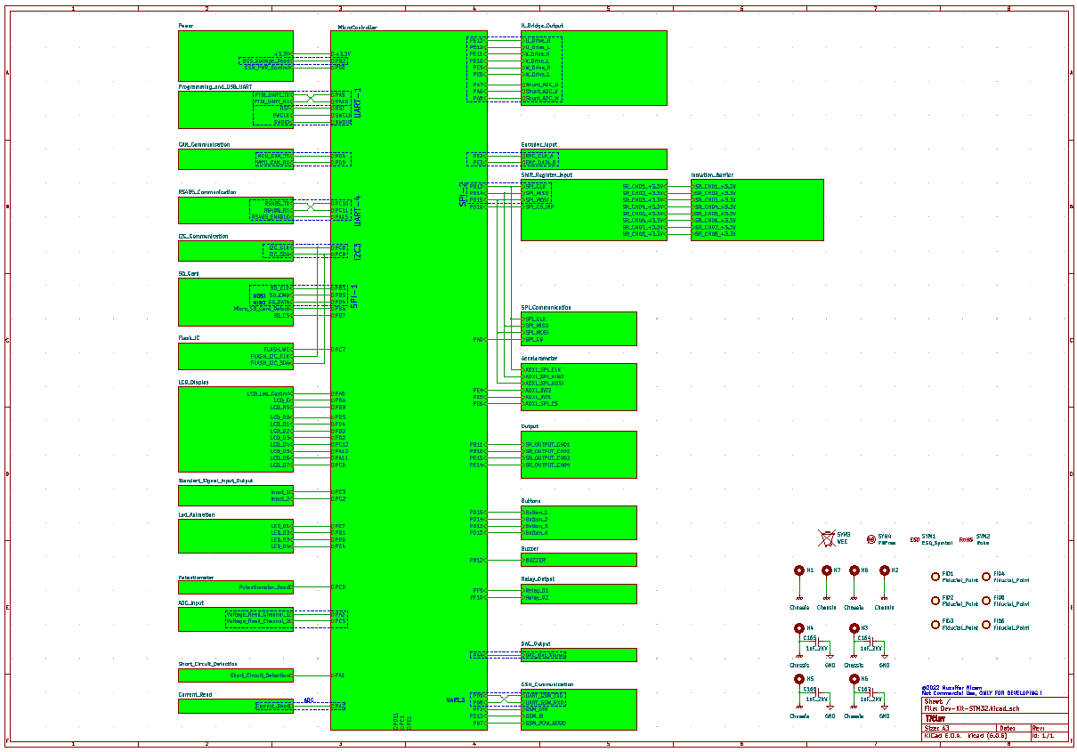

**Figure 1 :** Schematic Design Type

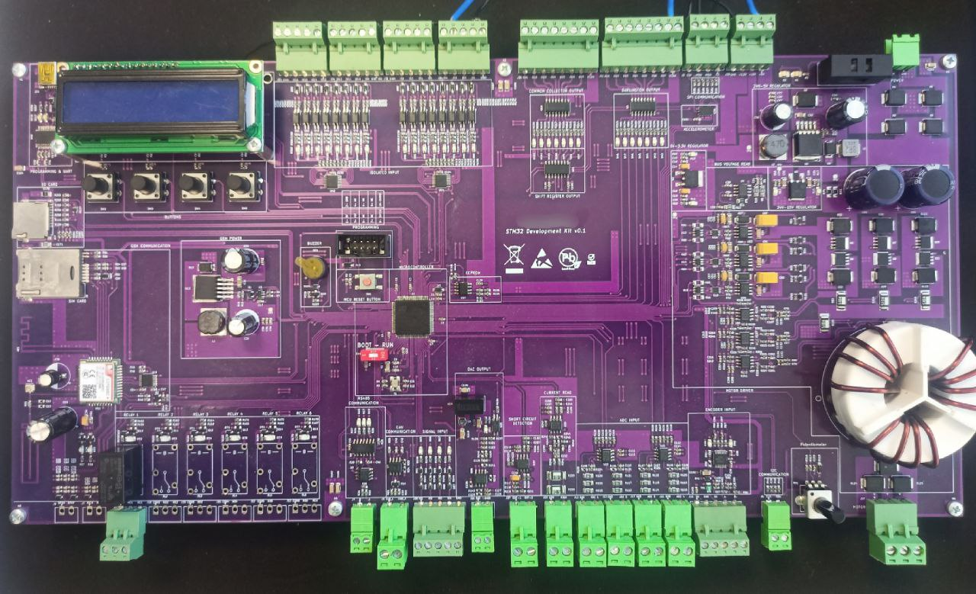

**Figure 2 :** STM32 MEGA Development Board

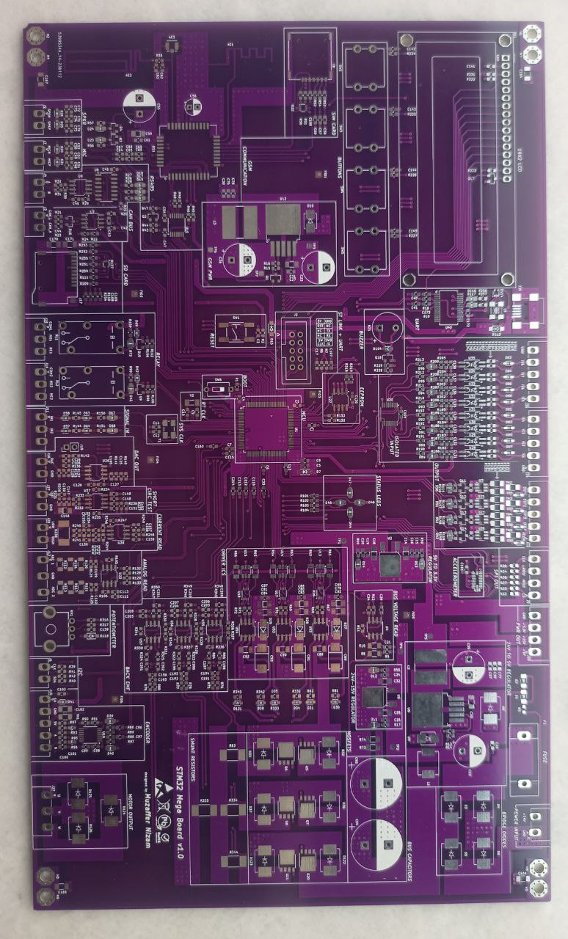

**Figure 3 :** STM32 MEGA Development Board (another version)