**MUZAFFER NIZAM**

Caybasi, 1346 St, Antalya, Turkey ●+90 (536) 222 90 10 ● [muzaffernizam@gmail.com](mailto:muzaffernizam@gmail.com)

**Education and Training**

**Bachelor's of Science, Electrical & Electronics Engineering** October. 2016

**Akdeniz University**

<https://eng.akdeniz.edu.tr/>

**British Culture Language Schools , English** March. 2023

**B2-Upper Intermediate**

**Certificate Code:** 8882201740

<https://verifiedportfolios.com/>

**Technical Competence**

* Project Management
* Altium, Kicad, Eagle EDA, LTSpice, Matlab, Gerbv, Visual Studio , Visual Studio Code, STM32CubeIDE, Code Composer Studio, Github, yEd, Trello.
* Programming Skills C/C#

**Accomplishments**

* I worked on many projects in all processes from idea to mass production and managed all processes.

**Professional Experience**

1. **Sr. Hardware Design Engineer,** April 2022-Present

**Company:** Acri Industrial LTD

**Location:** Antalya, Turkey

<https://www.acritechnology.com/>

* Worked on these Projects; Lift DC Door Control Driver project, Tracker Fault Errors and Remote Control with LTE Project, Lift Main Control Board , Test Machine Main Board for Manufacturing,
* Designed with TM4Cxx, Quectel EC200xx and Quectel EG915xx LTE Module,
* Designed , developed prototype and mass production board level analogue and digital electronic communication circuits and systems.

1. **Sr. Hardware Design Engineer,** February 2021-March 2022

**Company:** Ake Elevator and Escalator LTD

**Location:** Antalya, Turkey

<https://ake.com.tr/>

* Worked on these Projects; Lift DC Door Control Driver project, Tracker Fault Errors and Remote Control with GSM Project, Lift Cabinet Button Main Board , Top and Bottom Lift Cabinet Boards, Floor Calling Boards, Water Vending Control Boards, Escalator Doppler Radar Projects,
* Designed with TM4Cxx, MSP432xx, MSP430xx, Quectel MC60xx GSM module,
* Designed , developed prototype and mass production board level analogue and digital electronic communication circuits and systems.

1. **Mid. Hardware Design Engineer,** May 2018- February 2021

**Company:** Desird Tasarım Arge A.S.

**Location:** Antalya, Turkey

<https://desird.com/en/>

* Worked on these Projects; Test Machine Main Board for manufacturing, Lift BLDC Door Control Driver project, Linear Motor Projects for Lift Motors, Railway Peron Separator BLDC Door Control with Safety Relay (SIL-2 certified),
* Designed with STM32xx, STM8xx,
* Designed , developed prototype and mass production board level analogue and digital electronic communication circuits and systems,

1. **Jr. Hardware Design Engineer,** August 2015- October 2017

**Company:** Desird Tasarım Arge Uygulama Elekt. Des. Ith. Ihr. San LTD STI

**Location:** Antalya, Turkey

<https://desird.com/en/>

* Worked on these Projects; Lengthening Nails (Biomedical), IOT projects (Consumer Electronics), Telemetry Projects (Energy Services), Test Machine Main Board for manufacturing, Lift DC Door Control Driver project.
* Designed with STM32xx, CC13xx Ti MCU’s, PIC18xx MCU’s,
* Designed , developed prototype and mass production board level analogue and digital electronic communication circuits and systems,
* Developed cost effective test methods and low-level software to automate the hardware testing procedures,
* Mixed signal analysis on projects and tested for errors in hardware and software,
* Validated and tested designs for functionality and power efficiency,
* Supported senior engineers with design specifics, parameters and design trade off,
* Researched and designed necessary filtering, amplification, and control circuits for projects assigned to to me,
* Wrote test benches and performed simulations for design verification and optimising,
* Directed technicians with PCB design, layout issues, and testing,
* Assisted to senior engineers in product design reviews, and in conferences regarding hardware design and performance.

1. **Electrical & Electronics Engineer Intern,** June 2013- September 2013

**Company:** Turkcell Communication A.S.

**Location:** Antalya, Turkey

<https://www.turkcell.com.tr/>

* Worked on GSM Base Station Location Planning,
* Various Technical Calculating with Excel Macro,
* Analysis GSM Base Station’s Signal Data,
* Assisted to senior engineers in Field operations.

**Hardware Competence**

* Planning Design Block Diagram by various Programs such as yEd,
* Simulation by LTSpice and modelling by Matlab Simulink,
* Schematic and PCB design by Altium, Kicad and Eagle EDA,
* Pin assignment according to role such as various communication, input, output, PWM, Analogue Inputs etc.
* Design Compliant with IPC-2221 Electrical Conductor Spacing Standards and EMC Standards,
* Design Compliant with in Environmental Temperatures and Pressure,
* Multi layer PCB Design 2,4 and more Layers by following Layer Stack Management,
* Decide PCB types according to different temperatures density PCB Materials such as FR-4 TG 130-140-170 etc,
* Calculation Power Consumption by Excel,
* Creating Symbol and Footprint Library Design Compliant according to IPC standards,
* Various Design with STM32xx, CC13xx Ti, TM4Cxx Tiva Series MCU, RK3399 etc,
* Various Communication Board Design with Quectel MC60xx GSM Module, Quectel EC200xx LTE Module, Quectel EG915xx LTE module,
* Power Circuit Designs with Switching Regulator, Switching Controller, PMIC etc,
* DC, BLDC, PMSM, Motor Control Drivers Designs with discrete mosfet and gate driver, IPM Module,
* Digital Circuit Designs such as SPI, I2C, DAC, RS485, UART, Ethernet, CAN Bus,
* Wireless Communication Design such as GSM, GNSS, Bluetooth, RF Sub 1 GHz, 433 MHz, Wifi 2.4 GHz,
* ADC, DAC, FSK Communication on Power Line, various Active and Passive Filter design,
* Creating PBA and PCB Production Files, Gerber Files, Pick and Places Files, DXF and Step files for Mechanical Design,
* Controlling PCB Production data with GERBV (free Gerber viewer), compare stencil and panelized PCB,
* Prepare Bill of Materials List,
* Version Control with Github,
* Measurement with Oscilloscope and Report,
* Environmental Test such as Temperature, Pressure, ESD Gun etc.

**Firmware Competence**

* Generating code with STM32CubeIde and prepare low level driver library,
* Hardware Verification with Firmware,
* Firmware Testing with pooling mode, Interrupt and DMA,
  + UART/USART Communication,
  + Mod Bus ,CAN Bus Communication,
  + SPI, I2C Communication,
  + Analogue Input,
  + DAC Output,
  + PWM Generation,
  + General Inputs and Outputs.

**Certificate & Note of Accession**

* ✓Safety Integrity Level for RAILWAY SYSTEM ELECTRONICS - TUV NORD April 2019
* ✓Humanoid Robots Industrial Automation - ENTEK EDUCATION TECH. December 2012

**Interest**

I am passionate about keeping abreast with recent development in the technology. My hobbies are Latin Dances (Salsa & Bachata), Theatre, Chess.

**Some examples of my Personal Design Project**

* It is called STM32 Mega Development Board
* Contains Technologies as a below;
  + Power Input: 24V AC or DC ,
  + 2 different Switching Regulator for GSM and General System Power as 4.3V and 5V,
  + Controlling GSM Power with XOR Gate and Transistor,
  + Analogue Bus Voltage Read with Buffer Op amp (Rail to Rail),
  + DAC Output,
  + Voltage levels are 24V, 15V, 5V, 4.3V,3.3V,
  + USART communication with USB Mini also contains Programming,
  + CAN Bus Communication,
  + RS485 Half Duplex Communication,,
  + SPI and I2 Communication connected to Connectors,
  + SD Memory Card communicated with SPI Interface,
  + 16x2 Character LCD Display communicated with I2C Interface,
  + FLASH Memory communicated with I2C Interface
  + Non-Isolated Signal Input,
  + Analogue Read with Linear Potentiometer,
  + Between Range of 0V to 400V DC Voltage Read with op amp,
  + Between Range of 0-10A Current Read with op amp,
  + Short Circuit Detection,
  + DC and BLDC Motor Control Driver Circuit with Back EMF Current Reading,
  + Encoder Input (Absolute and Incremental)
  + 16 Channel Isolated Input detected with Shift Register Input,
  + Accelerometer (ADXL345 IC) communicated with SPI,
  + 4 Buttons for LCD Controlling,
  + 24V Relay Output (SPDT 1 FORM C),
  + SIM800C GSM Module communicated with SPI Interface

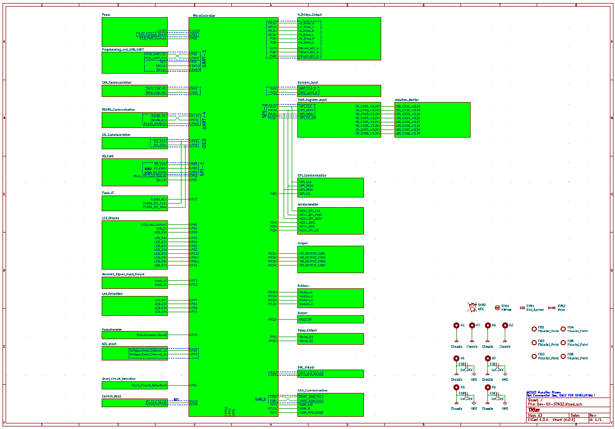

**Table 1:** Schematic Design

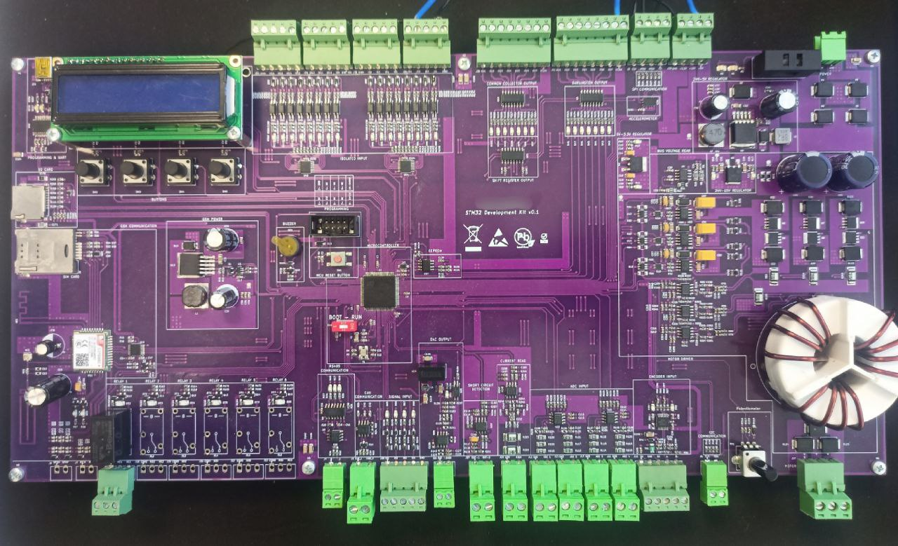

**Table 2:** STM32 MEGA Development Board

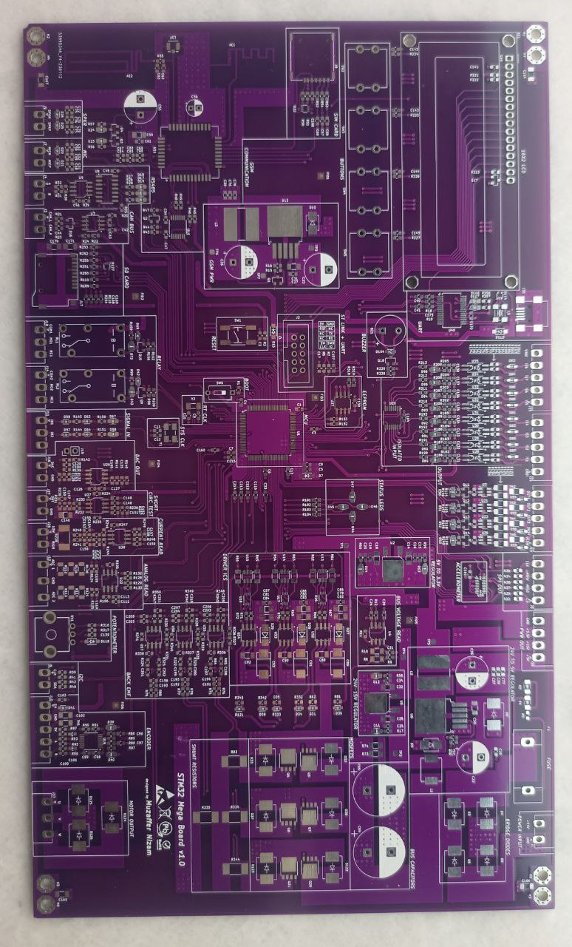

**Table 3:** STM32 MEGA Develoment Board (another version)