**MUZAFFER NIZAM**

Caybasi, 1346 St, Antalya, Turkey ●+90 (536) 222 90 10 ● [muzaffernizam@gmail.com](mailto:muzaffernizam@gmail.com)

**Profile**

Electronic Hardware Design Engineer from 2015 to now. Senior in Industrial Electronic, Lift Control, Robotic, Consumer Electronic, Automotive, and Biomedical. An enthusiastic and ambitious engineer. Willing to work with different projects. Team worker and researcher. Experienced electronics design engineer with a demonstrated history of working in R&D Departments for more than 7 years. Skilled in Digital and Analogue electronics design. Possess the analytical abilities and technical skills necessary for engineering innovative designs and applications. A solid track record of researching, designing, debugging, and producing high precision components and systems. Flexible and focused with an in-depth understanding of electronics engineering theory, industry-standard circuit design, complex design.

**Personal Details**

**Eligible to work in:** Need to Visa

**Industry:** Industrial Electronic, Lift Control, Robotic, Consumer Electronic, Automotive, Biomedical, Railway.

**Total years of experience:** 7 Years 2 Months

**Technical Competence**

* Project Management
* Altium, Kicad, Eagle EDA, LTSpice, Matlab, Gerbv, Visual Studio , Visual Studio Code, STM32CubeIDE, Code Composer Studio, Github, yEd, Trello.
* Programming Skills C/C#

**Accomplishments**

* I worked on many projects in all processes from idea to mass production and managed all processes.

**Professional Experience**

1. **Sr. Hardware Design Engineer,** April 2022-Present

**Company:** Acri Industrial LTD

**Location:** Antalya, Turkey

<https://www.acritechnology.com/>

* Worked on these Projects; Lift DC Door Control Driver project, Tracker Fault Errors and Remote Control with LTE Project, Lift Main Control Board , Test Machine Main Board for Manufacturing,
* Designed with TM4Cxx, Quectel EC200xx and Quectel EG915xx LTE Module,
* Designed , developed prototype and mass production board level analogue and digital electronic communication circuits and systems.

1. **Sr. Hardware Design Engineer,** February 2021-March 2022

**Company:** Ake Elevator and Escalator LTD

**Location:** Antalya, Turkey

<https://ake.com.tr/>

* Worked on these Projects; Lift DC Door Control Driver project, Tracker Fault Errors and Remote Control with GSM Project, Lift Cabinet Button Main Board , Top and Bottom Lift Cabinet Boards, Floor Calling Boards, Water Vending Control Boards, Escalator Doppler Radar Projects,
* Designed with TM4Cxx, MSP432xx, MSP430xx, Quectel MC60xx GSM module,
* Designed , developed prototype and mass production board level analogue and digital electronic communication circuits and systems.

1. **Md. Hardware Design Engineer,** May 2018- February 2021

**Company:** Desird Tasarım Arge A.S.

**Location:** Antalya, Turkey

[www.desird.com](http://www.desird.com)

* Worked on these Projects; Test Machine Main Board for manufacturing, Lift BLDC Door Control Driver project, Linear Motor Projects for Lift Motors, Railway Peron Separator BLDC Door Control with Safety Relay (SIL-2 certified),
* Designed with STM32xx, STM8xx,
* Designed , developed prototype and mass production board level analogue and digital electronic communication circuits and systems,

1. **Jr. Hardware Design Engineer,** August 2015- October 2017

**Company:** Desird Tasarım Arge Uygulama Elekt. Des. Ith. Ihr. San LTD STI

**Location:** Antalya, Turkey

[www.desird.com](http://www.desird.com)

* Worked on these Projects; Lengthening Nails (Biomedical), IOT projects (Consumer Electronics), Telemetry Projects (Energy Services), Test Machine Main Board for manufacturing, Lift DC Door Control Driver project.
* Designed with STM32xx, CC13xx Ti MCU’s, PIC18xx MCU’s,
* Designed , developed prototype and mass production board level analogue and digital electronic communication circuits and systems,
* Developed cost effective test methods and low-level software to automate the hardware testing procedures,
* Mixed signal analysis on projects and tested for errors in hardware and software,
* Validated and tested designs for functionality and power efficiency,
* Supported senior engineers with design specifics, parameters and design trade off,
* Researched and designed necessary filtering, amplification, and control circuits for projects assigned to to me,
* Wrote test benches and performed simulations for design verification and optimising,
* Directed technicians with PCB design, layout issues, and testing,
* Assisted to senior engineers in product design reviews, and in conferences regarding hardware design and performance.

1. **Electrical & Electronics Engineer Intern,** June 2013- September 2013

**Company:** Turkcell Communication A.S.

**Location:** Antalya, Turkey

<https://www.turkcell.com.tr/>

* Worked on GSM Base Station Location Planning,
* Various Technical Calculating with Excel Macro,
* Analysis GSM Base Station’s Signal Data,
* Assisted to senior engineers in Field operations.

**Education and Training**

**Bachelor's of Science, Electrical & Electronics Engineering** October. 2016

**Akdeniz University**

<https://www.akdeniz.edu.tr/>

**British Culture Language Schools , English** March. 2023

**B2-Upper Intermediate**

**Certificate Code:** 8882201740

<https://verifiedportfolios.com/>

**Hardware Competence**

* Planning Design Block Diagram by various Programs such as yEd,
* Simulation by LTSpice and modelling by Matlab Simulink,
* Schematic and PCB design by Altium, Kicad and Eagle EDA,
* Pin assignment according to role such as various communication, input, output, PWM, Analogue Inputs etc.
* Design Compliant with IPC-2221 Electrical Conductor Spacing Standards and EMC Standards,
* Design Compliant with in Environmental Temperatures and Pressure,
* Multi layer PCB Design 2,4 and more Layers by following Layer Stack Management,
* Decide PCB types according to different temperatures density PCB Materials such as FR-4 TG 130-140-170 etc,
* Calculation Power Consumption by Excel,
* Creating Symbol and Footprint Library Design Compliant according to IPC standards,
* Various Design with STM32xx, CC13xx Ti, TM4Cxx Tiva Series MCU, RK3399 etc,
* Various Communication Board Design with Quectel MC60xx GSM Module, Quectel EC200xx LTE Module, Quectel EG915xx LTE module,
* Power Circuit Designs with Switching Regulator, Switching Controller, PMIC etc,
* DC, BLDC, PMSM, Motor Control Drivers Designs with discrete mosfet and gate driver, IPM Module,
* Digital Circuit Designs such as SPI, I2C, DAC, RS485, UART, Ethernet, CAN Bus,
* Wireless Communication Design such as GSM, GNSS, Bluetooth, RF Sub 1 GHz, 433 MHz, Wifi 2.4 GHz,
* ADC, DAC, FSK Communication on Power Line, various Active and Passive Filter design,
* Creating PBA and PCB Production Files, Gerber Files, Pick and Places Files, DXF and Step files for Mechanical Design,
* Controlling PCB Production data with GERBV (free Gerber viewer), compare stencil and panelized PCB,
* Prepare Bill of Materials List,
* Version Control with Github,
* Measurement with Oscilloscope and Report,
* Environmental Test such as Temperature, Pressure, ESD Gun etc.

**Firmware Competence**

* Generating code with STM32CubeIde and prepare low level driver library,
* Hardware Verification with Firmware,
* Firmware Testing with pooling mode, Interrupt and DMA,
  + UART/USART Communication,
  + Mod Bus ,CAN Bus Communication,
  + SPI, I2C Communication,
  + Analogue Input,
  + DAC Output,
  + PWM Generation,
  + General Inputs and Outputs.

**Certificate & Note of Accession**

* ✓Safety Integrity Level for RAILWAY SYSTEM ELECTRONICS - TUV NORD April 2019
* ✓Humanoid Robots Industrial Automation - ENTEK EDUCATION TECH. December 2012

**Interest**

I am passionate about keeping abreast with recent development in the technology. My hobbies are Latin Dances (Salsa & Bachata), Theatre, Chess.

**Some examples of my Personal Design Project**

* It is called STM32 Mega Development Board
* Contains Technologies as a below;
  + Power Input: 24V AC or DC ,
  + 2 different Switching Regulator for GSM and General System Power as 4.3V and 5V,
  + Controlling GSM Power with XOR Gate and Transistor,
  + Analogue Bus Voltage Read with Buffer Op amp (Rail to Rail),
  + DAC Output,
  + Voltage levels are 24V, 15V, 5V, 4.3V,3.3V,
  + USART communication with USB Mini also contains Programming,
  + CAN Bus Communication,
  + RS485 Half Duplex Communication,,
  + SPI and I2 Communication connected to Connectors,
  + SD Memory Card communicated with SPI Interface,
  + 16x2 Character LCD Display communicated with I2C Interface,
  + FLASH Memory communicated with I2C Interface
  + Non-Isolated Signal Input,
  + Analogue Read with Linear Potentiometer,
  + Between Range of 0V to 400V DC Voltage Read with op amp,
  + Between Range of 0-10A Current Read with op amp,
  + Short Circuit Detection,
  + DC and BLDC Motor Control Driver Circuit with Back EMF Current Reading,
  + Encoder Input (Absolute and Incremental)
  + 16 Channel Isolated Input detected with Shift Register Input,
  + Accelerometer (ADXL345 IC) communicated with SPI,
  + 4 Buttons for LCD Controlling,
  + 24V Relay Output (SPDT 1 FORM C),
  + SIM800C GSM Module communicated with SPI Interface

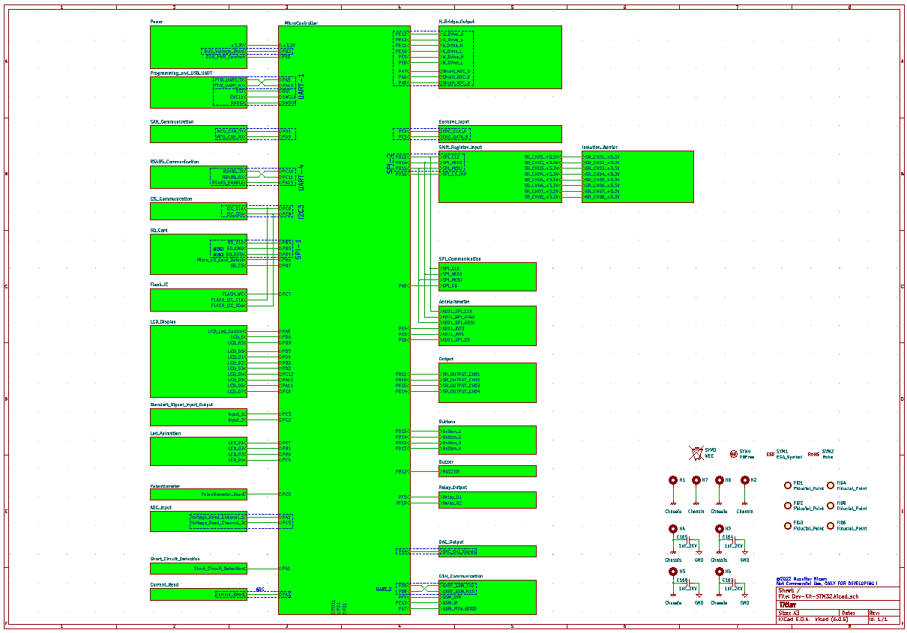

**Table 1:** Schematic Design

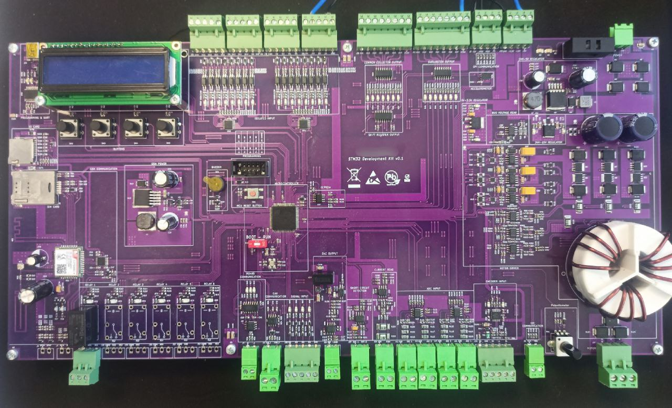

**Table 2:** STM32 MEGA Development Board

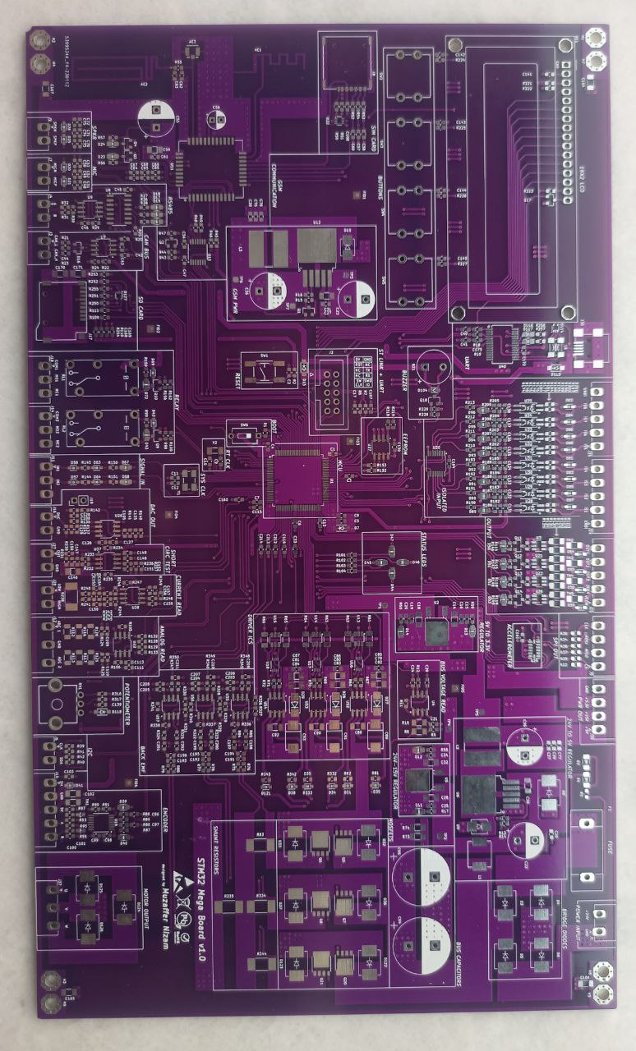

**Table 3:** STM32 MEGA Develoment Board (another version)