**Muzaffer Nizam**

**Location :** Antalya, TURKEY

**Age :** 35

**Phone :** +90 536 222 90 10

**Mail :** [muzaffernizam@gmail.com](mailto:muzaffernizam@gmail.com)

**Sr. Hardware Design Engineer**

**TOTAL EXPERIENCE ( 7 Years 2 Months )**

**Education**

**Bachelor's of Science, Electrical & Electronics Engineering Oct. 2016**

**Akdeniz University**

**Hardware Experiences;**

* I am using Kicad, Altium and Eagle EDA programs in Hardware Design,
* Pin assignment according to role such as communication, input, output, PWM, Analog etc.
* Design Compliant with IPC2221 Electrical Conductor Spacing Standards and EMC Standards,
* Design Compliant with different density Via dimensions of IPC-2221,
* Design Compliant with different Environmental Temperatures and Pressures
* Multilayer PCB Design 2,4 and more Layers by following Layer Stack Management,
* Various FR4 Types and Flex PCB Design,
* Design compliant with BGA components
* Choosing different temperatures density PCB Materials such as FR-4 TG 130-140, TG 170 etc,
* Various Design using with STM32xx, CC13xx Ti, TM4Cxx Tiva Series MCU,
* Various Communication Board Design with Quectel MC60xx GSM module, Quectel EC200xx LTE module, Quectel EG915xx LTE module
* Power Circuit Designs Such as Switching Regulators, Switching Controllers, PMIC,
* Motor Control Drivers Designs such as Brushed DC, BLDC, PMSM etc
* Digital Designs SPI, I2C, DAC, RS485, UART, Ethernet, CAN Bus,
* Wireless Communication Designs GSM, GNSS, Bluetooth, RF Sub 1 GHz, Wifi 2.4 GHz,
* System Modelling, simulation and analysis with Matlab Simulink,
* Analog Design ADC, DAC, FSK Communication on Power Line, various OP-AMPS Gain Calculating, Analog Filters Designs,
* Using LTspice, Measurements with Oscilloscopes and Reports
* Environmental Test such as Temperature test, Pressure Test, ESD Gun Test,
* Creating PBA and PCB Production Files, Gerber Files, Pick and Places Files, DXF and Step files for Mechanical Designs,
* Controlling with GERBV (free Gerber viewer)
* Prepare Bill of Materials List.
* Version Control with github.
* Short Circuit Testing,
* Voltage Level Testing,

**Firmware Experiences;**

* Code Generations with STM32CubeIde,
* Low level driver preparing,
* UART/USART Communication Firmware Testing,
* Can Bus Communication Firmware Testing,
* SPI, I2C and RS485 Communication Firmware Testing,
* ADC Input Firmware Testing,
* DAC Output Firmware Testing,
* PWM Generation Firmware Testing,
* General Input detect and Output Control Check Firmware Test even include Interrupts,
* Hardware Verification with Firmware.

**JOB EXPERIENCES**

1. **Electrical & Electronics Engineer Intern ( 3 Months)** June 2013- September 2013

**Company:** Turkcell Communication A.Ş.

**Website: <https://www.turkcell.com.tr/>**

**Job Type:** Intern / Full Time

**Reason for Leaving:** Intern Finished

**Job Deification:**

* GSM Base Station Location Planning,
* Various Technical Calculating,
* Field operations.

1. **Electronics R&D Engineer ( 2 Years 4 Months)** August 2015- October 2017

**Company:** Desird Tasarım Arge Uygulama Elekt. Des. İth. İhr. San LTD ŞTİ

**Website: <https://desird.com/>**

**Job Type:** Permanent/Full Time

**Reason for Leaving:**Military Status

**Job Deification:**

**Hardware Designed below projects;**

* Biomedical Electronic Card Designs
* Elevator DC Door Control Driver Board Designs
* IOT Card Designs
* Telemetry Card Designs with FSK communication on DC Power Line
* Main Board Designed which is communicating with Telemetry Cards,
* Test Machine Design contains with Pogo Test Probe Tips
* In addition in relevant projects doing Hardware Designs(Schematic and PCB), Measuring, Reports and Tests,
* Designed with STM32xx, CC13xx Ti MCU’s, PIC18xx MCU’s

1. **Electronics R&D Engineer ( 2 Years 8 Months 15 Days)** May 2018- February 2021

**Company:** Desird Tasarım Arge A.Ş. (Same Company previous one, but Commercial Title of Company changed)

**Website: <https://desird.com/>**

**Job Type:** Permanent/Full Time

**Reason for Leaving:**Resignation

**Job Definition:**

**Hardware Designed below projects;**

* Elevator BLDC Door Control Driver Board Designs
* IOT Card Designs
* Test Equipment Design contains with Pogo Test Probe Tips
* Railway BLDC Door Control and Safety Boards which has Safety Relay and compatible relevant SIL Certificate,
* In addition in relevant projects doing Hardware Designs(Schematic and PCB), Measuring, Reports and Tests,
* Designed with STM32xx, STM8xx, NXP MCU’s, PIC16xx MCU’s

1. **Electronics R&D Engineer ( 1 Years 1 Months 19 Days)** February 2021- April 2022

**Company:** Ake Elevator and Escalator LTD

**Website: <https://ake.com.tr/>**

**Job Type:** Permanent/Full Time

**Reason for Leaving:** Company created another Company as for Electronics R&D called Acri Industrial LTD ŞTİ

**Job Definition:**

**Hardware Designed below projects;**

* Elevator DC Door Control Driver Board Designs
* Remote control with GSM Communication Card Designs
* Various Elevator Control Boards Designs,
* Water Vending Control Boards Designs,
* Elevator Main Control, Cabin Buttons Boards, Top and Bottom of Cabinet Boards, Floor Calling Boards which is communicating with CAN Bus and DC and AC signal Lines,
* In addition in relevant projects doing Hardware Designs(Schematic and PCB), Measuring, Reports and Tests,
* Designed with TM4Cxx Ti, MSP432xx ARM Core, MSP430xx Ti, Quectel MC60xx GSM module

1. **Electronics R&D Engineer ( 1 Years)** April 2022 - Still Working

**Company:** Acri Industrial LTD ŞTİ

**Website: <https://www.acritechnology.com/>**

**Job Type:** Permanent/Full Time

**Reason for Leaving:** ***

**Job Definition:**

**Hardware Designed below projects;**

* Elevator DC Door Control Driver Board Designs
* Remote control with GSM Communication Card Designs
* Various Elevator Control Boards Designs,
* Elevator Main Control, Cabin Buttons Boards, Top and Bottom of Cabinet Boards, Floor Calling Boards which is communicating with CAN Bus and DC and AC signal Lines,
* Test Machine Design contains with Pogo Test Probe Tips
* Hand terminal Board design. To perform OTA update using GSM and LTE Moduls,
* In addition in relevant projects doing Hardware Designs(Schematic and PCB), Measuring, Reports and Tests,
* Designed with TM4Cxx Ti, STM32xx,Quectel MC60xx GSM module, Quectel EC200xx LTE module, Quectel EG915xx LTE module

**One of my Personal Design Project;**

* It is called STM32 Mega Development Board
* Contains Technologies as a below;
* 24V AC or DC Power Input,
* 2 different Switching Regulator GSM and General System Power as 4.3V and 5V,
* Controlling GSM Power with XOR Gate and Transistor,
* Analog Bus Voltage Read with Buffer op amp,
* DAC Output,
* Voltage levels are 24V, 15V, 5V, 4.3V,3.3V,
* USART communication with USB Mini also contains Programming,
* CAN Bus Communication,
* RS485 Communication,
* SPI and I2 Communication connected to Connectors,
* SD Memory Card communicated with SPI Interface,
* 16x2 Character LCD Display communicated with I2C Interface,
* FLASH Memory communicated with I2C Interface
* Non-Isolated Signal Input,
* Darlington Output with ULN2004 IC,
* Linear Potentiometer Analog Read,
* Between Range of 0V to 600V DC Voltage Read with op amp,
* Between Range of 0-10A Current Read with op amp,
* Short Circuit Detection,
* DC and BLDC Motor Control Driver Circuit with Back EMF Current Reading,
* Encoder Input (Absolute and Incremental)
* 16 Channel Isolated Input detected with Shift Register Input,
* Accelerometer (ADXL345 IC) communicated with SPI,
* 4 Buttons for LCD Controlling,
* 24V Relay Output (SPDT 1 FORM C),
* SIM800C GSM Modul communicated with SPI Interface

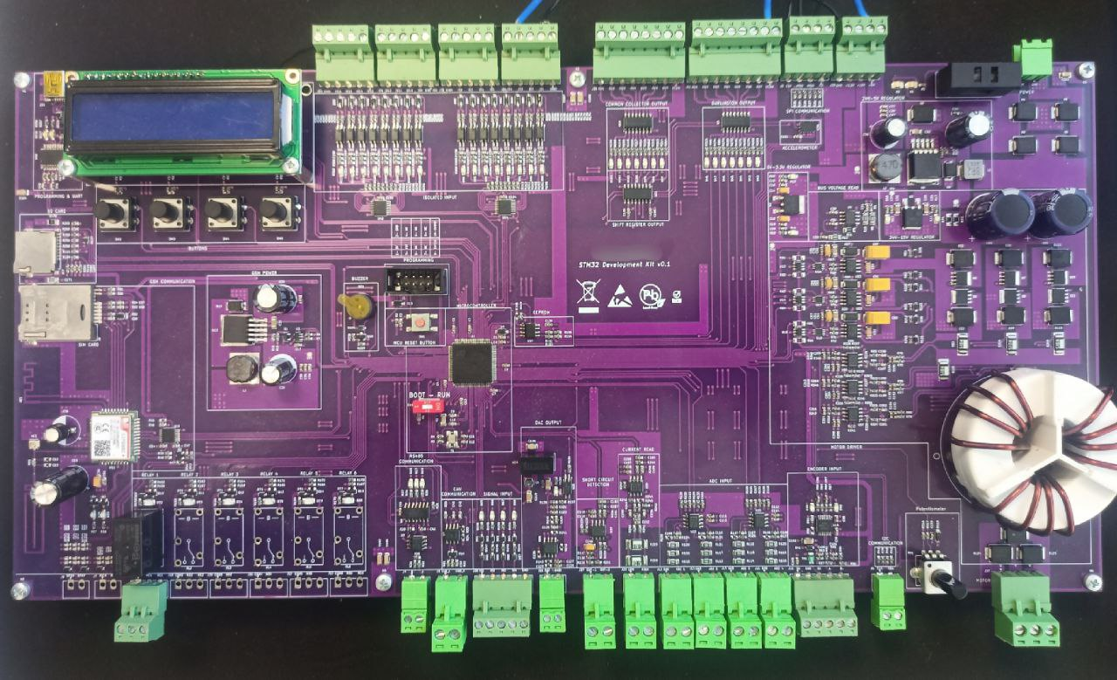

**Figure 1 :** STM32 MEGA Development Board

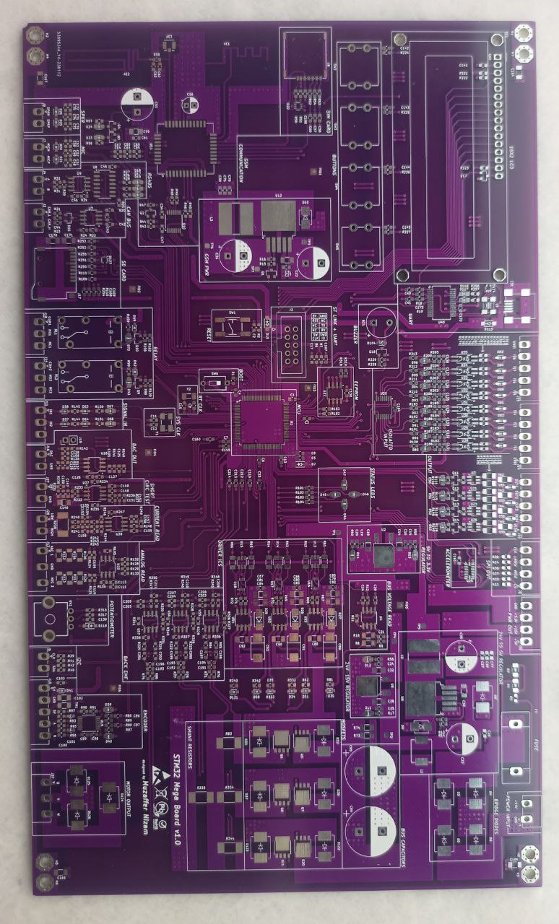

**Figure 2 :** STM32 MEGA Development Board (another version)

**Foreign Language**

* English Level : B2-Upper Intermediate (English Culture Course in Antalya )

**Certificate Code:** 8882201740

<https://verifiedportfolios.com/>

**Certificates**

* Safety Integrity Level for RAILWAY SYSTEM ELECTRONICS - **TUV NORD** April 2019
* Humanoid Robots Industrial Automation - **ENTEK EDUCATION TECH.** December 2012

**Hobbies**

* Latin Dances Salsa & Bachata
* Taking Photo
* Cats and Dogs