**Muzaffer Nizam**

**Location :** Antalya, TURKEY

**Age :** 35

**Phone :** +90 536 222 90 10

**Mail :** [muzaffernizam@gmail.com](mailto:muzaffernizam@gmail.com)

**Sr. Hardware Design Engineer**

**TOTAL EXPERIENCE ( 7 Years 2 Months )**

**Education**

**Bachelor's of Science, Electrical & Electronics Engineering Oct. 2016**

**Akdeniz University**

**Personal Statement**

Being an electronics engineer was my childhood dream. I thought my approaches to problem solving might be easier if I became an engineer. So it happened. I like to find best solutions to all kinds of problems not only in business life, but also in real life.

I was always curious about new things and researched to find solutions to new challenges. In my work environment, when a colleague was about to make the wrong decision, I always helped to someone make the right decisions. I've never been perfect, but I've always tried to do great things. I have always pursued real truths, not my own truths. I have always tried to apply real facts. From now on, I will always continue to pursue the real truth in my work.

I have never been egotistical. I've always been tolerant. Maybe good things can be done alone, but bigger things can be achieved with teamwork.

I have the qualifications related to the Hardware design you mentioned. I managed all design, power consumption, signal integrity, creation of design documents, creation of production files (pick and place, gerber, Bill of Material List in best prices etc), different production and assembly processes of electronic boards with mechanical boxes, creation of product tree, from idea to mass production.

Apart from that I'm not fully qualified for embedded software development. I have developed embedded software before. I contributed to testing many low-level hardware with software. For example, with STM32, I wrote codes for ADC, SPI, I2C, Can Bus, UART, various inputs and outputs, Interrupt, DMA and blocking code in embedded software, and I tested the hardware to work with embedded software. But I haven't developed the embedded software of the entire project from scratch, with all the mathematical and logical algorithm processes.

I do not know the house rents in the location of the workplace. That's why I leave my salary expectation to the employer's discretion.

Apart from these, I am ready to work in this position. But I ask the employer for a few months of familiarization time tolerance. My English level is good enough to continue my profession as long as it is in written, but I may have deficiencies in daily life and business life. I believe that I can overcome these in time. I am ambitious and hardworking. If you trust me, I will do my best not to disappoint your trust.

As the requirements of the job, neither designing analog or digital can't force me . I do overcome it all.

If my Job Application is accepted, I will need a letter of offer for the consulate. Visa application can be answered by the consulate within 3-5 weeks. As a result, I can come to England and start work as soon as possible.

I am ready for a new role and a new life.

**Hardware Experiences;**

* I am using Kicad, Altium and Eagle EDA programs in Hardware Design,
* Pin assignment according to role such as communication, input, output, PWM, Analog etc.
* Design Compliant with IPC2221 Electrical Conductor Spacing Standards and EMC Standards,
* Design Compliant with different density Via dimensions of IPC-2221,
* Design Compliant with different Environmental Temperatures and Pressures
* Multilayer PCB Design 2,4 and more Layers by following Layer Stack Management,
* Various FR4 Types and Flex PCB Design,
* Design compliant with BGA components
* Choosing different temperatures density PCB Materials such as FR-4 TG 130-140, TG 170 etc,
* Various Design using with STM32xx, CC13xx Ti, TM4Cxx Tiva Series MCU,
* Various Communication Board Design with Quectel MC60xx GSM module, Quectel EC200xx LTE module, Quectel EG915xx LTE module
* Power Circuit Designs Such as Switching Regulators, Switching Controllers, PMIC,
* Motor Control Drivers Designs such as Brushed DC, BLDC, PMSM etc
* Digital Designs SPI, I2C, DAC, RS485, UART, Ethernet, CAN Bus,
* Wireless Communication Designs GSM, GNSS, Bluetooth, RF Sub 1 GHz, Wifi 2.4 GHz,
* System Modelling, simulation and analysis with Matlab Simulink,
* Analog Design ADC, DAC, FSK Communication on Power Line, various OP-AMPS Gain Calculating, Analog Filters Designs,
* Using LTspice, Measurements with Oscilloscopes and Reports
* Environmental Test such as Temperature test, Pressure Test, ESD Gun Test,
* Creating PBA and PCB Production Files, Gerber Files, Pick and Places Files, DXF and Step files for Mechanical Designs,
* Controlling with GERBV (free Gerber viewer)
* Prepare Bill of Materials List.
* Version Control with github.
* Short Circuit Testing,
* Voltage Level Testing,

**Firmware Experiences;**

* Code Generations with STM32CubeIde,
* Low level driver preparing,
* UART/USART Communication Firmware Testing,
* Can Bus Communication Firmware Testing,
* SPI, I2C and RS485 Communication Firmware Testing,
* ADC Input Firmware Testing,
* DAC Output Firmware Testing,
* PWM Generation Firmware Testing,
* General Input detect and Output Control Check Firmware Test even include Interrupts,
* Hardware Verification with Firmware.

**JOB EXPERIENCES**

1. **Electrical & Electronics Engineer Intern ( 3 Months)** June 2013- September 2013

**Company:** Turkcell Communication A.Ş.

**Website: <https://www.turkcell.com.tr/>**

**Job Type:** Intern / Full Time

**Reason for Leaving:** Intern Finished

**Job Deification:**

* GSM Base Station Location Planning,
* Various Technical Calculating,
* Field operations.

1. **Electronics R&D Engineer ( 2 Years 4 Months)** August 2015- October 2017

**Company:** Desird Tasarım Arge Uygulama Elekt. Des. İth. İhr. San LTD ŞTİ

**Website: <https://desird.com/>**

**Job Type:** Permanent/Full Time

**Reason for Leaving:**Military Status

**Job Deification:**

**Hardware Designed below projects;**

* Biomedical Electronic Card Designs
* Elevator DC Door Control Driver Board Designs
* IOT Card Designs
* Telemetry Card Designs with FSK communication on DC Power Line
* Main Board Designed which is communicating with Telemetry Cards,
* Test Machine Design contains with Pogo Test Probe Tips
* In addition in relevant projects doing Hardware Designs(Schematic and PCB), Measuring, Reports and Tests,
* Designed with STM32xx, CC13xx Ti MCU’s, PIC18xx MCU’s

1. **Electronics R&D Engineer ( 2 Years 8 Months 15 Days)** May 2018- February 2021

**Company:** Desird Tasarım Arge A.Ş. (Same Company previous one, but Commercial Title of Company changed)

**Website: <https://desird.com/>**

**Job Type:** Permanent/Full Time

**Reason for Leaving:**Resignation

**Job Definition:**

**Hardware Designed below projects;**

* Elevator BLDC Door Control Driver Board Designs
* IOT Card Designs
* Test Equipment Design contains with Pogo Test Probe Tips
* Railway BLDC Door Control and Safety Boards which has Safety Relay and compatible relevant SIL Certificate,
* In addition in relevant projects doing Hardware Designs(Schematic and PCB), Measuring, Reports and Tests,
* Designed with STM32xx, STM8xx, NXP MCU’s, PIC16xx MCU’s

1. **Electronics R&D Engineer ( 1 Years 1 Months 19 Days)** February 2021- April 2022

**Company:** Ake Elevator and Escalator LTD

**Website: <https://ake.com.tr/>**

**Job Type:** Permanent/Full Time

**Reason for Leaving:** Company created another Company as for Electronics R&D called Acri Industrial LTD ŞTİ

**Job Definition:**

**Hardware Designed below projects;**

* Elevator DC Door Control Driver Board Designs
* Remote control with GSM Communication Card Designs
* Various Elevator Control Boards Designs,
* Water Vending Control Boards Designs,
* Elevator Main Control, Cabin Buttons Boards, Top and Bottom of Cabinet Boards, Floor Calling Boards which is communicating with CAN Bus and DC and AC signal Lines,
* In addition in relevant projects doing Hardware Designs(Schematic and PCB), Measuring, Reports and Tests,
* Designed with TM4Cxx Ti, MSP432xx ARM Core, MSP430xx Ti, Quectel MC60xx GSM module

1. **Electronics R&D Engineer ( 1 Years)** April 2022 - Still Working

**Company:** Acri Industrial LTD ŞTİ

**Website: <https://www.acritechnology.com/>**

**Job Type:** Permanent/Full Time

**Reason for Leaving:** Immigration

**Job Definition:**

**Hardware Designed below projects;**

* Elevator DC Door Control Driver Board Designs
* Remote control with GSM Communication Card Designs
* Various Elevator Control Boards Designs,
* Elevator Main Control, Cabin Buttons Boards, Top and Bottom of Cabinet Boards, Floor Calling Boards which is communicating with CAN Bus and DC and AC signal Lines,
* Test Machine Design contains with Pogo Test Probe Tips
* Hand terminal Board design. To perform OTA update using GSM and LTE Moduls,
* In addition in relevant projects doing Hardware Designs(Schematic and PCB), Measuring, Reports and Tests,
* Designed with TM4Cxx Ti, STM32xx,Quectel MC60xx GSM module, Quectel EC200xx LTE module, Quectel EG915xx LTE module

**One of my Personal Design Project;**

* It is called STM32 Mega Development Board
* Contains Technologies as a below;
* 24V AC or DC Power Input,
* 2 different Switching Regulator GSM and General System Power as 4.3V and 5V,
* Controlling GSM Power with XOR Gate and Transistor,
* Analog Bus Voltage Read with Buffer op amp,
* DAC Output,
* Voltage levels are 24V, 15V, 5V, 4.3V,3.3V,
* USART communication with USB Mini also contains Programming,
* CAN Bus Communication,
* RS485 Communication,
* SPI and I2 Communication connected to Connectors,
* SD Memory Card communicated with SPI Interface,
* 16x2 Character LCD Display communicated with I2C Interface,
* FLASH Memory communicated with I2C Interface
* Non-Isolated Signal Input,
* Darlington Output with ULN2004 IC,
* Linear Potentiometer Analog Read,
* Between Range of 0V to 600V DC Voltage Read with op amp,
* Between Range of 0-10A Current Read with op amp,
* Short Circuit Detection,
* DC and BLDC Motor Control Driver Circuit with Back EMF Current Reading,
* Encoder Input (Absolute and Incremental)
* 16 Channel Isolated Input detected with Shift Register Input,
* Accelerometer (ADXL345 IC) communicated with SPI,
* 4 Buttons for LCD Controlling,
* 24V Relay Output (SPDT 1 FORM C),
* SIM800C GSM Modul communicated with SPI Interface

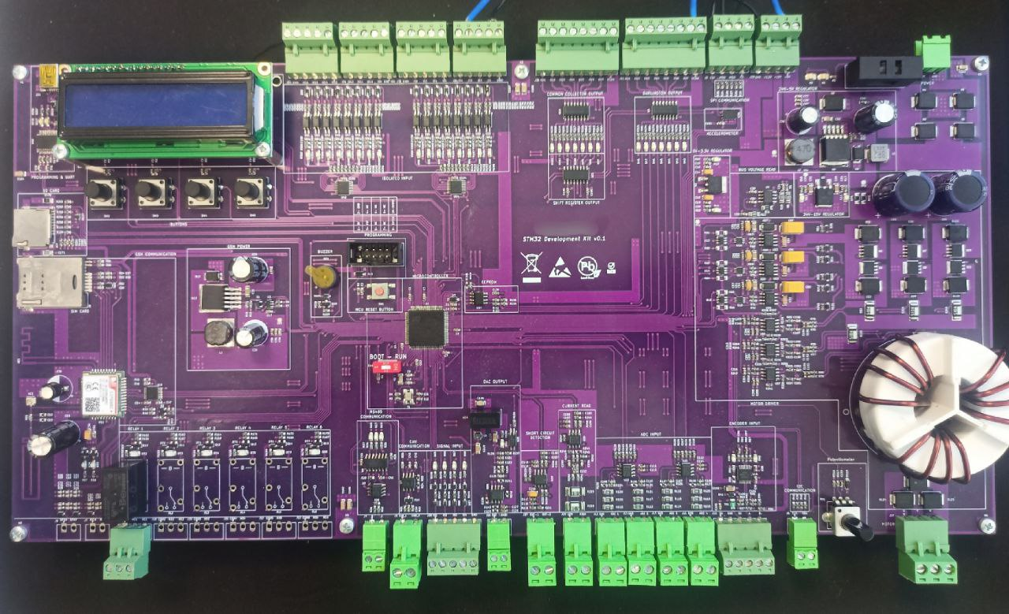

**Figure 1 :** STM32 MEGA Development Board

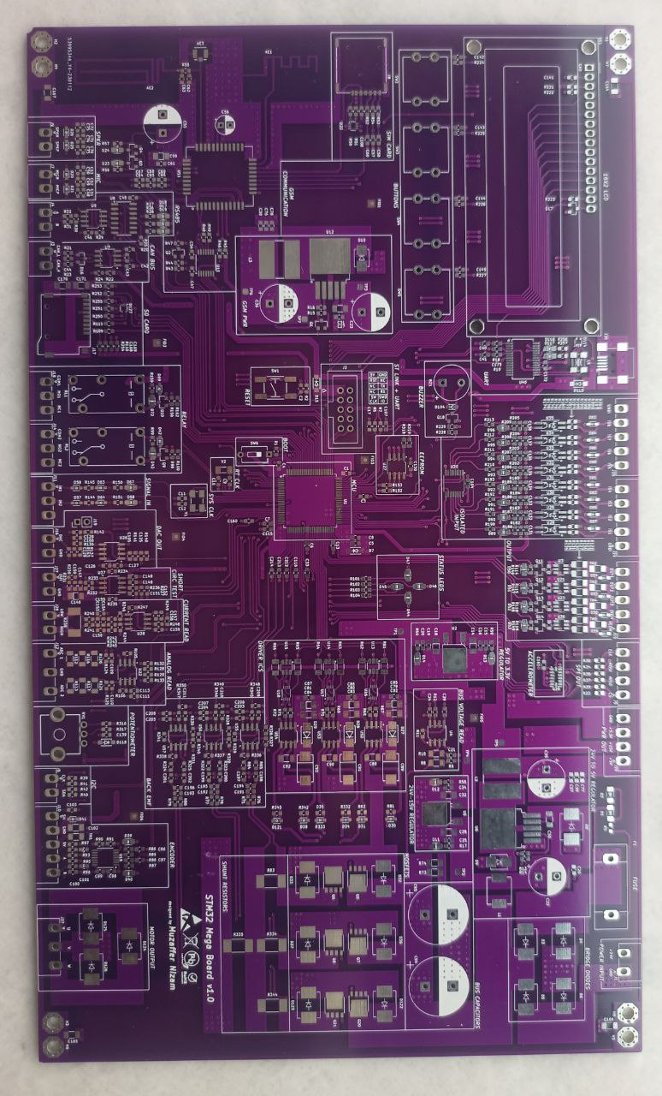

**Figure 2 :** STM32 MEGA Development Board (another version)

**Foreign Language**

* English Level : B2-Upper Intermediate (English Culture Course in Antalya, Turkey )

**Certificate Code:** 8882201740

<https://verifiedportfolios.com/>

**Certificates**

* Safety Integrity Level for RAILWAY SYSTEM ELECTRONICS - **TUV NORD** April 2019
* Humanoid Robots Industrial Automation - **ENTEK EDUCATION TECH.** December 2012

**Hobbies**

* Latin Dances (Salsa & Bachata)
* Theater
* Cats and Dogs