|  |
| --- |
| SALES AND PROFITABILITY ANALYSIS  Report on Findings |
| Superstore X |

Contents

Introduction 3

Sales and Profitability 3

Analysis and Impact of Returned Orders 10

Conclusion 15

## Introduction

This report aims to provide the findings of the analysis of the Superstore X’s data.

**Sales and Profitability Analysis**

**Main figures:**

|  |  |  |
| --- | --- | --- |
| Total Sales | Total Profit | Profit / Sales |
| $2,297,200 | **$286,397** | **12%** |

*Figure 1: Total Sales and Profit*

* Based on the data, the profit/sales ratio stands at 12%.
* Further analysis of the sales figures reveals that 10 states that contribute to the sales the most are not necessarily the most profitable ones, as seen below:10 Sta

tes for Tota

|  |  |  |
| --- | --- | --- |
| States | Total Sales | Total Profit |
| California | 457687 | 76381 |
| New York | 310876 | 74038 |
| Texas | 170188 | -25729 |
| Washington | 138641 | 33402 |
| Pennsylvania | 116511 | -15559 |
| Florida | 89473 | -3399 |
| Illinois | 80166 | -12607 |
| Ohio | 78258 | -16971 |
| Michigan | 76269 | 24463 |
| Virginia | 70636 | 18597 |

*Figure 2: Top 10 States for Total Sales* *Figure 3: Top 10 States for Total Profits*

|  |  |  |
| --- | --- | --- |
| States | Total Sales | Total Profit |
| California | 457687 | 76381 |
| New York | 310876 | 74038 |
| Washington | 138641 | 33402 |
| Michigan | 76269 | 24463 |
| Virginia | 70636 | 18597 |
| Indiana | 53555 | 18382 |
| Georgia | 49095 | 16250 |
| Kentucky | 36591 | 11199 |
| Minnesota | 29863 | 10823 |
| Delaware | 27451 | 9977 |

* Bottom 10 States based on their total sales figures are found to be profitable, although at low levels:

m 10 States for Total Sales

|  |  |  |
| --- | --- | --- |
| States | Total Sales | Total Profit |
| North Dakota | 919 | 230 |
| West Virginia | 1209 | 185 |
| Maine | 1270 | 454 |
| South Dakota | 1315 | 394 |
| Wyoming | 1603 | 100 |
| District of Columbia | 2865 | 1059 |
| Kansas | 2914 | 836 |
| Idaho | 4382 | 826 |
| Iowa | 4579 | 1183 |
| New Mexico | 4783 | 1157 |

*Figure 4: Bottom 10 States for total sales*

**Profitability (Gross Profit Margin)**

|  |  |  |  |
| --- | --- | --- | --- |
| States | Total Sales | Total Profit | Profitability |
| Ohio | 78258 | -16971 | -0.22 |
| Colorado | 32108 | -6527 | -0.20 |
| Tennessee | 30661 | -5341 | -0.17 |
| Illinois | 80166 | -12607 | -0.16 |
| Texas | 170188 | -25729 | -0.15 |
| North Carolina | 55603 | -7490 | -0.13 |
| Pennsylvania | 116511 | -15559 | -0.13 |
| Arizona | 35282 | -3427 | -0.10 |
| Oregon | 17431 | -1190 | -0.07 |
| Florida | 89473 | -3399 | -0.04 |

*Figure 5: Bottom 10 States for profitability Figure 6: Top 10 States for profitability*

|  |  |  |  |
| --- | --- | --- | --- |
| States | Total Sales | Total Profit | Profitability |
| District of Columbia | 2865 | 1059.589 | 0.37 |
| Delaware | 27451 | 9977 | 0.36 |
| Minnesota | 29863 | 10823 | 0.36 |
| Maine | 1270 | 454 | 0.36 |
| Arkansas | 11678 | 4008 | 0.34 |
| Indiana | 53555 | 18382 | 0.34 |
| Georgia | 49095 | 16250 | 0.33 |
| Montana | 5589 | 1833 | 0.33 |
| Rhode Island | 22627 | 7285 | 0.32 |
| Michigan | 76269 | 24463 | 0.32 |

## The above two charts reveal that high total sales figures do not necessarily attract high profits.

## To illustrate, Michigan has a GPM ratio over 32%, whilst Ohio, with a similar sales figure, incur more than 21% loss.

## PRODUCT CATEGORY PROFITABILITY ANALYSIS

*Figure 7: Total Sales by Product Category*

*Figure 8: Total Profits by Product Category*

* Sales of technology products return more than half of all profit.
* Furniture sales is barely profitable.

*Figure 9: Profitability by Product Category*

* Whilst the sales figures are nearly the same for Office Supplies and Furniture, GPM ratio for Office Supplies is at a high of 46% as opposed to Furniture, where this ratio is only 7%.

*Figure 10: Profits Earned by Sub-Category*

* Phones and copiers from technology category are the most profitable products, whilst tables and bookcases sub-categories from furniture are not profitable.

## Correlation Analysis for 10 States with Lowest Profitability Ratio:

## 

## *Figure 11: Top 10 States for profitability*

## The above analysis further highlights the need to analyse the states with lowest profitability.

## The reason is that the negative correlation between sales and profit reveals that although some of the low-performing states have higher sales figures than others, they are incurring loss at similar or even higher levels.

## State-specific analysis can be done in a more detailed way and actions can be taken accordingly to boost the company’s 12% GPM ratio.

## Discount / Sales correlation

## Correlation coefficient: 0.028

## Discounts and the amount paid by customers have no correlation, as seen below:

## *Figure 12: Discount/Sales Scatterplot*

This could be interpreted as:

* Higher discounts do not necessarily attract higher sales.
* Higher sales do not necessarily attract higher discounts.

For certain states, where the sales are aimed to be boosted, proportionate discounts can be applied and then in a later analysis, it could be checked whether this correlation increased.

Profit/Sales Correlation

* Profit and sales have a correlation coefficient of 0.48, which is relatively high as expected.
* Whether this figure satisfies the company’s goals can also be investigated and further actions can be taken to increase the dependency between sales and profit, in line with business goals.

**IMPACT OF RETURNED ORDERS**

*Figure 13: Sales Lost due to Returned Orders*

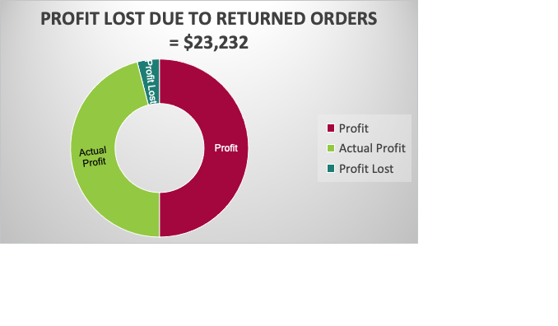

*Figure 14: Sales Lost Due to Returned Orders*

*Figure 15: Profit Lost from Returns by Customer Segment*

*Figure 16: Actual Profit by Customer Segment (taking into account the profit lost due to returns)*

* 73% of the lost profit is due to returns from Consumer segment, which, however, also brings in the most profit (44%).

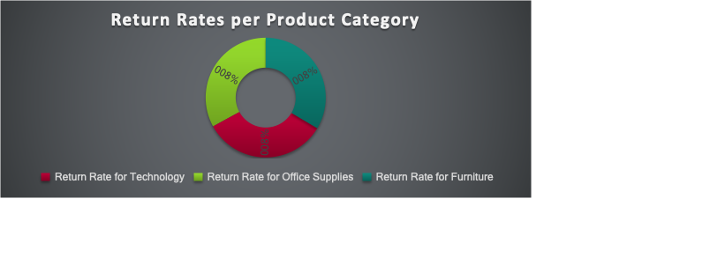

*Figure 17: Return Rates per Product Category*

*Figure 18: Return Rates per Product Sub-Category*

Out of 1851 distinct products, 647 of them have been returned in varying degrees. Top 50 most returned items based on their return rate (returned/total number of sales) are listed below. For more, please refer to the spreadsheet.



*Figure 19*

*Figure 20*

* Some states like Utah have high return rates at low total order numbers, which could be analysed further to get more insights about the reasons and find out ways to improve.

**CONCLUSION**

The report has provided some important insights from the analysis of superstore X’s data. Relevant teams and stakeholders can make use of the findings from the data to improve operations and boost profitability as well as to plan the future.