1. WAP to enter the age and based on the input, the if..else statement checks whether the entered age is greater than or equal to 18. If this condition meet then display message “You are eligible for voting”, however if the condition doesn’t meet then display a different message “You are not eligible for voting”.

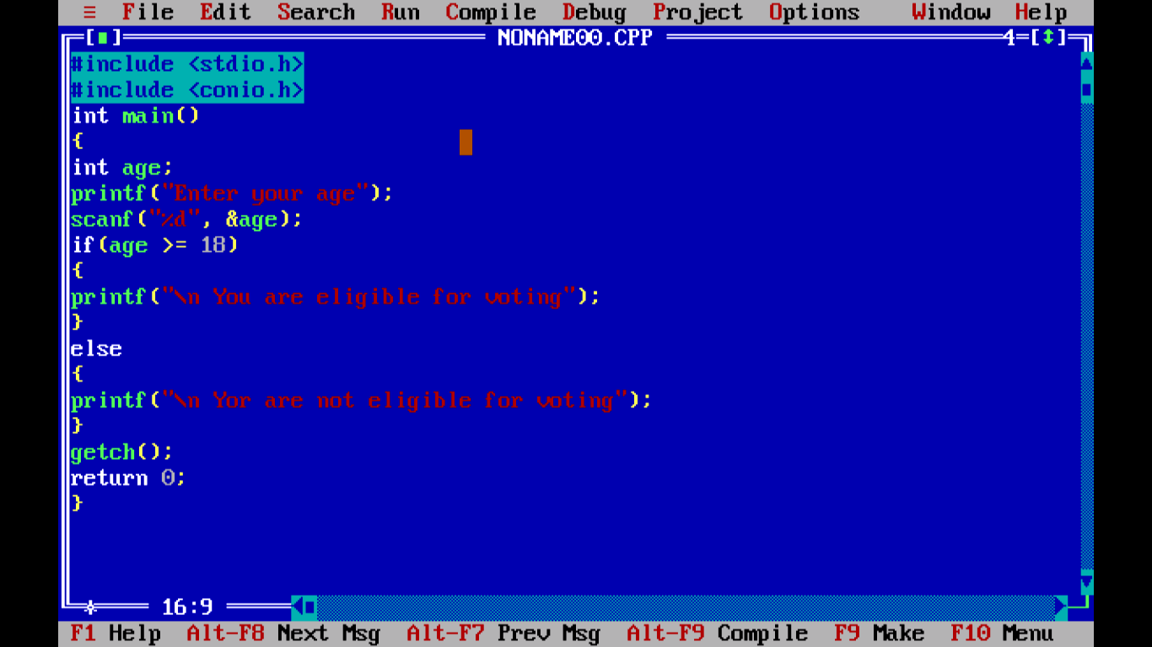

1. WAP to accept 3 subject marks . Calculate total, percentage, and grade. (Using Else if)

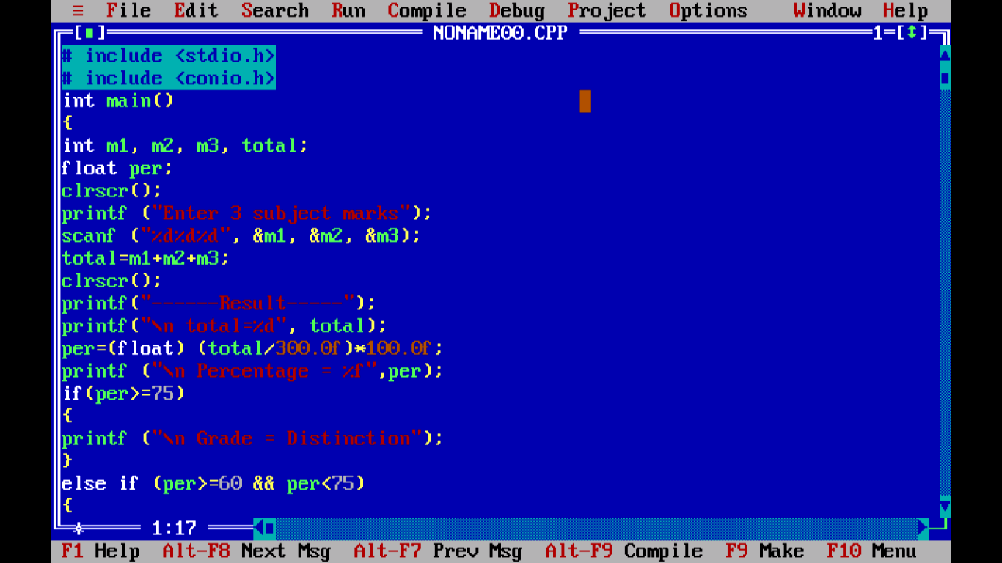

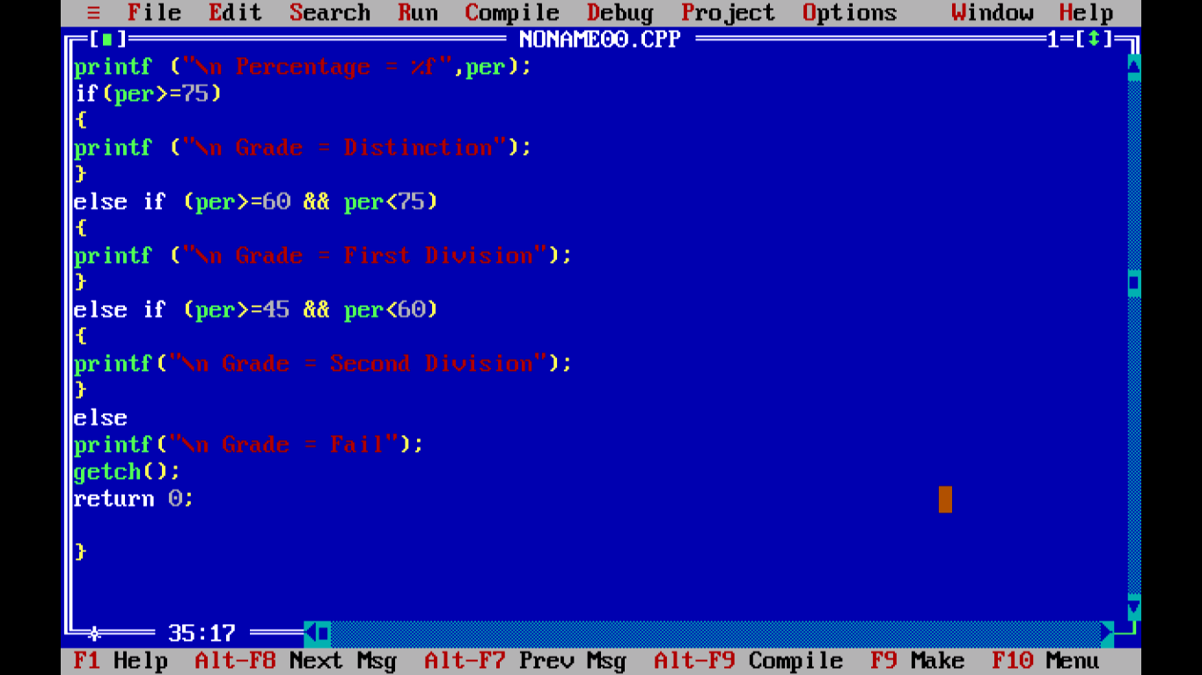

1. WAP to accept day numbers and display name of days

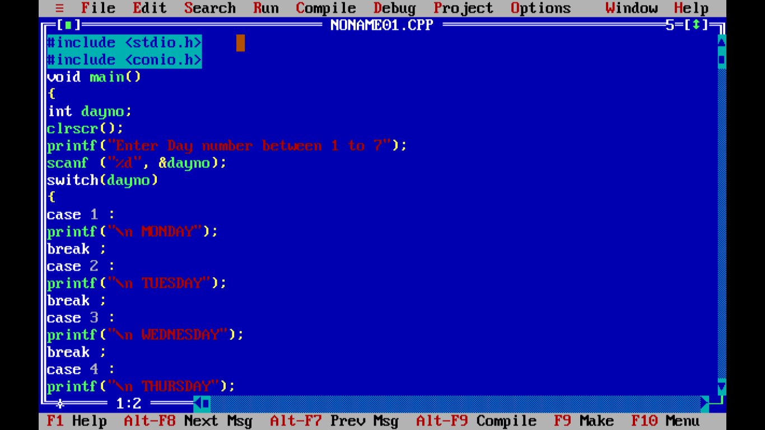

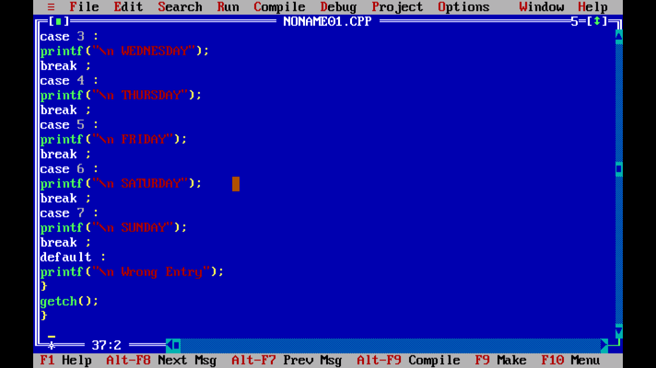

1. WAP to accept a character & print whether it’s a vowel or not.

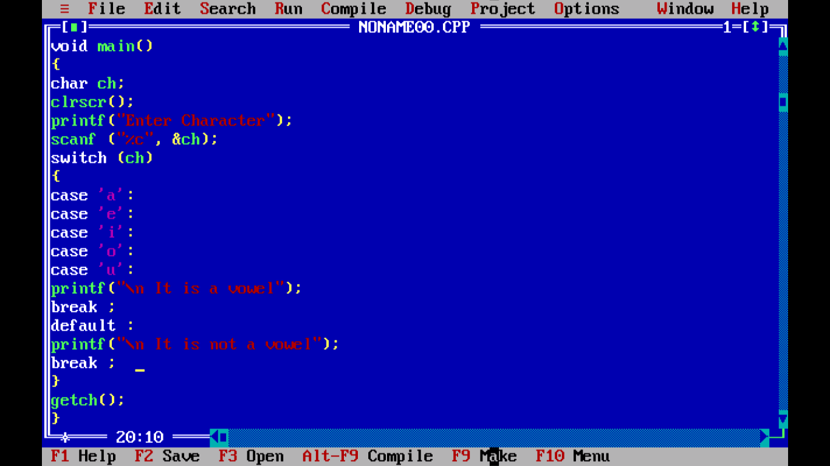

1. WAP to accept 2 numbers and then operators +, -, \*, / & display the result.

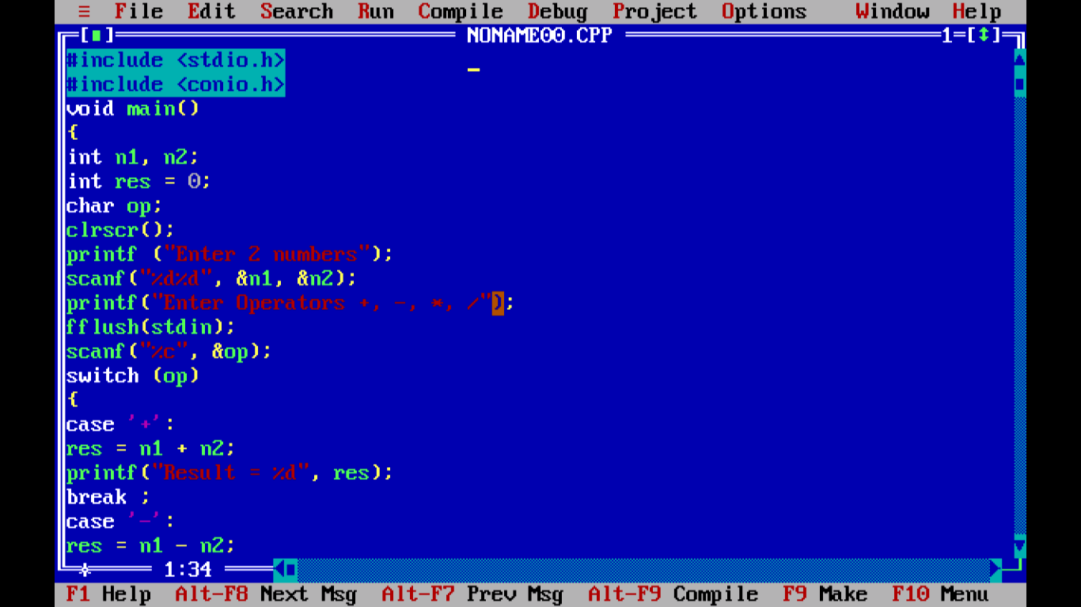

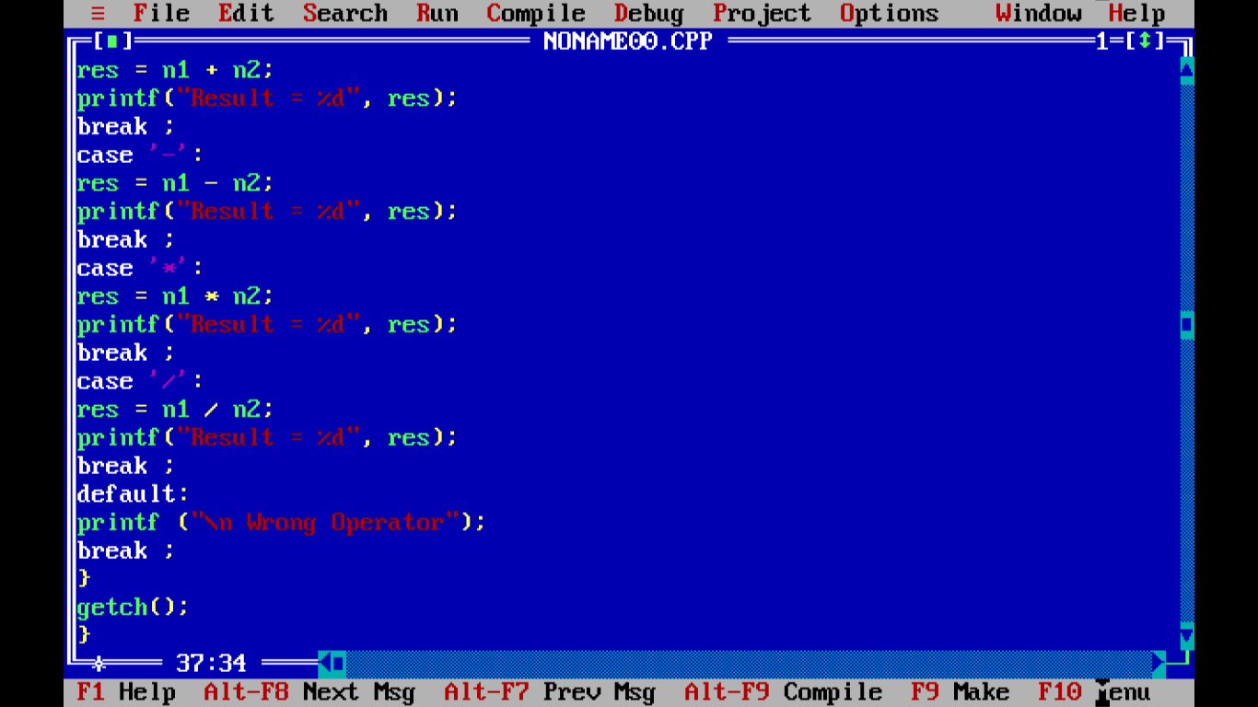

1. WAP to accept basic salary and designation (m for manager, c for clerk and p for peon) calculate bonus =1000 for manager ; 500 for clerk ; 200 for peon.

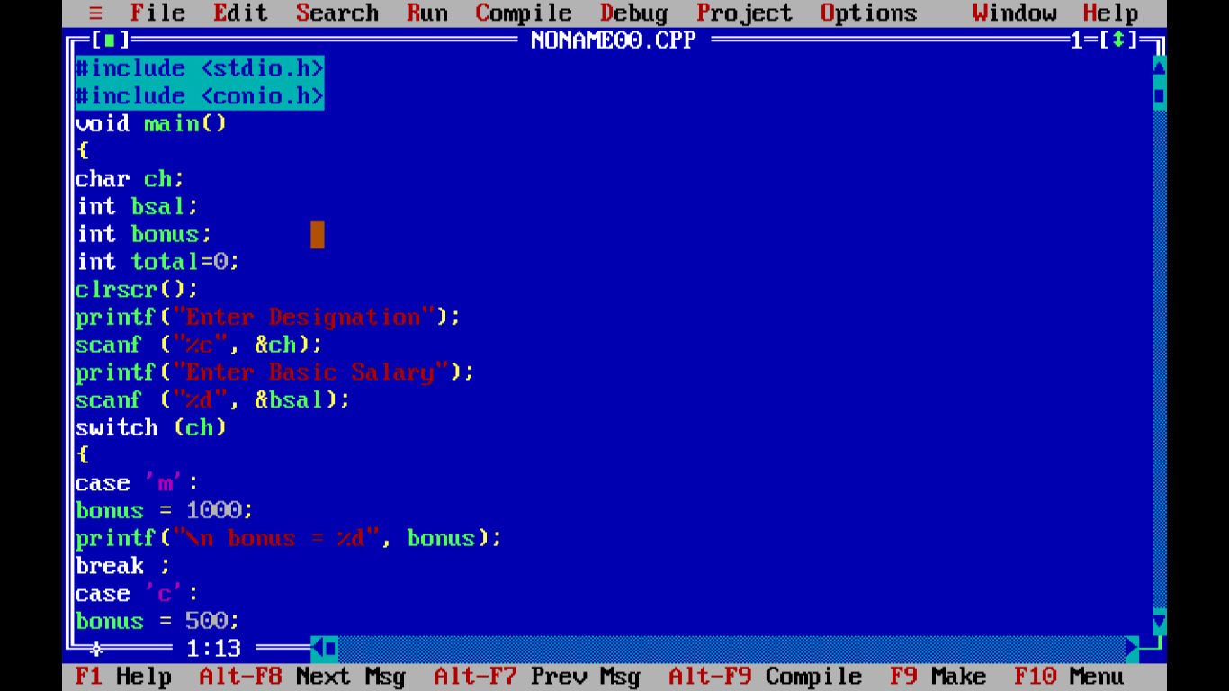

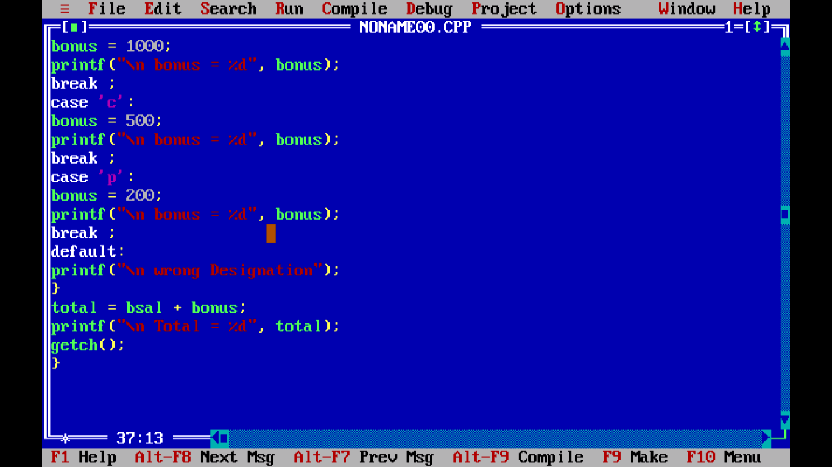

1. WAp to print no from 1 to 10 using while loop

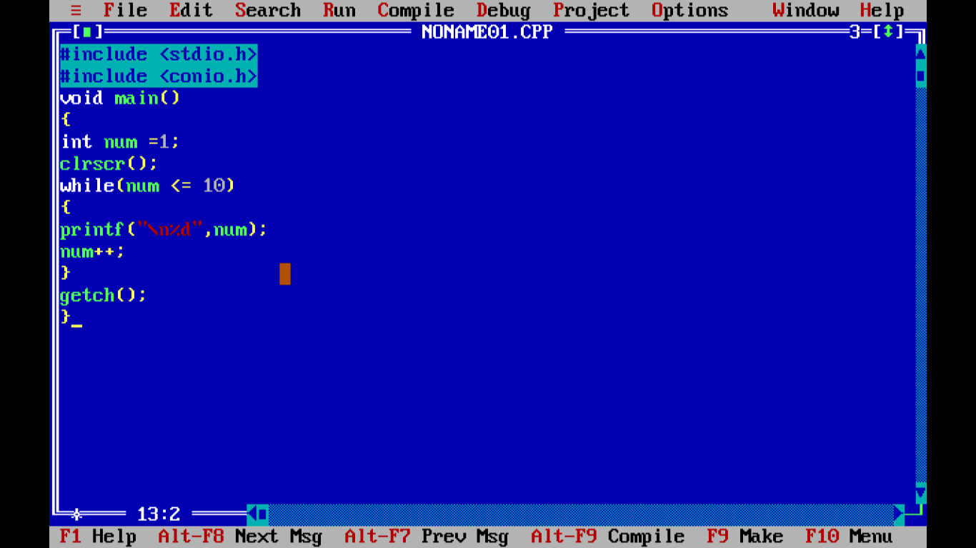

1. WAP to print numbers from 1 to 5

