**Graded Project on Orchestration and Scaling**

Step 1: Set Up the AWS Environment

1. Set Up AWS CLI and Boto3:

* Install AWS CLI and configure it with AWS credentials.
* Install Boto3 for Python and configure it.
  + pip install boto3
  + sudo apt install awscli

Step 2: Prepare the MERN Application

1. Containerize the MERN Application:

* Ensure the MERN application is containerized using Docker. Create a Dockerfile for each component (frontend and backend).

1. Push Docker Images to Amazon ECR:

* Build Docker images for the frontend and backend.
  + Create Dockerfile for all three services (code on git)
  + Build docker image
    - cd backend/helloservice
    - docker build -t samplemernwithmicroservices_helloservice .
    - cd backend /profileservice
    - docker build -t samplemernwithmicroservices_profileservice .
    - cd /frontend
    - docker build -t samplemernwithmicroservices_frontend .

Additionally, we can use docker-compose.yml to run and build the images.

* Create an Amazon ECR repository for each image.
  + aws configure
  + aws ecr create-repository --repository-name helloservice --region ap-south-1
  + aws ecr create-repository --repository-name profileservice --region ap-south-1
  + aws ecr create-repository --repository-name frontend --region ap-south-1
* Push the Docker images to their respective ECR repositories.
  + aws ecr get-login-password --region ap-south-1 | docker login --username AWS --password-stdin 471112564396.dkr.ecr.ap-south-1.amazonaws.com
  + docker tag samplemernwithmicroservices_helloservice:latest 471112564396.dkr.ecr.ap-south-1.amazonaws.com/helloservice:latest
  + docker tag samplemernwithmicroservices_profileservice:latest 471112564396.dkr.ecr.ap-south-1.amazonaws.com/profileservice:latest
  + docker tag samplemernwithmicroservices_frontend:latest 471112564396.dkr.ecr.ap-south-1.amazonaws.com/frontend:latest
  + docker push 471112564396.dkr.ecr.ap-south-1.amazonaws.com/helloservice:latest
  + docker push 471112564396.dkr.ecr.ap-south-1.amazonaws.com/profileservice:latest
  + docker push 471112564396.dkr.ecr.ap-south-1.amazonaws.com/frontend:latest

Step 3: Version Control

1. Use AWS CodeCommit:

* Create a CodeCommit repository.

* Push the MERN application source code to the CodeCommit repository.
  + git init
  + git remote add origin <https://git-codecommit.ap-south-1.amazonaws.com/v1/repos/MERN-App>
  + git add .
  + git commit -m "First Commit"
  + git push -u origin main

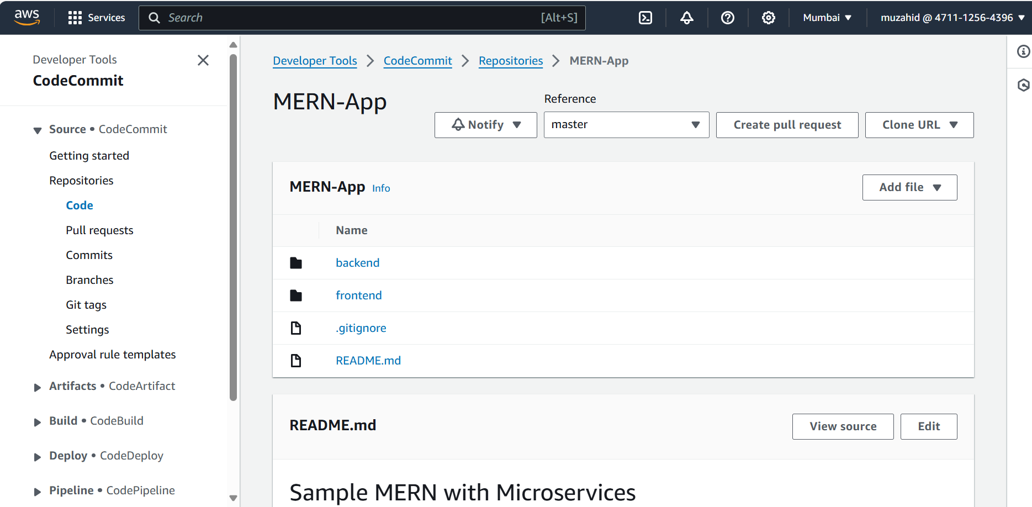

Step 4: Continuous Integration with Jenkins

1. Set Up Jenkins:

* Install Jenkins on an EC2 instance.
* Configure Jenkins with necessary plugins.

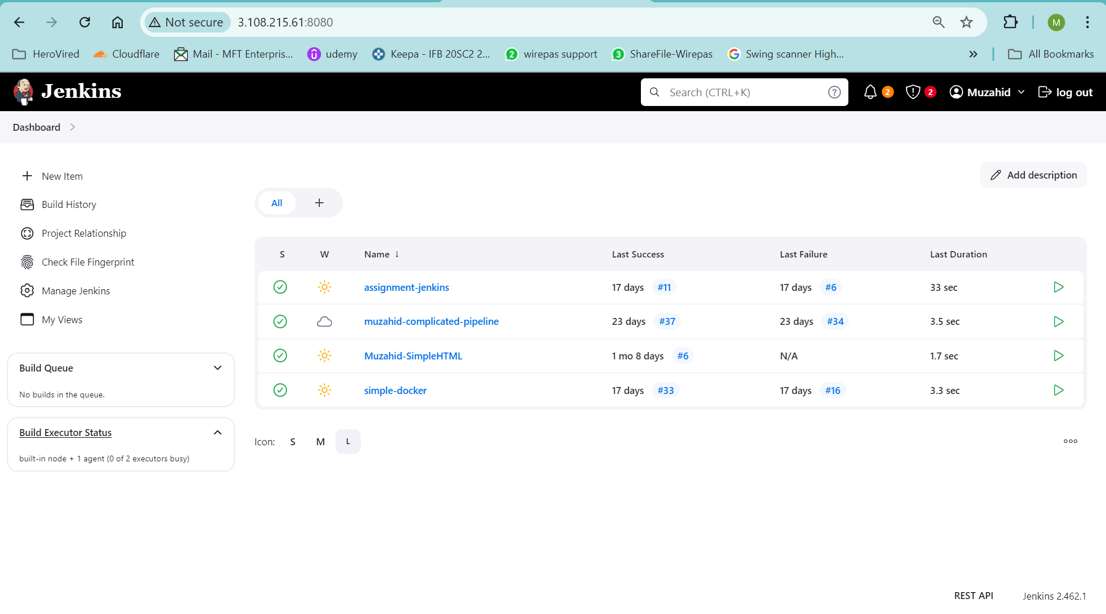

1. Create Jenkins Jobs:

* Create Jenkins jobs for building and pushing Docker images to ECR.
* Trigger the Jenkins jobs whenever there's a new commit in the Code Commit repository.

1. Add AWS Accesskey and codecommit HTTPS credential in Jenkins credential manager.

1. Create Jenkins Pipeline

1. The Jenkins code is in github repo.

Step 5: Infrastructure as Code (IaC) with Boto3

1. Define Infrastructure with Boto3 (Python Script):

* Use Boto3 to define the infrastructure (VPC, subnets, security groups).
* Define an Auto Scaling Group (ASG) for the backend.
* Create AWS Lambda functions if needed.

Code added in Github repo.

Step 6: Deploying Backend Services

1. Deploy Backend on EC2 with ASG:

* Use Boto3 to deploy EC2 instances with the Dockerized backend application in the ASG.

Code added in Github repo.

Step 7: Set Up Networking

1. Create Load Balancer:

* Set up an Elastic Load Balancer (ELB) for the backend ASG.

1. Configure DNS:

* Set up DNS using Route 53 or any other DNS service.

1. Create Target group for both helloservice and profileservice for port 3001 and 3002 respectively.

1. Create Network load balancer and attach both target group

Step 8: Deploying Frontend Services

1. Deploy Frontend on EC2:

* Use Boto3 to deploy EC2 instances with the Dockerized frontend application.

Code added in Github repo.

Step 9: AWS Lambda Deployment

1. Create Lambda Functions:

* Use Boto3 to create AWS Lambda functions for specific tasks within the application.
* Backup of Db using Lambda Functions and store in S3 bucket - put time stamping on the backup

Step 10: Kubernetes (EKS) Deployment

1. Create EKS Cluster:

* Use eksctl or other tools to create an Amazon EKS cluster.

1. Create EKS cluster

*eksctl create cluster --name my-cluster --region us-west-2 --nodegroup-name my-nodes --node-type t3.medium --nodes 2 --nodes-min 1 --nodes-max 4 –managed*

1. Update kubeconfig

*aws eks --region us-west-2 update-kubeconfig --name my-cluster*

1. Verify the cluster

*Kubectl get nodes*

1. Deploy Application with Helm:

* Use Helm to package and deploy the MERN application on EKS.

Helm file is added in github repository

Step 11: Monitoring and Logging

1. Set Up Monitoring:

* Use CloudWatch for monitoring and setting up alarms.

1. Configure Logging:

* Use CloudWatch Logs or another logging solution for collecting logs.