
Name: Muzamil Mushtaq
Roll no: SU92-BSAIM-F24-037
Section: BSAI-4A
Submitted To: Sir Rasikh Ali
Linkedin Post link: click here
Project Title: GenAI Resume Optimizer – Project Documentation
1. Project Overview:
GenAI Resume Optimizer is an AI-powered web application designed to help users improve their job application process. It allows users to upload their resume, receive professional analysis, generate a customized cover letter, and practice interviews using AI-generated questions and feedback.
This platform is especially useful for students, fresh graduates, and professionals who want to enhance their resumes and prepare for job interviews efficiently.

2. Main Dashboard Functionalities:
A. Resume Upload Module
The user can upload their resume in PDF or DOC/DOCX format through the dashboard.
Purpose:
- To collect resume data for AI analysis
- To extract user skills, education, and experience
- To begin the optimization process
User Interface:
- File Upload Button
- Resume Selection Area
- Analyze Resume Button

B. Resume Analysis System:
Once the resume is uploaded, the system analyzes the content using AI.
It checks:
- Skills and technologies mentioned
- Work experience details
- Education background
- Resume formatting and structure
- Important keywords for ATS systems
- Grammar and presentation quality
Output:
- Suggestions for improvement
- Missing keywords
- Better formatting recommendations
- Professional resume enhancement tips

C. Cover Letter Generator:
After resume analysis, the system automatically creates a professional cover letter based on the user’s profile.
Features:
- Personalized content
- Based on user skills and experience
- Professional tone
- Ready to use for job applications
Benefit:
Users save time and get a high-quality cover letter instantly.

D. AI Interview Questions Generator
The system generates 5 interview questions based on the uploaded resume.
Example Questions:
- Tell me about yourself.
- What are your strongest technical skills?
- Describe a project you worked on.
- Why do you want this job?
- How do you solve challenges under pressure?
Purpose:
These questions help users prepare for real interviews based on their own background.

E. Mock Interview Practice:
Users can practice answering interview questions directly on the dashboard.
Options:
- Type answers manually
- Speak answers using microphone
Benefit:
This creates a real interview-like environment and improves confidence.

F. Voice Recording Feature:
The dashboard includes a Record Voice button for spoken answers.
Functionality:
- User records verbal responses
- Helps improve speaking confidence
- Useful for communication practice

G. AI Feedback System:
After answering interview questions, users can click Get AI Feedback.
AI evaluates:
- Grammar accuracy
- Communication clarity
- Confidence level
- Relevance of answer
- Professional tone
Output:
Detailed feedback with suggestions for improvement.

3. Complete User Workflow:
- Open dashboard
- Upload resume
- Click Analyze Resume
- Get resume suggestions
- Generate cover letter
- Receive 5 interview questions
- Practice answers by text or voice
- Click Get AI Feedback
- Improve performance based on suggestions

4. Frontend Dashboard Components:
The dashboard includes:
- Resume Upload Section
- Analyze Resume Button
- Interview Practice Text Area
- Record Voice Button
- Get AI Feedback Button
- Clean and responsive user interface

5. Benefits of the Project:
- Saves time during job preparation
- Improves resume quality
- Generates professional cover letters
- Helps prepare for interviews
- Increases user confidence
- Personalized AI guidance

6. Future Enhancements:
Possible future improvements include:
- Resume score system
- Job description matching
- Downloadable PDF reports
- Live speech analysis
- Multi-language support
- Real-time ATS checker

7. Conclusion:
GenAI Resume Optimizer is a smart career support platform that combines resume improvement, cover letter generation, and interview preparation into one system. It provides users with an intelligent and practical solution for modern job searching using AI technology.
Project Dashboard screenshot:
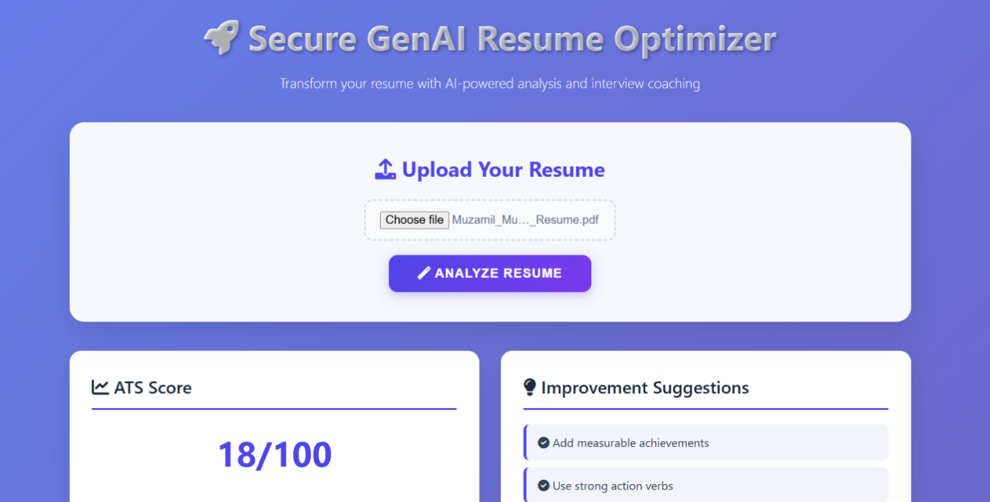
Thank you for viewing my work……

LinkedIn post link: https://www.linkedin.com/posts/muzamil-mushtaq38_ai-genai-machinelearning-ugcPost-7456726851361759232-tWIp?utm_source=share&utm_medium=member_desktop&rcm=ACoAAGUmjaABDEwvdPH6F9S86DmAWOqB-yd5axM

