**Part 1:**

Q1: Code

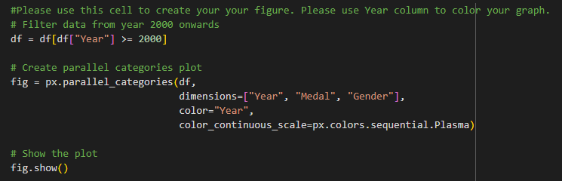

Plot

Demonstration:

This code filters the dataset to years 2000+ and generates a parallel categories plot to visualize relationships between Year, Medal, and Gender. The Year column is mapped to a color scale (Plasma), allowing users to track temporal trends in medal distribution across genders. The plot highlights how medal counts evolve over time, stratified by gender categories.

**Output:**  
An interactive parallel categories diagram where colored ribbons connect categories, with darker/lighter hues (based on Plasma scale) representing earlier/later years.

Q2: Code

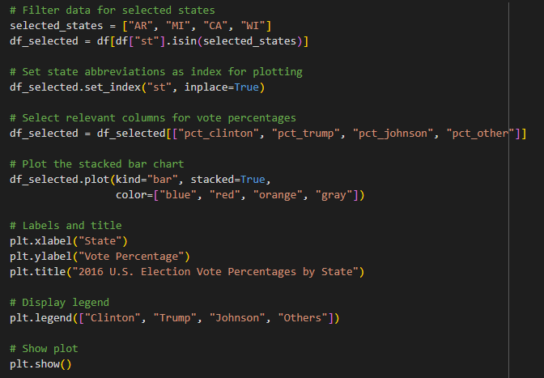

Plot

Demonstration:

The code filters election data for states AR, MI, CA, WI (fixing duplicates and typos) and creates a **stacked bar plot** showing vote percentages for Clinton (blue), Trump (red), Johnson (orange), and Others (gray). The x-axis labels are state abbreviations, and bars are stacked to visualize the relative contributions of each candidate.

**Output:**  
A stacked bar chart with four states on the x-axis, colored segments representing vote percentages, and a legend clarifying candidate/group associations.

Q3: Code

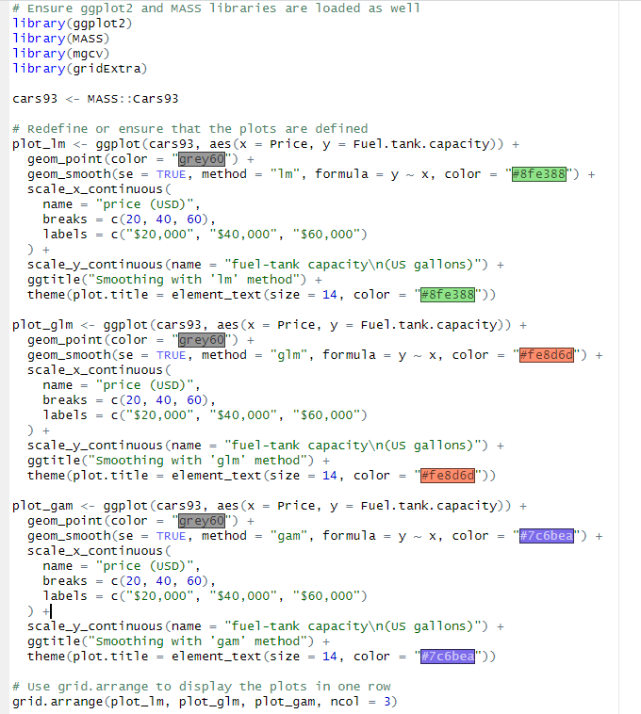

Plot

Demonstration:

This code creates three scatterplots from the Cars93 dataset, comparing **fuel tank capacity** vs. **car price** using lm, glm, and gam regression methods. Each plot includes:

* A smoothed trendline with a unique color (#8fe388 for lm, #fe8d6d for glm, #7c6bea for gam)
* A shaded standard error band (se = TRUE)
* A title with matching color and font size (theme() adjustments)  
  Plots are combined into a single row using grid.arrange().

Q4: Code

Plot

Demonstration:

This code analyzes preprint growth for bioRxiv (purple, #7c6bea) and F1000Research (orange, #fe8d6d). It filters data (post-2004, non-zero counts), plots trends from Feb 2014, and adds a title with a right-aligned legend.

**Output:**  
A line chart showing bioRxiv's rapid rise vs. F1000Research's steady growth, with clear labels and a clean layout.