

**Get the Fastest Approval on your**

**EPermit for Dubai**

We understand that obtaining permits and navigating complex regulations can be challenging. So, we offer expert and comprehensive Epermit services to individuals and businesses in the United Arab Emirates.

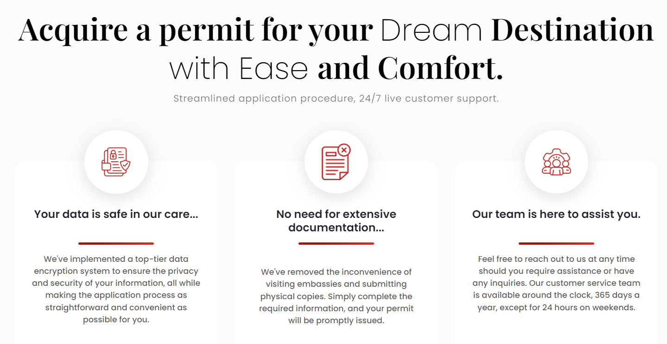

## ****Go To your Dream Destination EPermit in No Time****

Immediate Application Process & 24/7 Live Customer Support

## We prioritize your data security...

Enjoy a secure and convenient application process. Our top-notch encryption safeguards your data.

## No more embassy visits or paperwork...

Say goodbye to the inconvenience of physical applications. Apply online today for a fast and easy permit process.

## Feel free to reach out...

If you need help or have questions, please don't hesitate to contact our customer service team. They're available around the clock.

## Reviews and Testimonials

**Review 1**

Khalid Mohammed

Excellent service! Professional and friendly staff. My permit was issued within a few days. I highly recommend using ePermit Dubai.

**Review 2**

Amit Sharma

ePermit Dubai is a fantastic online service. I got my visa in just a few days. Their customer service representatives were very helpful.

**Review 3**

John Smith Riverra

I am really very impressed with the ePermit Dubai's e-application process. It was a straight and efficient ward, and I received my permit quickly. The customer support team was always available to answer my questions.

**Review 4**

Fatima Ali

Great experience! The ePermit Dubai team is very professional and helpful. They assisted me through every step of the application process.

**Review 5**

Priya Patel

ePermit Dubai made my visa application experience very easy. Their website is user-friendly, and their customer service team is very helpful.

**Review 6**

Brenda Coleson

I highly recommend ePermit Dubai. They made the visa application process a breeze. Their customer service was top-notch, and I received my permit in record time.