**Project Title:** The Last Helldiver

**Group Members:**

* Muhammad Ateeb Ali (24K-0839)
* Syed Muhammad Muzammil Zaidi (24K-0887)

**Submission Date:** 24/04/2025

**1. Executive Summary**

**Overview:**  
"The Last Helldiver" is a 2D Battle Royale game designed in C++ using the SFML library. Developed as a semester project for Object-Oriented Programming, the game showcases OOP principles through gameplay mechanics like shooting, enemy AI, safe zones, and health tracking. The project simulates a single-player survival experience with dynamically shrinking zones and increasingly aggressive AI bots.

**Key Findings:**

* Demonstrated deep integration of OOP concepts: encapsulation, inheritance, and abstraction.
* Delivered a fully interactive graphical application using SFML.

**2. Introduction**

**Background:**  
Battle Royale games have revolutionized the gaming world, combining survival instincts with tactical engagement. However, such games are often resource-intensive. "The Last Helldiver" simplifies the genre into a compact 2D experience using C++, focusing on core survival elements and OOP practices.

**Project Objectives:**

* Implement a playable single-player battle royale.
* Apply OOP concepts: encapsulation, inheritance, and polymorphism.
* Build core features: movement, AI, shooting, UI, and safe zone mechanics.

**3. Project Description**

**Scope:**  
**Included:**

* Player class and controls
* Enemy AI and behavior
* Bullet physics and collision
* Safe zone implementation

**Excluded:**

* Multiplayer
* Advanced animation
* Sound effects (planned but not integrated)
* HUD for health and score

**Technical Overview:**

* **Language:** C++
* **Library:** SFML
* **IDE:** Visual Studio Code
* **Version Control:** Git (private repo)

**4. Methodology**

**Approach:**  
The project followed an agile-inspired weekly cycle. After initial planning and diagramming, each week was used to develop one major feature, followed by testing and integration.

**Roles and Responsibilities:**

* **Muhammad Ateeb Ali:** Player movement, bullet shooting system, SFML integration (through GCR tutorial)
* **Syed Muhammad Muzammil Zaidi:** Enemy AI, safe zone logic

**5. Project Implementation**

**Design and Structure:**

* Entity (base class for all game objects)
* Player, Enemy, and Bullet inherit from Entity
* SafeZone class encapsulates logic for the shrinking survival circle

**Functionalities Developed:**

* WASD player movement
* Left-click bullet shooting
* Random enemy spawning and movement toward player
* Shrinking safe zone damage

**Challenges Faced:**

* Game not getting over when losing
* The player not getting damage
* Safe zone not shrinking

**6. Results**

**Project Outcomes:**

* Fully playable 2D battle royale game
* Proper usage of OOP principles in all components

**Testing and Validation:**

* Manual testing with different parameters to give the user the best experience

**Screenshots:**

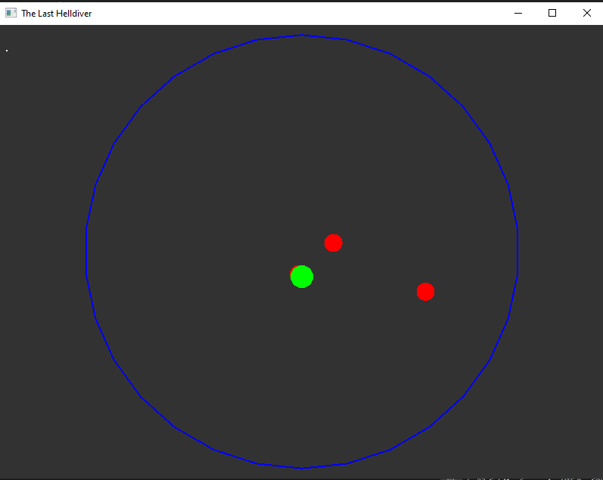

**7. Conclusion**

**Summary of Findings:**  
The Last Helldiver meets all project goals and showcases the power of OOP in game development. It really gave us a stroll in the park of the enchanted world of coding.

**Final Remarks:**  
The project was both an enjoyable and intellectually rewarding experience. It pushed our learning till many extremes. In Future, many features can be added like multiplayer, sounds, and power-ups.