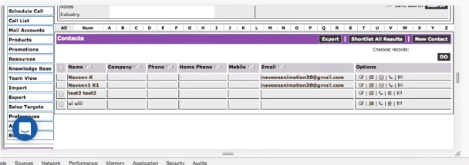

Click on checkbox corresponding to test2 test2

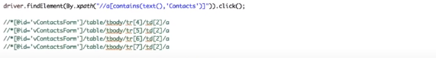

**First Way:**

String before_xpath= “//*id= ‘vContactsForm’]/ table/ tbody/tr [ ”;

String after_xpath= ” ] /td[**2**]/a ”;

for(int i=4; i<=7; i++)

{ String xpath = before_xpath + i + after_xpath;

String name= driver.findElement (By.xpath (xpath)) .getText();

Syso(name);

If (name. contains(“test2 test2”))

{ //i=6

//below is the xpath of checkbox

Driver.findElement(By. Xpath ( “//*id= ‘vContactsForm’]/ table/ tbody/tr[” + i + “ ] /td[**1**]/input ” )).click()

}

}

Second Way: Learn from Naveen automation post your interview