 | National University  of Computer and Emerging Sciences  Chiniot-Faisalabad Campus  Department of Artificial Intelligence and Data Science | 
Course Code | AI4002
Course Title | Computer Vision – Lab
Lab Task | 1
Due Date | 02 September 2025
Instructions:
- Rename this Word file as LT1_22F0007
- If found plagiarism, straight zero will be marked against task.
- Submit task on Due Date. No Late Submission will be Tolerated.

Question 1
Write a python code that traverse a 2D Matrix. Multiply even number by 10 and odd number by 7. Print the Output in a Matrix form.
Code
# Sample matrix
matrix = [
[1, 2, 3],
[4, 5, 6],
[7, 8, 9]
]

# Processed result matrix
result = []

for row in matrix:
new_row = []
for element in row:
if element % 2 == 0: # even
new_row.append(element * 10)
else: # odd
new_row.append(element * 7)
result.append(new_row)

# Print output in matrix form
print("Original Matrix:")
for row in matrix:
print(row)

print("\nProcessed Matrix:")
for row in result:
print(row)
Screenshot
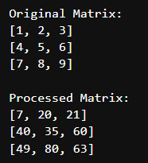

Question 2
Write a python code that divide image into Red, Green, Blue channels and merge as Green, Blue, Red channels to make a new image. GBR means Green will be first channel, Blue will be second and Red will be the third one.
Code
import cv2
print(cv2.__version__)
import matplotlib.pyplot as plt

# Read the image
image = cv2.imread("unnamed.jpg")

# Convert BGR (OpenCV default) to RGB for display
image_rgb = cv2.cvtColor(image, cv2.COLOR_BGR2RGB)

print(image_rgb.shape)

# Split into channels (BGR order in OpenCV)
b, g, r = cv2.split(image)
print(b)
print(b.shape)

# Merge channels in GBR order
gbr_image = cv2.merge([g, b, r])

# Convert GBR to RGB for proper display in matplotlib
gbr_rgb = cv2.cvtColor(gbr_image, cv2.COLOR_BGR2RGB)

# Show both images side by side
plt.figure(figsize=(10, 5))

plt.subplot(1, 2, 1)
plt.imshow(image_rgb)
plt.title("Original Image (RGB)")
plt.axis("off")

plt.subplot(1, 2, 2)
plt.imshow(gbr_rgb)
plt.title("GBR Image")
plt.axis("off")

plt.show()

Screenshot
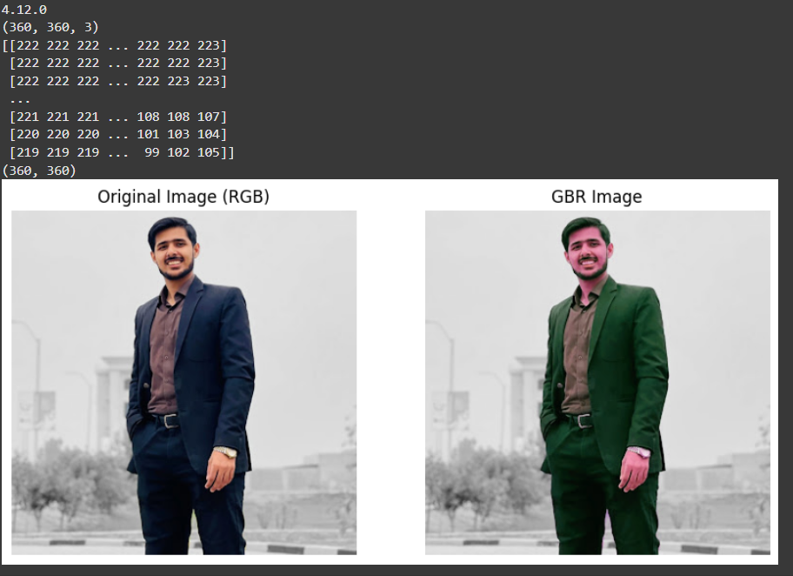

Question 3
Write a python code to traverse an image and inverse its pixel intensity to make a resultant image aka negative image. And show both images side by side (1 by 2).
Hint: (Out = 255 – In)
Code
import cv2
import matplotlib.pyplot as plt

# Read the image (in grayscale or color)
image = cv2.imread("unnamed.jpg", cv2.IMREAD_GRAYSCALE) # grayscale for clarity

# Create negative image
negative_image = 255 - image

# Show original and negative images side by side
plt.figure(figsize=(10, 5))

plt.subplot(1, 2, 1)
plt.imshow(image, cmap='gray')
plt.title("Original Image")
plt.axis("off")

plt.subplot(1, 2, 2)
plt.imshow(negative_image, cmap='gray')
plt.title("Negative Image")
plt.axis("off")

plt.show()

Screenshot
