 | National University  of Computer and Emerging Sciences  Chiniot-Faisalabad Campus  Department of Artificial Intelligence and Data Science | 
Course Code | AI4002
Course Title | Computer Vision – Lab
Lab Task | 3
Due Date | 16 September 2025
Instructions:
- Rename this Word file as LT2_22F0007
- If found plagiarism, straight zero will be marked against task.
- Submit task on Due Date. No Late Submission will be Tolerated.

Question 1
Write a python code that traverse a grayscale 2D Image. Make a 5x5 Gaussian Average Filter and Convolve with that Image. At the End Original Image with Average Image will be shown side by side.
1 | 1 | 2 | 1 | 1
1 | 2 | 4 | 2 | 1
2 | 4 | 8 | 4 | 2
1 | 2 | 4 | 2 | 1
1 | 1 | 2 | 1 | 1
Hint:

$$Average Filter= \frac{1}{25}$$

Code 1 (Gaussian Filter with 1/25)
import cv2
import numpy as np
import matplotlib.pyplot as plt

img_rgb = cv2.imread("unnamed.jpg")
img_rgb = cv2.cvtColor(img_rgb, cv2.COLOR_BGR2RGB)

img = cv2.cvtColor(img_rgb, cv2.COLOR_RGB2GRAY)

gaussian_kernel = np.array([[1, 1, 2, 1, 1],
[1, 2, 4, 2, 1],
[2, 4, 8, 4, 2],
[1, 2, 4, 2, 1],
[1, 1, 2, 1, 1]], dtype=np.float32)

gaussian_kernel = gaussian_kernel / 25.0

pad = 2
padded = np.pad(img, pad, mode='constant')

filtered = np.zeros_like(img, dtype=np.float32)

for i in range(img.shape[0]):
for j in range(img.shape[1]):
region = padded[i:i+5, j:j+5]
filtered[i, j] = np.sum(region * gaussian_kernel)

filtered = np.clip(filtered, 0, 255).astype(np.uint8)

plt.figure(figsize=(10,5))
plt.subplot(1,2,1)
plt.title("Original Grayscale Image")
plt.imshow(img, cmap='gray')
plt.axis("off")

plt.subplot(1,2,2)
plt.title("5x5 Gaussian Filtered")
plt.imshow(filtered, cmap='gray')
plt.axis("off")

plt.show()

Screenshot 1
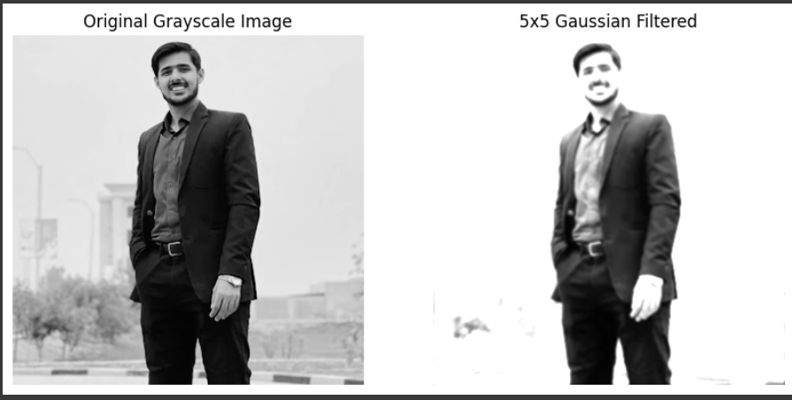
Code 2 (Gaussian Filter with sum)
import cv2
import numpy as np
import matplotlib.pyplot as plt

img_rgb = cv2.imread("unnamed.jpg")
img_rgb = cv2.cvtColor(img_rgb, cv2.COLOR_BGR2RGB)

img = cv2.cvtColor(img_rgb, cv2.COLOR_RGB2GRAY)

gaussian_kernel = np.array([[1, 1, 2, 1, 1],
[1, 2, 4, 2, 1],
[2, 4, 8, 4, 2],
[1, 2, 4, 2, 1],
[1, 1, 2, 1, 1]], dtype=np.float32)

gaussian_kernel /= gaussian_kernel.sum()

pad = 2
padded = np.pad(img, pad, mode='constant')

filtered = np.zeros_like(img, dtype=np.float32)

for i in range(img.shape[0]):
for j in range(img.shape[1]):
region = padded[i:i+5, j:j+5]
filtered[i, j] = np.sum(region * gaussian_kernel)

filtered = np.clip(filtered, 0, 255).astype(np.uint8)

plt.figure(figsize=(10,5))
plt.subplot(1,2,1)
plt.title("Original Grayscale Image")
plt.imshow(img, cmap='gray')
plt.axis("off")

plt.subplot(1,2,2)
plt.title("5x5 Gaussian Filtered")
plt.imshow(filtered, cmap='gray')
plt.axis("off")

plt.show()

Screenshot 2
