 | National University  of Computer and Emerging Sciences  Chiniot-Faisalabad Campus  Department of Artificial Intelligence and Data Science | 
Course Code | AI4002
Course Title | Computer Vision – Lab
Lab Task | 5
Due Date | 17 September 2025
Instructions:
- Rename this Word file as LT5_22F0007
- If found plagiarism, straight zero will be marked against task.
- Submit task on Due Date. No Late Submission will be Tolerated.

Question 1
Write a Python code that reads the attached 2D Grayscale Image (wheel.png). Use the OpenCV library to extract the edges of that image. Use:
- Sobel Filter (H & V & H+V)
- Prewitt (H & V)
- Scharr (H & V)
- Canny

At the End, the Original Image with these edge detection algorithms, will be shown side by side, like shown in attached sample output.

Hint: Explore https://www.theobjects.com/dragonfly/dfhelp/3-5/Content/05_Image%20Processing/Edge%20Detection%20Filters.htm

Original Image | Sobel (Horizontal) | Sobel (Vertical)
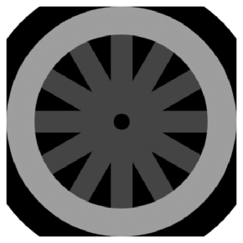 | 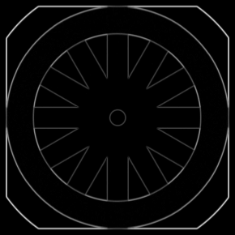 | 
Sobel (H + V) | Prewitt (Horizontal) | Prewitt (Vertical)
 | 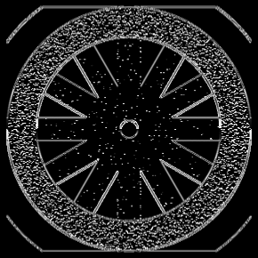 | 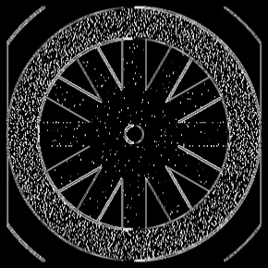
Canny | Scharr (Horizontal) | Scharr (Vertical)
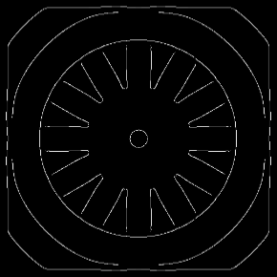 | 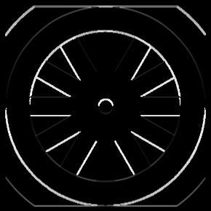 | 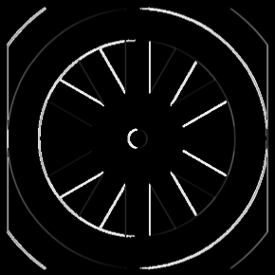

Code
import cv2
import numpy as np
import matplotlib.pyplot as plt

img = cv2.imread('wheel.png', cv2.IMREAD_GRAYSCALE)

sobel_x = cv2.Sobel(img, cv2.CV_64F, 1, 0, ksize=3)
sobel_y = cv2.Sobel(img, cv2.CV_64F, 0, 1, ksize=3)
sobel_v = cv2.convertScaleAbs(sobel_x)
sobel_h = cv2.convertScaleAbs(sobel_y)
sobel_hv = cv2.addWeighted(sobel_h, 0.5, sobel_v, 0.5, 0)

prewitt_x = np.array([[-1, 0, 1],
[-1, 0, 1],
[-1, 0, 1]], dtype=np.float32)
prewitt_y = np.array([[1, 1, 1],
[0, 0, 0],
[-1, -1, -1]], dtype=np.float32)
prewitt_v = cv2.convertScaleAbs(cv2.filter2D(img, cv2.CV_64F, prewitt_x))
prewitt_h = cv2.convertScaleAbs(cv2.filter2D(img, cv2.CV_64F, prewitt_y))

scharr_x = cv2.Scharr(img, cv2.CV_64F, 1, 0)
scharr_y = cv2.Scharr(img, cv2.CV_64F, 0, 1)
scharr_v = cv2.convertScaleAbs(scharr_x)
scharr_h = cv2.convertScaleAbs(scharr_y)

canny = cv2.Canny(img, 100, 200)

fig, axs = plt.subplots(3, 3, figsize=(14, 14))
images = [img, sobel_h, sobel_v, sobel_hv, prewitt_h, prewitt_v, scharr_h, scharr_v, canny]
titles = ['Original', 'Sobel H', 'Sobel V', 'Sobel H+V', 'Prewitt H', 'Prewitt V', 'Scharr H', 'Scharr V', 'Canny']

for ax, im, title in zip(axs.ravel(), images, titles):
ax.imshow(im, cmap='gray')
ax.set_title(title)
ax.axis('off')

plt.tight_layout()
plt.show()

Screenshot
