 | National University  of Computer and Emerging Sciences  Chiniot-Faisalabad Campus  Department of Artificial Intelligence and Data Science | 
Course Code | AI4002
Course Title | Computer Vision – Lab
Lab Task | 7
Due Date (A Section) | 09:00 pm - 07 October 2025
Due Date (B Section) | 09:00 pm - 10 October 2025
Instructions:
- Rename this Word file as LT7_22F0000
- If found plagiarism, straight zero will be marked against task.
- Submit task on Due Date. No Late Submission will be Tolerated.

Question 1
Write a Python code that reads the attached 2D Binary Images. Use the OpenCV library to implement different Morphological Operations like:
- Erosion
- Dilation
- Opening
- Closing
- Boundary (Internal)
- Boundary (External)

At the End, the Original Image with each Operation, will be shown side by side.

Note: Structural Element size and shape is your choice, but you should have the reason.

Code 1
import cv2
import numpy as np
import matplotlib.pyplot as plt

img = cv2.imread("blobs.png", cv2.IMREAD_GRAYSCALE)

_, binary = cv2.threshold(img, 127, 255, cv2.THRESH_BINARY)

kernel = cv2.getStructuringElement(cv2.MORPH_RECT, (3,3))

erosion = cv2.erode(binary, kernel, iterations=1)
dilation = cv2.dilate(binary, kernel, iterations=1)
opening = cv2.morphologyEx(binary, cv2.MORPH_OPEN, kernel)
closing = cv2.morphologyEx(binary, cv2.MORPH_CLOSE, kernel)
internal_boundary = cv2.subtract(binary, erosion)
external_boundary = cv2.subtract(dilation, binary)

operations = {
"Erosion": erosion,
"Dilation": dilation,
"Opening": opening,
"Closing": closing,
"Internal Boundary": internal_boundary,
"External Boundary": external_boundary
}

plt.figure(figsize=(12, 15))

for i, (title, img_op) in enumerate(operations.items(), 1):
plt.subplot(len(operations), 2, 2*i - 1)
plt.imshow(binary, cmap='gray')
plt.title("Original Image")
plt.axis("off")

plt.subplot(len(operations), 2, 2*i)
plt.imshow(img_op, cmap='gray')
plt.title(title)
plt.axis("off")

plt.tight_layout()
plt.show()

Screenshot 1
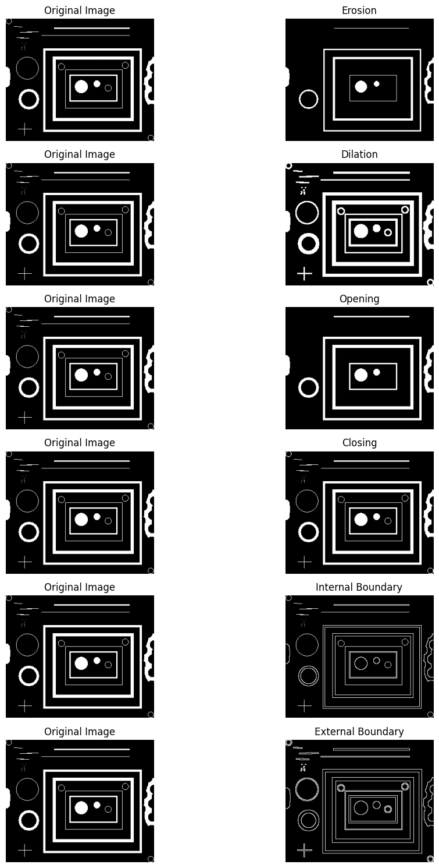
Code 2
import cv2
import numpy as np
import matplotlib.pyplot as plt

img = cv2.imread("wirebond.tif", cv2.IMREAD_GRAYSCALE)

_, binary = cv2.threshold(img, 127, 255, cv2.THRESH_BINARY)

kernel = cv2.getStructuringElement(cv2.MORPH_RECT, (3,3))

erosion = cv2.erode(binary, kernel, iterations=1)
dilation = cv2.dilate(binary, kernel, iterations=1)
opening = cv2.morphologyEx(binary, cv2.MORPH_OPEN, kernel)
closing = cv2.morphologyEx(binary, cv2.MORPH_CLOSE, kernel)
internal_boundary = cv2.subtract(binary, erosion)
external_boundary = cv2.subtract(dilation, binary)

operations = {
"Erosion": erosion,
"Dilation": dilation,
"Opening": opening,
"Closing": closing,
"Internal Boundary": internal_boundary,
"External Boundary": external_boundary
}

plt.figure(figsize=(12, 15))

for i, (title, img_op) in enumerate(operations.items(), 1):
plt.subplot(len(operations), 2, 2*i - 1)
plt.imshow(binary, cmap='gray')
plt.title("Original Image")
plt.axis("off")

plt.subplot(len(operations), 2, 2*i)
plt.imshow(img_op, cmap='gray')
plt.title(title)
plt.axis("off")

plt.tight_layout()
plt.show()

Screenshot 2
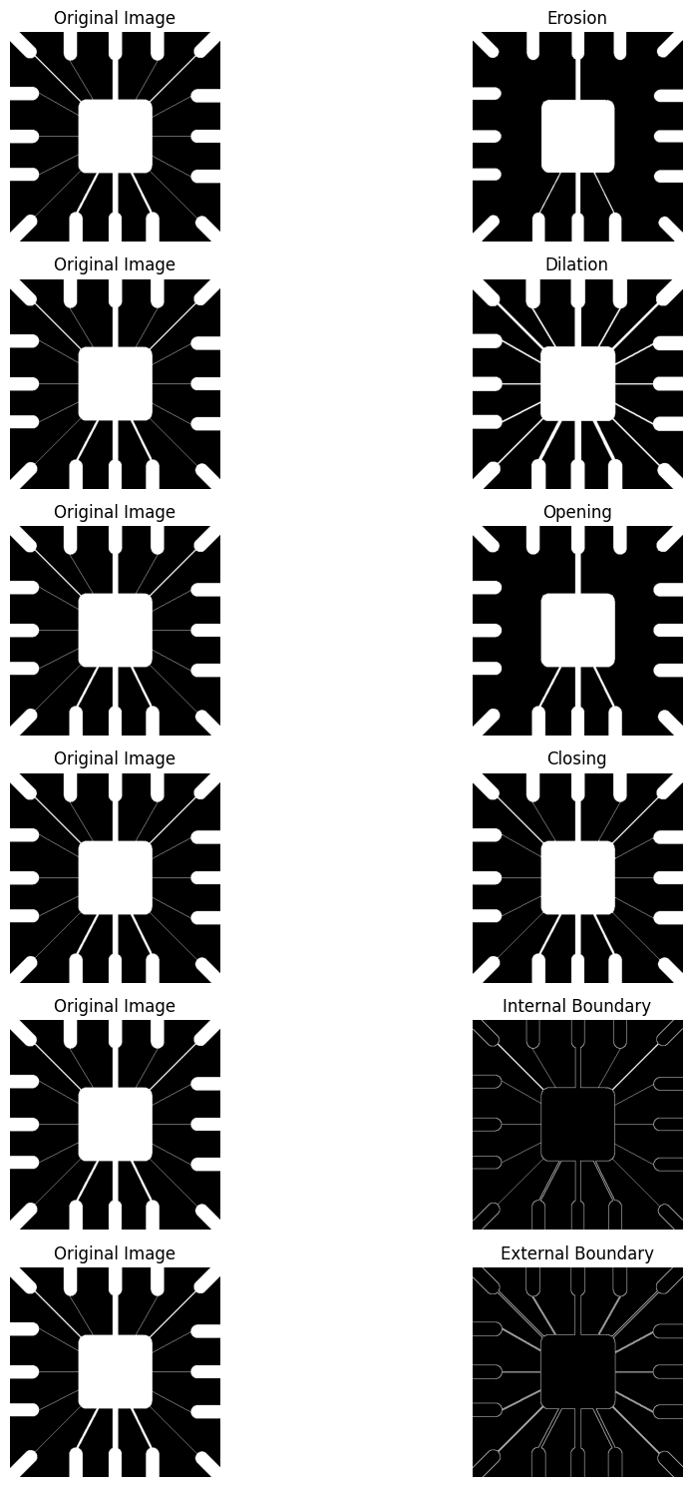

Question 2
Write a Python code that reads the attached 2D Grayscale Images. Use the OpenCV library to:
Apply thresholding to get the liquid as a white object
Apply the appropriate morphological operation to remove noise
Find the area of the liquid
Highlight the boundary of the bottle with half/low liquid
At the End, the Original Image with the Highlighted Image will be shown side by side.

Code
import cv2
import numpy as np
import matplotlib.pyplot as plt

img = cv2.imread("bottles.jpg", cv2.IMREAD_GRAYSCALE)

_, thresh = cv2.threshold(img, 130, 255, cv2.THRESH_BINARY_INV)

kernel = np.ones((5, 5), np.uint8)
opened = cv2.morphologyEx(thresh, cv2.MORPH_OPEN, kernel)
clean = cv2.morphologyEx(opened, cv2.MORPH_CLOSE, kernel)

contours, _ = cv2.findContours(clean, cv2.RETR_EXTERNAL, cv2.CHAIN_APPROX_SIMPLE)

highlighted = cv2.cvtColor(img, cv2.COLOR_GRAY2BGR)

contours = sorted(contours, key=lambda c: cv2.boundingRect(c)[0])

areas = []
for i, cnt in enumerate(contours):
x, y, w, h = cv2.boundingRect(cnt)

if w < 50 or h < 100:
continue

bottle_region = clean[y:y+h, x:x+w]
area = cv2.countNonZero(bottle_region)
areas.append(area)

cv2.putText(highlighted, f"B{i+1}", (x + w//2 - 10, y - 10),
cv2.FONT_HERSHEY_SIMPLEX, 0.6, (255, 255, 0), 2)

max_area = max(areas)
threshold_area = 0.8 * max_area

for i, cnt in enumerate(contours):
x, y, w, h = cv2.boundingRect(cnt)
if w < 50 or h < 100:
continue
area = cv2.countNonZero(clean[y:y+h, x:x+w])

if area < threshold_area:
color = (255, 0, 0)
label = "Low"
else:
color = (0, 255, 0)
label = "Full"

cv2.drawContours(highlighted, [cnt], -1, color, 2)
cv2.putText(highlighted, f"{label}: {area}", (x, y + h + 20),
cv2.FONT_HERSHEY_SIMPLEX, 0.5, color, 2)

print(f"Bottle {i+1}: Area = {area} -> {label}")

plt.figure(figsize=(12, 6))
plt.subplot(1, 2, 1)
plt.title("Original Image")
plt.imshow(img, cmap='gray')
plt.axis('off')

plt.subplot(1, 2, 2)
plt.title("Highlighted Bottles (Full vs Low)")
plt.imshow(cv2.cvtColor(highlighted, cv2.COLOR_BGR2RGB))
plt.axis('off')

plt.tight_layout()
plt.show()

Screenshot
