 | National University  of Computer and Emerging Sciences  Chiniot-Faisalabad Campus  Department of Artificial Intelligence and Data Science | 
Course Code | AI4002
Course Title | Computer Vision – Lab
Lab Task | 8
Due Date (A Section) | 09:00 pm - 14 October 2025
Due Date (B Section) | 09:00 pm - 17 October 2025
Instructions:
- Rename this Word file as LT8_22F0000
- If found plagiarism, straight zero will be marked against task.
- Submit task on Due Date. No Late Submission will be Tolerated.

Question 1
The SIFT algorithm extracts feature descriptors around interest points in an image to uniquely describe their local texture patterns. Consider a single grayscale image and a single interest point located at coordinates (x, y). You are required to extract a 128- dimensional SIFT feature descriptor around this interest point.

Write Python code for extracting a 128-dimensional descriptor around one interest
point using the following assumptions:
- Image gradients Gx and Gy are already computed.
- Feature point = (x, y).
- Window size = 16×16.
- Sub-block size = 4×4.
- Orientation bins = 8.
Write a Python function that performs descriptor extraction as described above:
import numpy as np
def compute_descriptor(Gx, Gy, x, y):
# Your code here
return descriptor # shape (128,)
The function should:
1. Take gradient matrices Gx, Gy and interest point (x, y).
2. For each 4×4 block in the 16×16 window:
o Compute gradient magnitude and orientation.
o Build an 8-bin histogram.
3. Concatenate all 16 histograms to form the 128-dimensional vector.
Code
import cv2
import numpy as np
import matplotlib.pyplot as plt

def compute_descriptor(Gx, Gy, x, y):

window_size = 16
block_size = 4
num_bins = 8
half = window_size // 2

Gx_win = Gx[y - half:y + half, x - half:x + half]
Gy_win = Gy[y - half:y + half, x - half:x + half]

if Gx_win.shape != (16, 16) or Gy_win.shape != (16, 16):
raise ValueError("Interest point too close to border for a 16x16 window.")

mag = np.sqrt(Gx_win**2 + Gy_win**2)
ang = (np.degrees(np.arctan2(Gy_win, Gx_win)) + 360) % 360

descriptor = []

for i in range(0, 16, block_size):
for j in range(0, 16, block_size):
sub_mag = mag[i:i+block_size, j:j+block_size]
sub_ang = ang[i:i+block_size, j:j+block_size]

hist = np.zeros(num_bins, dtype=float)
for u in range(block_size):
for v in range(block_size):
bin_idx = int(sub_ang[u, v] // (360.0 / num_bins)) % num_bins
hist[bin_idx] += sub_mag[u, v]

descriptor.extend(hist)

descriptor = np.array(descriptor, dtype=float)

norm = np.linalg.norm(descriptor)
if norm > 1e-6:
descriptor /= norm

return descriptor

if __name__ == "__main__":

img_path = "dog_grayscale.jpeg"

img = cv2.imread(img_path, cv2.IMREAD_GRAYSCALE)
if img is None:
raise FileNotFoundError(f"Could not read image at '{img_path}'")

h, w = img.shape

x = w // 2
y = h // 2
half = 8

x = max(half, min(w - half - 1, x))
y = max(half, min(h - half - 1, y))

Gx = cv2.Sobel(img, cv2.CV_64F, 1, 0, ksize=3)
Gy = cv2.Sobel(img, cv2.CV_64F, 0, 1, ksize=3)

descriptor = compute_descriptor(Gx, Gy, x, y)
print("Descriptor shape:", descriptor.shape)
print("First 12 descriptor values:", np.round(descriptor[:12], 4))

patch = img[y - half:y + half, x - half:x + half].copy()

img_rgb = cv2.cvtColor(img, cv2.COLOR_GRAY2RGB)
top_left = (x - half, y - half)
bottom_right = (x + half - 1, y + half - 1)

cv2.rectangle(img_rgb, top_left, bottom_right, (255, 0, 0), 1)

scale = 8
patch_big = cv2.resize(patch, (16*scale, 16*scale), interpolation=cv2.INTER_NEAREST)

fig, axes = plt.subplots(1, 2, figsize=(6, 3))
axes[0].imshow(img_rgb)
axes[0].set_title("Original Image (red = 16×16 window)")
axes[0].axis('off')

axes[1].imshow(patch_big, cmap='gray', vmin=0, vmax=255)
axes[1].set_title("Extracted 16×16 Patch (enlarged)")
axes[1].axis('off')

plt.tight_layout()
plt.show()

Screenshot
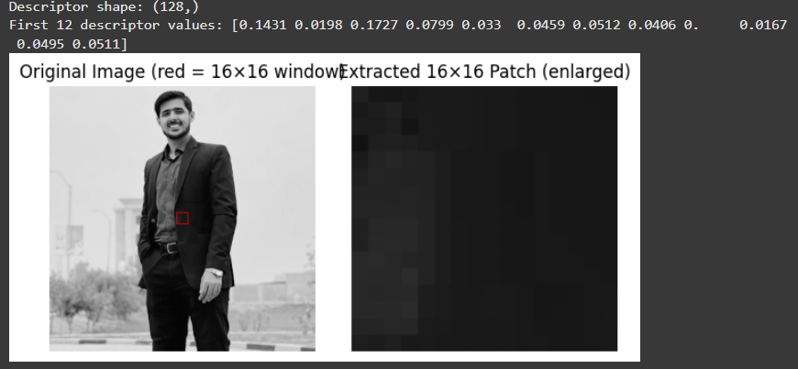

Question 2
The Histogram of Oriented Gradients (HOG) is a feature descriptor used to capture local shape information from an image by analyzing the distribution of intensity gradients or edge directions. You are required to develop and explain the process of extracting a HOG feature descriptor from a grayscale image for one detection window.

Write a Python program (without using built-in HOG functions) to:
1. Convert a grayscale image into gradients using Sobel operators.
2. Compute the gradient magnitude and orientation for each pixel.
3. Divide the image into 8×8 pixel cells.
4. For each cell, build a histogram of gradient orientations (0°–180°) with 9 bins.
5. Group 2×2 cells into a block and normalize the histogram values.
6. Concatenate all normalized histograms into one HOG feature vector.
You may test your code on a simple 128×128 pixel grayscale image.
Code
import cv2
import numpy as np
import matplotlib.pyplot as plt
from skimage.feature import hog

img = cv2.imread('LION.jpg')
img_gray = cv2.cvtColor(img, cv2.COLOR_BGR2GRAY)
img_gray = cv2.resize(img_gray, (128, 128))

Gx = cv2.Sobel(img_gray, cv2.CV_32F, 1, 0, ksize=3)
Gy = cv2.Sobel(img_gray, cv2.CV_32F, 0, 1, ksize=3)

magnitude = cv2.magnitude(Gx, Gy)
orientation = cv2.phase(Gx, Gy, angleInDegrees=True)
orientation = np.where(orientation > 180, orientation - 180, orientation)

hog_features, hog_image = hog(
img_gray,
orientations=9,
pixels_per_cell=(8, 8),
cells_per_block=(2, 2),
block_norm='L2-Hys',
visualize=True,
feature_vector=True
)

print("✅ HOG feature vector length:", len(hog_features))
print("First 15 feature values:", hog_features[:15])

fig, ax = plt.subplots(1, 4, figsize=(12, 4))

ax[0].imshow(img_gray, cmap='gray')
ax[0].set_title("Original Image")
ax[0].axis('off')

ax[1].imshow(magnitude, cmap='inferno')
ax[1].set_title("Gradient Magnitude")
ax[1].axis('off')

orientation_display = orientation / 180.0
ax[2].imshow(orientation_display, cmap='hsv')
ax[2].set_title("Gradient Orientation (0°–180°)")
ax[2].axis('off')

ax[3].imshow(hog_image, cmap='gray')
ax[3].set_title("HOG Visualization")
ax[3].axis('off')

plt.tight_layout()
plt.show()

Screenshot
