 | National University  of Computer and Emerging Sciences  Chiniot-Faisalabad Campus  Department of Artificial Intelligence and Data Science | 
Course Code | AI4002
Course Title | Computer Vision – Lab
Lab Task | 9
Due Date (A Section) | 09:00 pm - 21 October 2025
Due Date (B Section) | 09:00 pm - 24 October 2025
Instructions:
- Rename this Word file as LT9_22F0000
- If found plagiarism, straight zero will be marked against task.
- Submit task on Due Date. No Late Submission will be Tolerated.

Question 1
Image stitching is a process in computer vision and image processing where multiple images, typically of overlapping scenes, are combined to produce a single panoramic image. This technique involves aligning and blending the images to create a seamless and high-resolution composite.

Use the attached four images to practice image stitching technique using SIFT as feature descriptor. Use OpenCV in Python for Feature Detection, Feature Matching, and Image Warping.

Images Obtained from: https://support.captureone.com/hc/en-us/articles/4413050000785-Panorama-Stitching-Best-Practice

Helping Reads:
https://pyimagesearch.com/2018/12/17/image-stitching-with-opencv-and-python/
https://www.geeksforgeeks.org/computer-vision/image-stitching-with-opencv/

Code
import cv2
import numpy as np
import sys
from google.colab.patches import cv2_imshow

def stitch_images(img1, img2):
"""
Stitches img2 onto img1.
img1 is the 'base' image (e.g., left image).
img2 is the 'secondary' image (e.g., right image) that will be warped.
"""

print("Stitching images...")

# 1. Feature Detection and Description
# -------------------------------------
# Convert images to grayscale for feature detection
gray1 = cv2.cvtColor(img1, cv2.COLOR_BGR2GRAY)
gray2 = cv2.cvtColor(img2, cv2.COLOR_BGR2GRAY)

# Initialize the SIFT detector
# This is the Scale-Invariant Feature Transform
sift = cv2.SIFT_create()

# Find keypoints and descriptors with SIFT
# kp = keypoints (coordinates, size, orientation)
# des = descriptors (a 128-element vector for each keypoint)
kp1, des1 = sift.detectAndCompute(gray1, None)
kp2, des2 = sift.detectAndCompute(gray2, None)

print(f"Keypoints found in img1: {len(kp1)}")
print(f"Keypoints found in img2: {len(kp2)}")

# 2. Feature Matching
# -------------------
# We use BFMatcher (Brute-Force Matcher) with default params
# It will compare every descriptor from img1 with every descriptor from img2.
bf = cv2.BFMatcher()

# Use k-Nearest Neighbor matching (k=2)
# This finds the 2 best matches for each descriptor
matches = bf.knnMatch(des1, des2, k=2)

# Apply Lowe's Ratio Test to filter for good matches
# This is a crucial step to remove >90% of false matches.
# A good match (m) should be significantly better than the
# second-best match (n).
good_matches = []
for m, n in matches:
if m.distance < 0.75 * n.distance:
good_matches.append(m)

print(f"Good matches found: {len(good_matches)}")

# 3. Image Warping (Homography)
# -----------------------------
# We need at least 4 good matches to find the homography matrix.
# We'll use a more stable number, e.g., 10.
MIN_MATCH_COUNT = 10

if len(good_matches) > MIN_MATCH_COUNT:
# Extract the coordinates of the good matches from both images

# queryIdx is the index of the descriptor in des1 (img1)
# trainIdx is the index of the descriptor in des2 (img2)
src_pts = np.float32([ kp1[m.queryIdx].pt for m in good_matches ]).reshape(-1, 1, 2)
dst_pts = np.float32([ kp2[m.trainIdx].pt for m in good_matches ]).reshape(-1, 1, 2)

# Find the Homography matrix (H)
# H maps points from img2's coordinate system to img1's coordinate system
# cv2.RANSAC is a robust method (RANdom SAmple Consensus)
# that ignores outliers (bad matches) when calculating the transform.
H, mask = cv2.findHomography(dst_pts, src_pts, cv2.RANSAC, 5.0)

# (Optional) Draw matches to visualize
# matchesMask = mask.ravel().tolist()
# draw_params = dict(matchColor=(0, 255, 0), singlePointColor=None, matchesMask=matchesMask, flags=2)
# img_matches = cv2.drawMatches(img1, kp1, img2, kp2, good_matches, None, **draw_params)
# cv2.imshow("Good Matches", img_matches)
# cv2.waitKey(0)

# 4. Perform the Warp
# -------------------
# Get the dimensions of the images
h1, w1 = img1.shape[:2]
h2, w2 = img2.shape[:2]

# Create the 'canvas' for the final panorama
# The width is w1 + w2, and height is the max of h1 and h2
# (A more advanced method would transform the corners of img2 to find
# the exact required canvas size, but this is simpler.)

# We are warping img2 to align with img1
# The homography H maps img2_points -> img1_points
# So, we use cv2.warpPerspective on img2
result_canvas = cv2.warpPerspective(img2, H, (w1 + w2, h1))

# Place the base image (img1) on the left side of the canvas
result_canvas[0:h1, 0:w1] = img1

# Return the stitched image
return result_canvas

else:
print(f"Not enough good matches found - {len(good_matches)}/{MIN_MATCH_COUNT}")
return None

def crop_black_padding(img):
"""Crops the black padding from a stitched image."""
# Convert to grayscale and find the largest contour
gray = cv2.cvtColor(img, cv2.COLOR_BGR2GRAY)
_, thresh = cv2.threshold(gray, 1, 255, cv2.THRESH_BINARY)

contours, _ = cv2.findContours(thresh, cv2.RETR_EXTERNAL, cv2.CHAIN_APPROX_SIMPLE)

if not contours:
print("No content found in image.")
return img # Return original if no contours

# Find the bounding box of the largest contour
cnt = max(contours, key=cv2.contourArea)
x, y, w, h = cv2.boundingRect(cnt)

# Crop the image
return img[y:y+h, x:x+w]

# --- MAIN EXECUTION ---
if __name__ == "__main__":

# !!! IMPORTANT: CHANGE THESE FILE PATHS !!!
# Let's assume you are stitching 4 images in order: 1 -> 2 -> 3 -> 4
try:
img1 = cv2.imread('1.png')
img2 = cv2.imread('2.png')
img3 = cv2.imread('3.png')
img4 = cv2.imread('4.png')

# Check if images loaded
if img1 is None or img2 is None or img3 is None or img4 is None:
raise IOError("Could not load one or more images. Check file paths.")

except Exception as e:
print(e)
print("Please make sure your image files (image1.jpg, image2.jpg, etc.) are in the same directory.")
sys.exit(1)

print("--- Stitching Image 1 and 2 ---")
panorama_12 = stitch_images(img1, img2)
if panorama_12 is None:
print("Stitching failed for 1 & 2.")
sys.exit(1)

# Crop black padding before next stitch
panorama_12_cropped = crop_black_padding(panorama_12)
cv2_imshow(panorama_12_cropped)
cv2.waitKey(0)

print("\n--- Stitching (1+2) and 3 ---")
panorama_123 = stitch_images(panorama_12_cropped, img3)
if panorama_123 is None:
print("Stitching failed for 12 & 3.")
sys.exit(1)

panorama_123_cropped = crop_black_padding(panorama_123)
cv2_imshow(panorama_123_cropped)
cv2.waitKey(0)

print("\n--- Stitching (1+2+3) and 4 ---")
final_panorama = stitch_images(panorama_123_cropped, img4)
if final_panorama is None:
print("Stitching failed for 123 & 4.")
sys.exit(1)

# Crop the final result
final_panorama_cropped = crop_black_padding(final_panorama)

# --- Show and Save Final Result ---
print("\nStitching complete! Showing final panorama.")
cv2_imshow(final_panorama_cropped)
cv2.imwrite("final_panorama.jpg", final_panorama_cropped)
print("Final panorama saved as 'final_panorama.jpg'")

cv2.waitKey(0)
cv2.destroyAllWindows()

Screenshot
--- Stitching Image 1 and 2 ---
Stitching images...
Keypoints found in img1: 2401
Keypoints found in img2: 2190
Good matches found: 237
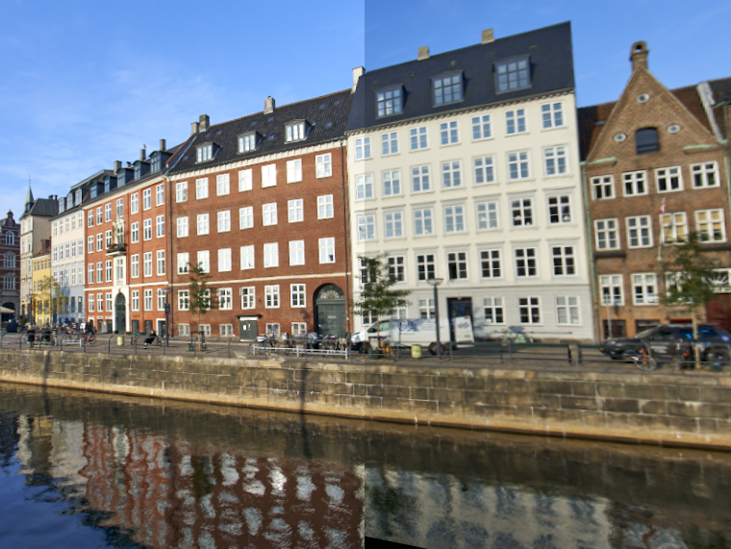

--- Stitching (1+2) and 3 ---
Stitching images...
Keypoints found in img1: 4581
Keypoints found in img2: 2448
Good matches found: 207
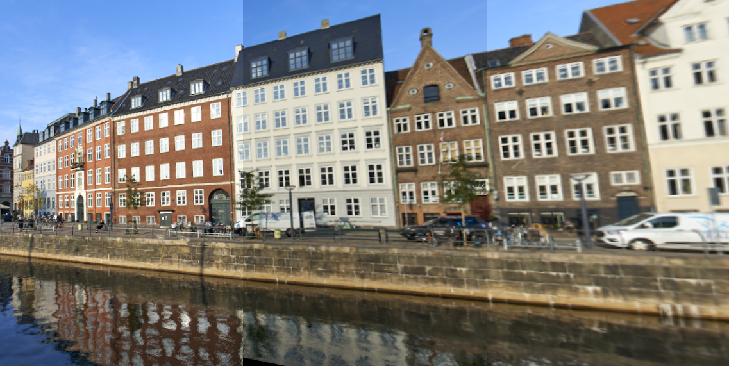
--- Stitching (1+2+3) and 4 ---
Stitching images...
Keypoints found in img1: 5631
Keypoints found in img2: 2323
Good matches found: 134

Stitching complete! Showing final panorama.
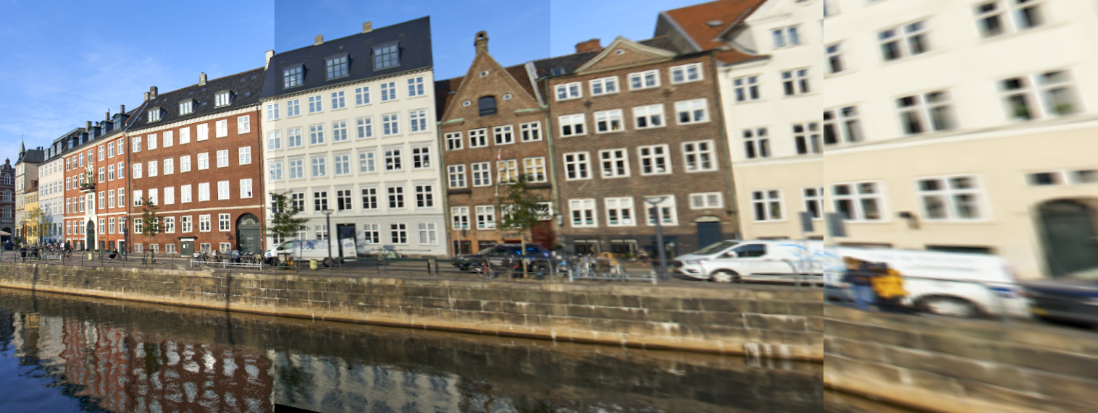
Final panorama saved as 'final_panorama.jpg'

