
NED University of Engineering and Technology
Department of Computer Science & Information Technology
CT-260 – Object Oriented Programming
Summer 2026
Complex Computing Problem (CCP) Report
Smart Expense Tracker System
A Web-Based Personal Finance Management Application
Group Members
Name | Roll Number
[Student Name 1] | [CT-XXXXX]
[Student Name 2] | [CT-XXXXX]
[Student Name 3] | [CT-XXXXX]

Submitted to: [Instructor Name]
Submission Date: 2 August 2026

Table of Contents

1. Problem Statement

1.1 Background
Personal financial management is a challenge for most individuals and small households. People typically track spending using paper notebooks, generic notes apps, or scattered spreadsheet files. These methods do not scale well, are error-prone, and provide no meaningful insight into spending habits over time.
To address this, our group has designed and is implementing the Smart Expense Tracker System, a web-based application built with Python (Django, Django REST Framework) on the backend and React on the frontend. The system allows a user to record income and expenses, organize them into categories, set monthly budgets, and view automatically generated reports and visual summaries of their financial activity.

1.2 Problem Description and Significance
Manual expense tracking suffers from several concrete issues that make it a genuine, non-trivial computing problem rather than a simple bookkeeping exercise:
- Data is scattered across notebooks, chat messages, or unrelated spreadsheet files, with no single source of truth.
- There is no automatic validation, so a user can log an impossible transaction (e.g., a negative amount, or an expense with no category).
- Different kinds of financial entries (a one-time expense, a recurring subscription, salary income) behave differently but are usually treated identically, leading to inaccurate summaries.
- Without a persistent, queryable data model, generating a report for “how much did I spend on food last month” requires manual, repeated effort.
- There is no automated mechanism to warn a user when spending approaches or exceeds a self-defined budget.
These issues are precisely the kind of problem Object-Oriented Programming is well suited to solve: the domain naturally decomposes into distinct entities (users, transactions, categories, budgets, reports) that have their own data, behaviour, and relationships to one another — which is the justification for using an OOP-based design, developed in the following sections.

1.3 Objectives
- Design an object-oriented domain model for personal expense/income tracking.
- Apply Encapsulation, Inheritance, Polymorphism, and Abstraction to structure the solution.
- Implement role-based access for regular users and administrators.
- Allow categorized transaction entry, budget definition, and automatic budget-threshold alerts.
- Generate spending reports and simple visual summaries (e.g., monthly, per-category).
- Persist all data in a relational database with a clean REST API separating frontend and backend concerns.

1.4 Scope
The system scope covers single-currency personal/household expense tracking: transaction entry (expenses and income), category management, budget definitions with threshold alerts, and report generation. It excludes multi-currency conversion, bank integration, and payment processing — these are discussed as future work in Section 6.

2. OOP Principles Identification
This is the central chapter of the report. All four OOP pillars are applied in the design of the Smart Expense Tracker System; each is identified below with a concrete justification tied to the domain, not just a textbook definition.

2.1 Encapsulation
Every core entity in the system — User, Transaction, Budget, Account — is implemented as a Django model class that bundles its data (fields) together with the logic that operates on that data (methods), and hides internal representation behind a controlled interface (model methods and DRF serializers), rather than exposing raw database rows to the frontend.
For example, an Account object never lets external code set its balance field directly; balance is only ever changed through deposit() and withdraw() methods, which can enforce invariants such as “balance cannot go negative”. This is what justifies calling it encapsulation rather than a plain data container: behaviour and validation travel with the data.
class Account(models.Model):
_balance = models.DecimalField(max_digits=12, decimal_places=2, default=0)

def deposit(self, amount):
if amount <= 0:
raise ValueError('Deposit must be positive')
self._balance += amount
self.save()

def withdraw(self, amount):
if amount > self._balance:
raise ValueError('Insufficient balance')
self._balance -= amount
self.save()

@property
def balance(self):
return self._balance
Figure 3: Encapsulation – Account exposes balance only through controlled methods

2.2 Inheritance
The system uses two inheritance hierarchies to avoid duplicated logic between entities that share structure but differ in behaviour:
- User is the base class; Admin and RegularUser inherit from it and add role-specific behaviour (user management vs. budget/expense management).
- Transaction is an abstract base class; Expense and Income inherit its shared fields (amount, date, category) while each overrides how it affects the account balance.
class Transaction(models.Model):
amount = models.DecimalField(max_digits=10, decimal_places=2)
date = models.DateField(auto_now_add=True)
category = models.ForeignKey('Category', on_delete=models.CASCADE)

class Meta:
abstract = True

def calculate_impact(self):
raise NotImplementedError

class Expense(Transaction):
payment_method = models.CharField(max_length=30)

def calculate_impact(self):
return -self.amount # reduces account balance

class Income(Transaction):
source = models.CharField(max_length=60)

def calculate_impact(self):
return self.amount # increases account balance
Figure 4: Inheritance – Expense and Income share the Transaction base

2.3 Polymorphism
Because Expense and Income both override calculate_impact(), the ExpenseManager (Section 5) can iterate over a mixed list of transactions and call transaction.calculate_impact() on each one without checking its concrete type. The correct behaviour is selected automatically at runtime — this is the justification for calling it polymorphism, rather than simply “having two similar classes”: the calling code is written once, against the abstract Transaction interface, and works correctly for every subclass, present or future.
def get_net_balance(transactions):
total = 0
for t in transactions: # t may be Expense or Income
total += t.calculate_impact() # correct method runs automatically
return total
Figure 5: Polymorphism – uniform handling of mixed transaction types

2.4 Abstraction
Abstraction is applied at two levels. First, Transaction and ReportGenerator are abstract classes that define a contract (calculate_impact(), generate()) without specifying implementation, forcing subclasses to supply the details while callers only ever depend on the abstract interface. Second, Django REST Framework serializers abstract away the database schema from the frontend: the React client only ever sees a clean JSON representation of a transaction, never the underlying SQL table structure, indexes, or ORM internals.
class TransactionSerializer(serializers.ModelSerializer):
class Meta:
model = Transaction
fields = ['id', 'amount', 'date', 'category', 'type']
# internal DB fields (row id sequencing, FK constraints) are hidden
Figure 6: Abstraction – serializer hides database implementation detail from clients

3. System Design & UML

3.1 UML Class Diagram
The diagram below presents the core domain model. It uses standard UML notation: a hollow-triangle arrow for inheritance, a hollow diamond for aggregation, a filled diamond for composition, and plain lines with multiplicities for association.
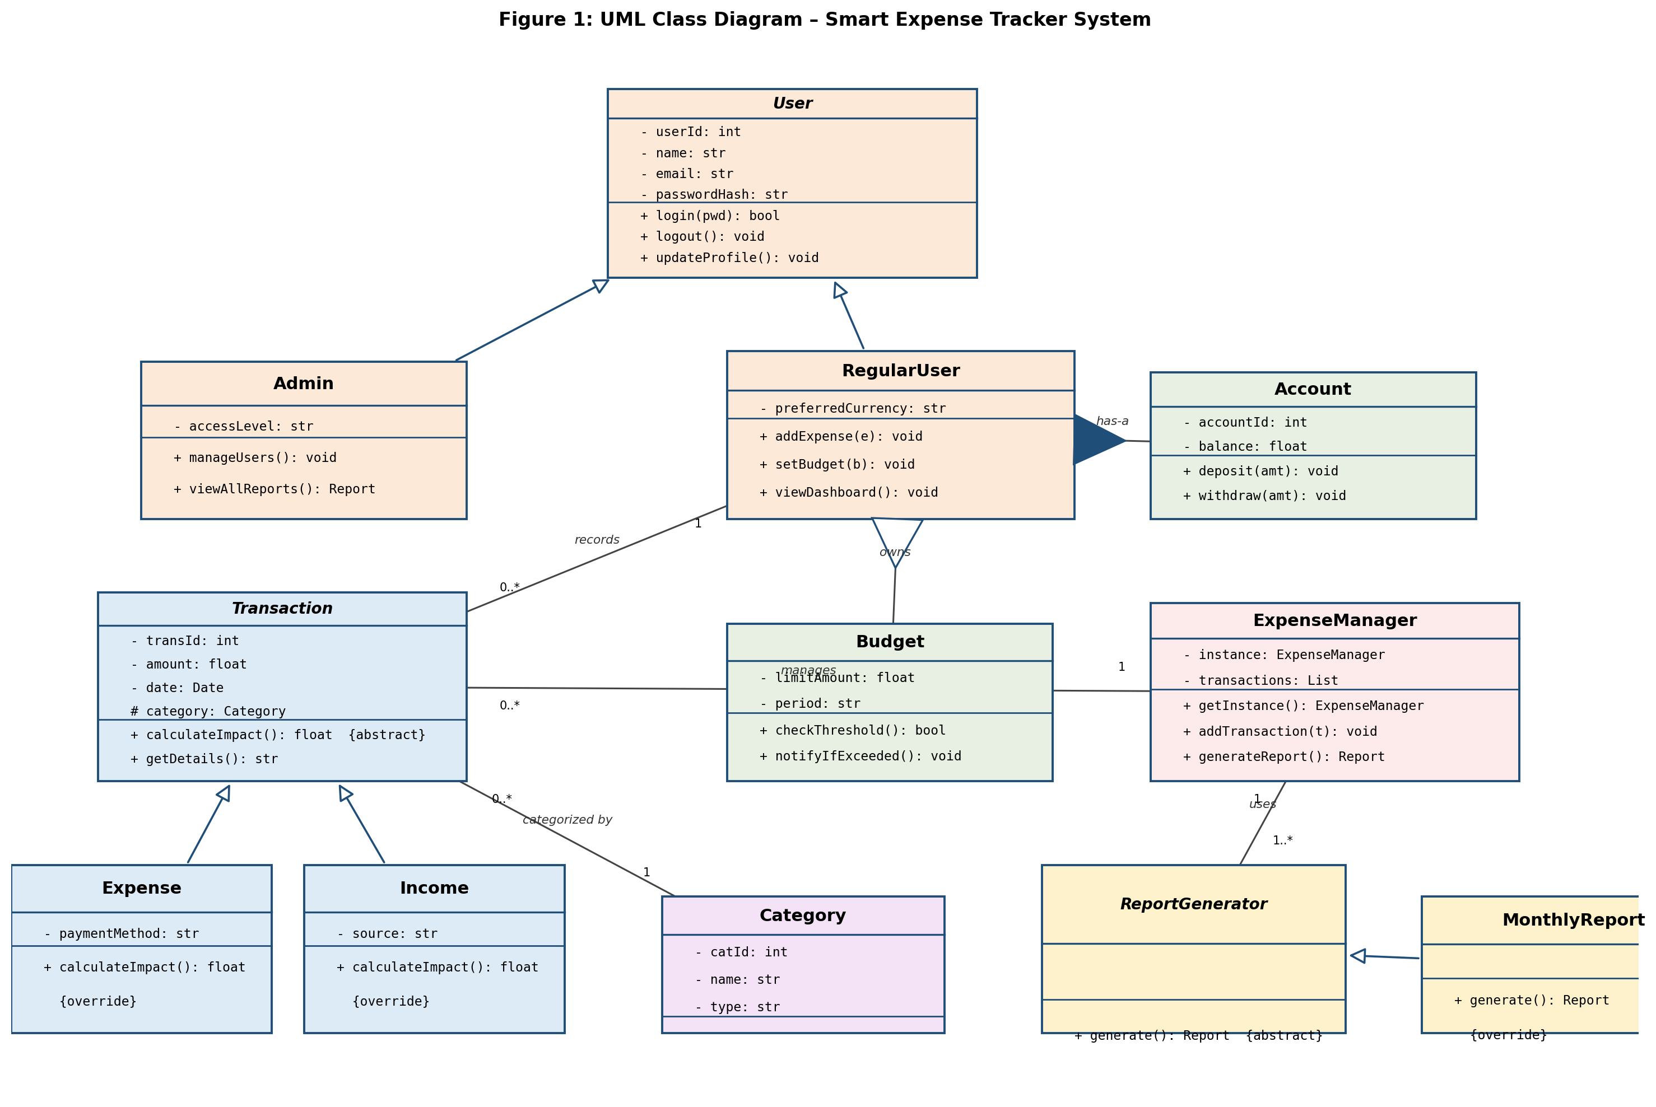
Figure 1: UML Class Diagram of the Smart Expense Tracker System

3.2 Class Responsibilities and Relationships
Class | Responsibility | Key Relationships
User (abstract) | Base identity, credentials, authentication | Superclass of Admin, RegularUser
Admin | Manage users, view all system reports | Inherits User
RegularUser | Add transactions, set budgets, view dashboard | Inherits User; owns Account (composition), Budgets (aggregation)
Account | Holds current balance for a user | Composition with RegularUser — cannot exist without its owner
Transaction (abstract) | Common transaction fields/contract | Superclass of Expense, Income; associated with Category
Expense / Income | Concrete transaction types, override impact calculation | Inherit Transaction
Category | Groups transactions (e.g., Food, Rent, Salary) | Associated 1..* with Transaction
Budget | Defines a spending limit per category/period | Aggregated by RegularUser — can exist independently of the user object
ExpenseManager (Singleton) | Central coordinator: stores transactions, triggers reports | Manages Transaction list; uses ReportGenerator
ReportGenerator (abstract) / MonthlyReport | Defines and implements report generation | Inherited/used by ExpenseManager

Aggregation is used between RegularUser and Budget because a budget definition is conceptually independent of the user record (it could be reassigned or archived); composition is used between RegularUser and Account because an account has no meaning and cannot persist without exactly one owning user — deleting the user deletes the account.

3.3 Proposed System Architecture
At the implementation level, the class design above is realised across three layers, keeping the frontend, business logic, and persistence concerns cleanly separated:
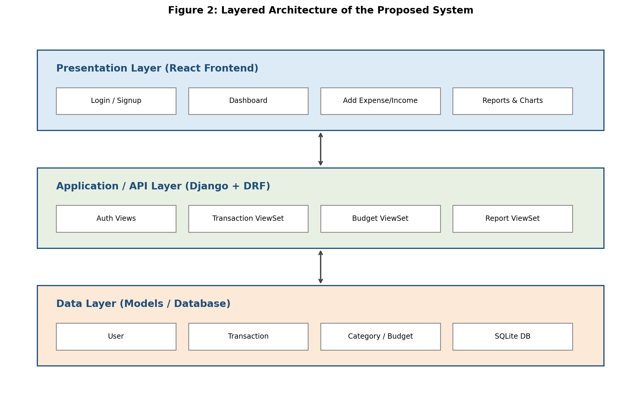
Figure 2: Layered Architecture – React frontend, Django/DRF API layer, and database

4. Solution Definition
The system solves the problem stated in Section 1 through the following high-level flow, expressed as pseudocode built directly on the class model from Section 3:

4.1 Recording a Transaction
PROCEDURE addTransaction(user, type, amount, category, extra_info):
IF amount <= 0: REJECT "amount must be positive"
IF type == "expense":
t = new Expense(amount, category, payment_method = extra_info)
ELSE:
t = new Income(amount, category, source = extra_info)
ExpenseManager.getInstance().addTransaction(t)
user.account.balance += t.calculateImpact()
FOR EACH budget IN user.budgets WHERE budget.category == category:
IF budget.checkThreshold(): notifyUser("Budget limit exceeded")
RETURN t

4.2 Generating a Report
PROCEDURE generateMonthlyReport(user, month):
transactions = ExpenseManager.getInstance()
.getTransactions(user, month)
report = MonthlyReport(transactions) # polymorphic call
RETURN report.generate()
Because calculateImpact() and generate() are polymorphic, this same pseudocode works unchanged whether a transaction is an Expense or Income, and whether a report is a MonthlyReport or a future CategoryReport — new transaction or report types can be added by creating a new subclass, without modifying this logic (the Open/Closed principle in practice).

5. Design Pattern Application
Three design patterns are used in the solution, each addressing a specific structural need rather than being applied for its own sake.

5.1 Singleton Pattern
ExpenseManager is implemented as a Singleton: there must be exactly one coordinator holding the authoritative in-memory view of transactions and dispatching report generation, so that different parts of the application (dashboard, budget checker, report exporter) are never working from inconsistent state.
class ExpenseManager:
_instance = None

@staticmethod
def get_instance():
if ExpenseManager._instance is None:
ExpenseManager._instance = ExpenseManager()
return ExpenseManager._instance

5.2 Factory Pattern
A TransactionFactory decides at runtime whether to instantiate an Expense or an Income, isolating that decision from the calling API view. This keeps the view code simple and makes it trivial to add a new transaction type later (e.g., Transfer) without changing any calling code.
class TransactionFactory:
@staticmethod
def create(type_, **kwargs):
if type_ == "expense":
return Expense(**kwargs)
elif type_ == "income":
return Income(**kwargs)
raise ValueError(f"Unknown transaction type: {type_}")

5.3 Observer Pattern
Each Budget acts as an observer of its category's transactions: whenever ExpenseManager adds a new Expense, it notifies the relevant Budget object, which checks whether its threshold has been crossed and raises an alert. This decouples the alerting logic from the core transaction-recording flow — new alert types can be added by adding new observers, without editing ExpenseManager.

5.4 Architectural Pattern: MVC / MVT
At the framework level, Django follows the Model-View-Template (Django's variant of MVC) pattern: Models (Section 2) hold data and business rules, Views/ViewSets handle request logic, and the React frontend plays the role of the presentation layer, consuming the API as JSON rather than server-rendered templates.

6. Limitations & Future Work

6.1 Limitations
- Single currency only — no exchange-rate handling for users tracking spending in multiple currencies.
- No integration with real bank feeds or payment gateways; all entries are manual.
- Budget alerts are threshold-based only; there is no predictive/forecasting logic for future overspending.
- SQLite is used for development, which does not scale to concurrent multi-user production load.
- The Observer-based alert mechanism assumes budgets are checked synchronously on each transaction; this does not scale well if transaction volume becomes very high.

6.2 Future Work
- Add a Strategy pattern for pluggable report formats (PDF, CSV export) alongside the existing MonthlyReport.
- Introduce a Transfer transaction subclass (money moved between two of the user's own accounts).
- Add bank/API integration for automatic transaction import.
- Add simple predictive analytics (e.g., projected month-end spend based on current trend).
- Migrate from SQLite to PostgreSQL for production deployment.

7. Team Contribution Table
The following table lists each group member's individual contribution to this report and the associated implementation work, as required for group submissions.
Member Name | Roll Number | Contribution
[Student Name 1] | [CT-XXXXX] | [e.g., Problem statement, OOP principles section, encapsulation & inheritance code]
[Student Name 2] | [CT-XXXXX] | [e.g., UML class diagram, system design, architecture]
[Student Name 3] | [CT-XXXXX] | [e.g., Design patterns, limitations & future work, report formatting]

8. References
- Django Software Foundation, “Django Documentation.”
- Django REST Framework, “DRF Documentation.”
- Meta Platforms, Inc., “React Documentation.”
- E. Gamma, R. Helm, R. Johnson, J. Vlissides, “Design Patterns: Elements of Reusable Object-Oriented Software,” Addison-Wesley, 1994.
- NED University of Engineering & Technology, “CT-260 Object Oriented Programming – Course Plan, Summer 2026.”

