1. send the request using post man with http://127.0.0.1:8000/

2. change the type = post

3. two parameter fst parameter name 'front_side' and type file
and 2nd parameter name 'back_side' and type file (optional)

4. then give the image in parameter and hit send image save in static/result folder

result will show like this:

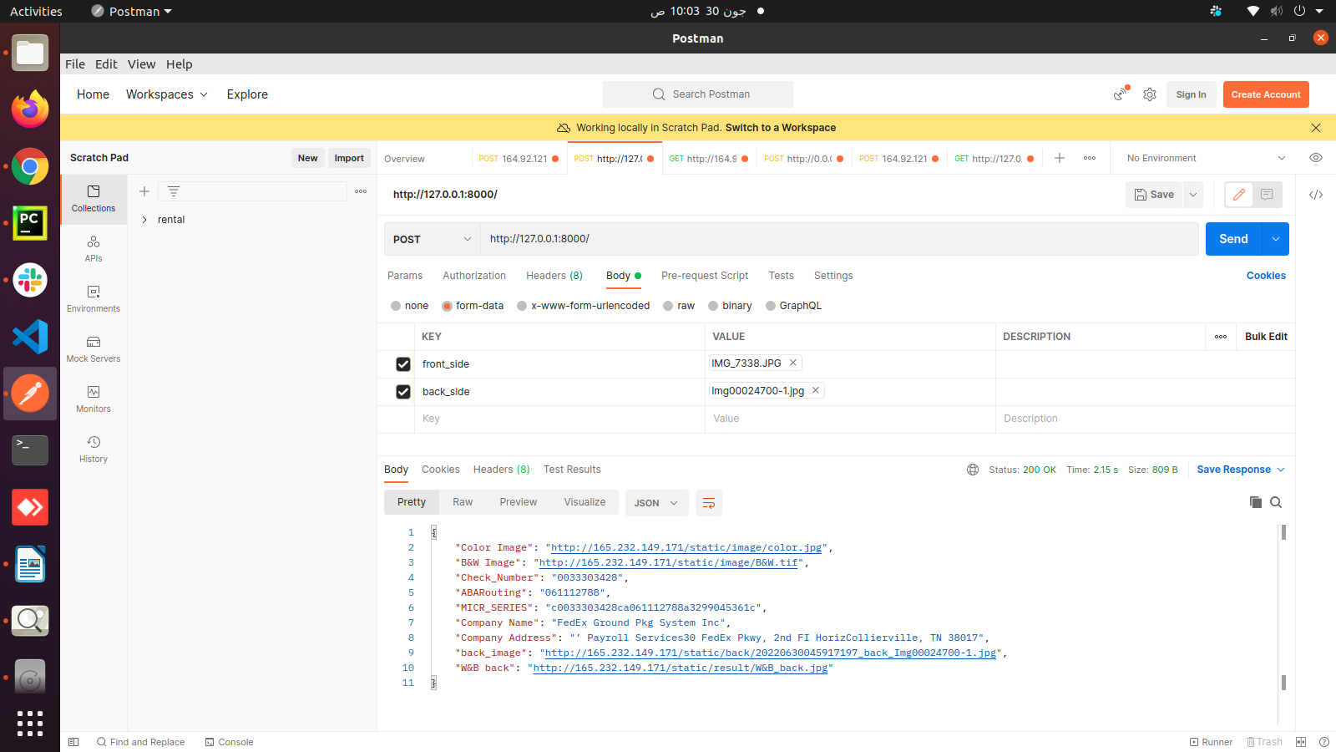

5. The result will be save in static/result/(image name)

6. if the wrong image send without check then we return the error. Not save the image in result folder

