Lab 10

**Muzammil Iqbal**

**Fa17-bece-0011**

**EXERCISE 1**

**1)**

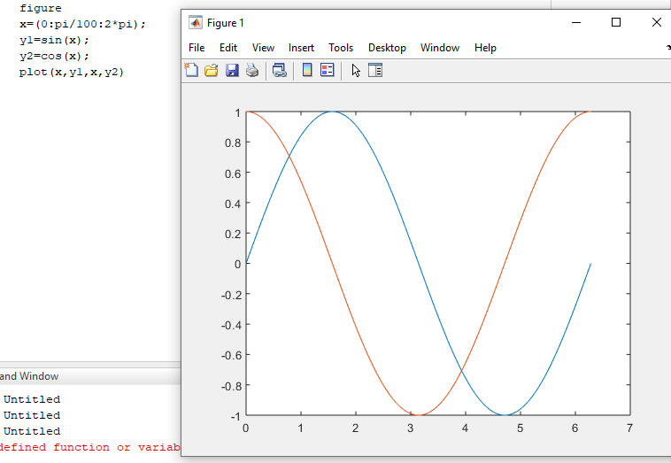

2

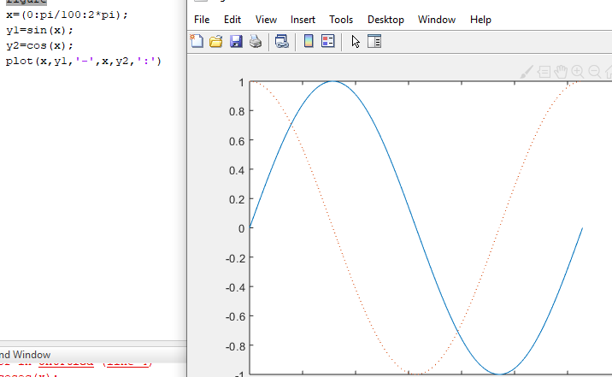

3)

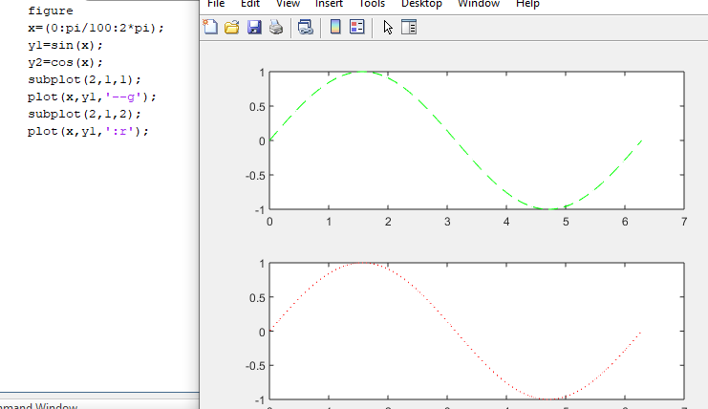

Exercise 2

