LAB12

**MUZAMMIL IQBAL**

**FA17-BECE-0011**

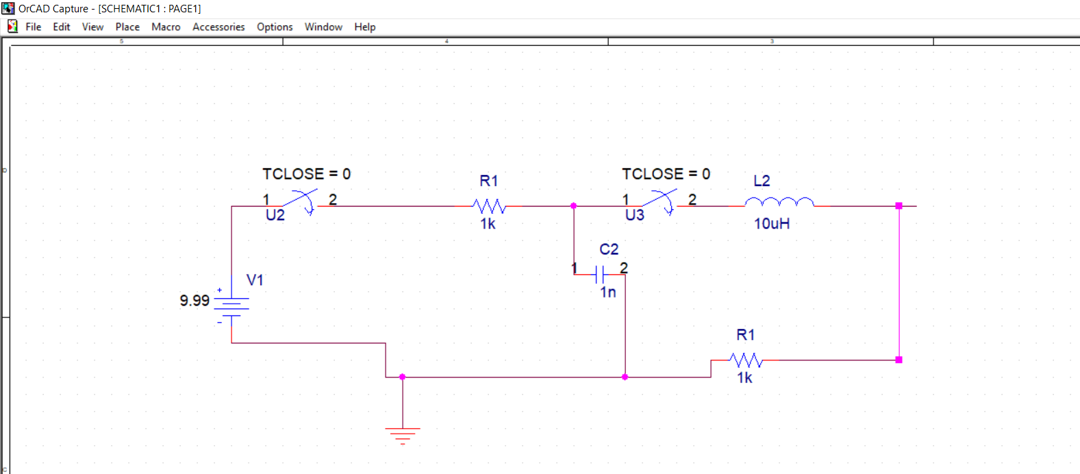

**Output**

