LAB 13

MUZAMMIL IQBAL

FA17-BECE-0011

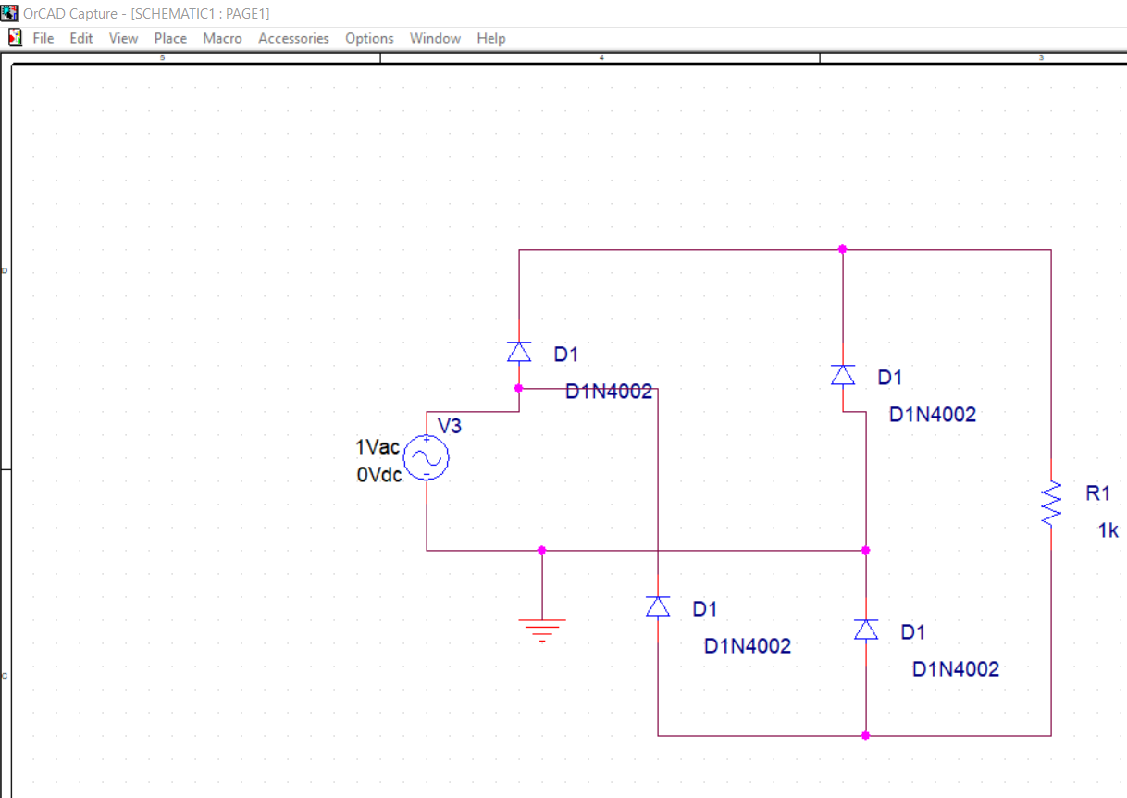

OUTPUT

