LAB 14

MUZAMMIL IQBAL
FA17-BECE-0011

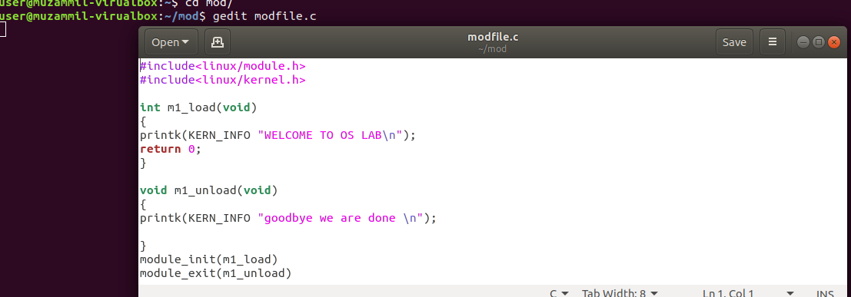
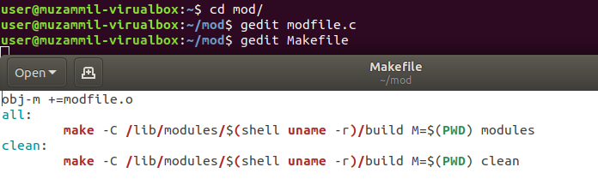
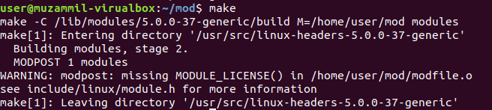

output

FOR MODULE 2

source file
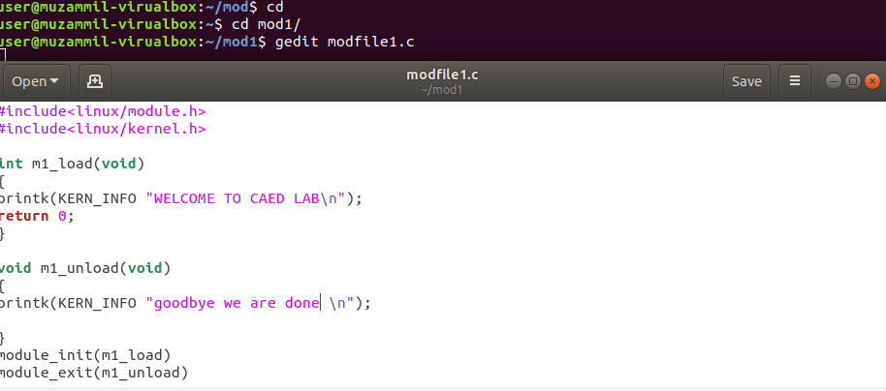
Same make file for mule 2 as well
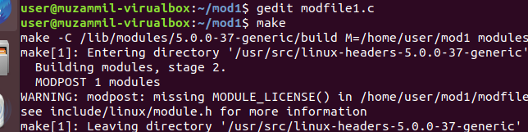
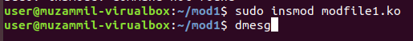

output
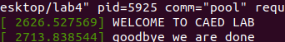

COMPLETE OUTPUT
