MUZAMMIL IQBAL
FA17-BECE-0011

lab 10

TASK1 CODE

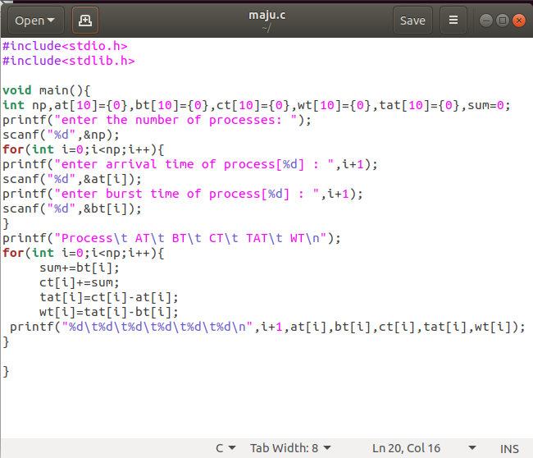

TASK1 CMD

