Lab 9

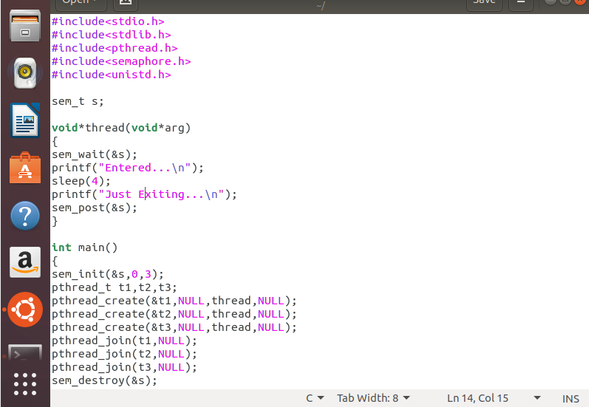
OUTPUT:

When s=1:
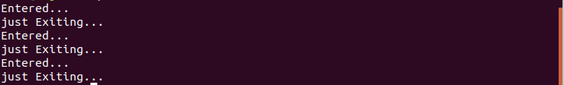

When s=5:
