Lab12

Muzammil Iqbal
Fa17-bece-0011

TASK1
CODE OF THE TASK
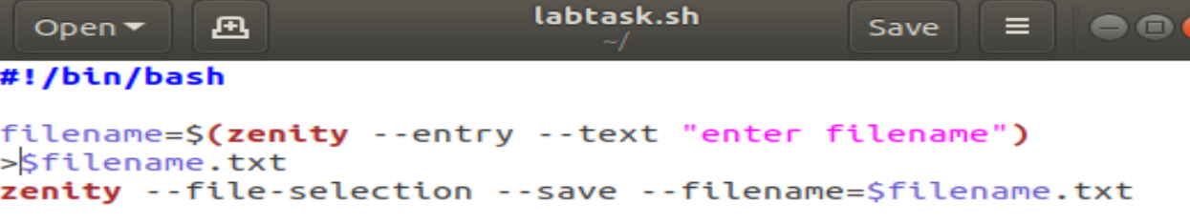

Entering the file name in the dialogbox
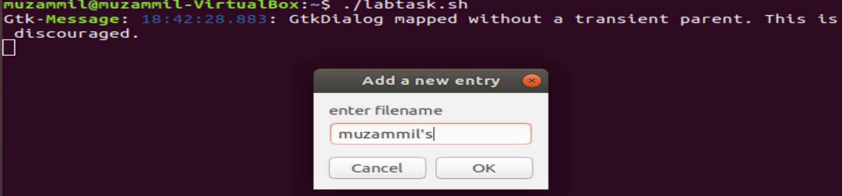
Now would be created or directly saved on desktop as per the shell commands
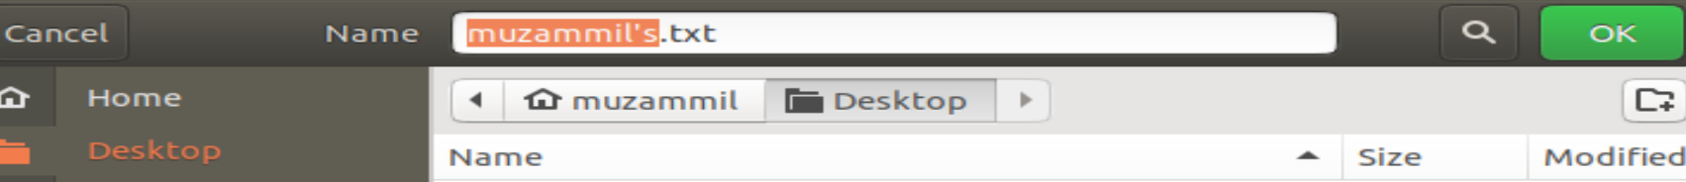
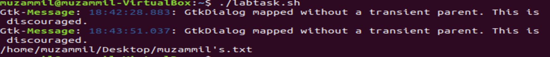

TASK2
SHELL Program
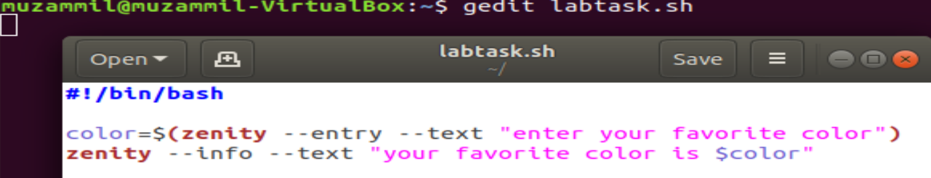

WORKING
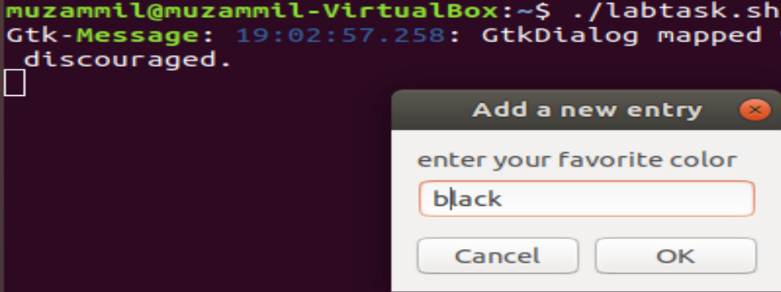
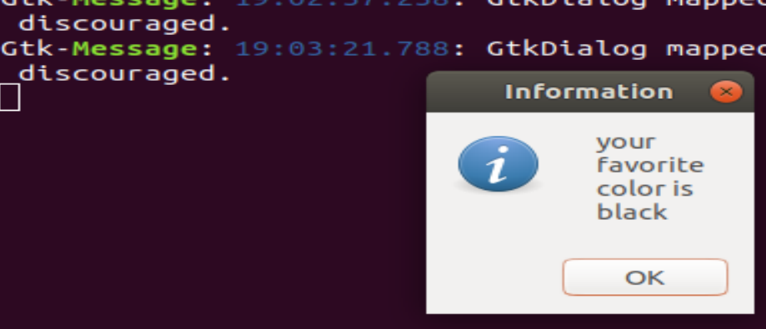

TASK 3
Code
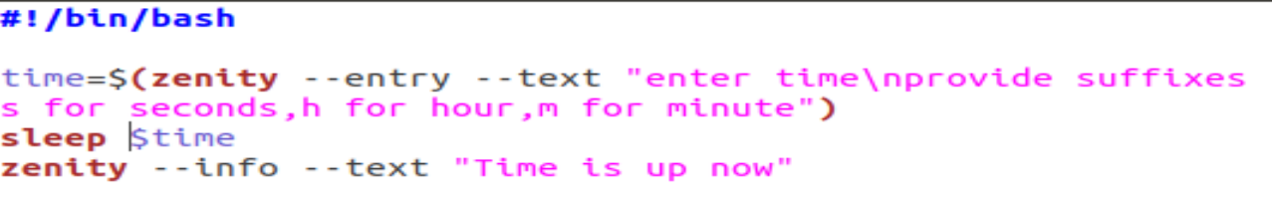
Working
