LAB11

**MUZAMMIL IQBAL**

**FA17-BECE-0011**

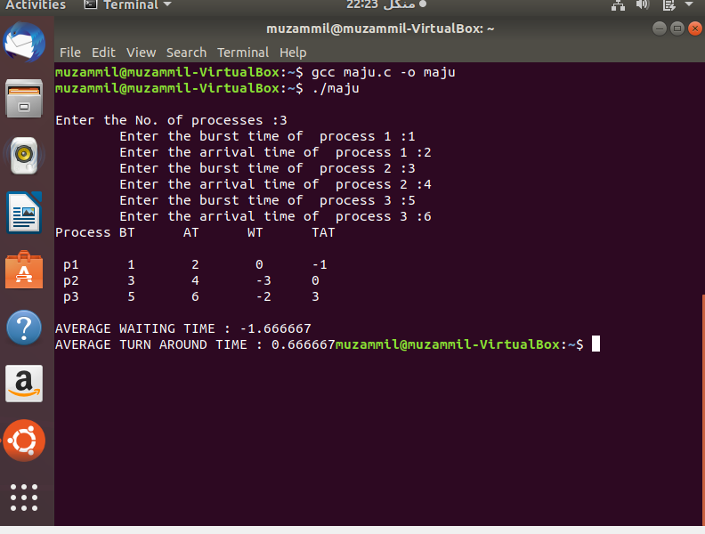

**CODE**

#include<stdio.h>  
int main()  
{  
int i,n,p[10]={1,2,3,4,5,6,7,8,9,10},min,k=1,btime=0;  
int bt[10],temp,j,at[10],wt[10],tt[10],ta=0,sum=0;  
float wavg=0,tavg=0,tsum=0,wsum=0;  
printf("\nEnter the No. of processes :");  
scanf("%d",&n);  
   
for(i=0;i<n;i++)  
{  
printf("\tEnter the burst time of  process %d :",i+1);  
scanf(" %d",&bt[i]);  
printf("\tEnter the arrival time of  process %d :",i+1);  
scanf(" %d",&at[i]);  
}  
   
/*Sorting According to Arrival Time*/  
   
for(i=0;i<n;i++)  
{  
for(j=0;j<n;j++)  
{  
if(at[i]<at[j])  
{  
temp=p[j];  
p[j]=p[i];  
p[i]=temp;  
temp=at[j];  
at[j]=at[i];  
at[i]=temp;  
temp=bt[j];  
bt[j]=bt[i];  
bt[i]=temp;  
}  
}  
}  
   
/*Arranging the table according to Burst time,  
Execution time and Arrival Time  
Arrival time <= Execution time  
*/  
   
for(j=0;j<n;j++)  
{  
btime=btime+bt[j];  
min=bt[k];  
for(i=k;i<n;i++)  
{  
if (btime>=at[i] && bt[i]<min)  
{  
temp=p[k];  
p[k]=p[i];  
p[i]=temp;  
temp=at[k];  
at[k]=at[i];  
at[i]=temp;  
temp=bt[k];  
bt[k]=bt[i];  
bt[i]=temp;  
}  
}  
k++;  
}  
wt[0]=0;  
for(i=1;i<n;i++)  
{  
sum=sum+bt[i-1];  
wt[i]=sum-at[i];  
wsum=wsum+wt[i];  
}  
   
wavg=(wsum/n);  
for(i=0;i<n;i++)  
{  
ta=ta+bt[i];  
tt[i]=ta-at[i];  
tsum=tsum+tt[i];  
}  
   
tavg=(tsum/n);  
   
  
  
printf("Process\tBT\tAT\tWT\tTAT\n" );  
for(i=0;i<n;i++)  
{  
printf("\n p%d\t %d\t %d\t %d\t%d",p[i],bt[i],at[i],wt[i],tt[i]);  
}  
   
printf("\n\nAVERAGE WAITING TIME : %f",wavg);  
printf("\nAVERAGE TURN AROUND TIME : %f",tavg);  
return 0;  
}