

Data Structures

Semester Project Proposal– Car Rental management system
Subject Code: COC2074L
Submitted To: Sir Abdul Basit
Section: BSCS-B (3rd)
Date of Submission: 8-Jan-2026
Submitted By

NAME | REG. NO.
Mujtaba Sohail | 24-NTU-CS-FL-1076
Muzammil Abbas | 24-NTU-CS-FL-1082

1. INTRODUCTION
The Car Workshop & Rental Management System is a comprehensive console-based application designed to streamline and automate the operations of car rental businesses and automotive workshops. In today's fast-paced automotive industry, managing vehicle inventory, customer records, rental transactions, and maintenance services manually can be time-consuming, error-prone, and inefficient. This system addresses these challenges by providing an integrated digital solution that combines rental operations with workshop management.
Built using C++ and implementing fundamental data structures such as Binary Search Trees, Queues, and Stacks, this system offers a robust and efficient approach to managing day-to-day operations. The system maintains persistent storage through text files, ensuring that all business-critical data is preserved and can be retrieved even after system restarts.
The primary objective of this system is to provide a user-friendly interface that enables business owners, managers, and staff to efficiently handle multiple aspects of their operations from a single platform. By automating routine tasks and providing organized data management, the system reduces human error, saves time, and improves overall business efficiency.

2. KEY FUNCTIONALITIES

2.1 Fleet Management
- Add New Vehicles: Register new cars with unique IDs, brand names, and model information
- View Vehicle Inventory: Display complete fleet with availability status (Available/Rented)
- Track Vehicle Status: Monitor which vehicles are available for rent and which are currently in use
- Automatic ID Generation: System automatically assigns unique IDs to new vehicles

2.2 Customer Management
- Customer Registration: Store customer information including name and contact details
- Customer Database: Maintain a searchable database of all registered customers
- Quick Customer Lookup: Fast search functionality using Binary Search Tree implementation
- Automatic ID Assignment: Each customer receives a unique identification number

2.3 Rental Operations
- Rental Request Processing: Create rental requests linking customers with available vehicles
- Cost Management: Record rental costs and dates for each transaction
- Queue-Based Processing: Handle rental requests in first-come-first-served order
- Availability Verification: Automatic checking of vehicle availability before processing rentals
- Status Updates: Mark vehicles as rented once transactions are processed

2.4 Service & Maintenance Operations
- Service Request Creation: Log service and maintenance requests for vehicles
- Workshop Queue Management: Organize service requests in order of arrival
- Maintenance History: Track all completed maintenance work with dates and costs
- Service Revenue Tracking: Record income generated from workshop services

2.5 Financial & Reporting
- Revenue Reports: View complete revenue generated from rentals and services
- Maintenance Cost Tracking: Monitor expenses related to vehicle maintenance
- Transaction History: Access chronological records of all financial transactions
- Automatic Calculations: System automatically calculates total revenues and costs

2.6 Data Persistence
- File Storage: All data automatically saved to text files
- Automatic Loading: Data restored when system restarts
- Data Backup: Multiple text files ensure data safety and easy backup
- CSV Format: Easy-to-read comma-separated format for manual verification if needed

3. REAL-WORLD APPLICATIONS & BENEFITS

3.1 For Small to Medium Car Rental Businesses
Use Case: A local car rental company with 20-50 vehicles
Benefits:
- Organized Inventory: Track which cars are available, rented, or under maintenance
- Customer History: Maintain records of repeat customers and their rental patterns
- Revenue Tracking: Monitor daily, weekly, or monthly income from rentals
- Reduced Paperwork: Eliminate manual ledgers and paper-based record keeping
- Quick Processing: Process rental requests faster, improving customer satisfaction

3.2 For Automotive Workshops with Rental Services
Use Case: A car repair shop that also offers rental vehicles to customers whose cars are being serviced
Benefits:
- Dual Functionality: Manage both workshop services and rental operations from one system
- Service Queue Management: Organize incoming repair jobs systematically
- Maintenance Records: Keep detailed history of all work performed on vehicles
- Financial Integration: Track both service revenue and rental income in one place
- Customer Convenience: Offer rental cars to customers while their vehicles are in service

3.3 For Vehicle Leasing Companies
Use Case: Companies providing short-term or long-term vehicle leases
Benefits:
- Fleet Utilization: Monitor which vehicles are leased and which are idle
- Customer Management: Maintain database of lessees with contact information
- Payment Tracking: Record lease payments and costs
- Maintenance Scheduling: Track when vehicles need service
- Business Analytics: Analyze revenue patterns and popular vehicle models

3.4 For Car Sharing Platforms
Use Case: Small-scale car-sharing services in residential communities or business parks
Benefits:
- Member Registration: Register users who want to share or rent vehicles
- Booking System: Manage vehicle reservations through the request queue
- Usage History: Track which members use which vehicles
- Cost Sharing: Record expenses and distribute costs among shareholders
- Transparent Records: All transactions documented with dates and amounts

3.5 Real-World Operational Improvements

Time Efficiency
- Manual searching through paper records: 5-10 minutes
- System search using BST: Less than 1 second
- Result: 99% reduction in search time

Error Reduction
- Manual tracking prone to human mistakes (wrong IDs, double bookings)
- System validates all inputs and prevents duplicate IDs
- Result: Near-zero booking conflicts

Data Security
- Paper records can be lost, damaged, or destroyed
- Digital files can be backed up and recovered
- Result: Permanent, recoverable business records

Scalability
- Manual systems become unmanageable beyond 10-15 vehicles
- This system can handle hundreds of vehicles efficiently
- Result: Business can grow without system limitations

Financial Transparency
- Manual calculation of revenues is time-consuming and error-prone
- System provides instant revenue reports with accurate totals
- Result: Better financial decision-making

4. TECHNICAL ADVANTAGES

4.1 Efficient Data Structures
- Binary Search Tree: O(log n) search time for quick customer and vehicle lookups
- Queue: Fair processing of requests in chronological order
- Stack: Easy access to most recent transactions and history

4.2 Persistent Storage
- All data saved automatically to text files
- No data loss even after power failures or system crashes
- Easy data backup and transfer between systems

4.3 User-Friendly Interface
- Clear menu-driven navigation
- Descriptive prompts guide users through each operation
- Organized display of information in tabular format
- Success and error messages for user feedback

4.4 Modular Design
- Separate classes for each component (Cars, Customers, Queue, Stack)
- Easy to maintain and extend functionality
- Clean separation of data and operations

5. TARGET USERS
- Car Rental Business Owners: Small to medium-sized rental companies
- Workshop Managers: Automotive service centers with rental operations
- Fleet Managers: Companies managing multiple vehicles
- Startup Entrepreneurs: New car-sharing or rental ventures
- Educational Institutions: Vehicle pools for staff or students

Data Structures Justification:

1. Binary Search Tree (BST)
- Used for: Cars and Customers
- Why BST? Fast searching by ID - finds data in O(log n) time
- How it works: Each node has left and right pointers, organized by ID
- Implementation: YES, uses linked structure (nodes connected via pointers)
Example Car BST:
105
/ \
102 108
/ \
100 110

2. Queue (FIFO - First In First Out)
- Used for: Rental Requests and Service Requests
- Why Queue? Process requests in order they arrive (fair system)
- How it works: Has front and rear pointers, new items added at rear
- Implementation: YES, linked list implementation using QueueNode
Front → [Req1] → [Req2] → [Req3] → Rear

3. Stack (LIFO - Last In First Out)
- Used for: Maintenance History and Revenue Records
- Why Stack? Shows most recent transactions first
- How it works: Has top pointer, new items added/removed from top only
- Implementation: YES, linked list implementation using StackNode
Top → [Latest Record]
↓
[Previous Record]
↓
[Older Record]

Diagrams



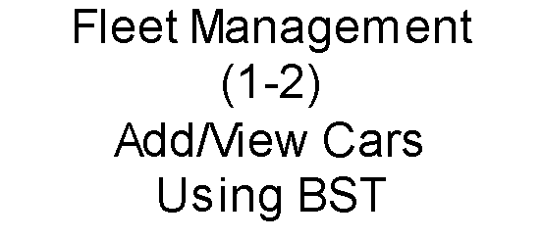
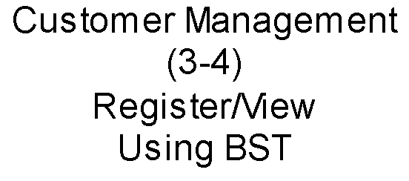
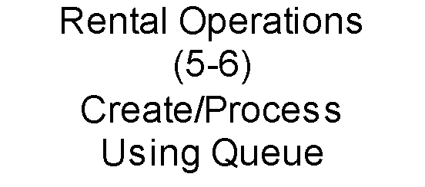
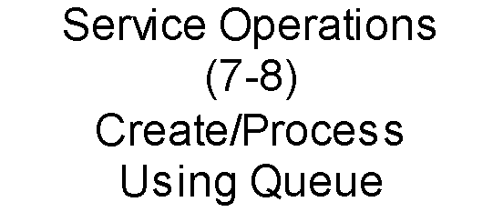
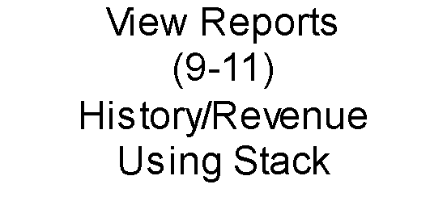










Flow Chart Diagram

System Diagram

